Cumulative comparator-arm initiation at the horizon does not determine the attenuation of the observational intention-to-treat analogue
A simulation study answering catalog problem CNF-01
Ahmad Sofi-Mahmudi
2026-07-31

Abstract
Background. In an emulated trial of initiating treatment now versus not now, patients assigned to “not now” often initiate later, so the observational intention-to-treat analogue attenuates with follow-up. Catalog entry CNF-01 proposes that authors report the cumulative incidence of initiation in the comparator arm so readers can judge the attenuation. Whether that number determines the attenuation has not been tested.
Methods. Discrete-time simulation over 120 months, n = 4000 per replicate, confounded baseline initiation and a treatment that works. A 24-scenario factorial crossed three convergence levels, two initiation timings tuned to the same cumulative initiation at 120 months, prognosis-dependent or independent initiation, and two effect-persistence regimes; 1000 replicates each. Truth was enumerated at two million individuals per scenario. The registered decision rule called the diagnostic insufficient if matched early and late scenarios differed in attenuation by at least 0.05.
Results. Standardization and stabilized inverse probability weighting estimated the intention-to-treat analogue with absolute bias at most 0.0019 and coverage 0.934 to 0.970. Median attenuation rose from 0.024 at one year to 0.245 at ten years, to a maximum of 0.567. At 120 months, matched pairs whose reported diagnostic agreed within 0.0005 differed in attenuation by 0.053 to 0.203; 9 of 12 pairs exceeded the threshold by at least three Monte Carlo standard errors.
Conclusions. Within this grid, a single cumulative-initiation value at the horizon does not determine the attenuation. Timing of initiation and who initiates both move it, and the ambiguity is largest where convergence is largest.

1. Introduction
A target trial emulation of “initiate now” against “do not initiate now” contrasts assignment strategies, not sustained treatment (1). Because the comparator arm is not required to stay untreated, its members initiate over follow-up and the two strategies converge. The resulting risk difference attenuates towards the null with the horizon for reasons unrelated to efficacy. Designs that name the later initiation explicitly, as dynamic strategies, avoid the open-ended comparator (2).
CNF-01 recommends two things: report the cumulative incidence of initiation in both arms, and quantify by simulation how much attenuation a given convergence produces at each horizon. The second presupposes that the first carries the information needed. This study tests that premise. If attenuation at a horizon is a function of cumulative comparator-arm initiation at that horizon, a conversion table suffices. If two emulations reporting the same value can carry materially different attenuation, the reported number is insufficient and more must be reported.

2. Methods
The study follows the ADEMP structure (3). The protocol was committed before the run (studies/CNF-01-convergence-attenuation/protocol.md).

2.1 Data-generating mechanism
Monthly time to 120 months. Baseline covariates L ~ N(0, 1) and Z ~ Bernoulli(0.4). Baseline initiation A0 follows logit P(A0 = 1) = −0.4 + 0.6L + 0.4Z, so assignment is confounded. Individuals with A0 = 0 initiate in later months with hazard , where is an early or late timing shape and is tuned so that cumulative initiation at 120 months among observed non-initiators equals 0.20, 0.45 or 0.70 under both shapes. is 0 (initiation independent of prognosis) or 0.6 (higher-risk patients initiate first). Treated individuals do not discontinue. The monthly event hazard is expit(−5.4 + 0.45L + 0.35Z − 0.90E(t)), where exposure E(t) is either current treatment (transient) or a 12-month ramp after initiation (legacy). There is no loss to follow-up and no competing event.

2.2 Estimands
At horizons of 12, 24, 36, 60, 84 and 120 months: the intention-to-treat analogue RD_ITT(h), the risk difference for assignment to initiate at baseline against not, with later initiation left to run; the sustained-strategy contrast RD_PP(h), always against never treated; the attenuation A(h) = 1 − RD_ITT(h) / RD_PP(h); and the diagnostic C(h), cumulative initiation among observed comparator-arm patients by h. Truth was enumerated from the mechanism at two million individuals per scenario.

2.3 Methods evaluated
Two estimators of RD_ITT(h), to confirm that attenuation is a property of the estimand and not of estimation: g-formula standardization over (L, Z) and stabilized inverse probability of treatment weighting. The method under test is the diagnostic C(120) as a predictor of A(120).

2.4 Design and performance measures
Full factorial, 3 × 2 × 2 × 2 = 24 scenarios, 1000 replicates each. Estimators were assessed by bias, empirical and model standard errors and 95% coverage, each with a Monte Carlo standard error (MCSE). The decisive quantity is the difference in attenuation between the early and late member of each of the 12 pairs matched on C(120), with its MCSE.

2.5 Registered decision rule
The diagnostic is sufficient if matched pairs differ in attenuation by less than 0.05 at every horizon; necessary but not sufficient if they differ by 0.05 or more; and the premise fails if the estimators are biased for RD_ITT. After the first results review, a pair was counted as exceeding the threshold only if its difference exceeded 0.05 by at least three MCSE.

3. Results

3.1 Estimation
Both estimators converged in every replicate. Across 288 scenario, horizon and method cells, absolute bias was at most 0.0019 and coverage ran from 0.934 to 0.970. 14 cells showed bias beyond three MCSE, to a maximum of 4.2 MCSE; the largest such bias was 0.0019 on a true risk difference of -0.162. This does not affect the decisive comparison, which uses enumerated truth rather than estimates. The premise holds: attenuation here is a property of the estimand.

3.2 Attenuation grows with the horizon
Pooled across scenarios, median attenuation was 0.024 at 12 months, 0.119 at 60 months and 0.245 at 120 months (Figure 1). The largest value, 0.567, arose with 70% convergence, early timing and prognosis-dependent initiation: more than half of the sustained-strategy effect was absent from the intention-to-treat analogue. Effect persistence mattered least: transient and legacy regimes differed by at most 0.034, at 24 months while the 12-month ramp was under way, and by at most 0.014 at 120 months.
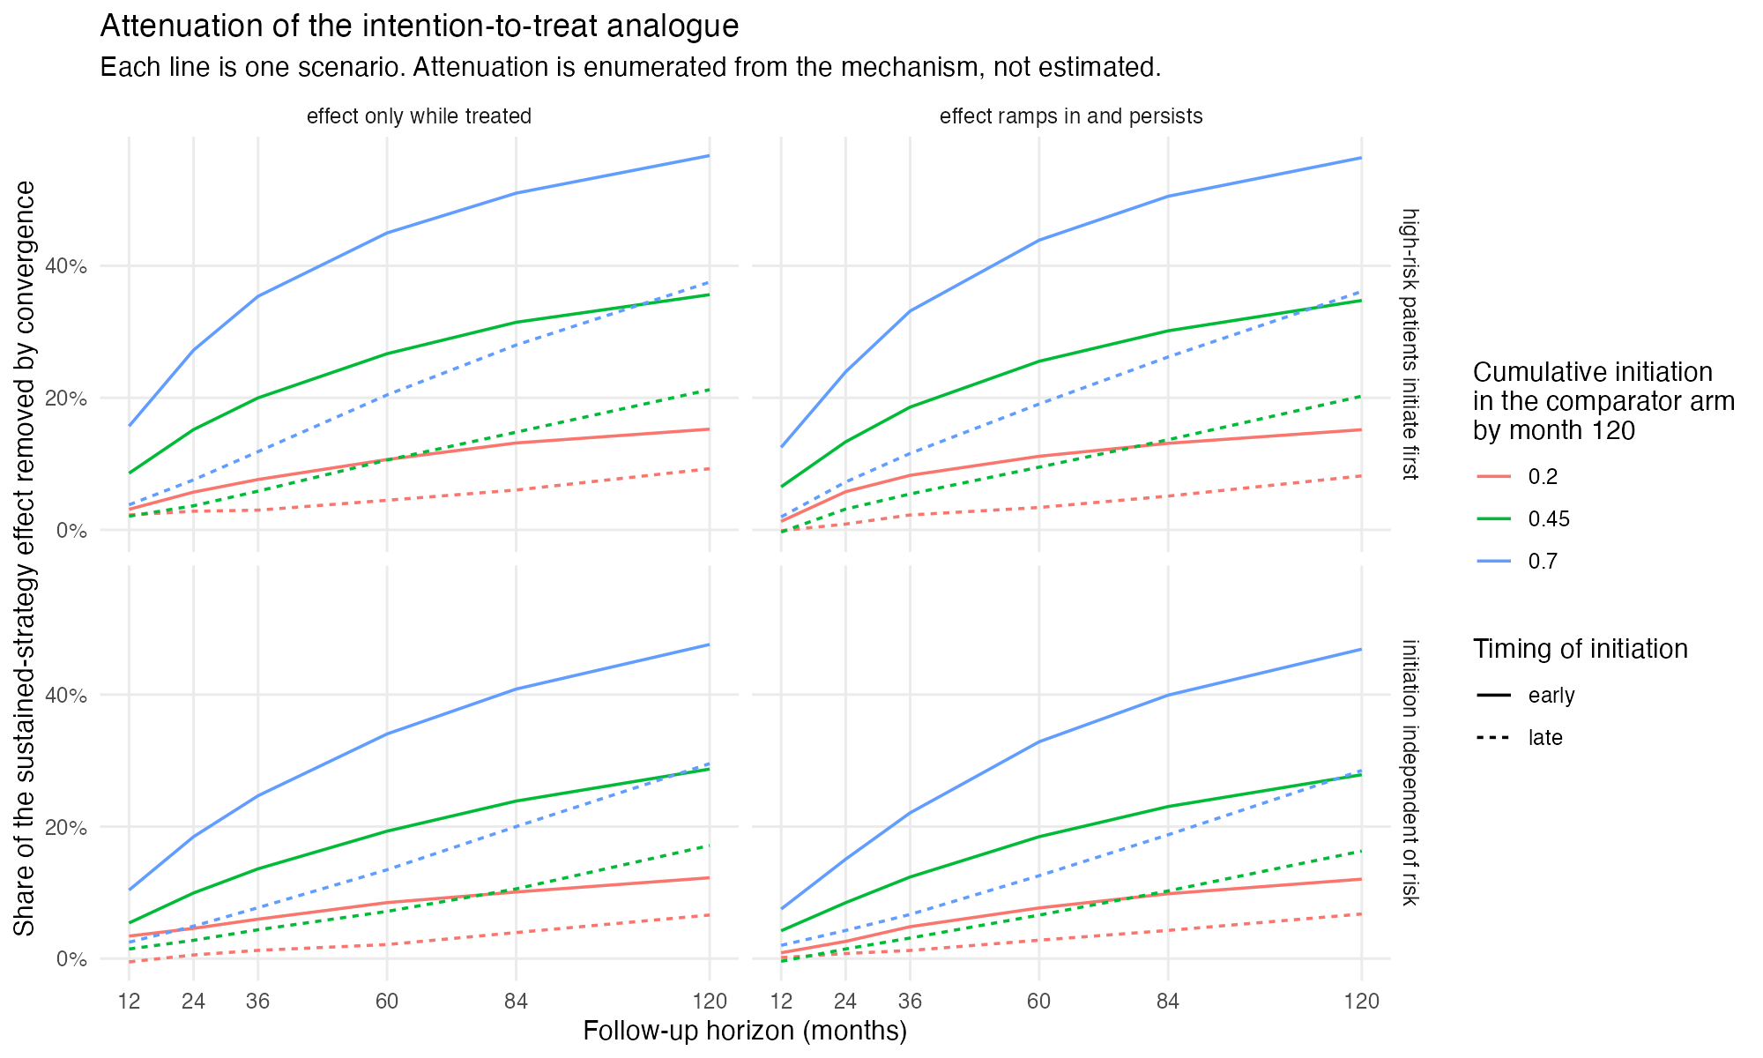
Figure 1: Attenuation of the intention-to-treat analogue by horizon.

3.3 The decisive comparison
Table 1 shows the 12 matched pairs at 120 months. Their reported diagnostic agreed to within 0.0005, yet attenuation differed by 0.053 to 0.203. 9 of 12 pairs exceeded 0.05 by at least three MCSE, at 5 to 46 MCSE. The remaining 3 sat within three MCSE of the threshold and are individually inconclusive; all are at 20% convergence, where there is least attenuation to misattribute. The difference grew with convergence: 0.053 to 0.070 at 20%, 0.116 to 0.145 at 45%, and 0.181 to 0.203 at 70% (Figure 2).
Table 1: Matched early and late scenarios at 120 months. d_att is early minus late attenuation; z is its distance above 0.05 in Monte Carlo standard errors.
C(120) | initiation | persistence | C early | C late | A early | A late | d_att | MCSE | z
0.20 | neutral | legacy | 0.2000 | 0.2001 | 0.120 | 0.068 | 0.053 | 0.0040 | 0.7
0.20 | neutral | transient | 0.2000 | 0.1995 | 0.122 | 0.066 | 0.056 | 0.0038 | 1.7
0.20 | prognostic | legacy | 0.2000 | 0.1999 | 0.152 | 0.082 | 0.070 | 0.0039 | 5.1
0.20 | prognostic | transient | 0.2000 | 0.2002 | 0.153 | 0.093 | 0.060 | 0.0037 | 2.7
0.45 | neutral | legacy | 0.4498 | 0.4498 | 0.279 | 0.163 | 0.116 | 0.0037 | 17.6
0.45 | neutral | transient | 0.4503 | 0.4498 | 0.287 | 0.171 | 0.116 | 0.0035 | 18.7
0.45 | prognostic | legacy | 0.4495 | 0.4500 | 0.348 | 0.202 | 0.145 | 0.0036 | 26.1
0.45 | prognostic | transient | 0.4501 | 0.4501 | 0.356 | 0.212 | 0.144 | 0.0034 | 27.4
0.70 | neutral | legacy | 0.6999 | 0.7003 | 0.469 | 0.285 | 0.184 | 0.0035 | 38.6
0.70 | neutral | transient | 0.6998 | 0.7003 | 0.476 | 0.295 | 0.181 | 0.0033 | 40.1
0.70 | prognostic | legacy | 0.6998 | 0.6997 | 0.564 | 0.361 | 0.203 | 0.0033 | 46.1
0.70 | prognostic | transient | 0.7004 | 0.7001 | 0.567 | 0.375 | 0.192 | 0.0031 | 45.3

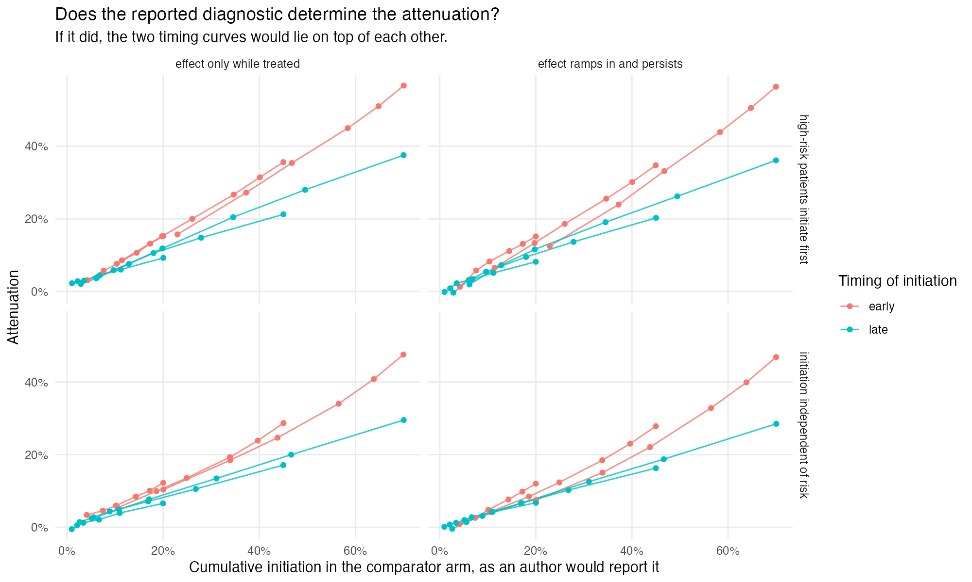
Figure 2: Attenuation against the reported diagnostic. If the diagnostic determined attenuation, the early and late curves would coincide.

3.4 Who initiates
Prognosis-dependent initiation raised attenuation at 70% convergence from 0.476 to 0.567. It also separated the reported diagnostic from initiation under assignment: among observed non-initiators C(120) was 0.700, while cumulative initiation in the whole population under assignment to “not now” was 0.742. Baseline confounding leaves lower-risk patients in the observed comparator arm, so the arm-level number understates the convergence of the assigned strategy.

4. Discussion
Reporting cumulative comparator-arm initiation at the horizon is not enough to recover the attenuation it is meant to explain. Two emulations that report the same value can differ in attenuation by up to 0.20 on a scale where the whole effect is 1, because the value is blind to when the comparator arm initiated and to who initiated. The ambiguity is largest exactly where attenuation is largest.
A report that lets a reader interpret a null or small intention-to-treat estimate therefore needs the initiation curve over follow-up, not its endpoint, and some statement of how initiation relates to prognosis. Where the question is about sustained treatment, a per-protocol or dynamic-strategy estimand answers it directly (1,2).

4.1 What this study does not establish
The diagnostic was held fixed only at 120 months. At earlier horizons the early and late scenarios differ in C(h) by up to 0.269, so those contrasts are not comparisons at equal C(h). The study shows that C(120) alone is insufficient in this grid. It does not show that reporting C is necessary, that the full curve is sufficient, or that a general conversion from convergence to attenuation exists. Convergence runs in one direction only: the comparator initiates and the treated arm never discontinues. There is no loss to follow-up or competing event. Results are on the risk-difference scale; a hazard ratio would add non-collapsibility to the mechanism under study.

4.2 Review
The design was reviewed before the run. The results were reviewed in three rounds, each in a fresh context that saw the catalog entry, the protocol and the result files but not this summary. Round 1 required Monte Carlo uncertainty on the decisive quantity, which reduced the pairs clearing the threshold from 12 to 9. Round 2 found an arithmetic error in how the study reported bias: it was described as a share of the attenuation but computed against the risk difference. Round 3 returned supported with three minor findings on claim strength.

Data and code availability
Code, protocol and result files: https://github.com/choxos/TTE-open-problems/tree/main/studies/CNF-01-convergence-attenuation. Raw replicate files regenerate from the recorded seed.

References
1. Miguel A. Hernán, James M. Robins. Using big data to emulate a target trial when a randomized trial is not available. American Journal of Epidemiology. 2016;183(8):758–64. doi:10.1093/aje/kwv254
2. Lauren E. Cain, James M. Robins, Emilie Lanoy, Roger Logan, Dominique Costagliola, Miguel A. Hernán. Using observational data to emulate a randomized trial of dynamic treatment-switching strategies: An application to antiretroviral therapy. International Journal of Epidemiology. 2016;45(6):2038–49. doi:10.1093/ije/dyv295
3. Tim P. Morris, Ian R. White, Michael J. Crowther. Using simulation studies to evaluate statistical methods. Statistics in Medicine. 2019;38(11):2074–102. doi:10.1002/sim.8086

