ATTENDANCE MONITORING SYSTEM

---------------------------------------------------------------------

Introduction To Computing Project
Presented to the
Faculty of the College of Information Technology
Cagayan de Oro College
Cagayan de Oro City

-------------------------------------------------------------------------------

In Partial Fulfillment
of the Requirements for the Degree
Bachelor of Science in Information Technology

-------------------------------------------------------------------------------

NAME OF RESEARCHER

WAGA, JERICK
BACTONG, DON JOSENILO L.
DE GUZMAN, CHESCKA I.
IGNALIG, NINO JHON C.
MADERA, JONATHAN C.
MECATE, JHON FRANCIN O.

OCTOBER, 2026
  - Introduction
Attendance is one of the most basic records in a school. It tells the teacher who came to class, who came late, and who was absent. Keeping correct attendance records is important because class attendance has a strong relationship with students’ grades (Credé et al., 2010). Even so, many classes still record attendance on paper sheets, and the teacher has to update the records and count them by hand (Saari et al., 2017). Computer-based attendance systems were developed to replace this manual work and to reduce its errors and the time it takes (Shoewu & Idowu, 2012).
No actual client was interviewed for this project, so the proponents assumed a common classroom setting. In this setting, one teacher handles several subjects and sections, and attendance is taken manually, such as by calling names or passing an attendance sheet. Three problems were identified in this assumed setting. First, manual recording takes class time, can have mistakes, and the paper sheets can be lost or damaged (Saari et al., 2017). Dassanayake and Wanniarachchi (2021) likewise describe the attendance systems they studied as mostly manual and paper-based, with both the marking and the calculating done by hand. Second, there is no automatic, time-based way to check whether a student logged in on time or late, and no fixed rule for when a student is counted as present, late, or absent, so the result can be different from one class to another. Third, the records are kept on separate sheets and are not organized by section or quarter, so searching for a student or counting the total present, late, and absent by hand is slow and can cause counting errors (Shoewu & Idowu, 2012).
The proponents developed the Attendance Monitoring System using a Python console-based application to help the teacher, who is the primary user, monitor and manage class attendance. The first screen lets the user choose Teacher or Student. The teacher logs in with a username and password and then uses the Teacher Dashboard to add and remove students, add, edit, and remove subjects and class schedules, edit attendance records, and view summaries by quarter. The information is shown in tables so that it is easy to read. Students are secondary users who log in with their Student ID and section to log their own attendance and view their own records. If a user types a wrong entry, the program shows an error and asks again, and typing a Space and pressing Enter cancels the current process and goes back to the previous menu. For the first problem, students log their own attendance by themselves. For the second problem, the system decides Present, Late, or Absent by itself using the class start time and the time the student logs in. For the third problem, the teacher can search, filter, organize by section, edit, and summarize the records by quarter. The program uses only Python’s built-in datetime module to get the current date and time (Python Software Foundation, n.d.), and it keeps its data in the computer’s memory while the program is running, so no data file is created.

1.2 Statement of the Problem

General Problem
Recording attendance by hand is slow, can have mistakes, and makes it hard for the teacher to track, organize, and summarize the records. This affects teachers, who spend extra class time and effort on attendance, and students, whose attendance may not be recorded or counted correctly.

Specific Problems
1. No Self-Service Recording — Students have no way to record their own attendance, so the teacher has to record it manually for every student in every class. This takes class time and can have mistakes, and paper sheets can be lost or damaged, so the records become unreliable.
2. No Automatic, Time-Based Status Detection — There is no automatic way to check if a student logged in on time, late, or absent, and no fixed rule for the status, so the result may be different from one class to another.
3. No Organized Record-Keeping by Section and Quarter — Attendance records are scattered and not separated by section or academic quarter, so they are hard to search, organize, and count by hand, and the teacher needs a lot of time to check one student or one class.

1.3 Objectives of the Study

General Objective
To develop the Attendance Monitoring System, a Python console-based application that enables the teacher, as the primary user, to manage and monitor class attendance records, and enables students to log their own attendance.

Specific Objectives
1. To let students log their own attendance by logging in as a Student with a Student ID and section and then typing the subject, with the program checking each entry and asking again when the information is wrong.
2. To automatically set the attendance status to Present, Late, or Absent based on the class start time and the time the student logs in.
3. To provide the teacher, as the primary user, with a table-based dashboard for adding and removing students; adding, editing, and removing subjects, by sections and schedules; and viewing, filtering, editing, and summarizing attendance records organized by section and separated by quarter, while students can only view their own records.

1.4 Scope
The study covers the Attendance Monitoring System, a Python console-based program for a classroom setting where the teacher is the primary user and the students are secondary users. The program runs on one computer and keeps all of its data in the computer’s memory (Python lists) while it is running. No data file or database is used, so the program starts again with three sample students and two sample subjects each time it is opened. Figure 1 shows how the system works, from the first screen to the Teacher and Student dashboards.
- Login: The first screen has three options: 1. Teacher, 2. Student, and 3. Exit. The teacher enters a Username and Password. The student enters a Student ID (format 02-2627-010147) and then the Section, and the student’s name is shown automatically.

- Teacher functions (primary user): After logging in, the Teacher Dashboard has five categories: Dashboard, Students, Subjects & Schedules, Attendance, and Quarter. The teacher can view today’s attendance and a summary; add, view, search, organize by section, and remove students; add (choosing the section from the registered sections and entering times in the HH:MM AM/PM format), edit, and remove subjects and schedules; view and filter attendance, edit a status, and view the statistics and history of one student; and switch the quarter (P1, P2, or P3).
- Tables: Teacher information is shown in tables: the student list, search results, and students by section; the subjects and schedules; today’s attendance, the attendance records, and a student’s history; and the summary and statistics (the number of Present, Late, Excuse, and Absent records).
- Student functions: After logging in, the student sees a dashboard with his or her name, Student ID, section, and the current quarter. A student can log attendance for a subject (only once per subject per date), view the attendance recorded today, view the whole attendance history, and log out. Students have view-only access and cannot edit any record.
- Automatic status: The system sets Present, Late, or Absent using the class start time and the time the student logs in.
- Retry and cancel: If the information typed is wrong (for example, a wrong Student ID, a blank name, a wrong time format, or a subject that does not exist), the program shows an error message and asks again, so the user does not need to start over. Typing a Space and pressing Enter at any input cancels the process and returns to the previous menu without closing the program.
- Data handled: Student ID, name, and section; subject name, section, start time, end time, and class days; and attendance records (student, section, subject, quarter, date, time, and status). All of these are kept in memory only while the program is running.
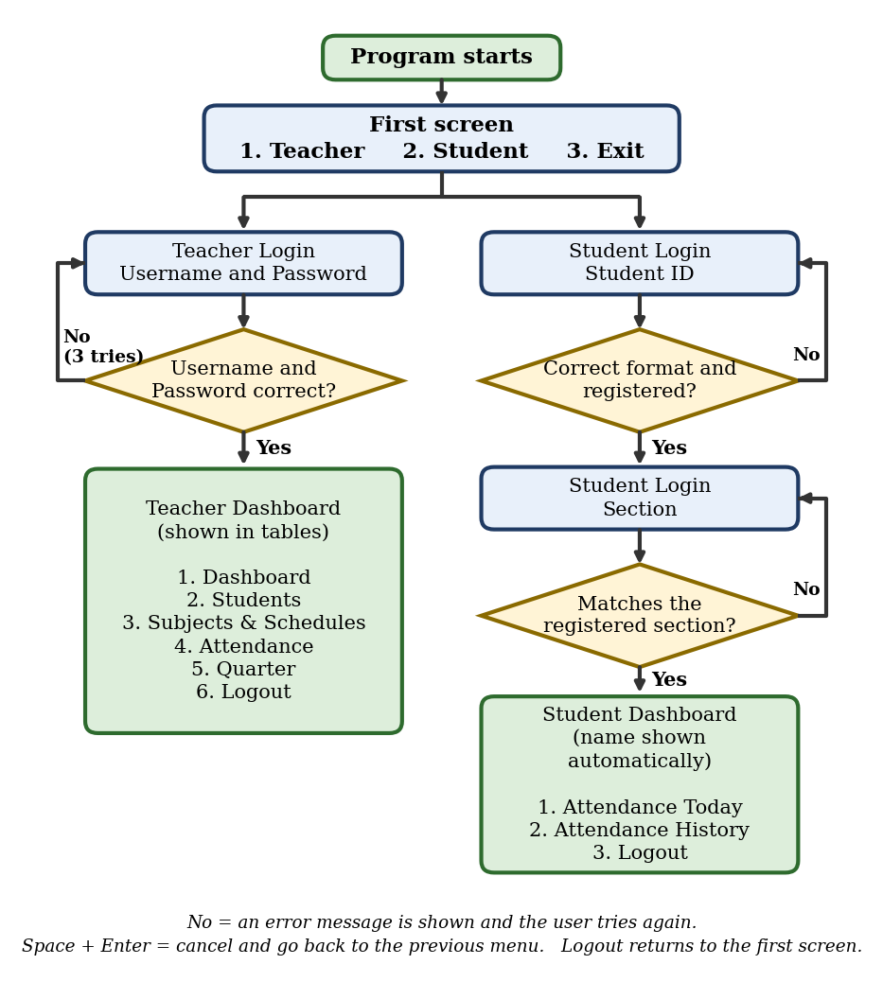
Figure 1. Overall flow of the Attendance Monitoring System

1.5 Limitations
The system is a console program and works only on the computer where it is run. It has no screen buttons, mobile app, biometric scanner, or QR code attendance, no internet or network connection, no email or text notifications, and no connection to any other school system. Only one person can use the program at a time. The data is kept only in the computer’s memory and is not saved to a file or database, so all records are lost when the program is closed and the program starts again with the sample data. The following restrictions also apply:
- Students log in with their Student ID and section only. There is no student password, so the system cannot confirm that the person typing is the real student.
- Teacher access depends only on one username and a plain password check. Both are kept inside the program code and are not encrypted. There is only one teacher account.
- Absent is recorded only when a student logs in more than 90 minutes after the class starts, or when the teacher changes a status. A student who never logs in does not get a record automatically, and the teacher can only edit records that already exist.
- The Excuse status can only be set by the teacher through Edit Status.
- The subject name (and the section, when editing or removing a subject) must be typed exactly as it was saved, and dates used in filters must be typed in the same format as the records (for example, October 06, 2026).
- The status is based on the class start time only. The end time is saved and shown in the schedule, and classes that end after midnight can be saved, but the status is still computed using the time of the same day.
- The program has no printing or exporting of reports, and only three quarters (P1, P2, and P3) are available.
- To cancel an input, the user must type a Space and press Enter, because the console cannot detect a single key press without extra code.
- A student who was removed from the list can no longer log in, and the teacher can no longer edit that student’s status, but the old records can still be seen in the attendance records and statistics while the program is running.

1.6 System Requirements

Hardware Requirements
- A desktop computer or laptop that can run Python 3, for example one with a dual-core processor, 2 GB of RAM, and at least 100 MB of free storage space.
- A monitor and a keyboard for typing the inputs. A mouse is optional. The hardware listed here is a justified minimum for a console program, not a tested specification.

Software Requirements
- Operating system: Windows 10 or later, or any operating system that can run Python 3.
- Python 3 only. The program uses only the built-in datetime module, so no extra package needs to be installed. No data file or database is needed because the data is kept in memory while the program is running.
- Development tool (not needed to run the program): Visual Studio Code, used for writing and running the code.

Functional Requirements
- Any user can start from the first screen and choose 1. Teacher, 2. Student, or 3. Exit. Logging out of either dashboard returns to this screen.
- The teacher can log in by entering the Username and Password, with up to three tries, after which the program returns to the first screen.
- A student can log in by entering a valid Student ID and then the section registered for that ID. If the ID or the section is wrong, an error is shown and the student can try again. The student’s name is then shown automatically.
- The teacher can add a student by entering the Student ID, name, and section. If an entry is wrong, an error is shown and the teacher can type it again. The added student is shown in a table.
- The teacher can view all students, search by ID or name, and view students by section, each shown in a table, and can remove a student after typing “yes” to confirm. The removed student’s past attendance records stay in the records.
- The teacher can add, edit, and remove a subject. When adding a subject, the section is chosen from the registered sections and the class days are chosen from a numbered list of the seven weekdays. The subjects and schedules are shown in a table.
- The teacher can view today’s attendance and a summary, view attendance with filters, change a record’s status to Present, Late, Excuse, or Absent, and view the statistics and history of one student. These are shown in tables.
- The teacher can switch the current quarter to P1, P2, or P3. The views of today’s attendance, the summary, the filtered records, and the student statistics then show the records of that quarter, and new attendance logged by students is recorded under that quarter.
- A student can log attendance by typing the subject; the system records the date and time and shows the status. If the subject does not exist for the student’s section, the student is asked to type it again (or press Enter to skip).
- A student can view today’s attendance and the attendance history, but cannot edit or delete any record.
- In any input process (for example, a login or Add Student), the user can type a Space and press Enter to cancel and return to the previous menu. The program does not close.
- Validation: the Student ID must follow the format 02-2627-010147; the student name, section, and subject name cannot be blank; time must follow HH:MM AM/PM; the end time must be after the start time unless the teacher confirms that the class ends after midnight; a Student ID or a subject for the same section cannot be added twice; and a student has only one record per subject per day.
- Validation: a student cannot log attendance for a subject that is not scheduled today or for a class that has not started yet. No record is created in these cases.

1.7 Code Snippet of Attendance Monitoring System
The following snippets are taken from the final working program. Each one shows how the system meets one of the objectives.

Snippet 1 First Screen: Teacher or Student
Related objective: Objective 1 – let students log their own attendance, starting from the Student option on the first screen.
def main():
print("===== ATTENDANCE MONITORING SYSTEM =====")
while True:
print("\n----- LOGIN -----")
print("1. Teacher")
print("2. Student")
print("3. Exit")
choice = input("Enter your choice: ").strip()
if choice == "1":
run_action(teacher_login)
elif choice == "2":
run_action(student_login)
elif choice == "3":
print("Thank you for using the system.")
break
else:
print("Invalid choice. Please try again.")
The function shows the first screen with the options Teacher, Student, and Exit, and it repeats until the user chooses Exit. Choice 1 runs teacher_login(), which asks for the Username and Password and allows up to three tries. Choice 2 runs student_login(), which asks for the Student ID and the Section. Any other input shows “Invalid choice” and the menu is shown again. Each login is started through run_action(), so a cancel only returns to this screen and does not close the program. Because the user picks Teacher or Student first, each side asks only for its own information, and this leads students to attendance logging and the teacher to the Teacher Dashboard.

Snippet 2 Student Login with Retry
Related objective: Objective 1 – let students log in with a Student ID and section and try again when the information is wrong.
def student_login():
print("\n--- Student Login ---")
print(CANCEL_HINT)

# Keep asking until the ID has the right format AND is registered.
while True:
student_id = ask("Enter Student ID (e.g. 02-2627-010147): ")
if not is_valid_student_id(student_id):
print("Error: Invalid Student ID. Please enter a valid Student ID and try again.")
continue
student = find_student(student_id)
if student is None:
print("Error: Student ID not found. Please check your ID and try again.")
continue
break

# Keep asking until the section matches the one registered for that ID.
while True:
section = ask("Enter Section: ")
if section == student[2]:
break
print("Error: The Student ID and Section do not match our records. Please check your information and try again.")

print("\nWelcome, " + student[1] + "!")
student_dashboard(student)
The function asks for the Student ID. It shows an error and asks again if the ID does not follow the correct format (is_valid_student_id) or is not registered (find_student). Then it asks for the Section and keeps asking until it matches the section saved for that student. When both are correct, it shows a welcome message with the student’s name, which comes from the registered record, and opens the Student Dashboard. The student never has to start over after a wrong entry.

Snippet 3 Student Logs Attendance
Related objective: Objective 1 – let students log their own attendance and record it correctly.
def log_student_attendance(student, subject_name):
# Step 1: subject + section must exactly match a real, scheduled class.
subject = find_subject(subject_name, student[2])
if subject is None:
print("No matching section or subject was found. Please check your information and try again.")
return

date_text, time_text, day_name = get_current_date_and_time()

# Step 2: is this subject even scheduled today? If not, stop here --
# never create a record and never mark the student Absent.
if not is_subject_scheduled_today(subject, day_name):
print("You do not have this subject scheduled today.")
return

# Step 3: was attendance for this class already recorded today?
existing = already_logged_today(student[0], subject_name, date_text, current_quarter)
if existing is not None:
print("Your attendance for this class has already been recorded today.")
print("Status:", existing[7])
return

# Step 4: has the class actually started yet? If not, do not mark
# Absent and do not create a record -- just tell them to come back.
if time_to_minutes(time_text) < time_to_minutes(subject[2]):
print("You are too early. Your " + subject_name + " class starts at " + subject[2] + ".")
return

# Step 5: only now do we calculate Present / Late / Absent.
status = compute_status(subject[2], time_text)
attendance.append([student[0], student[1], student[2], subject_name,
current_quarter, date_text, time_text, status])
print("\nAttendance recorded!")
print("Date:", date_text)
print("Time:", time_text)
print("Status:", status)
The function receives the logged-in student and the subject name that the student typed. It checks, in order, that the subject exists for the student’s section, that it is scheduled today, that the student has not logged it yet today, and that the class has already started. If any check fails, it only shows a message and no record is created. If all checks pass, it gets the status from compute_status(), adds the record to the attendance list, and then displays the date, time, and status. Before this function runs, attendance_today() already asks the student to type the subject again if it does not exist. Figure 2 shows these checks as a flowchart.
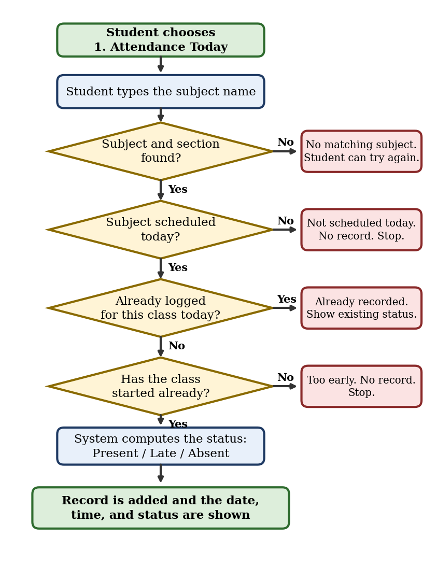
Figure 2. Checks done when a student logs attendance

Snippet 4 Automatic Present, Late, or Absent Status
Related objective: Objective 2 – decide the attendance status automatically.
LATE_AFTER_MINUTES = 15 # more than this many minutes late -> Late
ABSENT_AFTER_MINUTES = 90 # more than this many minutes late -> Absent

def compute_status(class_start, login_time):
"""Present = on time or within the grace period (<= 15 min late).
Late = more than 15 min late, up to and including 90 min late.
Absent = more than 90 min (1 hr 30 min) late.
This is only ever called once we already know the class has started,
so the difference here will never be negative."""
start_minutes = time_to_minutes(class_start)
login_minutes = time_to_minutes(login_time)
difference = login_minutes - start_minutes
if difference <= LATE_AFTER_MINUTES:
return "Present"
elif difference <= ABSENT_AFTER_MINUTES:
return "Late"
else:
return "Absent"
The function receives the class start time and the time the student logged in. It changes both times to minutes and gets the difference. A difference of 15 minutes or less is Present, more than 15 up to 90 minutes is Late, and more than 90 minutes is Absent. The result is returned to log_student_attendance(), so the teacher does not need to decide the status by hand.

Snippet 5 Cancel with a Space
Related objective: Objective 3 – let the teacher cancel any process safely and return to the previous menu.
class CancelInput(Exception):
"""Raised when the user types a Space to cancel what they are doing."""
pass

def ask(prompt):
"""Works like input(), but if the user types only a Space (then Enter),
the current process is cancelled. Just pressing Enter still gives a
blank answer, so 'leave blank for all' and 'press Enter to skip' still work."""
raw = input(prompt)
if raw != "" and raw.strip() == "":
raise CancelInput()
return raw.strip()

def run_action(action, *args):
"""Runs one menu action. If the user cancels with a Space, we just go
back to the menu that called it (the program does not close)."""
try:
action(*args)
except CancelInput:
print("\nCancelled. Returning to the previous menu.")
CancelInput is a small error type that is used only to signal a cancel. The ask() function works like input(): it shows the prompt and returns the typed text. If the user types only a Space and presses Enter, it raises CancelInput, while pressing Enter alone still gives a blank answer, so “leave blank for all” still works. The run_action() function runs a menu action and catches CancelInput. When that happens, it shows “Cancelled. Returning to the previous menu.” and the program continues with the same menu instead of closing. The same helpers are used on the Student side.

Snippet 6 Adding a Student with Retry
Related objective: Objective 3 – let the teacher add a student and correct a mistake right away.
def add_student():
print("\n--- Add Student ---")
print(CANCEL_HINT)

# Each answer is asked again until it is correct, so a mistake never
# sends the teacher back to the menu.
while True:
student_id = ask("Enter Student ID (e.g. 02-2627-010147): ")
if not is_valid_student_id(student_id):
print("Error: Invalid Student ID. Please try again.")
elif find_student(student_id) is not None:
print("Error: This Student ID already exists. Please try again.")
else:
break

while True:
name = ask("Enter Student Name: ")
if name == "":
print("Error: Student Name cannot be blank. Please try again.")
else:
break

while True:
section = ask("Enter Section: ")
if section == "":
print("Error: Section cannot be blank. Please try again.")
else:
break

students.append([student_id, name, section])
print("\nStudent successfully added.")
print_students_table([[student_id, name, section]], False)
Each entry is inside its own while True loop. The Student ID is asked again if the format is wrong or if the ID already exists, and the name and section are asked again if they are left blank. The program only moves on after a correct entry, so a mistake never sends the teacher back to the menu. When all three entries are correct, the student is added to the students list and shown in a table. Typing a Space at any prompt cancels the process through ask().

Snippet 7 Showing Information in a Table
Related objective: Objective 3 – show the teacher’s information in tables that are easy to read.
def print_table(headers, rows):
"""Prints a simple text table. Each column is as wide as its longest value."""
widths = []
for h in headers:
widths.append(len(h))
for row in rows:
for i in range(len(row)):
if len(str(row[i])) > widths[i]:
widths[i] = len(str(row[i]))

border = "+"
for w in widths:
border = border + "-" * (w + 2) + "+"

header_line = "|"
for i in range(len(headers)):
header_line = header_line + " " + headers[i].ljust(widths[i]) + " |"

print(border)
print(header_line)
print(border)
for row in rows:
line = "|"
for i in range(len(row)):
line = line + " " + str(row[i]).ljust(widths[i]) + " |"
print(line)
print(border)
The function receives the column headings and the rows. It first finds the longest text in each column so that every column is wide enough, then prints the border line, the heading line, and each row. Because it only needs the headings and the rows, the same function is used for the student, subject, attendance, and summary tables on the Teacher side.

Snippet 8 Teacher Views Attendance in a Table
Related objective: Objective 3 – let the teacher view and organize attendance records.
def view_attendance_records():
print(CANCEL_HINT)
section_filter = ask("Filter by Section (leave blank for all): ")
subject_filter = ask("Filter by Subject (leave blank for all): ")
student_filter = ask("Filter by Student ID or Name (leave blank for all): ")
date_filter = ask("Filter by Date, e.g. October 03, 2026 (leave blank for all): ")
status_filter = ask("Filter by Status (leave blank for all): ")

print("\n--- Attendance Records (" + current_quarter + ") ---")
rows = []
for record in attendance:
if record[4] != current_quarter:
continue
if section_filter != "" and record[2] != section_filter:
continue
if subject_filter != "" and record[3] != subject_filter:
continue
if status_filter != "" and record[7] != status_filter:
continue
if date_filter != "" and record[5] != date_filter:
continue
if student_filter != "":
sf = student_filter.lower()
if sf not in record[1].lower() and student_filter != record[0]:
continue
rows.append([record[5], record[6], record[1], record[2], record[3], record[7]])
if len(rows) == 0:
print("No matching records found.")
else:
print_table(["Date", "Time", "Student", "Section", "Subject", "Status"], rows)
The function asks the teacher for five optional filters: section, subject, student, date, and status. A blank answer means “all.” It then goes through the attendance records of the current quarter, skips the records that do not match the filters, and collects the matching ones as rows. The rows are shown in one table with the date, time, student, section, subject, and status. If nothing matches, it displays “No matching records found.” Typing a Space at any filter cancels the process.

References
Credé, M., Roch, S. G., & Kieszczynka, U. M. (2010). Class attendance in college: A meta-analytic review of the relationship of class attendance with grades and student characteristics. Review of Educational Research, 80(2), 272–295.
Dassanayake, D. M. T. S., & Wanniarachchi, W. A. A. M. (2021). Challenges of manual attendance system towards student motivation [Conference abstract]. KDU International Research Conference, 68. https://ir.kdu.ac.lk/handle/345/4624
Python Software Foundation. (n.d.). datetime — Basic date and time types. Python 3 documentation. https://docs.python.org/3/library/datetime.html
Saari, N., Baharom, B., Ismail, F., Abu Bakar, A. A., & Ibrahim, N. (2017). Development of student attendance using fingerprint identification method. UiTM Institutional Repository. https://ir.uitm.edu.my/id/eprint/47857
Shoewu, O., & Idowu, O. (2012). Development of attendance management system using biometrics. The Pacific Journal of Science and Technology, 13(1), 300–307.

