**CHAPTER 4**

**CASCADING STYLE SHEET**

TYPES OF CSS

1. INLINE CSS
2. INTERNAL CSS
3. EXTERNAL CSS

**INLINE CSS:**

**EXAMPLE:**

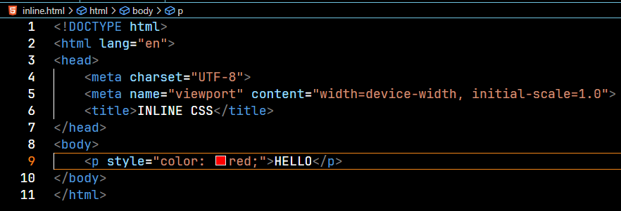

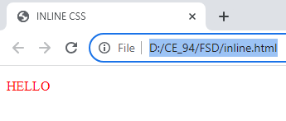

**INTERNAL CSS**

**EXMAPLE:**

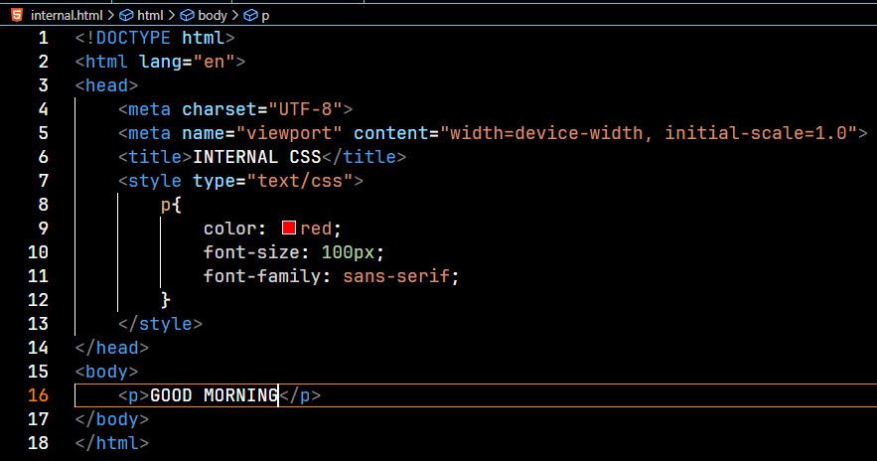

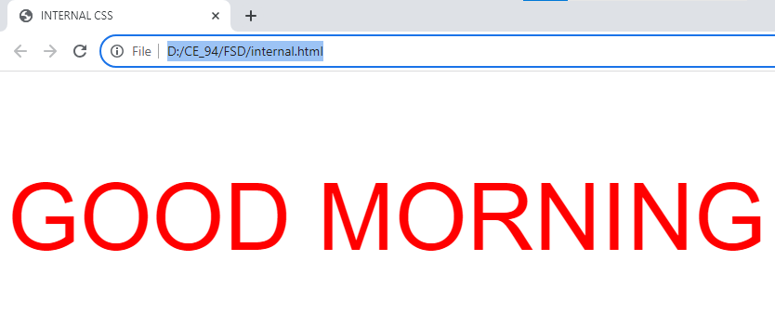

**EXTERNAL CSS**

**EXMAPLE:**

SEPRATE CSS MUST BE CREATED WITH “.CSS” EXTENSION

* ADDITOINAL TAG

<LINK> 🡪TO PROVIDE CONNECTION BETWEEN HTML AND CSS FILE

* ATTRIBUTE

1. HREF 🡪TO PROVIDE PATH OF GIVEN .CSS FILE {HREF=”PATH.CSS”}
2. REL 🡪 TO PROVIDE REALTIONSHIP WITH STYLESHEET {REL=”STYLESHEET”}
3. TYPE 🡪 {TYPE=”TYPE/CSS”}

HTML FILE:

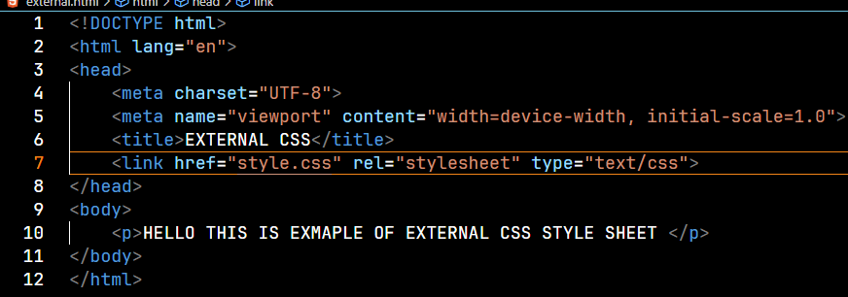

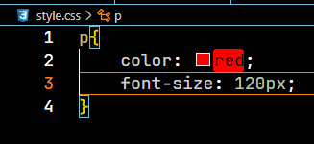CSS FILE:

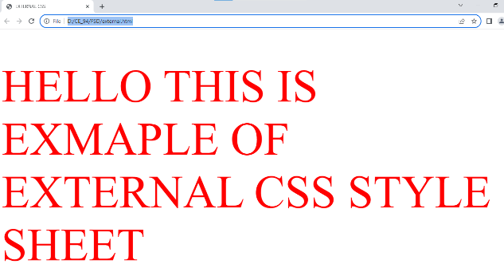**OUTPUT:**

**TYPES OF SELECTORS:**

1. ELEMENT SELECTOR
2. ID SELECTOR
3. CLASS SELECTOR
4. UNIVERSAL SELECTOR
5. DESCENDENT SELECTOR
6. CHILD SELECTOR
7. ATTRIBUTE SELECTOR

* **ELEMENT SELECTOR**

**ALWAYS ENDS WITH SEMICOLON AND DECORATION GROUPS ARE SURROUNDED BY CURLY BRACKETS**

*SYNTAX:

ELEMENT-NAME {

PROPERTY1 NAME: VALUE;

PROPERTY2 NAME: VALUE;

}

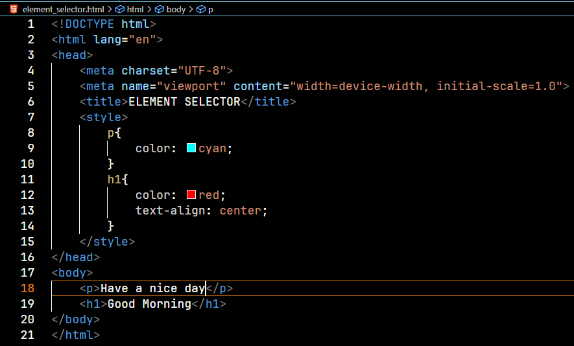**NOTE: THE ELEMENT SELECTOR SELECTS HTML ELEMENT BASED ON THE ELEMENT NAME**

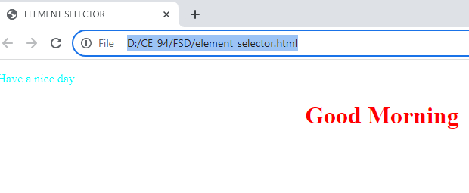

* **ID SELECTOR**

**IF SAME TAG NEED TO BE APPLIED DIFFERENT STYLE THEN THIS SELECT USED!**

**ID ATTRIBUTES MUST BE CONTAINS UNIQUE IDENTITY VALUE**

**REPRESENT 🡪 “ # “**

**NOTE: AN ID ATTRIBUTE CANNOT START WITH NUMBERS AND SPECIAL CHARACTERS**

*SYNTAX:

#ELEMENT_ID {

PROPERTY1: VALUE;

PROPERTY2: VALUE;

}

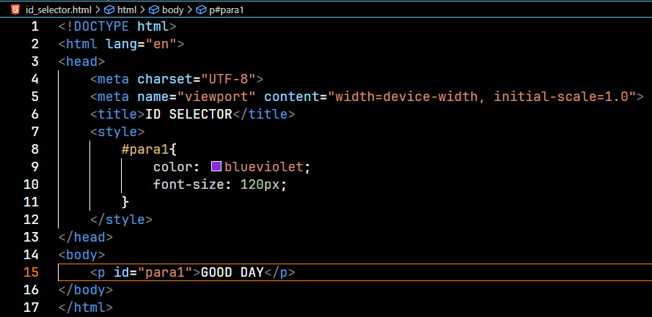

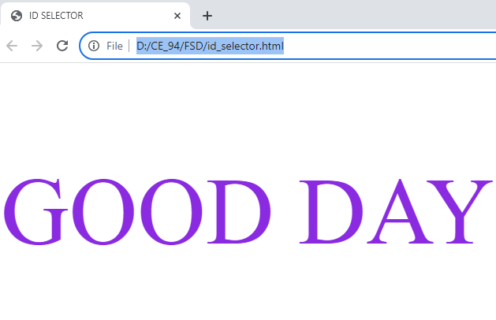

* **CLASS SELECTOR**

**THE CLASS SELECTOR SELECTS HTML ELEMENTS WITH A SPECIFC CLASS ATTRIBUTE**

**TO SELECT ELEMENTS WITH A SPECIFIC CLASS**

**REPRESENTS AS 🡪 “ . “**

**\***SYNTAX:

**.ELEMENT_CLASSNAME**

**{**

**CSS PROPERTY: VALUES;**

**}**

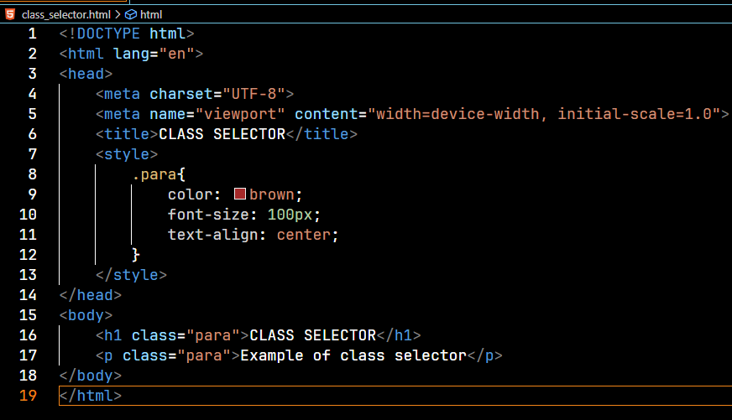

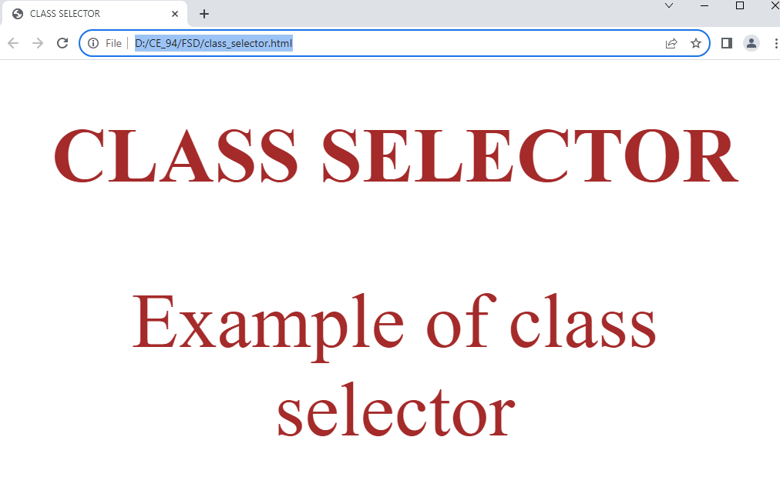

* **UNIVERSAL SLECTOR**

**GIVEN STYLE IS APPLIED TO ALL ELEMENTS IN DOCUMENTS**

**REPRESENT 🡪 “ * “**

**\***SYNTAX:

*

{

CSS PROPERTY: VLAUES:

}

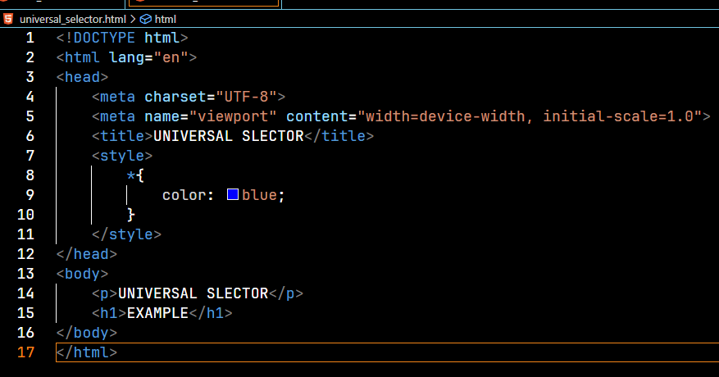

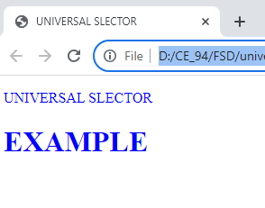

dfefef

* **DESCENDANT SELECTOR**

**IF SOME TAG IS NESTED IN THE OTHER TAG THEN NESTED TAG IS CALLED AS DESCENDANT OF PARENT TAG**

**NOTE: DIRECT CHILD TAG IS NOT MANDATORY**

**\***SYNTAX:

**ELE1 (space) P**

**{**

**CSS PROPERTY: VALUE;**

**}**

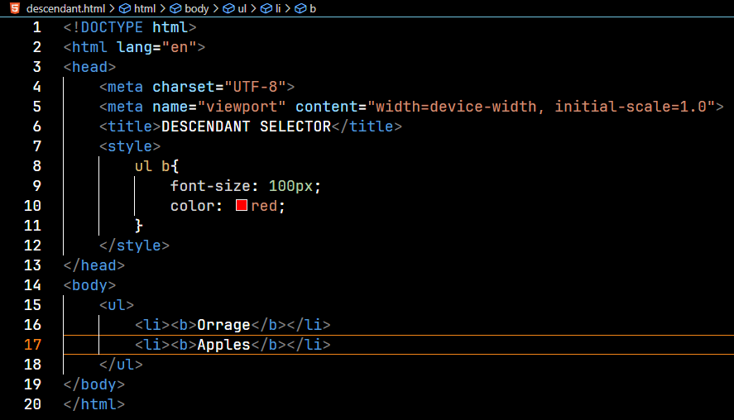

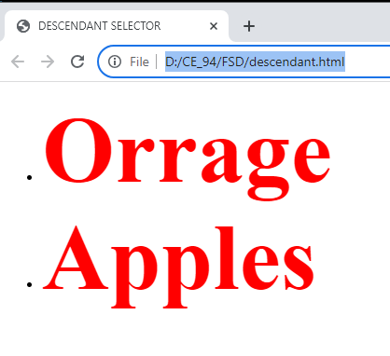

* **CHILD SELECTOR**

**TO APPLY CSS, NESTED TAG MUST BE A DIRECT TAG OF PREVIOUS TAG**

*SYNTAX:

**ELE1>ELE2**

**{**

**CSS PROPERTY: VALUE;**

**}**

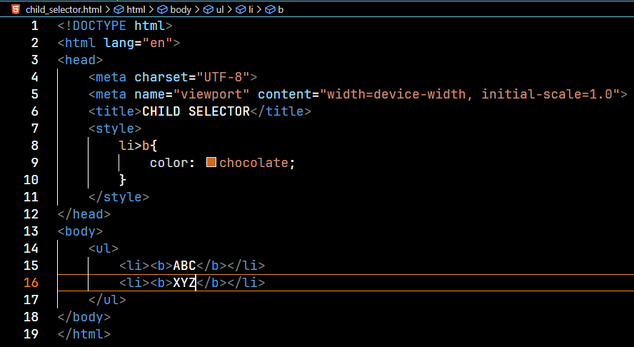

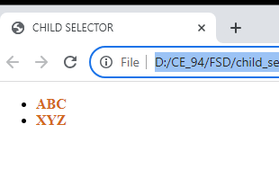

* **ATTRIBUTE SELECTOR**

**IT IS A USED FOR TEXT WHICH HAS SOME MEANING FULL ATTRBUTE**

**<INPUT> TAG**

**\***SYNTAX:

**ELEMENT NAME [ TYPE=”TEXT”]**

**{**

**CSS PROPERTY: VALUES;**

**}**

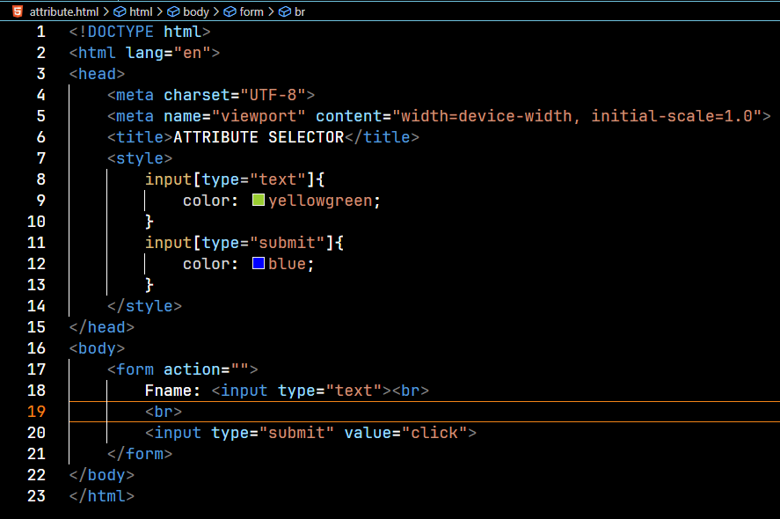

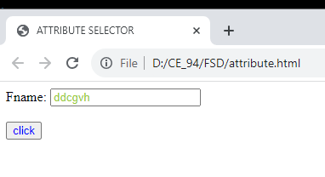

**CSS COLORS**

1. **HEXA CODE**
2. **RGB CODE**
3. **COLOR NAME**

**EXAMPLE:**

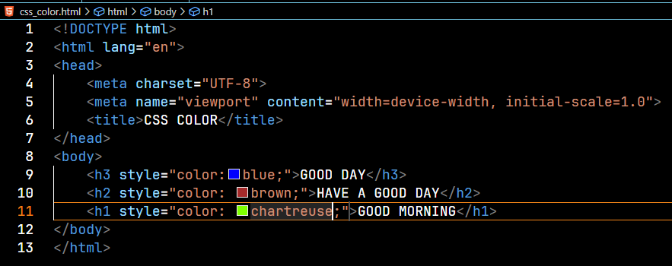

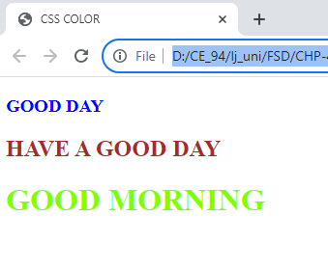

**CSS BACKGROUND IMAGE & COLOR PROPERTY**

**\***SYNTAX:

🡪 BACKGROUND IMAGE: URL(“IMAGE.PATH”);

*PROPERTY:

🡪 BACKGROUND-IMAGE – TAKES PATH OF IMAGE

🡪 BACKGROUND-REPEAT – REPEAT IMAGES IN SPECIFIC

AREA

VAL- REPEAT-X / REPEAT-Y / REPEAT / NO REPEAT

