Christabelle Peter

ASTR 1000

Project 2 (7/11/2013)

Proposal Mission to Titan

**Introduction**

Titan, the largest moon of Saturn has Earth-like characteristics such as thick atmosphere and organic-rich chemistry. Titan’s orbital period around Saturn is 15,945 days and its diameter is 5,150 kilometers which is about half the size of Earth. The surface temperature in Titan is -290 F and the surface pressure is 1.6 bars which is slightly higher than Earth's pressure which is 1 bar. Thus Titan bears a resemblance to a frozen version of Earth.

The first mission, Cassini-Huygens was launched to Titan in 1997 and it landed on Titan's surface on Jan. 14, 2005. The outcome of this mission of the joint effort of NASA and ESA has brought a new discovery about Titan. Cassini collected many spectroscopic, radar data and images at a distance from the moon while the Huygens probe revealed the surface of Titan up close and the composition of liquid methane found in lakes and rivers (European Space Agency, 2008).

This information gave scientist the idea of how the Earth was formed by looking at the changes in Titan. Dr. David Parker, director of technology, science and exploration at the UK Space Agency (UKSA) said "When the first images flashed up on a giant screen it was incredible. We saw a mountainous landscape with a network of rivers leading down to what looked like a sea with the coastal islands… It looked like our world and yet weirdly different, with water replaced by liquid hydrocarbons and the riverbed of pebbles that are probably actually snowballs." (Jha, 2012)

Even though the data gathered had shown all the basic features of Titan, there are still ore question that haven’t been answered like, “How often it rains?”, “How does Titan function as a

system; to what extent are there similarities and differences with Earth and other solar system bodies?” and more. Filling out these questions are important because it helps us to understand the origin of terrestrial life and our own complex atmosphere, discover new chemical process, and for future exploration. So we propose that we send a ‘Titan Bug’ to solve these mysteries. Further information of this device will be explained in the rest of the report.

**Recent mission**

So far the only mission that launched and succeeds to reach Titan was Cassini-Huygens. The Cassini-Huygens spacecraft was launched by a U. S. Titan IV-B launch vehicle. The primary launch period for Cassini was based on the alignment of the planets and the capabilities of the Titan IV/Centaur launch vehicle. The spacecraft was launched into a Venus-Venus-Earth-Jupiter Gravity-Assist (VVEJGA) trajectory before it reaches its final destination, Saturn. A gravity assist flight path is essential because the spacecraft is too heavy to be launched directly into Saturn. The principle of “gravity assist” boosts the spacecraft's velocity because the planet and the spacecraft pull on one another while orbiting the Sun.

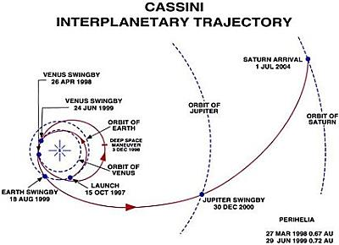After a long journey from Jupiter, the Cassini-Huygens spacecraft make a rapid flyby of the moon Phoebe on 11 June 2004 and brought the spacecraft within 2000 km of the surface of the moon. Then another flyby a trajectory correction maneuver was made on 16 June 2004 to place the Cassini-Huygens spacecraft on a precise intercept course with Saturn. On 1 July 2004 the Cassini-Huygens spacecraft arrived at Saturn. The whole journey took 7 years for the spacecraft to reach Saturn. The Cassini interplanetary trajectory is shown in Figure (1).

Figure 1

**Known facts**

Besides some of the properties mentioned earlier, we need to understand more of the known facts before proceeding with the mission. According to Space.com, large areas of Titan's surface are covered with sand dunes made of hydrocarbon. As for Titan's atmosphere, it spreads out around 370 miles high (about 600 kilometers), which is a lot higher than Earth's atmosphere. This is the reason why Titan's gravity is extremely low. Titan was also thought to be the largest moon in the solar system for a long time due to this high atmosphere (Space.com, 2013).

The lowest layer of the atmosphere, known as the boundary layer, is mostly influenced by moon’s surface. In return, this layer also influences the surface of Titan with clouds, winds, and sculpting dunes. Another discovery was the existence of methane found on the surface in a liquid form. So this shows us that the liquid also evaporates and forms clouds, then occasionally causes methane rain. There is an abundance of [methane lakes](http://www.space.com/8556-largest-lake-saturn-moon-titan-close.html), was found near its southern pole (Space.com, 2013).

An article called, “Saturn Moon Titan May Have Ice Floating in Lakes” published in Space.com, reported that Cassini scientists’ new study shows that hydrocarbon ice indeed float in the moon's seas, as long as the temperature is just below the methane's freezing point which is -297 degrees Fahrenheit, or -183 degrees Celsius. This shows a different result from what they previously assumed. Their hypothesis was that the seas in Titan would not have floating ice, since solid methane is denser than its liquid counterpart and should thus sink. In the study conducted, researchers created a model investigating how Titan's seas interact with the moon's nitrogen-rich atmosphere that creates varying composition and temperature (Space.com staff, 2013).

Next, we need to look at the climate and season change in Titan. From NASA's Cassini spacecraft data, it shows a shift in seasonal sunlight to an extensive reversal, at unexpected altitudes and in the circulation of the atmosphere of Titan. At the South Pole, the data show evidence for sinking air. The compression of this sinking air as it moved to lower altitudes produced a hot spot hovering high above the South Pole which shows the first indication of major changes. Thus the key to the circulation in Titan’s atmosphere turned out to be a certain angle of light (Cook, Zubritsky, Neal-Jones, (2012)).

One of Cassini instruments obtained images of the formation of haze and a vortex over Titan's South Pole. The data collected from the composite infrared spectrometer (CIRS) is sensitive to much higher altitudes but it provides measurable information and more directly investigations on circulation and chemistry. The results tell us that a detached layer of haze which was first detected by NASA's Voyager spacecraft may not be so separated after all, since complex chemistry and vertical atmospheric movement is occurring above this layer. This layer possibly is a region where small haze particles combine into larger size and eventually sink deeper into the atmosphere and give Titan its orange appearance (Cook, Zubritsky, Neal-Jones, (2012)). Figure (2) shows the angle of the light during Titan’s seasonal change. This figure made by an artist, shows the change in observed atmospheric effects before, during and after equinox in 2009.

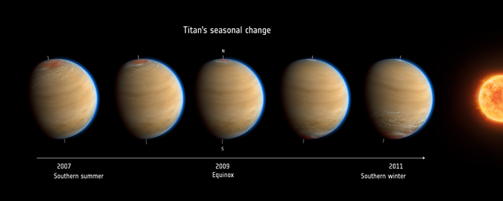

Figure 2

Now let’s look at the northern part of Titan. Recent images obtained by NASA's Cassini spacecraft on May 22, 2012, has shown that Titan's northern lake district is still stable when it was compared with the images taken six years ago (nearly one Titan season ago). It showed some previously unseen regions but also some regions containing lakes that were last observed. This marks the longest time interval between lake observations in the northern hemisphere.

In 2006, it was winter in the northern hemisphere and the lakes were in the dark. Even though Titan spring began in 2009 and the sun has now risen over the lakes, there is no apparent change in lake levels since the 2006 flybys. This is consistent with climate models that predict stability of liquid lakes over several years. This also shows that the northern lakes are not transient weather events, in contrast to the temporary darkening of parts of the equator after a rainstorm in 2010 (NASA, 2012)

**Unknown mysteries**

The following are questions that we hope to solve through this mission:

* How often does it rain in Titan?
* How do the phases of methane changes in Titan without much sunlight?
* Are the characteristics in the North Pole similar to the South Pole?

**Mission for a new probe lander**

We propose that we send two landers called “Titan Bug” for this mission. This new device is a Biomimicry of a Stenocara beetle and it has a capability to fly, swim, and move on the ground (Thickett, Neto, Harris, 2010). The idea of Titan Bug is almost similar to the robotic bug made by The Johns Hopkins University scientists (Johns Hopkins University, 2005). Figure (3) shows the characteristics of a Stenocara beetle that Titan Bug is imitating. The legs for Titan Bug does not only bends to lift up its abdomen, it can move sideways and outward so it can provide stability to float in liquid, and it also rolls so that it acts like wheels when moving on a solid surface.

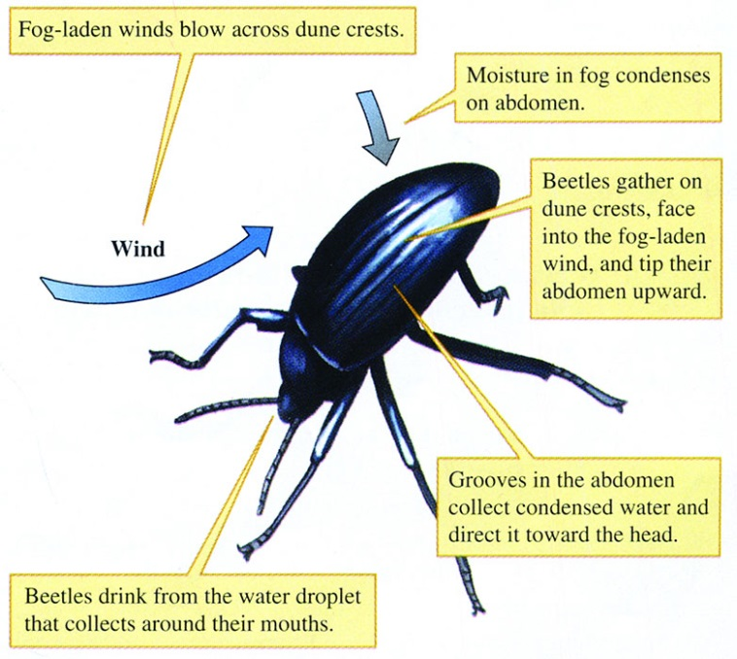

Figure 3

Titan Bug uses radioisotope power systems which a type of nuclear energy technology that uses heat to produce electric power for operating spacecraft instruments. The radioisotope that is used to produce heat is plutonium-238 which has a half-life of 88 years and it is ideal for a long duration mission like this one. So this device will probably last for a month depending on the unit of radioisotope power systems. A camera will also be inserted in the device so that it can record climate change. Similar to the past mission to Titan, a parachute will be used to drop Titan Bug on the surface before it carries out its purpose. The location to drop Titan Bug is at the North Pole and South Pole. Instruments that it we will use in Titan Bug are the following:

* Gas Chromatograph Mass Spectrometer (GCMS) – To measure atmospheric composition at different altitude [mass: 9kg, power: 15W]
* Atmospheric Structure Instrument (ASI) – To measure density, pressure, temperature, and wind dynamics [mass: 4kg, power: 4W]
* Nephelometer – To measure cloud particle size/density, and microphysical properties

[Mass: 2kg, power: 4W]

* Doppler Wind Experiment (DWE) – To calculate vertical profiles of zonal winds, and atmospheric waves [mass: 2.1kg, power: 5W]
* Surface Science Package (SSP) – As a sampling device and analysis, Seismometer, and Panoramic imager with color. [Mass: 2.5kg, power: 5W]
* Surface Physical Properties Instrument (SPPI) – Density, Surface Porosity, Surface thermal and electrical properties. [Mass: 2.7kg, power: 5W]

The total mass for all of these instruments are 22.3kg and the total power required are 38 W (NASA, 2005).

**Conclusion**

The whole purpose of this mission is to solve these questions and to discover new information about Titan. We hope that Titan Bug will bring a successful mission and reveal more of the atmosphere and the surface of Titan with various types of instruments.

**Resources**

Alok Jha. 'Boat' could explore the oceans of Saturn's moon Titan. (2012). *The Guardian*. Retrieved from <http://www.guardian.co.uk/science/2012/apr/25/uk-boat-oceans-saturn-moon-titan>

Approach and arrival at Saturn. (2008). *European Space Agency*. Retrieved from <http://sci.esa.int/cassini-huygens/34955-approach-and-arrival/>

Jia-Rui Cook, Elizabeth Zubritsky, Nancy Neal-Jones. NASA's Cassini Sees Abrupt Turn in Titan's Atmosphere. (2012). *NASA.* Retrieved from <http://www.nasa.gov/mission_pages/cassini/whycassini/cassini20121128.html>

Space.com staff. Saturn Moon Titan May Have Ice Floating in Lakes. (2013). *Space.com.* Retrieved from <http://www.space.com/19216-saturn-moon-titan-seas-ice.html>

Titan, Saturn's Largest Moon, Facts and Discovery. (2013).*Space.com.* Retrieved from <http://www.space.com/15257-titan-saturn-largest-moon-facts-discovery-sdcmp.html>

Titan's Lake District, One Season Later. (2012). *NASA.* Retrieved from <http://www.nasa.gov/mission_pages/cassini/multimedia/pia16167_prt.htm>

A Neptune/Triton Vision Mission Using Nuclear Electric Technologies. (2005). *NASA.* Retrieved from <https://solarsystem.nasa.gov/docs/01_beinstock_paper.pdf>

Johns Hopkins University. Undergraduate Develops Antenna To Help Robot Move Like A Cockroach. (2005). *ScienceDaily*. Retrieved from http://www.sciencedaily.com­/releases/2005/03/050321084250.htm

Stuart Thickett, Chiara Neto, Andrew Harris. Can Mimicking Nature Quench Our Thirst? (2010) *Australian Science*. Retrieved from http://www.australasianscience.com.au/article/issue-may-2010/can-mimicking-nature-quench-our-thirst.html