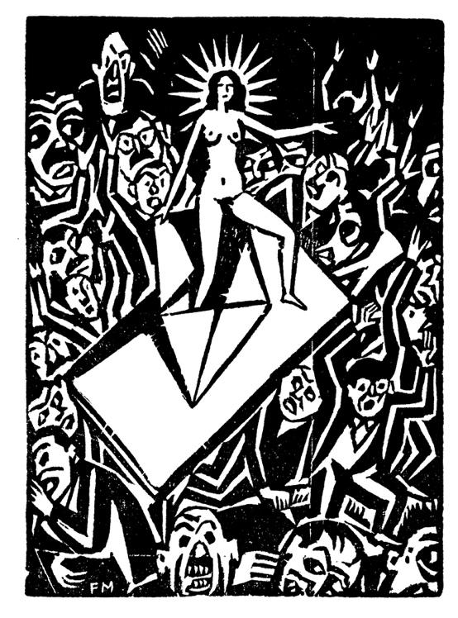
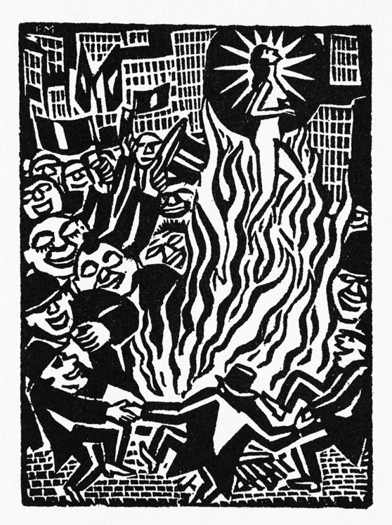
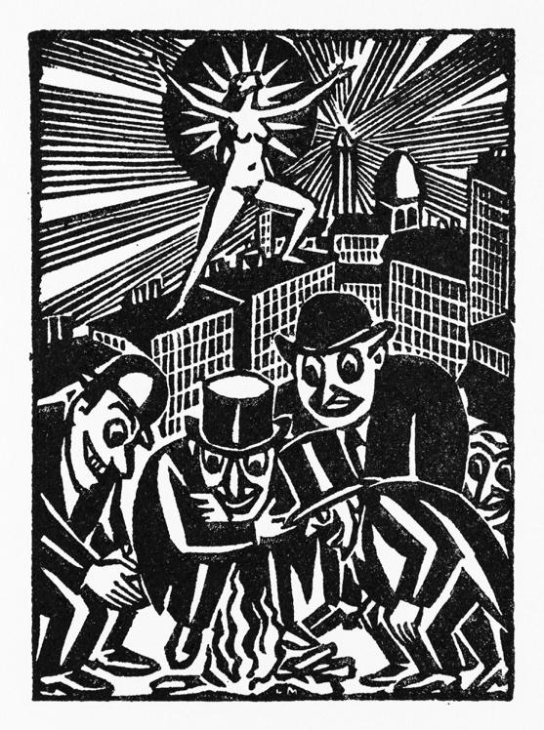
L’Idée. Sa naissance – sa vie – sa mort, Paris: Ollendorff, 1920.

“Let us remain what we are, and become ever stronger and more upright.”
STEFAN ZWEIG’S LETTERS TO FRANS MASEREEL
by Julia Rebecca Glunk

In spring 2016, the Literaturarchiv Salzburg purchased 19 postcards and 44 letters from Stefan Zweig to the Belgian-Flemish woodcutter and painter Frans Masereel (1889-1972). These documents had been in private ownership since their sale at auction in Paris in 1986. With this purchase, the LAS was able to expand its collection with a key piece of Zweig’s correspondence with one of his closest friends. Since September 2024, they have been accessible to the public on Stefan Zweig digital. Our long-standing project collaborator Julia Glunk compiled the 230 surviving letters of the Zweig/Masereel correspondence for the first time as part of her doctoral thesis at the Albert Ludwig University of Freiburg, translating them from French into German, contextualised them with the help of other relevant, unpublished sources and presented them in a critical edition. In the following, she will give an introduction to those of the letters and documents already available on Stefan Zweig digital in the context of the history of Zweig’s and Masereel’s friendship.

All images cited here are taken from the digital archive of the Frans Masereel Foundation (Saarbrücken), which together with the Studienbibliothek zur Geschichte der Arbeiterbewegung (Zürich) holds the copyright to the work of Frans Masereel. They are reproduced here with their kind permission. Excepted from this are the two portrait photographs of Zweig and Masereel from 1940 for which I would like to express my thanks to the heirs of Susanna von Winternitz, as well as the reproduction of the Masereel watercolour from Zweig’s private collection for which I owe thanks to Oliver Matuschek. Last but not least, I would like to thank Geoffrey Plow for proofreading the English version of this.

‘If everything were to perish,’ so runs one of Stefan Zweig’s most frequently quoted statements about his friend, the artist Frans Masereel, ‘and only the woodcuts he created over a period of ten years remained, it would be possible to reconstruct our entire present world from them alone [...].’ The essay in which he erects such a monument to Masereel – as a chronicler of modern times, a renovator of the medieval art of woodcutting and a man of rare sincerity, kindness and strength – appeared in 1923, in the midst of German hyperinflation, as part of the very first, but hardly affordable, illustrated Masereel monograph published in Berlin by the Dane Axel Juncker. A year later, in 1924, Masereel‘s German publisher Kurt Wolff, the great competitor of Zweig‘s regular publishing house Anton Kippenberg‘s Insel Verlag, brought Masereel’s woodcut books to the market in inexpensive, high-circulation ‘popular editions’, thus sealing what Zweig had attempted and foreseen since meeting Masereel seven years earlier: the triumph of his new art form, the first graphic novels in art history, throughout the young Weimar Republic. ‘Germany would offer you a much broader field than France,’ he predicted in July 1920 in one of his few letters to Masereel dictated in German, ‘and I believe your artistic standing would be recognised much better and sooner here.’ Masereel‘s woodcut series L‘Idée. Sa naissance – sa vie – sa mort (1920) https://archive.org/details/The_Idea_Frans_Masereel/img001.jpg, the story of a revolutionary idea encountering dissemination, falsification and persecution in the modern world but ultimately proving immortal, also points to the core of the close friendship that lasted almost 25 years, documented in their letters, only some of which have been published to date: their deep shared belief in the ultimate supremacy of the spiritual over the worldly and in the power of ideas and ideals, however much their disciples may be in the minority.

Meeting in Switzerland (1917)

Frans Masereel is Belgian, raised in Ghent, Flanders, in a well-to-do family belonging to the French-speaking bourgeoisie. He is the son of the musically gifted Louise Lava, widow Masereel, and stepson of the gynaecologist and progressive Louis Lava. When the German army invades the country in 1914 and the march through neutral territory to France, as envisaged in the so-called ‘Schlieffen Plan’, escalates into a brutal invasion and occupation, Masereel, then 25 years old, has already been living away from his native country for four years, having attempted to establish himself as an independent artist in Paris since 1911. As he is particularly interested in the possibilities of satirical press drawings and is also enthusiastic about modern literature, especially the Flemish naturalists and symbolists, he and Zweig could well have met in the French capital even before the war. All the more so since one of Masereel’s first acquaintances in Paris is the French translator Henri Guilbeaux, who has already introduced Masereel to Zweig’s friends Émile Verhaeren and Léon Bazalgette in 1913, the same year in which he meets Zweig several times during his stay in Paris in the spring. When Zweig finally comes to Switzerland in November 1917, in the fourth year of the Great War, on leave from his military service, where the French Nobel Prize winner for literature Romain Rolland, whom he admires, has given the impetus three years earlier to form an entire French-speaking colony of pacifist writers, the illustrator Masereel is already an integral part of this group.

Masereel initially lives in Geneva in somewhat precarious circumstances, supporting himself with various side jobs in addition to his work as an illustrator for Guilbeaux’s pacifist magazine demain, the illustrated supplement La Feuille to the Geneva newspaper La Nation and the magazine Les Tablettes, which he founded together with the French conscientious objector Jean Salives. He lives with his wife, the Frenchwoman Pauline Imhoff, and her 15-year-old daughter from her first marriage, Paule Thomas, in a small sublet attic. These circumstances may explain why no letters from Zweig to Masereel have survived from the first year of their acquaintance. However, Masereel’s replies, which have been preserved in Zweig’s estate in a total of 147 letters, as well as Zweig’s diary entries from the days of their first encounters, document their circumstances well:

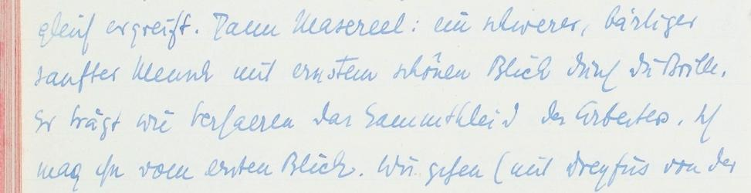

On 29 November 1917: ‘Masereel: a heavy, bearded, gentle man with a serious, beautiful gaze through his glasses. [...] I like him at first sight.‘ (Zweig Tagebücher 1984, 281-282)
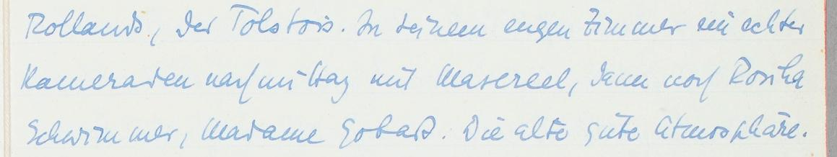

On 30 November 1917: ‘A genuine afternoon of camaraderie with Masereel [...]. How fair these people are. How great! How brotherly.’ (Zweig Tagebücher 1984, 283)

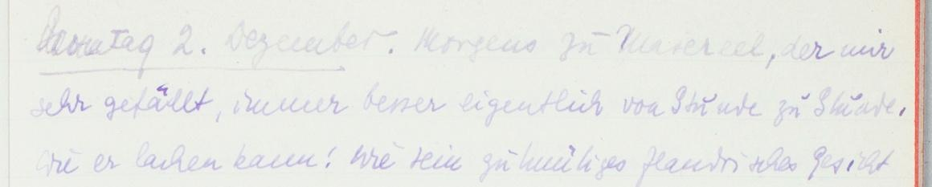

And on 2 December 1917: ‘Masereel, whom I like very much, actually better and better by the hour.’ (vgl. Zweig Tagebücher 1984, 283) TO THE DIGITAL FACSIMILES

On 2 December, Zweig devotes a remarkably long diary entry to his first visit to Masereel. Having already developed a strong personal affinity with him, he now gets to know him for the first time as the artist and observer he will always admire: ‘The series “Les Villes”,’ he writes, ‘one hundred and fifty black-and-white drawings, is among the most magnificent things I have ever seen. The whole city, but really the whole city with its tremendous dynamism, its speed, its mean gestures in a thousand forms.’ The very next day, he identifies Masereel to his publisher Anton Kippenberg in Leipzig as a potential book illustrator, which in the following months leads to negotiations for two specific commissions and later also to a personal correspondence between Kippenberg and Masereel. A week later, during Masereel’s return visit to Zurich, Zweig introduces him to local gallery owners and publishers: two brochures published by Zweig in 1918 at the local Max Rascher Verlag – his translation of an essay by Rolland and his own feuilleton about the International Red Cross headquarters in Geneva – both feature ink drawings by Masereel. And in September 1918, he enters into negotiations with art historian Arthur Rössler in Vienna regarding the publication of the novella Der Zwang (‘The Compulsion’), illustrated by Masereel, in Rössler’s newly founded Avalun Verlag. The book is finally published in 1920 as a collector’s edition by Insel Verlag.

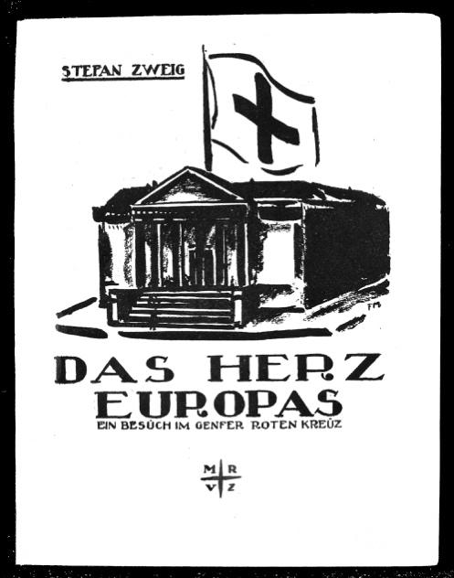
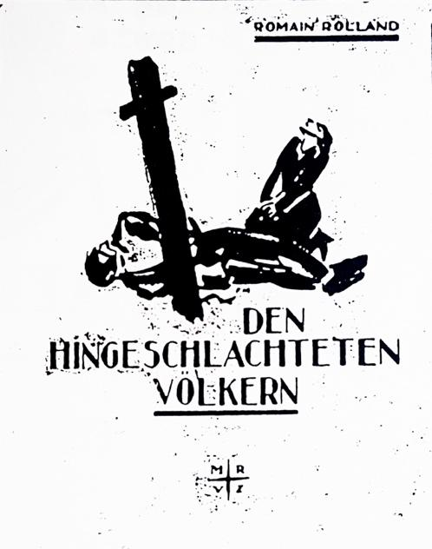

Das Herz Europas / Den hingeschlachteten Völkern, Zürich: Max Rascher, 1918.

Zweig and Masereel, who is visiting Zweig in Rüschlikon near Zurich at the time, witness the end of the First World War together, as well as the dramatic events in Switzerland, where the Federal Council, fearing a Bolshevik revolution, mobilises the army against the striking population. Zweig reads the international news with fear, particularly with regard to the collapse of Austria-Hungary and the political upheaval on all sides: ‘A consolation in these days Masereel, the clear, pure, kind man,’ he writes in his diary on 4 November 1918, one day after the Villa Giusti armistice between Italy and Austria: ‘I know that there are very few people I love as much as him.’ Similar feelings are expressed in his oldest surviving postcard to Masereel, dated 26 November 1918, ten days after the latter’s return to Geneva: ‘My dear friend,’ it says, ‘the house seems deserted without you’, and how infinitely difficult and uncertain his return to Austria now seems to him, and how crazy, how confusing the times are in which ‘revolutionaries become ministers and ministers become revolutionaries’.

‘Novels without words‘

Another story about a revolution is 25 Images de la Passion d’un Homme, the first of Masereel‘s woodcut series, which forms an independent narrative without any accompanying text. Zweig becomes aware of the booklet during a visit to Geneva in early October and is immediately enthusiastic. His review of the story, self-published by Masereel in a limited edition of only fifty copies, is published on 4 December 1918 in the National-Zeitung in Basel and is not only the first of Zweig’s five essays on Masereel (cf. the incomplete list on the corresponding index sheet in the contemporary essay archive). Under the title Ein Roman ohne Worte (‘A Novel without Words’), Zweig also anticipates, in a sense, the later genre designation ‘graphic novel’: ‘But this novel is not written at all. Words are not its medium. The twenty-five episodes of an anonymous human life are carved in wood by the young Belgian Frans Masereel, whom we have long loved as one of the most powerful artists of our era for many of his works, and who has given his best here.’

Encouraged both by Zweig, in whose essay he feels completely recognised in his artistic approach for the first time, and by Romain Rolland, their mutual friend and idol, Masereel goes even further in his next book: Mon Livre d‘Heures, ‘My Book of Hours’, is an autobiographically-influenced story in 169 small-format woodcuts, which alternates between anecdotal episodes in almost cinematic real time and panoramic mood images, thus coming even closer to the sensation of a ‘reading experience’. Once again, Masereel is only able to print just under 200 copies himself – but these find their way not only to Stefan Zweig in Salzburg, where he has just moved into his new home and reacts to the book with exuberant admiration. But also Rainer Maria Rilke, whose own ‘book of hours‘ was published by Insel-Verlag in 1905, makes insistent overtures to Anton Kippenberg about the potential of a German edition. However, Hans Mardersteig, who works for Kurt Wolff, is quicker off the mark. Shortly after the small private edition is published, he secures the rights to a German commercial edition for the publisher, paving the way for all four picture novels Masereel publishes in Geneva in 1919 and 1920 to appear exclusively with Kurt Wolff Verlag in Munich between 1920 and 1924. Zweig’s own repeated attempts to establish a long-term agreement between Masereel and Insel Verlag (cf. his letters from [early November 1919] and [late November 1919]) ultimately fail because Kippenberg is unable to create a relationship of trust in his personal correspondence with the artist that could come close to the one between Masereel and Mardersteig or Masereel and Wolff.
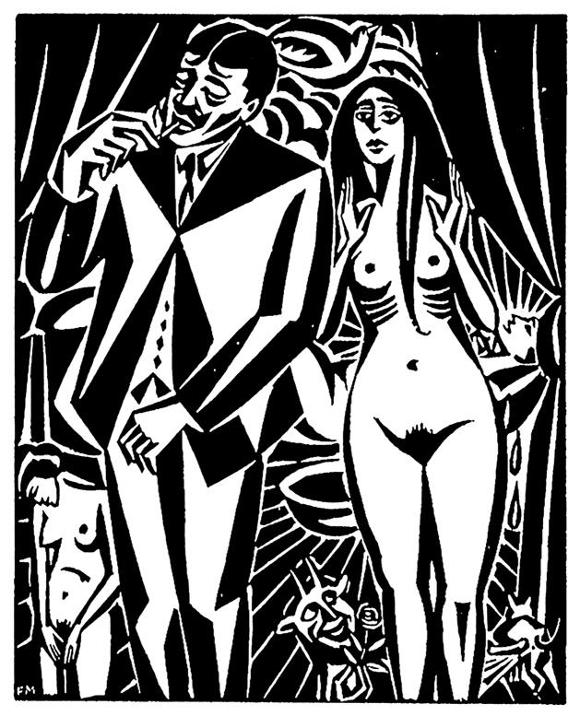
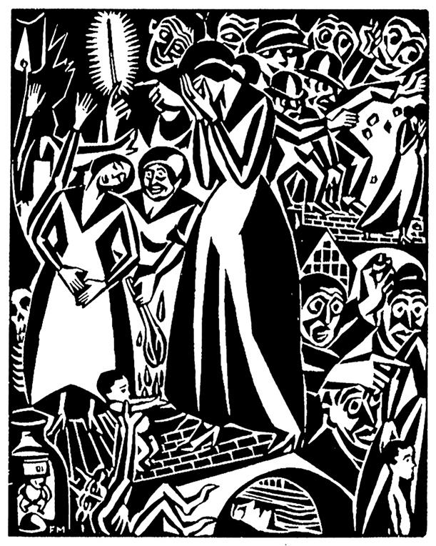

Un fait divers, Genf: self-published, 1920.

Zweig’s letters from these years already show what will remain true throughout his life: that he finds the artist Masereel, who will turn increasingly to painting after moving to Paris in 1922, at his strongest here, in woodcutting, and in innovative, autonomous storytelling in pictures. ‘It is the most beautiful thing you have ever produced, a striking poem, full of strength, incomparable in all modern art’, he writes to him about L’Idée in December 1920. In November 1920, he had already commented in the following way about Histoire sans paroles: ‘You have reached a point of mastery where I hardly know how you can possibly rise any higher’. On the other hand, his wife Friderike Zweig did not appreciate the work very much: a series about a man’s persistent, unsuccessful courtship of a woman and his sudden loss of interest in her when she turns to him. Even Un fait divers, a small series of eight woodcuts never reprinted in Germany about the momentous seduction of a woman and her suicide, met with Zweig‘s great admiration in July 1920 (‘somehow Flemish in its boldness, in its demonic freedom’). The themes of abuse, abortion and the ostracisation of women, which were already central to Un fait divers, are taken up by Masereel in a series of ink drawings, which he publishes in the same year as Groteskfilm, http://masereel.org/bilderfolgen/1921-grotesk-film/, with the young publisher Israel Ber Neumann while staying in Berlin with Carl and Thea Sternheim. However, Zweig will never integrate this work, like Masereel‘s other works clearly influenced by German New Objectivity and his new friend George Grosz, into his idealised image of the artist Masereel as a bard of modernism in the tradition of Walt Whitman and Émile Verhaeren.
Paris years

With Masereel‘s move to Paris in the spring of 1922 – shortly after his first and only visit to Zweig in Salzburg [cf. mid-May 1922] – a new phase of their friendship begins that involves more regular meetings. The year 1924 appears to be particularly important in this regard, as Zweig travels to Paris three times for extended stays and establishes an important working relationship with the translator Alzir Hella. Between 1927 and 1929, Hella will translate seven of his books and place them with the largest French publishing houses; thereafter, until 1939, each of Zweig‘s new publications appears simultaneously with the German first edition in Hella‘s French translation. The oil portrait Masereel paints of Zweig in Paris in January 1924 – ‘Dear Frans, thank you from the bottom of my heart, I feel recognised’ – thus shows the writer at a crucial point shortly before the unprecedented, groundbreaking internationalisation of his literary success.
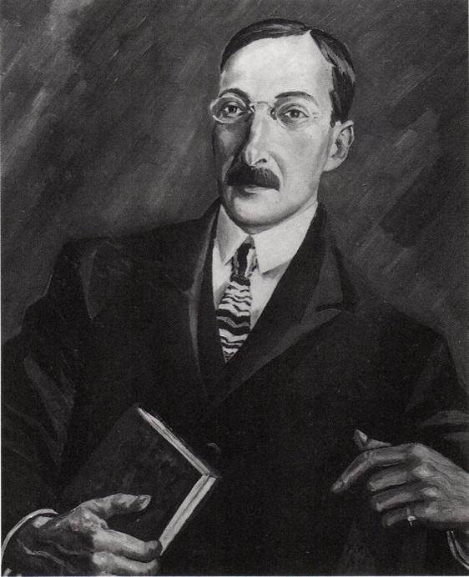
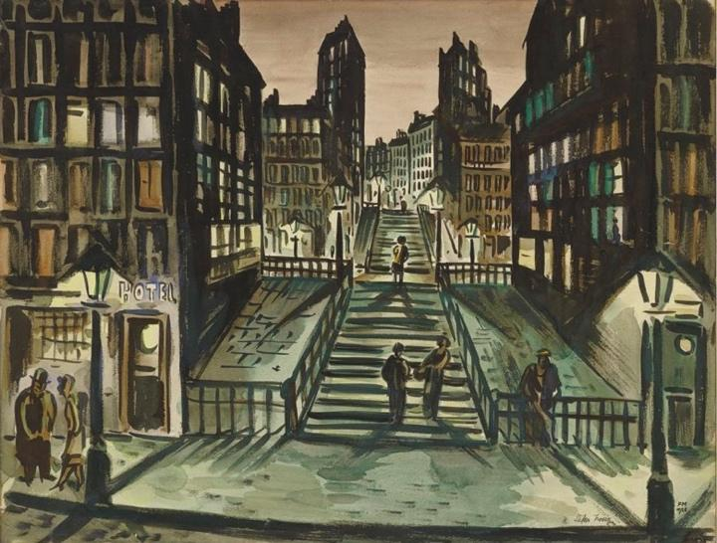
Portrait of Zweig (oil on canvas, 1924) and Montmartre. Hôtel et Escaliers (watercolour, 1926) with a dedication to Zweig.

The same enthusiasm for the metropolis of Paris in the midst of modernisation (Zweig raves to his wife Friderike in January 1924 about the radiantly beautiful, ‘worldly‘ French capital) can also be found in the city watercolours that Masereel creates during these years. However, several letters from the same period reveal that both men also share a great ambivalence towards the city. Here, Zweig confesses to Masereel that he is glad to have left the ‘pleasure machine that is Paris’ this time and to be recently discovering a new need within himself: ‘de devenir eremite, de m'enfoncer dans la foret du travail’ (‘to become a hermit, to immerse myself in the forest of work‘). Masereel, Zweig writes in the autumn of 1925, is one of the very few who can understand his desire for seclusion and anonymity. In the course of the following years, Zweig will often invite Masereel to join him on his increasingly frequent solitary working trips, to which he becomes accustomed in the years to come as a form of retreat – to Boulogne, to Marseille [B1.29], Dijon and Folkestone, England.

“Let us remain what we are”

‘Restons ce que nous sommes et devenons encore plus forts et plus sincères’ (‘Let us remain what we are and become even stronger and more sincere‘), Zweig had written to Masereel before leaving Switzerland in the spring of 1919 after a stay of a year and a half, adding the hope that among all the sad memories of the terrible times there, the memory of the beginning of their friendship would always remain clear and pure. Indeed, the shared key experience of an international circle of friends based on culture and literature, who together oppose the war between nations, will sustain Masereel and Zweig‘s friendship for almost 25 years, while the original ‘Geneva Circle’ of 1917 virtually disbands: The combative Henri Guilbeaux, deported from Switzerland, went to Moscow just in time for the founding of the Communist International and, 15 years later, back in France, will make a name for himself primarily through public polemics against most of his old friends. Pierre Jean Jouve, whose book Romain Rolland vivant: 1914-1919, alongside Zweig‘s Romain Rolland. Der Mann und das Werk, contributed above all to the stylisation of Rolland as the epitome of intellectual independence, falls out with Rolland first, then with Masereel, over his divorce from his wife, the women’s rights activist Andrée Charpentier-Jouve, and his relationship with the psychoanalyst Blanche Reverchon.

In 1929, under the influence of his new Russian partner Maria Kudaschewa (later Marie Rolland), Romain Rolland himself turns away from his former ideal and begins publicly to idealise Stalin’s Soviet communism as a peaceful and liberal counterpoint to the fascist movements of Western Europe. This will lead many of the old ‘Rollandists’, such as Marcel Martinet, to dissociate themselves from him. ‘We are almost the last ones who belong completely and unbreakably to his inner circle,’ Zweig writes to Masereel in June 1931. However, he himself ignores the differences already emerging between him, Rolland and Masereel which will manifest themselves in the course of the 1930s. (The grand celebration that Zweig plans in 1935 in honour of Romain Rolland‘s 70th birthday, for example, will be ultimately hijacked by the Comintern-affiliated ‘Association des artistes et écrivains révolutionnaires’ and the French Communist Party.) Against this backdrop, it is particularly interesting to note that in 1931, he still seriously pursues plans for several months to undertake a longer stay in the Soviet Union together with Masereel to collaborate on an illustrated travelogue there (cf. his letters to Masereel dated 13 June 1931, 1 August 1931 and 22 August 1931).

Censorship during National Socialism

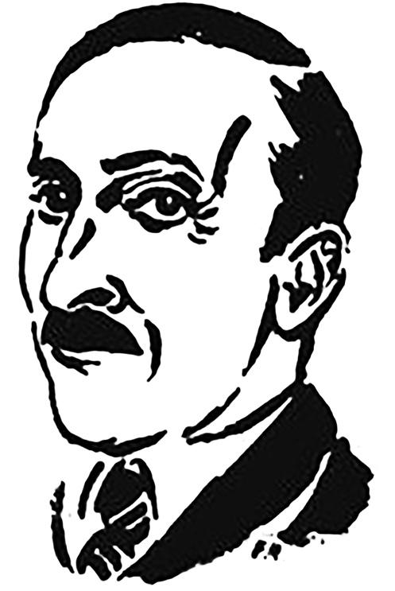
In the spring of 1931, Zweig, together with Romain Rolland and Heinrich Mann, serves on a jury for a competition [B1.38] to determine the best prose text based on one of Masereel‘s woodcut novels: an initiative by Masereel‘s new publisher Wilhelm Regendanz (Transmare-Verlag) after the dissolution of Kurt Wolff Verlag, finally won by the young writer Walter Bauer, who is promoted by Zweig. In January 1932, at Zweig‘s request, Masereel illustrates an interview that the Parisian journalist Florian Lefèvre conducts with Zweig on ‘The Role of Intellectuals in the Current Crisis‘ in the Parisian magazine Les Nouvelles littéraires with a portrait ink drawing. As Masereel sells fewer and fewer paintings due to the economic crisis, it weighs heavily on him that Transmare Verlag is quickly proving to be a rather unreliable partner for the German market. At Masereel’s request, Zweig tries to persuade his own publisher Anton Kippenberg to acquire the rights to Masereel’s entire graphic works from Transmare. Kippenberg, given his own publishing house’s economic struggle, refuses outright to take such a thoroughgoing step. It is possible that Zweig thinks Kippenberg may ultimately change his mind when writing to Masereel in December 1932, as he edits the relevant passage in the dictated letter by hand: ‘I have spoken to Kippenberg, and he is very keen (and therefore wants to come to an agreement with Transmare-Verlag) to introduce some of your earlier works, such as “Idee”, in the Inselbücherei at 80 pfennigs, as well as your new books.’ At least, in April 1933, Insel-Verlag still publishes a new edition of Geschichte ohne Worte (‘Story without Words’), even though, at the same time, Masereel’s works are already being shown – and denounced – in the National Socialist propaganda exhibition ‘Kulturbolschewistische Bilder’ (‘Cultural Bolshevik Pictures‘). Interestingly, due to the resounding success of the Geschichte, a second edition of 5,000 copies is published in 1935. Only one year later, in 1936, the works of both Zweig and Masereel are finally banned in Germany.

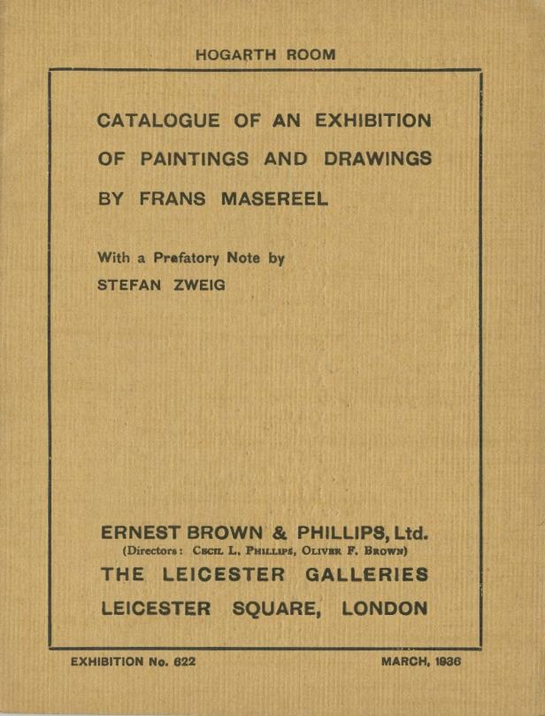
In October 1933, Zweig portrays to Masereel his own break with Insel-Verlag – in reality a complicated and protracted process – as somewhat more drastic than it actually is. While Zweig finds it difficult to join opposition circles of émigrés, Masereel begins working with German political émigrés in Paris very early on and is, among other things, also involved in initiatives of the Communist Party of Germany (KPD) in exile. The fact that this won’t lead to any deep alienation during these years, or at least no such alienation becomes apparent, can probably be explained in part by the fact that Masereel hopes to gain a foothold in the English art market through Zweig, who is now living in London – and thus closer to Paris than ever. By agreeing to write a foreword to the catalogue for Masereel’s first solo exhibition in England (‘Of course I will be delighted to write the short introduction’), he paves the way for this. At the same time, together with Masereel’s patron Georg Reinhart in Winterthur and Masereel’s publisher Wilhelm Regendanz, who has fled to London after the ‘Röhm Putsch’, he attempts to establish a micro-publishing house in the English capital for the reissue of Masereel‘s woodcut series from the 1920s – a plan that ultimately comes to nothing.

“We do not have the right to remain silent”

An appeal that Masereel publishes shortly before the outbreak of war in a German émigré magazine is entitled An meine Freunde, die Künstler! (‘To My Friends, the Artists!‘) and contains the decisive postulate ‘We do not have the right to remain silent or indifferent to what is happening around us’. The title of a speech that Zweig reads for Radio Paris during his last stay in Paris, shortly before his last meeting in person with Masereel, reads remarkably similary: Pour ceux qui ne peuvent pas parler: ‘For those who cannot speak.’ Along with the short letter informing Masereel of the exact time of the radio broadcast, he also sends him two tickets for him and his wife Pauline for the lecture La Vienne d'hier (‘The Vienna of Yesterday’) which he gives on the evening of 26 April 1940 at the Théâtre Marigny in front of an audience of 1,600. Just fourteen days later, the German Wehrmacht launches its blitzkrieg against Belgium, the Netherlands, Luxembourg and France, and while Zweig and his second wife Lotte, newly married, board a ship to New York in England in June 1940, Frans and Pauline Masereel flee Paris on foot as part of a mass column of refugees and retreating soldiers, 450 kilometres to the south of France, to the free zone. After a detour – ‘un détour via New York’, as he writes – Stefan Zweig learns of the Masereels’ whereabouts in Avignon in November 1940, five months later, and offers his help in leaving Europe.
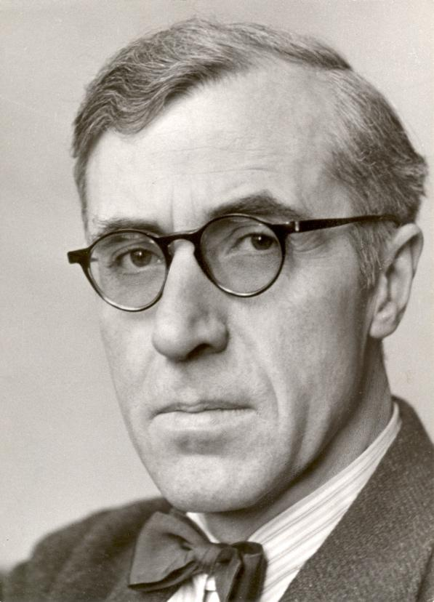
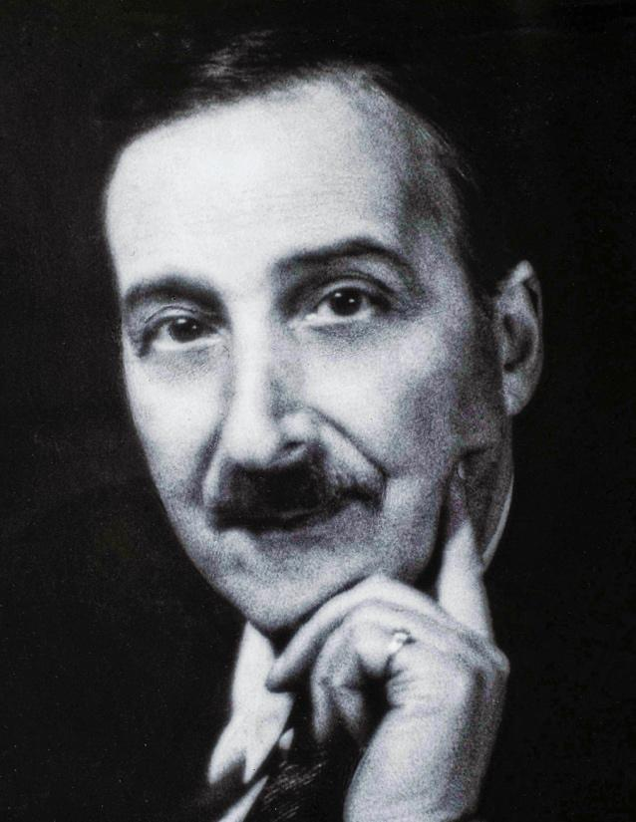
Masereel and Zweig around 1940, portrayed by Zweig’s stepdaughter, the photographer Suse von Winternitz.

Through their mutual friend Hermann Kesten, who has himself emigrated and is now working in the United States to help persecuted intellectuals leave Europe, Stefan Zweig keeps abreast of the difficulties arising from Masereel’s application for an emergency rescue visa. However, with the help of his links with the writer and Colombian ambassador to Argentina Germán Arciniegas and the contacts of Walter Engel, a Masereel collector who has emigrated to Argentina, with the Belgian diplomat René Louis van Meerbeke, he succeeds in obtaining a visa for Masereel to Colombia. Since Zweig’s letters to Masereel – and Masereel’s letters to Zweig – presumably arrive several months late, and since no replies from Masereel have been preserved after Zweig’s departure from England to America, it is not clear whether Zweig has heard from his friend again when taking his own life in February 1942. His last letter to Masereel is dated 15 August 1941. Frans and Pauline Masereel did not make use of the visa for Latin America.
***

The dissertation Stefan Zweig and Frans Masereel: History of Their Friendship in Letters and Documents 1917–1942 was submitted to the Albert Ludwig University of Freiburg im Breisgau in December 2025 as a doctoral thesis and is scheduled to be published in 2026 in the Klassische Moderne series by Nomos Verlag, Baden-Baden.

***

Selective bibliography

Also by Julia Rebecca Glunk:

With Joris van Parys: Eiland in de storm. Frans Masereel, Stefan Zweig en Zwitserland in de oorlogsjaren 1917-1918. in: Gent/Amsab-ISG: Brood & Rozen, 2025(3). S. 34-51.

„Jedenfalls lassen Sie sich diesen wundervollen Menschen nicht entgehen“. Stefan Zweig, Frans Masereel und Anton Kippenberg. in: Stefan Zweig. Biographie, Politik, Medien. Hrsg. von Clemens Woldan, Würzburg: Königshausen & Neumann, 2024. (Schriftenreihe des Stefan Zweig Zentrum, Bd. 21) S. 85–109.

Nous, les Rollandistes. Stefan Zweig, Frans Masereel et l’héritage genevois. In: Études Romain Rolland, Cahiers de Brèves, Bd. 50, Brèves: Association Romain Rolland, Januar 2023. S. 23–32.

„Wir Rollandisten“ – Stefan Zweig, Frans Masereel und das Genfer Erbe. In: Marina Ortrud Hertrampf (Hrsg.): Frieden! Pazifistische Gedanken im Umfeld von Romain Rolland, München: AVM Verlag, 2022. (Romain Rolland Studien, Bd. 1) S. 39–56.
https://www.avm-verlag.de/?listview&reihe=RH-RRS

„Es wird noch heftige Gewitter geben.“ Frans Masereel und die Friedensbewegung nach 1918. In: Idée de paix – Idee des Friedens – Idea of Peace. Frans Masereel. (Katalog zur gleichnamigen Ausstellung von 24. Februar 2022 bis 14. August 2022), Musée National de la Résistance et des Droits Humains: Esch-sur-Alzette, 2022. S. 218–243.

Primary sources:

Pierre Vorms: Gespräche mit Frans Masereel, Dresden: Verlag der Kunst, 1967.
Friderike Maria Zweig: Spiegelungen des Lebens, Wien/Stuttgart/Zürich: Hans Deutsch, 1964.
Stefan Zweig: Briefe. 1914–1919 (Bd. 2), 1920–1931 (Bd. 3), 1932–1942 (Bd. 4). Hrsg. von Knut Beck, Jeffrey B. Berlin und Natascha Weschenbach-Feggeler, Frankfurt a. M.: S. Fischer, 1998–2005.
Stefan Zweig: Briefe an Freunde. Hrsg. von Richard Friedenthal, Frankfurt a. M.: S. Fischer, 1978.
Stefan Zweig: Die Welt von gestern. Hrsg. und kommentiert von Oliver Matuschek, Frankfurt a.M.: S. Fischer, 2017.
Stefan Zweig: Frans Masereel. Der Mann und Bildner (1923). In: Das Geheimnis des künstlerischen Schaffens. Hrsg. von Knut Beck, Frankfurt a. M.: S. Fischer, 1984. S. 217–228.
Stefan Zweig: „Ich wünschte, dass ich Ihnen ein wenig fehlte“. Briefe an Lotte Zweig 1934–1940. Hrsg. von Oliver Matuschek, Frankfurt a. M.: S. Fischer, 2013.
Stefan Zweig: Tagebücher, Frankfurt a. M.: S. Fischer, 1984. (Gesammelte Werke in Einzelbänden)
Stefan Zweig/Anton Kippenberg: Briefwechsel 1905–1937. Ausgewählt von Oliver Matuschek und Klemens Renoldner. Hrsg. und kommentiert von Oliver Matuschek unter Mitwirkung von Klemens Renoldner, Berlin: Insel Verlag, 2022.
Stefan Zweig/Romain Rolland: Correspondance 1910–1919 (Bd. 1), 1920–1927 (Bd. 2), 1928–1940 (Bd. 3). Édition établie, présentée et annotée par Jean-Yves Brancy, Bd. 1, Paris: Albin Michel, 2014–2016.
Stefan Zweig/Romain Rolland: Briefwechsel 1910–1923 (Bd. 1), 1924–1940 (Bd. 2). Hrsg. von Waltraud Schwarze, Bd. 1, Berlin: Rütten & Loening, 1987.

Secundary literature:

David A. Beronä: Wordless Books. The Original Graphic Novels, New York: Abrams Books, 2008.
Susanne Buchinger: Stefan Zweig – Schriftsteller und literarischer Agent. Die Beziehungen zu seinen deutschsprachigen Verlegern (1901–1942), Frankfurt a. M.: S. Fischer, 1998. (Archiv für Geschichte des Buchwesens, Studien I)
Samuel Dégardin/Tatiana Trankvillitskaia: Frans Masereel. Voyage au pays des Soviets, Gent: Snoeck, 2022.
Gertrud Fiege (Hrsg.): „Von Schwarz zu Weiß“. Frans Masereel im literarischen Deutschland, Deutsches Literaturarchiv Marbach: Marbacher Magazin Nr. 31, 1984.
Oliver Matuschek: Stefan Zweig. Drei Leben. Eine Biographie, Frankfurt a. M.: S. Fischer, 2006.
Serge Niémetz: Stefan Zweig. Le Voyageur et ses mondes. Biographie, Paris: Belfond, 1996.
Joris van Parys: Masereel. Eine Biographie. Aus dem Niederländischen von Siegfried Theissen, Zürich: Edition 8, 1999.
Joris van Parys: The ‘Silent Novels’ of Frans Masereel: Godfather of the American Graphic Novel. Übersetzt von Astrid Vandendaele. in: The Low Countries, Rekkem/Den Haag, 2019.
https://www.the-low-countries.com/article/the-silent-novels-of-frans-masereel-godfather-of-the-american-graphic-novel
Donald A. Prater: Stefan Zweig. Das Leben eines Ungeduldigen. Aus dem Englischen von Annelie Hohenemser, München/Wien: Carl Hanser, 1981.
Paul Ritter: Frans Masereel. Eine annotierte Bibliographie, München/London/New York/Paris: K. G. Saur, 1992.
Pierre Vorms: Masereel. Catalogue raisonné, Antwerpen: Mercatorfonds, 1976.

Of the letters from Zweig to Masereel stored in the Literaturarchiv Salzburg and published here in digital form, the following twelve have already been published in their entirety: Letter from 10 July 1920 (B1.18, Briefe an Freunde 1978, S. 121-122), 9 November 1920 (B1.20, Briefe an Freunde 1978, S. 125-126), 2 July 1921 (B1.23, Briefe an Freunde 1978, S. 133-135), 8 November 1926 (B1.32, Briefe an Freunde 1978, S. 172-173), 29 June 1928 (B1.34, Briefe an Freunde 1978, S. 196), 23 March 1931 (B1.38, Briefe an Freunde 1978, S. 212), 13 June 1931 (B1.39, Briefe an Freunde 1978, S. 214-216), 18 June 1931 (B1.40, Zweig Briefe III 2000, S. 293-294), 18 January 1933 (B1.46, Briefe an Freunde 1978, S. 224-225), 15 April 1933 (B1.47, Briefe an Freunde 1978, S. 226-228), 23 November 1940 (B1.62, Briefe an Freunde 1978, S. 321-322), 1 August 1941 (B1.64, Briefe an Freunde 1978, S. 326).

