The Global Change Award

NABC Model

|  |  |
| --- | --- |
| Needs  Parents travelling with young children need to spend less or no time for packing and checking luggage for leisure trips with their children. They also need a solution to completely eliminate the risk of lost luggage or delayed luggage arrival. | Approach  We are proposing a product as service business model, capable to educate generation z and their parents for a smooth transition to Circular Economy. Actual competitors do not solve the burden of luggage preparation in terms of time and money when it comes to a long trip with children and the possibility to eliminate the risk of luggage loss. |
| Benefit  The obvious benefit to the customer is that it saves time and relieves stress because you don’t have to pack, check bags at the airport, and then collect luggage at your destination. Although mishandled luggage rates continue to drop, 5.73 bags per thousand passengers went astray in 2016 (Magnusson, 2017), which means a risk remains a risk. Almost all airlines require additional fees for luggage, which is often not built into the price of the ticket. These hidden fees add up quickly. | Competition  There is a market trend towards renting apparel. Successful business initiatives include Rent the Runway www.renttherunway.com in the US, Drexcode www.drexcode.com in Italy, Girl meets dress www.girlmeetsdress.com in the UK, "Flyrobe" www.flyrobe.com in India, MudJeans www.mudjeans.eu in Europe, Vigga www.vigga.us in Denmark and LeTote www.letote.com in San Francisco. |

1. Who is the intended customer and user of your idea?

The target market is the family tourism market. After comprehensive market research, we captured mothers with children 3 to 12 years old as our target customer.

1. How will you partner with individuals or organizations to develop your idea?

We aim at creating meaningful partnerships with pioneer companies that include Circular Economy strategies in their core business. Those are H&M and Patagonia – clothing brands to begin with-, low-cost airline companies, Cradle to Cradle products Innovation Institute, Design for all kind [www.designforallkind.com](http://www.designforallkind.com).

Instead of incubators or other institutions that have been put in place for the last decades resulting in little success, we would prefer a strict collaboration with global consulting brands (Accenture) and universities (Bocconi), so that we can benefit from their clients and human capital creating an interesting win-win triangle of opportunities. Other to that, a strict collaboration with actors such as Cariplo and Intesa san Paolo committed to bring positive change through Circular Economy is our place to be.

An interesting idea would be creating an app produced by Accenture to help their clients (example H&M) to better compete in the digital market from a different perspective. In such platform, only selected products would be provided in a new marketplace where companies that commit to a comprehensive Social Corporate Responsibility strategy could compete. Accenture could provide once a year a report of the activities of those companies to be present in the KidKit app. A good idea would be to rank clothing companies on Sustainability based on certain criteria capable to make an impact given their size and commitment for sustainability as “Brighter Planet” is doing for the Air Travel Carbon and Energy Efficiency Report (<https://brightplanet.com/data-feed-api-guide/>

<https://corporate.ryanair.com/wp-content/uploads/2018/03/Enviromental-Policy-Doc.pdf> ).

Then use KidKit or similar apps to provide visibility to the market.

We aim at creating meaningful partnerships with pioneer companies that either includes Circular Economy strategies in their core business (H&M) or have a traditionally environmentally positive concern (Patagonia) within the fashion industry. Actually, we are located at Impact Hub Milano part of Impact Hub International Network with a mission to support Social Entrepreneurship. We are trying to get in touch with low-cost airline services in Europe so as to engage them with the importance of a smooth transition to Circular Economy. We have tried to reach out Ellen Macarthur Foundation and their network, who although are not able to support us, they are happy about what we are trying to do. Last but not least we have tried to reach out Cradle to Cradle Products innovation institute to help us with product specifications for the KidKit items to have. The market has responded positively. However, implementation is key.

1. How is your idea funded today? Do you have any investors?

The idea is self-funded for now. We do not have investors. However, stakeholders such as H&M, Patagonia, Ellen Macarthur Foundation, low-cost airline companies and the Cradle to Cradle Products Innovation Institute come as a priority before asking for further investment.

1. How is your idea protecting the planet, its climate, its ecosystems and its natural resources?

By extending product lifetime by using each it repeatedly as long as it passes quality controls. Product lifecycle would be extended after repair or upgrade. Both Patagonia (WornWear) and H&M (at their flagship store on Rue LaFayette) have included similar operations as part of their sustainability strategy. Professional cleaning is intended to reduce or eliminate microplastics contamination and reduce the overall impact. On site logistics will reduce carbon footprint since luggage won’t have to travel along with passengers.

1. Does your idea include any social benefits to improve our living conditions besides protecting the planet?

By extending product lifetime more value will be enclosed in each garment and fewer products will have to be manufactured. In this way, it will be possible to ensure better lives for people working in the fashion supply chain by producing less for more value. Reduced footprint in our global transportation systems and reduced microplastics emissions are also part of our strategy to the overall resilience strategy for climate change. Future projects include learning by doing education programs for children in need.

1. What impact will your idea have on the fashion industry?

A smooth transition to Circular Economy is both matter of culture and technology. Although there is a market trend for renting apparel, global market is still interested in owning their clothes. A neat improvement towards customer needs along with their values could make them shift to take part in a circular economy model. Similarly, companies serving this market have to respond to its demand and certainly maintain financial sustainability and a healthy relationship with investors. This is a vicious circle which could be very much re-considered by adhering to KidKit.

1. How will you measure your idea’s impact on the fashion industry?

Measure quantities of garments that do not end to the landfill and microplastics that do not end to the ocean because of our services, carbon footprint reduction of airline companies that adhere to our services, customer satisfaction.

1. What is the most critical challenge to realizing your idea?

Market is not ready for the idea (slow adoption).

1. Describe the biggest challenges to realizing your idea in more detail.

We have repeatedly asked potential customers, who confirmed implementation is key in order for them to decide if using the proposed service. Creating strong relationships with shareholders that share our vision for educating for a smooth transition to Circular Economy. Find potential investors for project implementation.

1. How will you scale your idea (i.e. how will you grow your marketing, sales, production, and delivery capacity for a large number of customers/users)?

Here below we summarize the costs for running the business at one service point. The scale-up project is inspired by the Depot Location in Degradable networks research Chrysanthi has made at the Imperial College of London https://www.researchgate.net/publication/259511564_Depot_location_in_degradable_transport_networks and Ithaka laundry in Athens http://ithacalaundry.gr/ a mobile laundry social service business for homeless people. Each service centre consisted of the first three years by one employee and a leasing car. Operationally he/she will be assisting the service in terms of logistics, emergencies and in situ marketing with the client.

1. What capabilities, resources and competencies do you think are important to the success of your idea?

Team members that share our vision, mission and values is the main issue (logistics financials and marketing). Collaborators thought as sponsors to create a meaningful impact capable to change the mentality and ensure a smooth transition to Circular Economy is the second issue. If all previous issues are met, we need to forward this initiative to serious investment funds such as Intesa San Paolo with trace.cariplofactory.it.

1. Tell us about your team’s skills and experience. Additionally, what skills and experience does your team need to develop for your idea to succeed?

Chrysanthi has identified potential operational partners and has been involving serious efforts in elaborating different implementation plans for KidKit, for the last four years. She has been an academic for several years, holds a PhD in Natural Disasters Emergency Management and an MBA. Lately she has joined fellow students at the Beltesman nanodegree program by UDACITY developing a project on cotton sustainability for Climate Change https://sites.google.com/site/eucottonproject/. She is currently looking for people to engage with KidKit. In the core business three profiles are important: Operations, Finance and Marketing. Chrysanthi believes that for now Operations better fits her curriculum.

1. What difference would the grant and the [accelerator program](https://apply.globalchangeaward.com/static-assets/global-change-award-2019/PDF/Accelerator%20program.pdf) make to your idea and how will you make sure to get the most out of this year?

Direct connection with H&M Foundation, Accenture and KTH Royal Institute of Technology in Stockholm (KTH) are key in order to leverage and develop our innovation in the best and quickest way. We urge to connect with the industry, boost our exposure and confidence. In particular understand different cultures in Stockholm, New York and Hong Kong will indeed help us better implement our strategy for different markets.

1. Have you participated in any other accelerator programs or competitions with this idea?

We have been part of the Startup Training program at Bocconi University. Further information [www.thestartuptraining.com](http://www.thestartuptraining.com).

1. Share your timeline for the next 3 years and include your most important goals and milestones.

Create the team in the next four months (Marketing, Operations and Finance profiles). Create important partnerships with leading brands and organizations within Circular Economy ecosystem in the next eight months. Find an investor that shares our mindset and ambitions.

Wrap Up

* Describe the challenge your idea aims to solve in one sentence.

Smooth Transition to Circular Economy.

* Describe your solution in one sentence.

Educate families to Circular Economy by relieving them from the burden of preparing luggage for leisure trips with children.

* Describe the benefits and effects in one sentence.

Saves time and relieves stress because you don’t have to pack, check bags at the airport, and then collect luggage at your destination.

* Describe your entire concept in up to 120 words.

KidKit is a children’s clothing rental service for the holiday period. KidKit allows families to travel without luggage for their children. Parents who use KidKit will enjoy “luggage-less” travel, thus saving time packing and checking bags at the airport. Once your trip is over, there are no dirty clothes to launder. KidKit takes care of that for you too. KidKit relieves unnecessary stress because it eliminates the risk of losing luggage at the airport because your clothes are waiting at your destination.

The Circulars

# Organization

# Summary of Entry

KidKit is a children’s clothing rental service for the holiday period. KidKit allows families to travel without luggage for their children. Parents who use KidKit will enjoy “luggage-less” travel, thus saving time packing and checking bags at the airport. Once your trip is over, there are no dirty clothes to launder. KidKit takes care of that for you too. KidKit relieves unnecessary stress because it eliminates the risk of losing luggage at the airport because your clothes are waiting at your destination.

# Leadership

1. How are you differentiating yourself from your peers to drive transformational change in your industry and/or geography?

In terms of circularity, existing solutions do not provide a comprehensive pathway to a smooth and fast transition to Circular Economy any time soon. In terms of value proposition, they do not solve the burden of luggage preparation in terms of time and money when it comes to a long trip with children and the possibility to eliminate the risk of luggage loss. People are not able to understand the need to engage with an economy that could gain 1.8 trillion per year by 2030 in Europe. Successful renting apparel includes Rent the Runway (US), Drexcode (Italy), Girl meets dress (UK), "Flyrobe" (India), MudJeans (Europe), Vigga (Denmark) etc. We are proposing a product as service business model, capable to educate generation z and their parents for a smooth transition to Circular Economy. What is missing is an e-commerce involving existing brands and sharing their values for Circular Economy and SCR.

1. How are you working with internal and external stakeholders to drive your circular activity?

Key partnerships, are Patagonia and H&M clothing brands that systematically focus on Circular Economy. H&M is a 27 $ billion fast-fashion retailer that shell online only through their owned channels having to suffer from stronger digital rivals. Patagonia is a billion-dollar company with strong environmental identity, but when it comes to online selling it is difficult to incorporate a “Black Friday” marketing campaign of theirs, within online retailers selling their products. Airline efficiency is another issue to drive Circular activity, by creating partnerships with the greenest airline companies operating on the planet. In the 2017 financial year, easyJet’s carbon emissions per passenger km were 78.62 g, down from 79.98g per passenger km in the prior fiscal year. Ryanair’s commitment is to achieve an emissions rate of 61.4 grams of CO2 per passenger km by 2030. Imagine passengers travelling luggageless. Corporate Social Responsibility will drive further companies to include.Innovation

## Business Model

1. Select up to three circular business models that you are applying to drive your strategy:

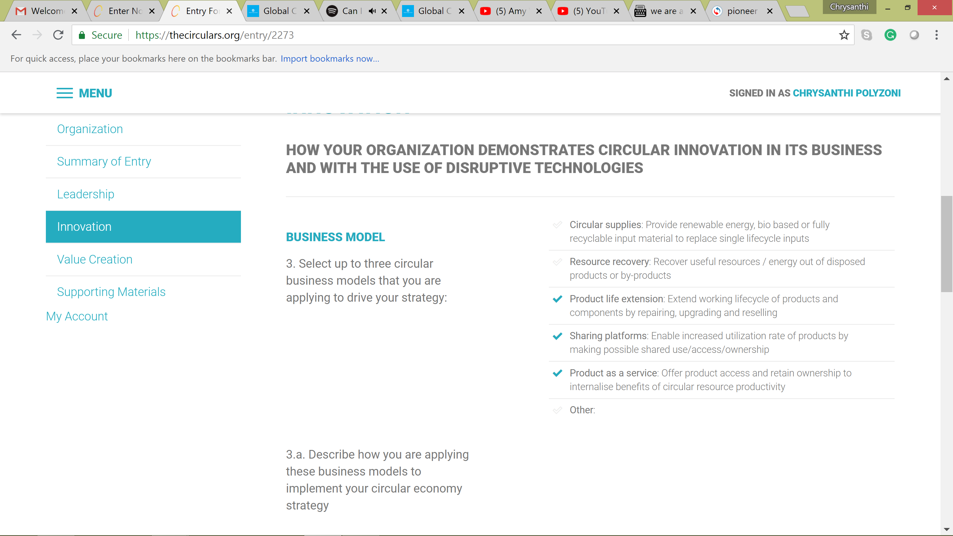

3.a. Describe how you are applying these business models to implement your circular economy strategy

Product life is being extended by using each product repeatedly as long as it passes quality controls, to be specified with standards imposed by the Cradle to Cradle Products Innovation Institute. Product specifications will also explain how each product's lifecycle would be extended after repair or upgrade. Both Patagonia (WornWear) and H&M (at their flagship store on Rue LaFayette) have included similar operations as part of their sustainability strategy. A sharing platform will be enabled for customers to book their kit where we will be operative. Please check www.kidkit.org and www.kidkit.it for further information. This is a product as a service product access. Shareholders will maintain ownership and garment maintenance responsibility.

## Technologies

1. Select the technologies that are enabling your circular initiatives:

|  |  |  |
| --- | --- | --- |
|  |  |  |

4.a. Describe how you are applying these technologies to enable your circular strategy

Data is thought to be collected in all stages of the customer relationship so as to provide the best experience and give us the possibility to improve over time. Data are telling us, parents book holidays using non-mobile solutions too. Their overall customer journey though includes critical information to be collected by mobile devices. The kit is thought to be co-created and share little traveler’s vacation story by their parents through our digital platform modularly. Some parents may want to include more t-shirts while others may want to include more trousers in their kit. In this way people share their particular needs and how they have benefit from our service. Bio-based materials, cellular and tissue engineering and green chemistry are all attributes that we wish to incorporate into our garments through innovations proposed by Cradle to Cradle products innovation institute or the global change award.

# Value Creation

HOW YOUR ORGANIZATION IS STRONGER AS A RESULT OF ADOPTING CIRCULAR ECONOMY BUSINESS MODELS

1. How has leading with a circular strategic approach created a competitive advantage for your business within your industry?

Our organization will be filling the gap for promoting existing brand’s involvement in Circular Economy with a different prospective. H&M’s operating profit fell 19 percent to 3.98 billion kronor ($450 million) in the three months through August, marking the 10th decline in 12 quarters. Analysts expected 4.16 billion kronor. Stock-in-trade rose 15 percent to 38.7 billion kronor. Online sales were a bright spot for H&M, rising 32 percent, though the retailer still may struggle to reach its target for a full-year increase of at least 25 percent because first-half e-commerce missed that level. Involving H&M within our innovative e-commerce could make the company reach that level.

Patagonia raised record braking $10 million Black Friday in sales to benefit the planet. They expected to reach $2 million in sales—they beat that expectation five times over. The enormous love our customers showed to the planet on Black Friday enables us to give every penny to hundreds of grassroots environmental organizations working around the world. We aim at embracing this commitment of theirs within a circular economy e-commerce focused on generation-z. Existing e-commerce do not embrace and respect this commitment.

Our organization will be filling the gap for promoting existing brand’s involvement in Circular Economy with a different prospective. H&M’s operating profit fell 19 percent to 3.98 billion kronor ($450 million) in the three months through August, marking the 10th decline in 12 quarters. Online sales raised 32 percent, though the retailer still may struggle to reach its target for a full-year increase of at least 25 percent because first-half e-commerce missed that level. Involving H&M within our innovative e-commerce could make the company reach that level.

Patagonia raised record braking $10 million Black Friday in sales to benefit the planet. The enormous love our customers showed to the planet on Black Friday enables them to do a lot for circular economy. We aim at embracing this commitment of theirs within a circular economy e-commerce focused on generation-z. Existing e-commerce do not embrace and respect this.

1. What are the key social and environmental advantages of your circular strategy?

Embrace low carbon commitments of important airline and fashion companies. Since 2000 easyJet has reduced its carbon emissions per passenger, per kilometre by over 32%. Its current target is a 10% reduction from its 2016 financial year performance by 2022, which would be a 38% improvement from 2000. Ryanair commitment to IATA’s 2050 climate target, aim to reduce their CO2 per RPK by 66% to 61.4 g CO2 per RPK against 2000 levels. Patagonia’s mission is to make the best product creating no unnecessary harm describes their billion-business success while H&M has improved their sustainability commitment by reducing emissions from their own operations by a further 21%, while 59% of the cotton they use is sustainably sourced. Their goal is to use 100% sustainably sourced cotton by 2020. During 2017 they collected 17,771 tons of textiles through their garment collecting initiative for reuse and recycling.

1. What are your strategic objectives and how do you intend to achieve them in the:  
   i. Short term (1-3 years)  
   ii. Long term (3-5 years)

Short term strategic objectives include creating partnerships with H&M, Patagonia, Ryanair, easyGroup, and Cradle to Cradle Products Innovation Institute in operational terms. An important aspect is involving KidKit to educational institutions such as Bocconi University in Italy to be a Circular Economy case study for students. As soon as we have a minimum of operational key partnerships and a valid income statement based on the capabilities we will be able to gain through our partnerships we will be seeking financial support from Intesa San Paolo, Ellen Macarthur Foundation’s financial strategic partner who has collected 5 billion until 2021 for Circular Economy initiatives. Long term strategic objectives include the possibility to incorporate as many as possible fashion brands within kidkit e-commerce following existing paradigm and creating a short of Circular Economy and SCR ranking where companies will be able to demonstrate their commitment to Circular Economy.