KIDKIT

H&M

March 21, 2018

Contents

KidKit in a nutshel 2

Benefits for the customer 3

Benefits for H&M 4

Competition 4

Conclusions 5

# KidKit in a nutshell

KidKit is a children’s clothing rental service for the holiday period. KidKit allows families to travel without luggage for their children. Parents who use KidKit will enjoy “luggage-less” travel, thus saving time packing and checking bags at the airport. Once your trip is over, there are no dirty clothes to launder. KidKit takes care of that for you too. KidKit relieves unnecessary stress because it eliminates the risk of losing luggage at the airport because your clothes are waiting at your destination. Picture 1 shows a schematic of how it potentially works.

H&M is one of the global partners of Ellen MacArthur foundation committed to accelerate the transition to circular economy. By co-founding KidKit there could be several advantages within the Circular Economy network put in place by other partners such as Intesa San Paolo who is also part of the Ellen MacArthur Foundation Global Partners.

Intesa San Paolo has launched in Italy an ambitious project for the emerging needs of the circular economy at trace.cariplofactory.it for which a comprehensive proposal along with H&M could really make an impact towards a truly circular economy initiative. This is an opportunity towards circular economy to co-author a proposal to Intesa San Paolo as a co-founder or spin-off company.

|  |  |  |
| --- | --- | --- |
|  |  |  |
|  |  |  |

Picture 1

The proposed service costs 120 euros per child, per trip, regardless of the length of the trip. This is approximately the same cost as checking luggage and maintaining your clothes.

The channel used for this initiative will be [www.kidkit.it](http://www.kidkit.it) or [www.kidkit.org](http://www.kidkit.org) website where an online product/service e-commerce like [www.yoox.com](http://www.yoox.com) can be developed.



Table 1

# Benefits for the customer

The obvious benefit to the customer is that it saves time and relieves stress because you don’t have to pack, check bags at the airport, and then collect luggage at your destination. Although mishandled luggage rates continue to drop, 5.73 bags per thousand passengers went astray in 2016 (Magnusson, 2017), which means a risk remains a risk.

Almost all airlines require additional fees for luggage, which is often not built into the price of the ticket. These hidden fees add up quickly.

We will offer a kit with all the necessary items for children, aged three to twelve years old, at vacation destinations. In this way families will save money and won’t have to worry if they forgot to pack something at the last minute. Instead, they can choose the kit in the convenience of their own home prior to starting their vacation. We take care of the rest including making sure your kit arrives at your destination and then laundering it after it is returned to us in a prepaid box.

# Benefits for H&M

H&M is one of the world’s largest fashion retailers offering fashion-forward apparel at affordable prices in a sustainable way. H&M has also committed to the Circular Economy and has partnered with the Ellen MacArthur Foundation, the Copenhagen Fashion Summit and Fashion Positive. We believe the Circular Economy must be achieved not only with new materials but also new business models.

H&M can drive change towards the circular economy by adopting KidKit’s proposal such that the entire industry will rally behind it by providing H&M #concious clothes for this initiative. Although other companies have adopted circular economy principles, H&M and the Global Change Award Initiative is important because it has an open mindset towards change and it provides opportunities to new businesses to help them develop and grow.

With KidKit, H&M will be able to prove that it is possible to minimize waste by producing less, while it will have a marketplace to test innovations presented at the Global Change Award, the open innovation initiative by H&M foundation.

# Competition

There are no direct competitors to KidKit; however, there is a market trend towards renting apparel. Successful business initiatives include Rent the Runway [www.renttherunway.com](http://www.renttherunway.com) in the US, Drexcode [www.drexcode.com](http://www.drexcode.com) in Italy, Girl meets dress [www.girlmeetsdress.com](http://www.girlmeetsdress.com) in the UK, Flyrobe [www.flyrobe.com](http://www.flyrobe.com) in India, MudJeans [www.mudjeans.eu](http://www.mudjeans.eu) in Europe, Vigga [www.vigga.us](http://www.vigga.us) in Denmark and LeTote [www.letote.com](http://www.letote.com) in San Francisco. Figure 1 and Table 2 are illustrated additional information.

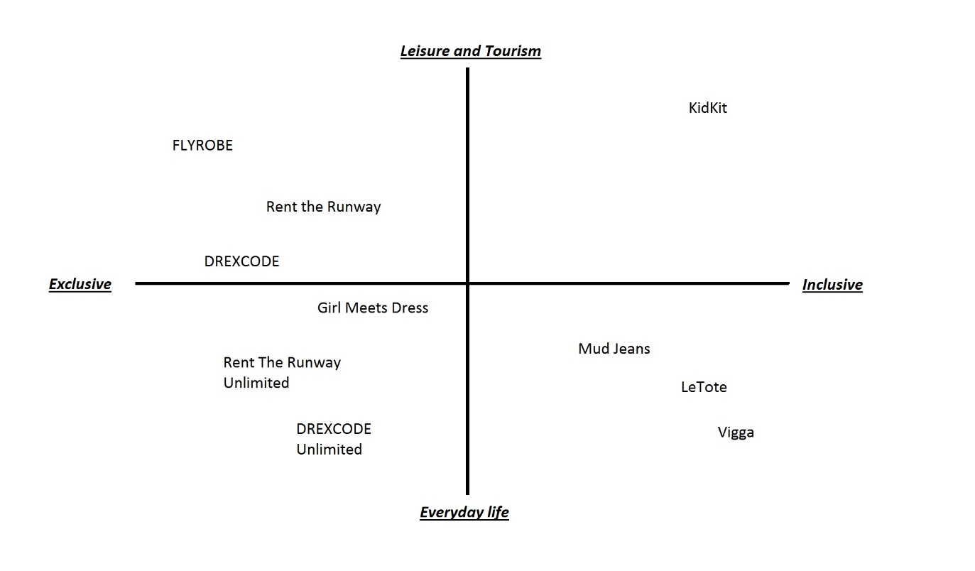

Figure 1



Table 2

# Conclusions

The market is ready for an innovative service, capable to facilitate their lives when travelling with children. The proposed service can be applied over a test market focusing on Swedish families travelling to Italy or Greece or even a smaller Danish market focusing on families traveling from Copenhagen to Tuscany for summer holidays.

H&M’s supply chain can be of enormous support in terms of customer service and logistics. Additionally, local laundries will be used to offer a complete service to the consumer. A business model canvas draft is shown in Figure 2.

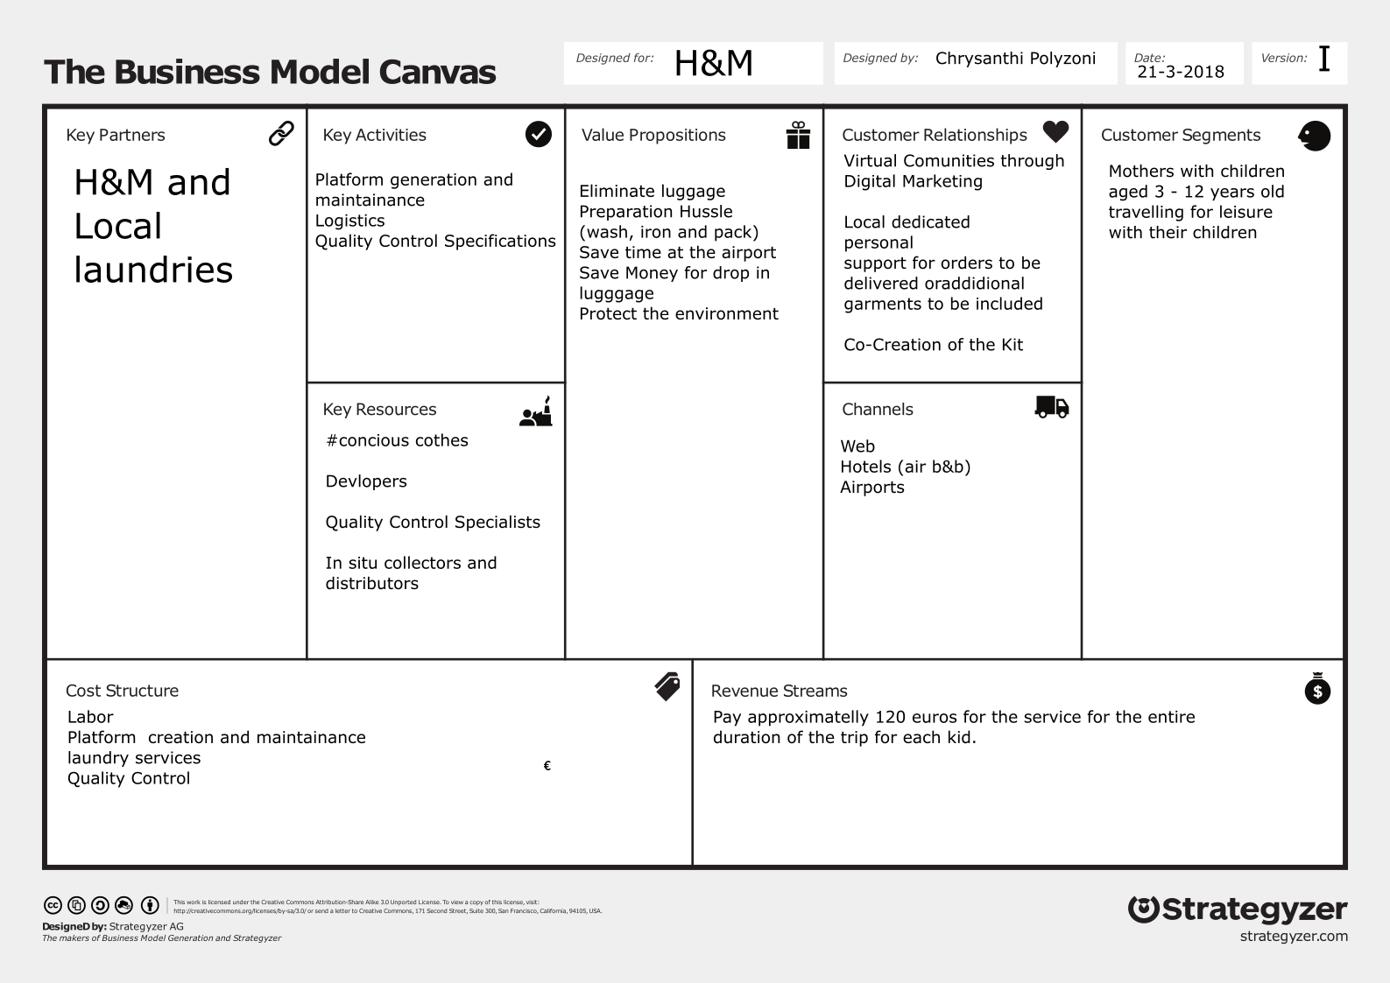

Figure 2

Foundation, E. M. (2017). *A New Textiles Economy.*

Magnusson, A. (2017). *Airline Passenger Experience Association (APEX)*. Retrieved from https://apex.aero/2017/05/04/sita-baggage-report-2017-lost-luggage-technology