**SOCIAL BUSINESS PLAN**

**KIDKIT**

THIS IS A DRAFT - BEAUTIFYING WILL BE DONE ON MICROSOFT WORD DOCUMENT

Alice Schroeder

Ammara Shabbir

Asena Modanli

Giulia Montani

Submission date: 17 December

Max 30 pages

**LIST OF CONTENTS:**

* INTRODUCTION
* THEORY OF CHANGE
* BUSINESS MODEL CANVAS
* INDUSTRY ANALYSIS VIA PORTER’S 5 FORCES
  + COMPETITORS
  + SUBSTITUTES
  + SUPPLIERS
  + NEW ENTRANTS
  + CUSTOMERS
* SWOT ANALYSIS OF THE BUSINESS MODEL
  + STRENGTHS
  + WEAKNESSES
  + OPPORTUNITIES
  + THREATS
* SOCIAL IMPACT ASSESSMENT
* REFERENCES

**INTRODUCTION**

KidKit is a start-up founded by Chrysanthi Polyzoni who has an academic background on Natural Disaster Emergency Management. Accordingly she has awareness that resilience is the best way to handle extreme events. Plus she was intrigued by the Circular Economy concept which presents itself as a resilient solution to overcome both environmental and social challenges. Current research implies that we may be living through the “sixth extinction” due to the harsh effects of the Anthropocene. (Kolbert 2015)

KidKit believes that we have to become resilient enough to tackle this challenge and this is why truly circular business models have a very good chance to succeed, if they manage to adapt to customer culture and needs, avoiding the cause of panic. In a nutshell, this is the reason why KidKit is needed as a solution to improve people’s lives without involving a sense of guilt in the consumer.

A smooth transition to product as service solutions has to be achieved, because ownership comes at a high cost which at the moment cannot be handled by individuals and brand collaboration. Who owns stuff, should have the responsibility to put them into circulation after their use because the global waste warehouse is unable to host any more waste.

If put in financial terms: “Inventory Turns” in the global warehouse has worsen logistics and made any kind of waste obsolete, that from now on, only companies able to overcome this issue, will be capable of creating positive financial growth.

**PART 1: THEORY OF CHANGE**

In current globalized world where people are becoming more concerned about their deteriorating footprints on environment, the focus is shifting from ‘’disposable” or fast’’ fashion to ‘’sustainable’’ fashion. The concept of shared or circular economy has extended from cars, homes, office space and bicycle has extended towards sharing clothes and other items of daily use. As clothing industry is considered as one of the most polluting industry in the world, the phenomenon of “Collaborative Fashion Consumption” is on rise with emphasize on renting clothes rather than buying clothes (Becker, 2018). Collaborative consumption is defined as “people coordinating the acquisition and distribution of a resource for a fee or other compensation” (Belk, 2014). However, the one-on-one coordination is not always easy for clothes as finding the right size, colour or clothes for special occasions and holidays require much research and hassle. Therefore, it creates the need of a platform where you can find all these at one place. This is where KidKit can plays a vital role in fulfilling the requirements of parents who want to travel hassle free with young children and don’t want to buy and carry clothes for the duration of leisure trips. In this way KidKit is creating value at two levels:

1. Collective Value: Environmental protection and sustainability by reducing the impacts of fast fashion and promoting the reuse of products and reduce the need for new products to prevent waste
2. Individual Value: Convenience and cost saving, by minimizing the costs and hassle of purchasing and carrying clothes for leisure trips. It also saves them from additional cost of luggage and risk of luggage loss during travel.

In relation to the planning phase, our theory of change is below. MUST BE DISCUSSED

*“If people prefer clothing kits when going to holidays, they will save money, protect the environment and contribute to circular economy.”*

|  |  |  |
| --- | --- | --- |
| Problem/Challenge  - Those who are aged 0-14 years comprise 14% of the total population in Italy whereas 26% of the the whole world.  - Children grow fast causing families to spend too much and frequently. | ← | Impacts  Main stakeholder: Families with children ages 3-12 years old  - Better household budget  - Saves time packing and checking at the airport  - Eliminates the risk of luggage loss  - Protect the environment for future generations  - Educate circular economy |
| ↓ |  | ↑ |
| Solution  - Create the kid kit for holidays with two options; winter and summer, so that families can at least save money and share the kits with other families, and eventually protect the environment and contribute to circular economy principles. | → | Activities  - Selection of ESG compatible partners  - Creation of raw material inventory (RMI)  - Quality control for RMI  - Laundry services for RMI  - Packaging services of RMI  - Creation of kits  - Logistic services of kits |
|  | ↑↑↑ |  |
| Assumptions  - KidKit assumes that families who are in need of kits are also tight on budget.  - ??? | | |

**PART 2: BUSINESS MODEL CANVAS**

Current one:

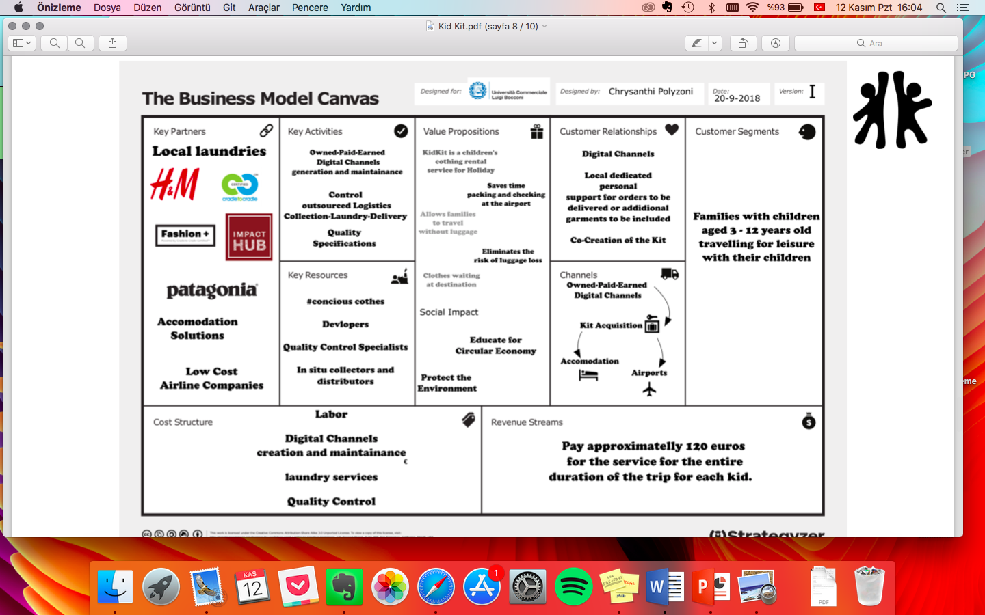

Adjustments to be made:

1- Key partners:

* Logistics: Not just airline companies but also local companies must be included
* Based on assumptions for now

2- Key activities:

3- Key resources:

4- Value proposition:

* Must be changed in order to be really comprehensible
* Too much focus on “luggage” causes a shift in the image of this start-up from a social entrepreneurship to other commercial concerns
* Luggage loss: Adult luggage can be lost too
* No luggage: Adults will still have luggage
* Accordingly, no saved time at the airport

5- Customer relationships:

* Can be better structured

6- Channels:

* Elaborate more on airports

7- Customer segments:

* Maybe add “with low purchasing power”

8- Cost structure:

* No logistics costs?
* Since partnerships are based on assumptions the cost structure may not be realistic

9- Revenue streams:

* Change according to these questions:
  + What is the duration of stay?
  + How are the costs calculated?
  + Could a subscription model be possible?
* Fees are too high
* Can consider segmentation: high- and low-income families
  + High-income: Patagonia, Bogner, North Face, Speedo → Higher than 25 Euros daily fee
  + Low-income: Decathlon, second hand first class brands, → Lower than 25 Euros daily fee

In general:

* Not entirely clear from the canvas what the focus/core work will be: logistics, online platform etc. and what partners could do.
* We must emphasize better the social value in this: circular economy may not be enough

Suggestion:

* We could create a really simple typeform and send it to families with children we know, in order to figure out what is real pain point for them when traveling

**PART 3: INDUSTRY ANALYSIS VIA PORTER’S 5 FORCES**

As Porter said in 1979, the essence of strategy formulation is coping with competition. This can be applied to all kinds of activities and plans. You need be aware of your surroundings whether you are acting as an individual or as a social enterprise. Therefore, it is crucial to analyze the Porter’s 5 forces which has always been a strong tool.

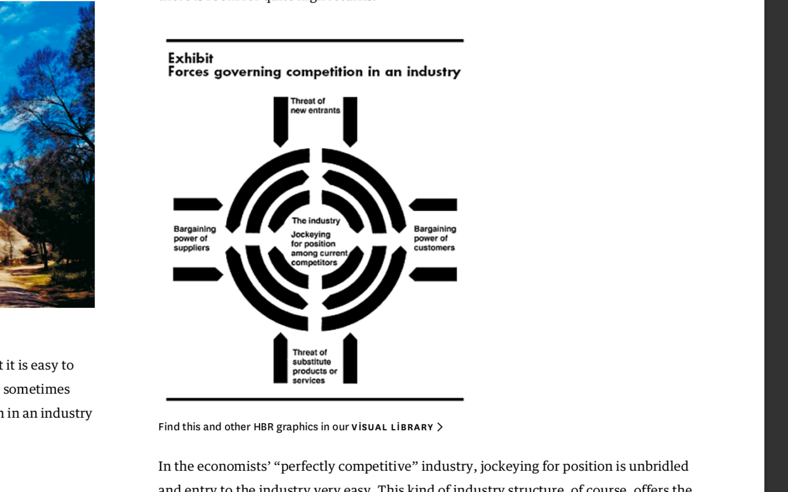

**3.1. Competitors Analysis**

As we described above, shared and circular economy is a growing phenomenon due to its collective and individual value therefore many innovative initiatives have started worldwide to promote these concepts on commercial scale. However the market segmentation for most of these ventures varies a great deal as they are either serving different country’s markets, different gender and age groups or offering entirely different product range. Therefore for now the intensity of competition in this industry is not that high however those companies who are already in business can pose direct competition for KidKit in future if they plan to expand their product portfolio and customer base. In the following section we have identified and analysed some of the major start-ups who are dealing in similar or substitute products as KidKit.

1. Rainey’s Closet: This US-based brand offers special occasion clothes for rentals along with coordinating accessories for children. It is an online store where customers can choose and order the styles they like for their children and can return them in same packaging without the hassle of washing or dry-cleaning. It also offers reward points and discounts on rental services as a recognition of customer’s loyalty to the brand and its services. The company is also offering collaborative photography services for its customers.
2. Ski-Chic: Ski Chic provides the service of renting ski-clothing for vacation trips to more than 30 ski resorts in the French Alps (Savoie, Haute-Savoie, Isère). The company is currently offering cloth rentals for men, women and kids and offers 3 ranges of products including lifestyle, premium and prestige. The prices vary depending upon the package customers want to rent. The on spot delivery of wide range of clothing option at economical daily rentals are the key features of this business’s success.
3. Vigga: It is a Danish kids and maternity organic-wear brand working purely on circular economy business model since 2014. It has won several awards for its innovative and environmental-friendly approach as It not only leases the clothes but also manufacture clothes in certified organic and socially responsible manner. The company is now extending its services into several other European and Scandinavian countries. The business model is based on subscription boxes where customers can choose the clothes and sizes from online store and pay on monthly basis. The clothes can be retained as long as customers want and replaced once kids outgrow the previous batch of clothing.
4. DrexCode: DrexCode is a luxury designer cloth and accessory rental service in Italy and Europe, particularly for women. It categorises its product portfolio both in terms of specific designers and specific occasions. The operational model is very customer-friendly where they can choose from the website and order the dresses as per their size specification which is delivered to them on scheduled date and time after paying the rent, insurance and shipping charges. Moreover, customers can also purchase new or used clothes at special prices.
5. Rent the Runway: It is a US based venture founded in 2010 which provides rental services both online and in-store. The product portfolio of Rent the Runway is similar to DrexCode catering to Women’s fashion however, it works mainly on membership basis with additional benefits on rental services for its members. The flexibility of membership as well ability of customers to physically pick, try, choose and swap a wide range of products are key characteristics of this initiative. The company is working on sustainable model of Rent-Reduce-Reuse where clothes are either sold through sample sales or donated to different organizations after end of the season. This brand is also actively pursuing its corporate social responsibility (CSR) through Rent the Runway Foundation providing financial and technical support to women entrepreneurs.
6. Girl meets dress: Just like Rent the Runway, this venture is also proving women’s clothing rental solutions with online and in-store services in UK. The customers have the facility of ordering 3 dresses at a time and can rent for more than 7 days as well for vacations. As most of the dresses offered by girls meet dresses are premium brand designer dresses therefore rentals range from £19 to £119. However, no membership services or benefits are offered.
7. FlyRobe: In India FlyRobe is providing a platform for customers and designers to share the consumption of clothes for various occasions. The company is catering both male and female customers and its product portfolio also includes décor rentals considering the festive culture of India. The price is set as a percentage (10%-15%) of the retail price of the dress and regular customers can benefit from loyalty card and enjoy additional discounts and benefits.
8. LeTote: LeTote is a monthly fashion subscription service based in San Francisco with product portfolio of clothes and accessories for women. The company is operating on the principle of **wear-return-repeat**. Customers are also given the option of buying the clothes they like after paying 50% of retail price of the clothes.

**3.2. Substitutes Analysis**

The main threat in terms of substitution for KidKit is the large and expanding retail industry of kids’ clothing including both online and offline stores. Currently it is almost USD 209 billion already established industry which is catering most of the clothing needs of children (Statistica, 2018). However with the passage of time due to rapid changes in customer’s behaviour this threat is expected to be minimised and more people will shift towards renting one time usage clothes rather than buying it.

**3.3. New Entrants:**

New Entrants threaten firms that are already competing in specific market. It influences their ability of achieving profitability and it may result in changes to existing product quality or price levels. New entrants either threaten or diminish the competitiveness of the existing companies and thus have to be considered in a sound market analysis. Important here is to understand the threat of entry and its severity. A low threat of new entrants makes an industry more attractive and increases profit potential for the firms already competing within the industry, and vice versa.

To analyze the severity of threat of entry in the case of KIdKit we should address the following questions:

- Does profitability require economics of scale? (1)

- Are the products differentiated? (2)

- Are brand names well-known? (3)

- How high is initial investment (high/low) (4)

- How high are the consumer switching costs? (5)

- Is it easy to access the distribution channels? (6)

- Is location an issue (7)

- Are property materials an issue (8)

- Is government policy an issue (9)

- Is expected retaliation of existing firms an issue? (10)

(1) No.

(2) more or less – looking at the “renting cloth part” you can see different models (subscriptions, high fashion, sport vs everyday cloths) and targets

(3) no (only some partners)

(4) depends on business model, but rather low

(5)

(6)

(7)

(8) yes

(9) no

(10)

Thus the threat of entry is rather high.

**3.4. Suppliers:**

According to Porter’s 5 forces, the fourth element is suppliers both strategic and non-strategic ones. They have a certain bargaining power which may threat the downstream integration. Within KidKit there are three types of suppliers; raw material inventory (RMI) suppliers, laundry service suppliers and logistics service suppliers. Currently, KidKit is solely subject to in-store pricing policies of each since there’s not formal partnership with relevant firms.

**3.5. Customers:**

Targeting potential customers of the business might be more complicated than the expected. The service indeed, does not reflect a clear need on the community, but it might be in the future if well target. Potential customer of the enterprise are families with children. Moreover, not only families but other potential customers that might be considered are orphanages and organizations focused on the children. The business may be perfect for events or weeks organized by churchs or charity associations for children. All of them, permits to increase the awareness and the knowledge of the company, expand the market, and achieve economy of scale’ beneficiaries for operational costs ( as cleaning or shipping). However the actual price may be too high and not affordable for those kind of customers. This is an important weakness to take into consideration, the high price might make the market smaller, only focused on a restricted niche of it.

**Part 4: SWOT ANALYSIS OF THE BUSINESS MODEL**

**4.1. Strengths**

Strengths are advantages a firm has, unique resources they can leverage from and the organization’s unique selling points (USP). Strengths should be considered externally and internally – from the companies’ inside and from customer and market participants point of view.

KidKits Strengths are the following:

Internal:

* Highly skilled CEO and Founder – the experience in catastrophe management helps by reacting fast to unexpected scenarios, as well as with the view of the biggest positive outcome
* Focus on environmental friendliness, by focusing on circular and sharing economy partnerships can be closed in a more collaborative way (long-lasting meaningful partnerships)

External:

* Regarding newest IPSOS study there are 3 main triggers of sustainability: ethics, fear and high quality. These 3 triggers tell why people buy sustainable products ore use services of a sustainability driven company – as KidKit (I will elaborate more on this)
* H&M Partnership shows strong business idea and the belief of large cooperation in it (?)
* Proof of work: 10 kits were rented in Monza area, although it was recently created.

**4.2. Weaknesses**

The current model unfortunately suffers from various weakness points. It is expected that although considering that KidKit is currently at the “seed” phase, some will remain throughout its lifespan.

As KidKit we are aware of the presence of some potential reasons for failure:

Skills: Our founder Polyzoni is a competent professional on emergency management of natural disasters. Therefore, she is skillful enough for planning and managerial phases. However, this market is new and requires specific know-how which is currently not present.

Entrepreneurial team: There’s a lack of a proper team within KidKit.

Financial market: KidKit is not expected to suffer from newness however there are issues related to smallness. These include;

* Laundry: Absence of laundry firms causes KidKit to do laundry services internally. Which is costly and not environmentally friendly.
* Provision of raw material inventory: Lack of formal partnerships with retail firms, causes KidKit to buy at in-shop prices.

Symbolic capital: KidKit name is shared by other firms as well. Especially the German version has more visibility online. Kidkit.de is a network that helps children with psychological support when they have parents with drug, alcohol or gambling addiction, are psychologically ill or violent. It is an online and offline services.

Key partners: Must be selected really carefully and as in every partnership the acts of the partner may affect our credibility.

Key activities: Currently there exists three main activities which are owned-paid-earned digital channels generation and maintenance, control of outsourced logistics collection-laundry-delivery, quality specifications. All lack a systemized operational stream.

Value proposition: MUST BE DISCUSSED ACCORDING TO THE CANVAS, CURRENTLY PROBLEMATIC

Channels: Subscription currently works offline via phone. The Website should be improved to be open to online subscriptions.

Customer segments: More specific segmentation must be done. 25 euros is a lot for a low income family. Use decathlon for some, use patagonia for other segments.

Revenue streams: Also in relation to customer segments it is currently too expensive. That’s why proper partnerships will help us save some money and also reduce the service fee. Investors are needed.

**4.3. Opportunities**

The online cloth rental services is relatively new yet growing concern offering wide range of opportunities both in terms of geographical dispersion as well as product portfolio. According to a report by Allied Market research the **market size for online clothing rentals** is estimated to reach USD 1,856 million by 2023 (Allied Market Research , 2017). The market offers a wide range of opportunities as discussed below:

Technological and Social Change: The advent of e-commerce and ease of secure online payments have shifted the mind-set and behaviour of consumers towards online shopping in last few years. However, like business corporates, global consumers are now becoming more socially responsible and want to minimise the wastage and negative impact of their consumption on environment which is paving way for rental services. The availability of top brands and designer products for rental is also increasing the social acceptability of using rented clothes and this trend will continue to prevail. Therefore, KidKit has a huge, geographically dispersed and global market to tap in North America, Europe and Asia Pacific region where market is growing at a rate of 10.6% to 11.4% (PR News, 2017).

Market Segmentation and Niche Selection: The market of cloth rental services is segregated based upon geographical regions, demographics of customers, clothing styles and occasion, price range and end user (B2B and B2C). KidKit is currently focussing on market niche of kids for vacation clothing only whereas, in most cases families travel together and it is hard for them to rent clothes from different platforms. In order to acquire larger customer base KidKit can enhance its product portfolio to men and women clothing which can offer more composite opportunities of expansion as women segment is expected to grow fastest at a rate of 9.5% over next 10 years (Digital Journal, 2018).

Children Preferences and product portfolio expansion: Children fashion has become a new industry with changing trends and new products for every season. In 2017 the size of Children wear market was USD 203.4 billion and designer clothing for children was estimated to be USD 5.89 billion (Statistica, 2018). As kids wear rental is a part of this huge industry therefore KidKit should look into other one time clothe usage occasions like birthdays, wedding, Halloween costumes etc. These events are celebrated globally, and people want to have best for their children at economical costs.

Emerging Markets: Just like many other industries fashion and clothing industry is targeting customers in emerging market like China, India, Brazil, Indonesia etc where with increasing income people are becoming more open to consume on holidays and clothes (Amed & Berg, 2017). These countries are also relying a great deal on e-commerce and in China growth rate of online sales is in double digit i-e 27% in 2017 and this trend is expected to prevail in other countries in Asia as well (World Economic Forum, 2018). This trend will also open new horizons of growth opportunities for KidKit in these markets where people are ready to accept new business models and innovative ideas.

H&M: Open innovation framework → sustainability vision

Estimations are currently based on Bormio & Thessaloniki however we can introduce Izmir and Istanbul where it would be operationally best for KidKit. Overall other countries that are on our plans: Spain + Greece + Italy + Turkey.

**4.4. Threats**

Kids can lose gloves etc. and there’s no insurance plan for such occasions.

**PART 5: SOCIAL IMPACT ASSESSMENT**

Option 1: SROI

Option 2: Why not create a survey?

→ Possible questions:

* Are you married?
  + yes
  + no
* Do you have children? If yes how many?
  + No → eliminate directly from the data set
  + 1
  + 2
  + 3
  + 4 or more
* How much money do you spend monthly per children?
  + 100 euros
  + 200 euros
  + 300 euros
  + 400 euros or more
* How often do you go to holidays with your children?
  + Once a year
  + Twice a year
  + More than twice a year
* What solution do you prefer buy clothes for the holidays?
  + Each year

# 

**References**

Allied Market Research , 2017. *Online Clothing Rental Market by End-Users (Women, Men, and Kids) and Clothing Style (Ethnic, Western, and Others) - Global Opportunity Analysis and Industry Forecast, 2017-2023.* [Online]

Available at: https://www.alliedmarketresearch.com/online-clothing-rental-market

Amed, I. & Berg, A., 2017. *Amidst New Optimism, Emerging Markets to Overtake West in 2018.* [Online]

Available at: https://www.businessoffashion.com/articles/intelligence/amidst-new-optimism-what-can-fashion-expect-in-2018

Becker, C. V., 2018. The role of values in collaborative fashion consumption - A critical investigation through the lenses of the theory of planned behavior. *Journal of Cleaner Production,* Volume 199, pp. 781-791.

Belk, R., 2014. You are what you can access: Sharing and collaborative consumption online. *Journal of Business Research,* 67(8), pp. 1595-1600.

Digital Journal, 2018. *Online Clothing Rental Market Estimated to Expand at 9.8% During 2016 to 2026.* [Online]

Available at: http://www.digitaljournal.com/pr/3642499

Kolbert, E., 2015. The Sixth Extinction: An unnatural history. Bloomsbury.

PR News, 2017. *PR News Wire.* [Online]

Available at: https://www.prnewswire.com/news-releases/online-clothing-rental-market-is-expected-to-reach--1856-million-globally-by-2023---allied-market-research-618522543.html

Statistica, 2018. *Children's wear and designer kid's wear market sizes worldwide as of 2017.* [Online]

Available at: https://www.statista.com/statistics/874374/childrenswear-and-designer-kidswear-market-sizes-worldwide/

World Economic Forum, 2018. *This is what you need to know about China’s e-commerce explosion.* [Online]

Available at: https://www.weforum.org/agenda/2018/01/china-ecommerce-what-we-can-learn/