Assignment 1

Part 1:

It seems like the trend follows the real data quite well. With private investment, it would be favorable to have a lower lambda so it would follow the real data a bit better.

The problems with the end points are that there are not any data to correct the line, so it will be more affected by the last data point.

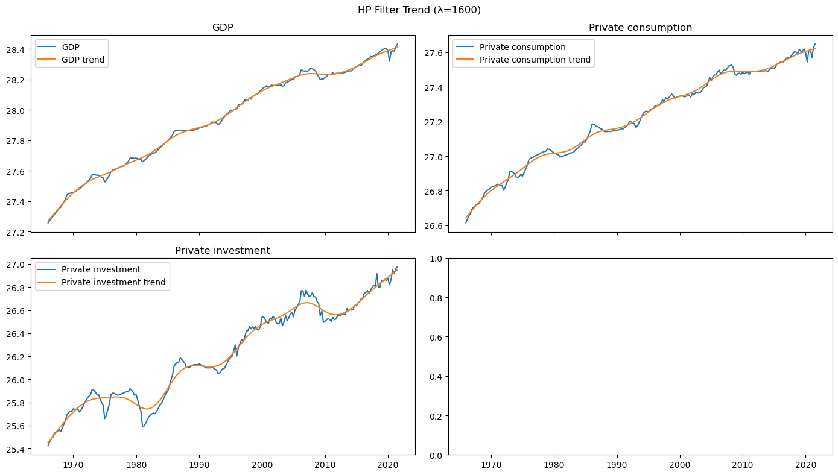

Part 2:

Here I can see the cycles and in the table are GDP cycle and GDP log.

|  | **GDP cycle** | **GDP** |
| --- | --- | --- |
| count | 223.00 | 223.00 |
| mean | -0.00 | 27.94 |
| std | 1.50 | 0.31 |
| min | -7.28 | 27.26 |
| 25% | -0.74 | 27.68 |
| 50% | -0.12 | 27.94 |
| 75% | 0.80 | 28.23 |
| max | 3.43 | 28.43 |

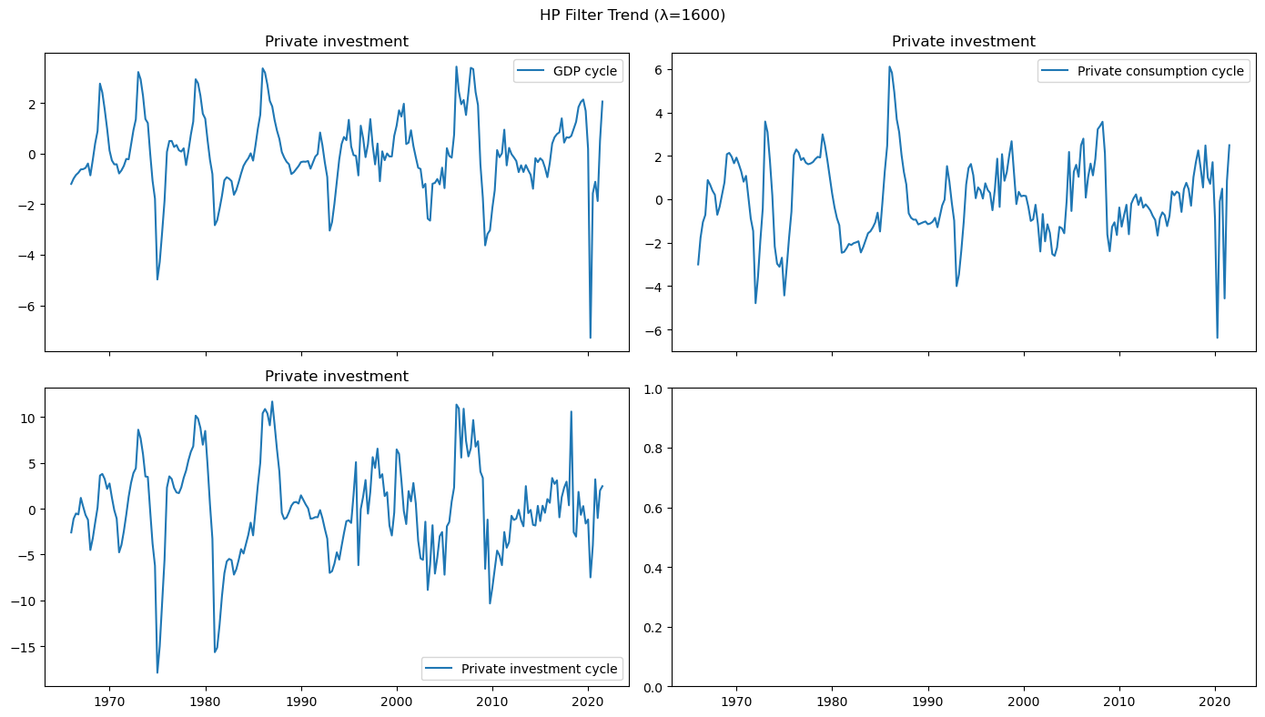

Part 3:

Private investment is the most volatile variable by far. This also correlates with the Stylized Business Cycle Fact 2 saying that investment is around 4-5 times more volatile than GDP.

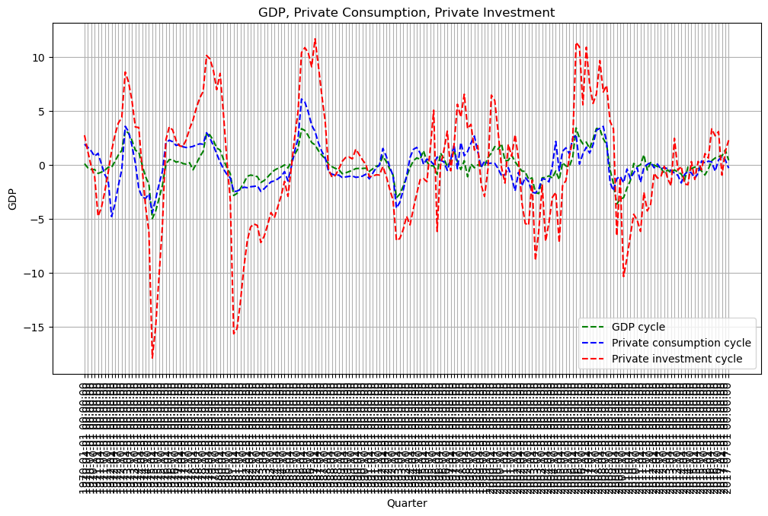

Part 4:

It fits Table 13.3 quite well.

Private consumption and private investment are neither leading nor lagged variables. They are coincident indicators, meaning that they follow the economy in sync. This means that they show what is happening right now and do not indicate the past or the future.

If I should choose either lead or lag for these two, then consumption is a bit towards a leading variable, and investment is a bit towards a lagging variable.

| | -2 | -1 | 0 | 1 | 2

|:--------------------------|---------:|---------:|---------:|---------:|--------:|

| GDP | 0.567821 | 0.773673 | 1 | 0.773673 | 0.567821|

| Private consumption cycle | 0.495021 | 0.642181 | 0.747857 | 0.537166 | 0.37571 |

| Private investment cycle | 0.51046 | 0.634392 | 0.78946 | 0.70897 | 0.579298|