Auf dem Weg zu offenen Bildungsressourcen (OER)
BrandenbOERg
2020-10-19

Prerequisites
This is a sample book written in Markdown. You can use anything that Pandoc’s Markdown supports, e.g., a math equation .
The bookdown package can be installed from CRAN or Github:
install.packages("bookdown")
# or the development version
# devtools::install_github("rstudio/bookdown")
Remember each Rmd file contains one and only one chapter, and a chapter is defined by the first-level heading #.
To compile this example to PDF, you need XeLaTeX. You are recommended to install TinyTeX (which includes XeLaTeX): https://yihui.org/tinytex/.

Introduction
You can label chapter and section titles using {#label} after them, e.g., we can reference Chapter 2. If you do not manually label them, there will be automatic labels anyway, e.g., Chapter 4.
Figures and tables with captions will be placed in figure and table environments, respectively.
par(mar = c(4, 4, .1, .1))
plot(pressure, type = 'b', pch = 19)
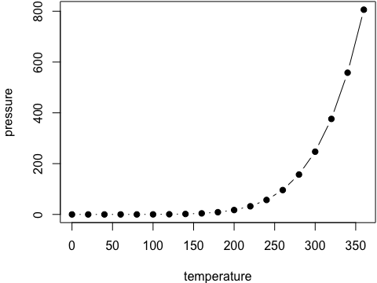
Figure 1: Here is a nice figure!
Reference a figure by its code chunk label with the fig: prefix, e.g., see Figure 1. Similarly, you can reference tables generated from knitr::kable(), e.g., see Table 1.
knitr::kable(
head(iris, 20), caption = 'Here is a nice table!',
booktabs = TRUE
)
Sepal.Length | Sepal.Width | Petal.Length | Petal.Width | Species
5.1 | 3.5 | 1.4 | 0.2 | setosa
4.9 | 3.0 | 1.4 | 0.2 | setosa
4.7 | 3.2 | 1.3 | 0.2 | setosa
4.6 | 3.1 | 1.5 | 0.2 | setosa
5.0 | 3.6 | 1.4 | 0.2 | setosa
5.4 | 3.9 | 1.7 | 0.4 | setosa
4.6 | 3.4 | 1.4 | 0.3 | setosa
5.0 | 3.4 | 1.5 | 0.2 | setosa
4.4 | 2.9 | 1.4 | 0.2 | setosa
4.9 | 3.1 | 1.5 | 0.1 | setosa
5.4 | 3.7 | 1.5 | 0.2 | setosa
4.8 | 3.4 | 1.6 | 0.2 | setosa
4.8 | 3.0 | 1.4 | 0.1 | setosa
4.3 | 3.0 | 1.1 | 0.1 | setosa
5.8 | 4.0 | 1.2 | 0.2 | setosa
5.7 | 4.4 | 1.5 | 0.4 | setosa
5.4 | 3.9 | 1.3 | 0.4 | setosa
5.1 | 3.5 | 1.4 | 0.3 | setosa
5.7 | 3.8 | 1.7 | 0.3 | setosa
5.1 | 3.8 | 1.5 | 0.3 | setosa
Table 1: Here is a nice table!
You can write citations, too. For example, we are using the bookdown package (Xie 2020) in this sample book, which was built on top of R Markdown and knitr (Xie 2015).

Literature
Here is a review of existing methods.

Methods
We describe our methods in this chapter.

Applications
Some significant applications are demonstrated in this chapter.

Example one

Example two

Final Words
We have finished a nice book.
Xie, Yihui. 2015. Dynamic Documents with R and Knitr. 2nd ed. Boca Raton, Florida: Chapman; Hall/CRC. http://yihui.org/knitr/.
———. 2020. Bookdown: Authoring Books and Technical Documents with R Markdown. https://github.com/rstudio/bookdown.

