Project 1
Katy Robison
Christopher Miller

Problems we had: Erroneous character readings when running on linux | fixed by adding getchar() before fgets(),

Any special features:

Screenshots:

gentle.txt
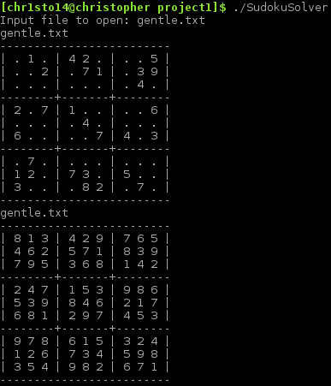

minimal.txt
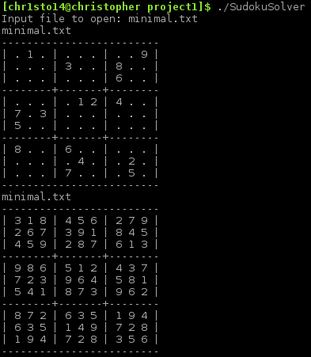

worlds-hardest.txt
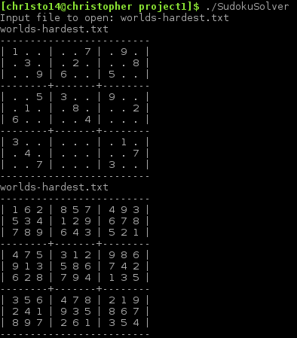

worst-case.txt
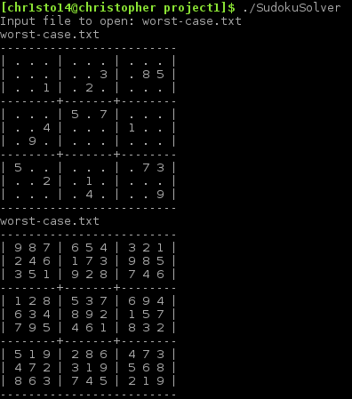

wrong.txt
