Project Embedded Controls:
Halloween Project

“Through the arduino glass”
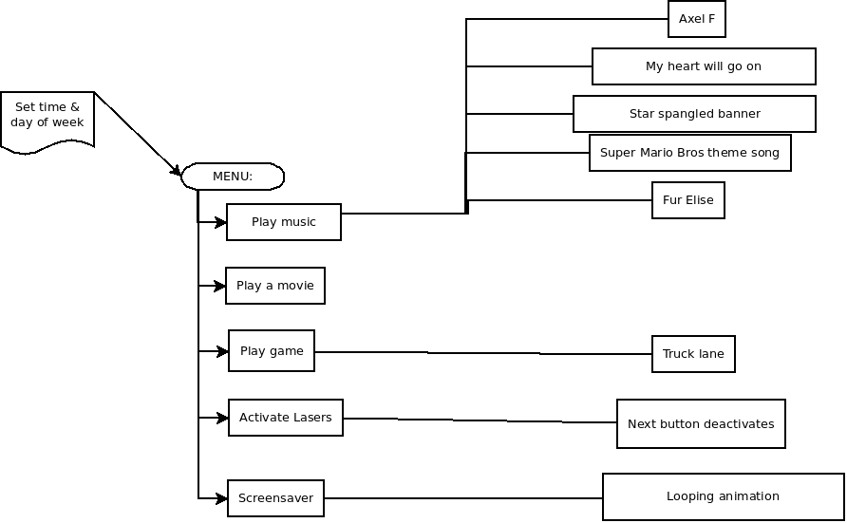
- Play music
  - http://www.arduino.cc/en/Tutorial/PlayMelody

- Play a game
  - http://www.instructables.com/id/Truck-Lane-a-16x2-LCD-Arduino-game/
  - http://forum.arduino.cc/index.php/topic,8729.0.html

