VPC Creation
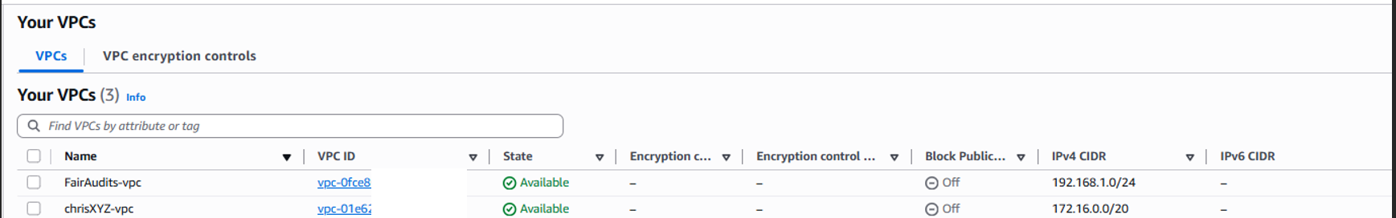

Subnet Creation
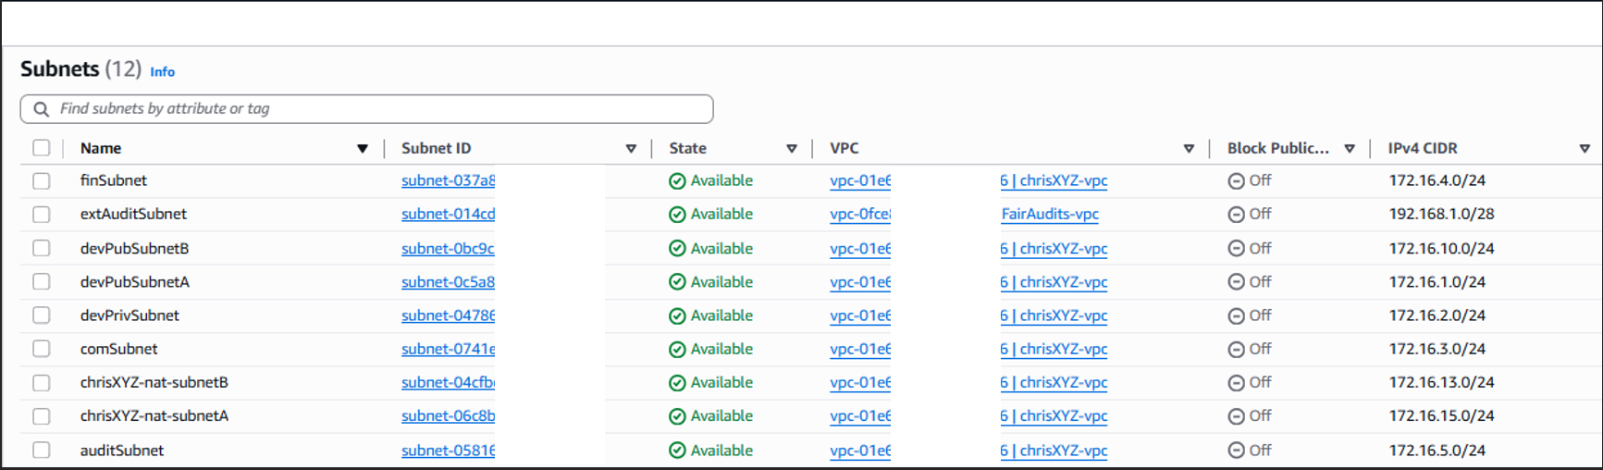

Internet Gateway
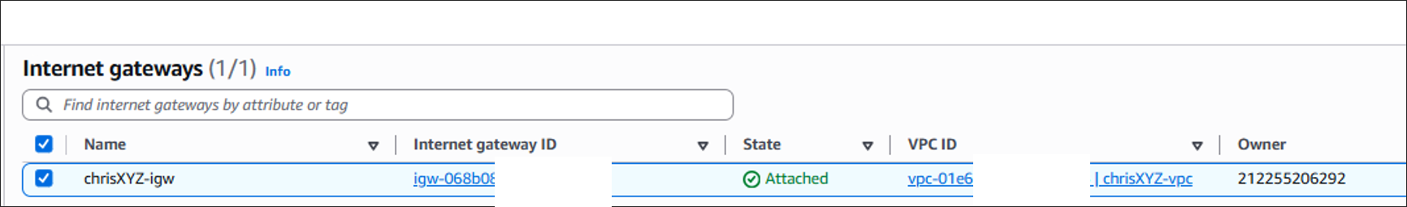

NAT Gateway
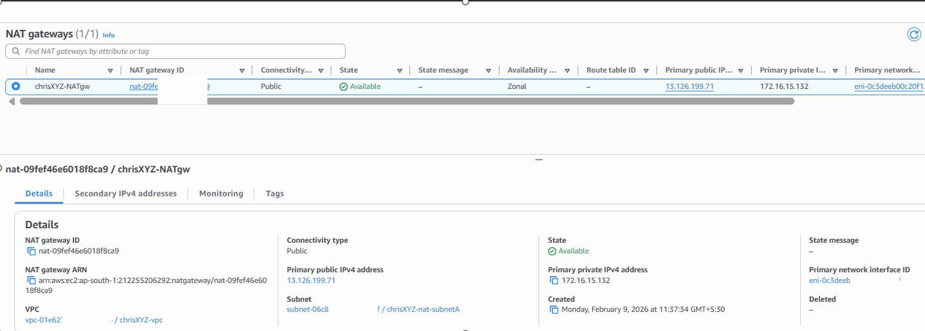

VPC Peering
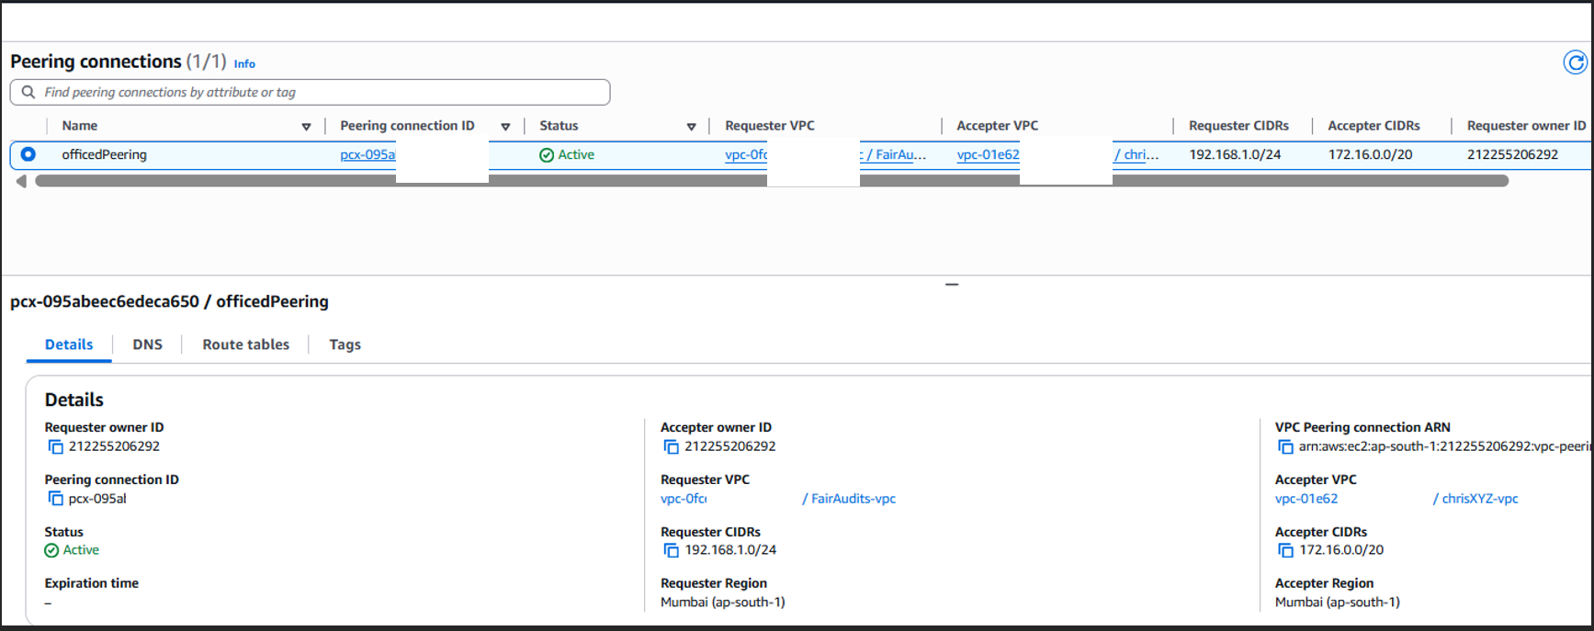

Endpoint
