Project 1 Readme Space Invaders

Space Invaders is a Japanese arcade game that was released in 1978 and was one of the first worldwide popular video games. A ship is spawned at the bottom of the screen and you need to move the ship left and right whilst shooting the aliens descending from the top of the screen.

Link to my game:

https://chrainey.github.io/Space-Invaders/

Project brief:

I had one week to design a space invaders game using a Javascript generated grid, Javascript, HTML and CSS. This was not to be done using HTML canvas.

Technologies Used:

HTML:

Header with Logo.
Start Button
Divs for grouping

CSS:

Grid using flexbox.
Background Images.
Images for game icons.

JavaScript:

Keyup to move characters.
Set Interval to move bullets fired and bombs dropped by enemies.
Click Event to start the game

Plan and Approach:

Day 1:

I started by writing out a wireframe on Excalidraw. This showed where my positioning of elements was going to go so I could laydown my HTML tags. I would generate the grid using javascript but I still needed a header and some divs to sort the layout of the game display and style it to look professional.

First, I needed to decide what size the grid would be. I wanted to have a good amount of enemies so that the game would be challenging. If there were too many enemies and too small a screen they would reach a player quickly. The enemies move to one side of the screen then move down one row, closer to the player, and continue in the opposite direction until they hit the other side.

I decided on 3 rows of 10 enemies in a 15 x 15 grid. This would give them 5 squares of sideways movement before moving downwards.

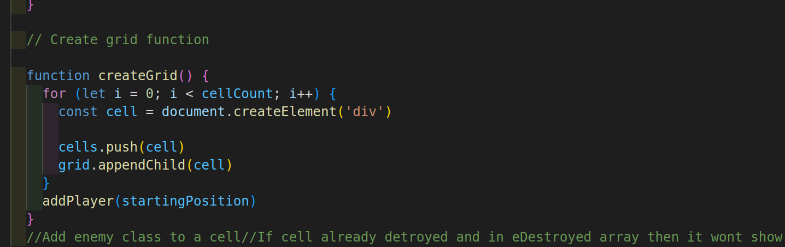
The above shows the code to generate the divs using a loop to create cells in the grid that can be styled using CSS. I sed felx box so it would wrap into a grid. I also temporarily added numbers visually to each cell so it would be easier to work out the math and equations to get everything moving properly and fix any bugs.

Day 2:

I used https://www.classicgaming.cc/classics/space-invaders/ to download all of my icons and sounds to be used in the game. These images were added to the document and I used CSS to add a class on the cell to give it an icon.
I would use adding and removing of various classes to determine what is shown in each cell at each given time. (As shown below)
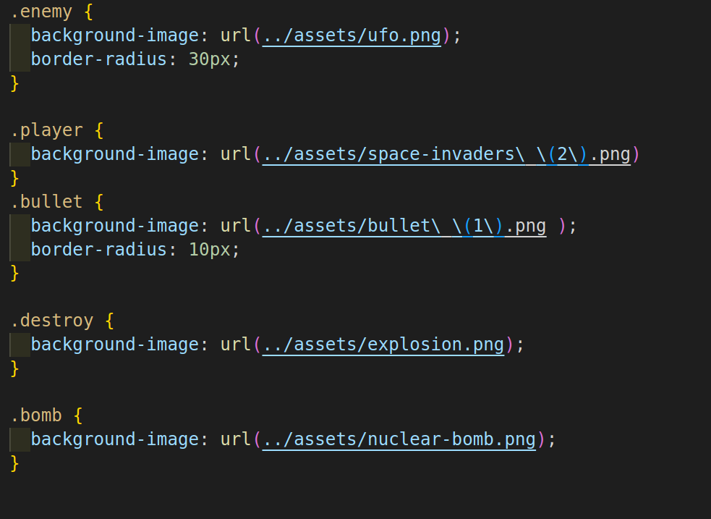
I spent a lot of this start time going over previous lessons from our javascipt sessions.
I knew I would be moving everything using Intervals. I would also be using numerous for loops and functions. I went back over arrays, functions and also the grid workshop that we did. This helped me plan much more effectively.
I decided I would put the enemies in an array and use javascript to move that array around the grid.
I used a starting array and set a start position for the player.

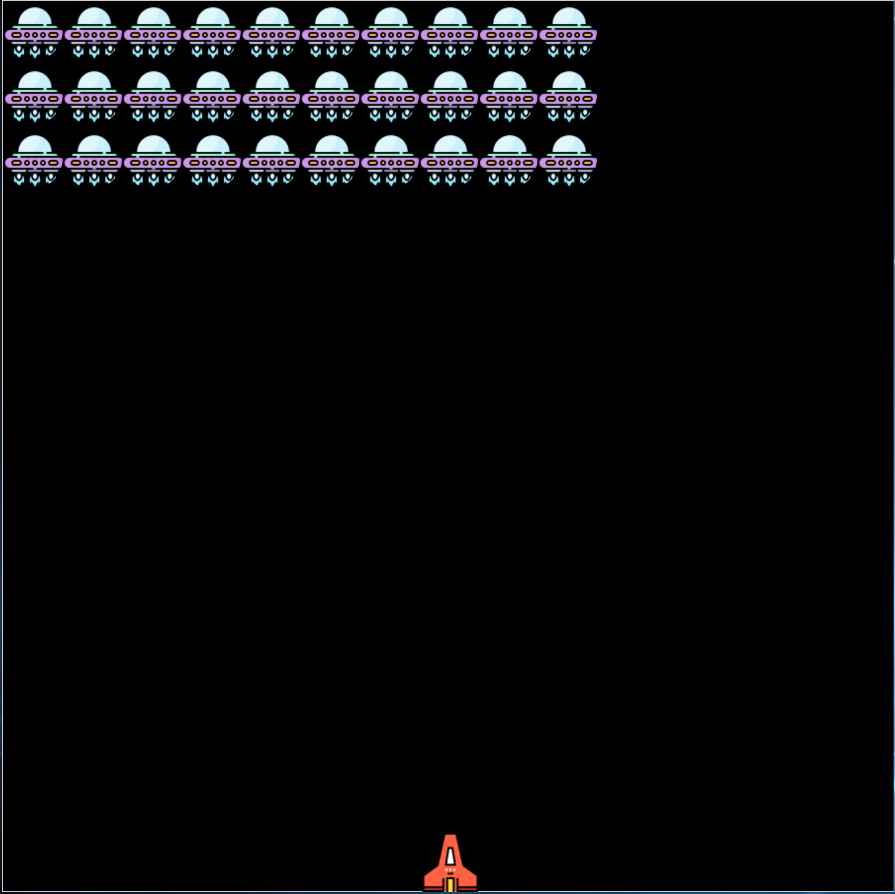
(The enemies above are displayed using an array:

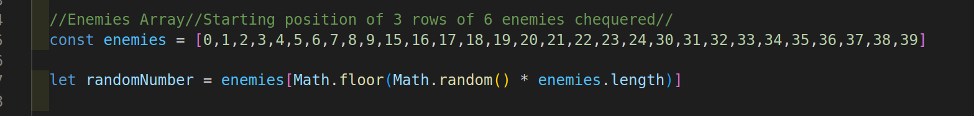

Day 3 :

I used this Sunday to search for audio, main logo and a decent background picture to have behind the game. Idecided with the neon blue background as it was very 80s ‘Tron-like’ and also didn’t dominate with too many colours and take you attention away from the game.

Day 4:

Added functions that I would need to generate icons:

AddPlayer – Function to add player class to a cell
RemovePlayer – Function to remove player classics
ShowEnemy – Function to add classes to all cells in enemy array
RemovEnemy – Function to remove enemy class to each cell (and then it will move to another cell next door to show movement)
HandleMovement – Function assigning keycode strokes to player movement. If then added to this to assign left, right and also to assign execution of the shoot function when space bar is pressed.

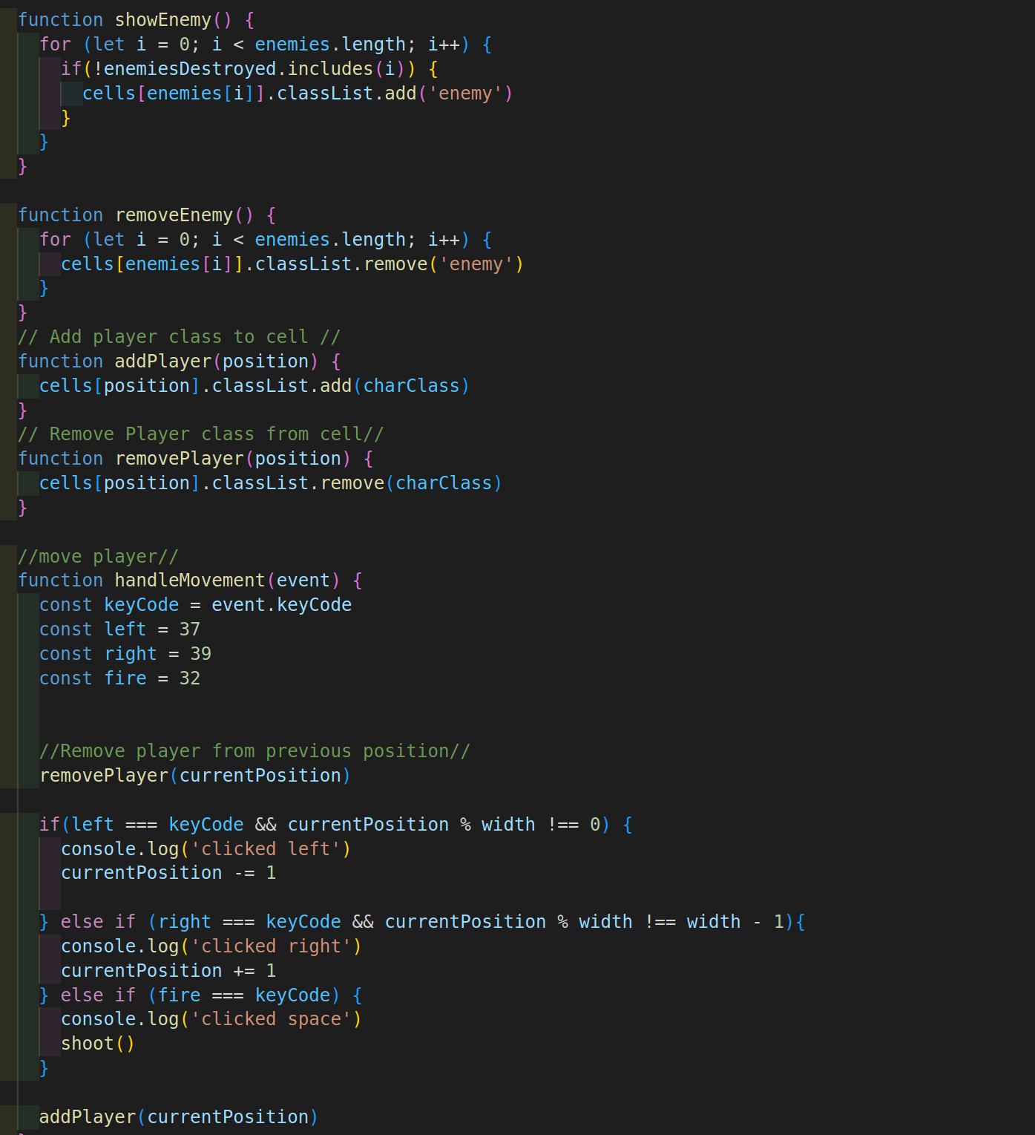

This now meant I had my grid with populated enemies anmd a player at the bootom that copuld move.
Day 5 :

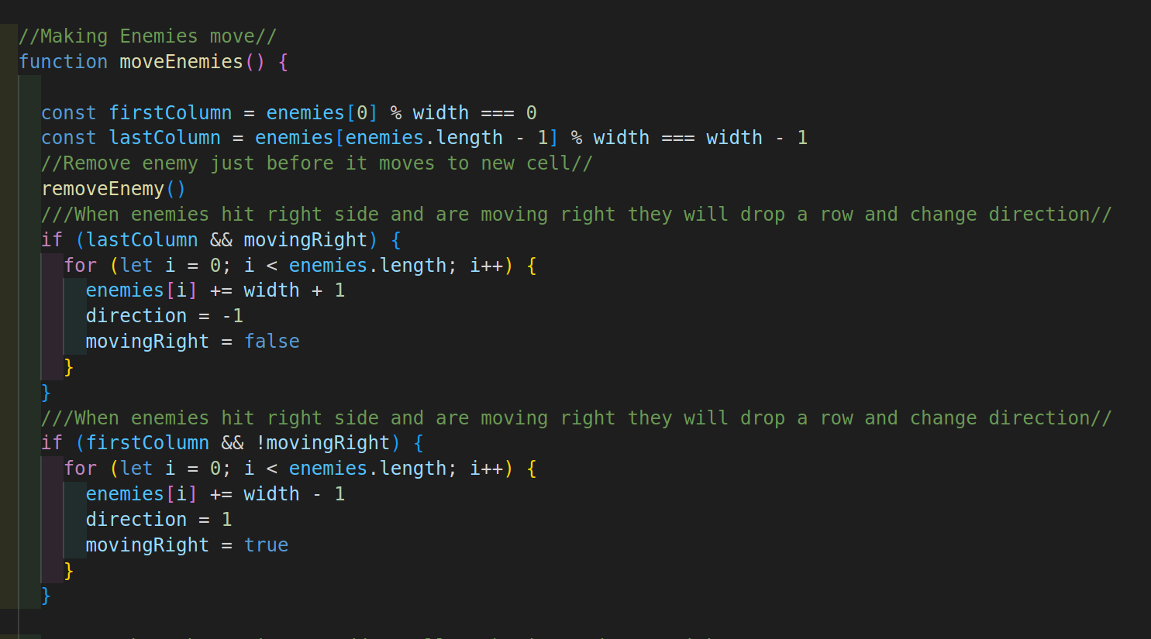
Wrote moveEnemies function to start the enemies moving on screen. I found straight away that they would just move through the grid and not hit the sides and move dwon. By setting moving Right variable I could makes sure that when enemies were at the end of a row they would move down. Then using a change in the direction I would move them back in the opposite direction.

Added Shoot function:

Added function so that when spacebar pushed the player would shoot. I used an interval to move the bullet up screen to fire at the enemies.
What I did find was that when hitting spacebar each time my enemies would speed up. By console logging I found that it was starting the game multiple times because the start game button was in focus. Used blur method to stop this.

I then added a similar function for the enemies to shoot bombs:

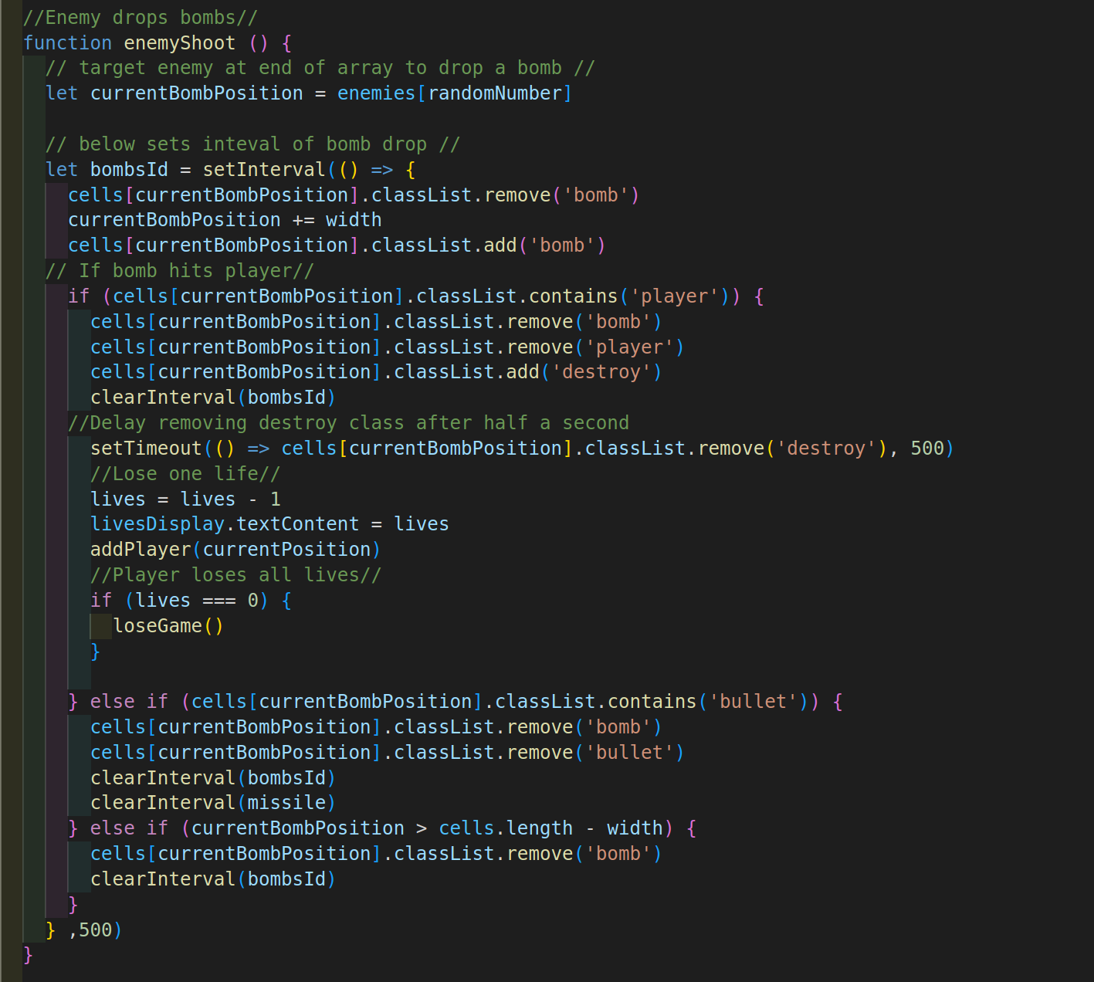
.

Day 6:

AddedStart game function and sorted out all of the collisions.

TBC

