Title: The cost of immortality

Participants: Amalia Bogri, Christian Berrig & Jonas Bolduan

Background and Motivation:

The project will examine the case of the immortal jellyfish, *Turritopsis dohrnii* (Cnidaria, Medusozoa). Typically, Medusozoa have a complex life cycle and reproduce both sexually and asexually. The fertilized egg (zygote) becomes a free-living planula, which swims to the sea floor and settles. It metamorphoses into a polyp that multiplies asexually into several clonal polyps creating a colony (hydroid). Then, the polyps bud and free-swimming medusas are released. Medusas become sexually mature, spawn gametes into the sea, and then eventually die off. The immortal jellyfish, however, has an extra **trait**; it can metamorphose backwards, from the medusoid stage into the polyp stage, through an intermediate cyst form. In essence, it escapes death by returning to an earlier developmental stage. This peculiar metamorphosis intensifies when the medusa is stressed by environmental factors (e.g. temperature / acidity change) or injury.

This immortality-trait has the obvious benefit of reduced mortality in the population (as the medusas do not die). After a threshold, however, it has a cost: if medusas are turning into cysts too quickly, then there is reduced spawning, which reduces the overall growth rate of this jellyfish species. We are interested in finding whether there is an optimal rate of backwards metamorphosis (**cysting rate**), that maximizes the species’ growth rate. Given that the cysting is induced by environmental stress, we will then investigate whether the trait would be beneficial or costly under the changing environmental conditions caused by climate change, such as increasing sea temperatures or water acidification. Overall, we are looking at this structured population both from an evolutionary prespective (optimization of the trait) and from an environmental perspective (trait is affected by environment).

Problem statement:

How will the growth rate evolution of *Turritopsis dohrnii* be affected by the changing marine environment?

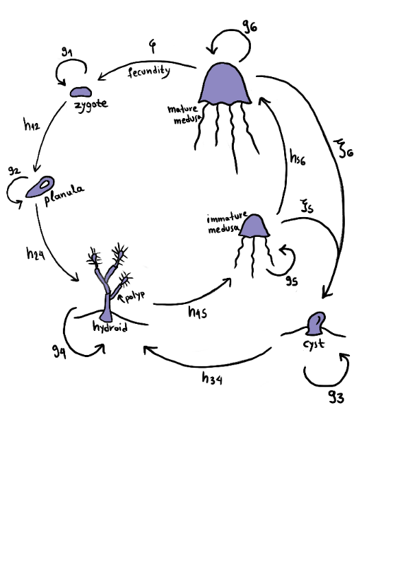

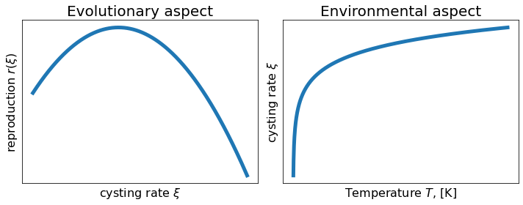

We present these two plots to emphasize that we’ll look at two processes (evolutionary, environmental) that are independed of each other. Eventually, we will also produce a plot of r(ξ) and temperature.

**Equations:**

This is our structured population equation, that we will solve for each time point.

$$\left[\begin{matrix}\begin{matrix}n_{Zygote} \\ n_{Planula}\end{matrix} \\ \begin{matrix}n_{Cyst} \\ n_{Hydroid}\end{matrix} \\ \begin{matrix}n_{Juv medusa} \\ n_{Medusa}\end{matrix}\end{matrix}\right]\left(t\right)\left[\begin{matrix}\begin{matrix}g_{ 1} & 0 \\ h_{12} & g_{ 2}\end{matrix} & \begin{matrix}0 & 0 \\ 0 & 0\end{matrix} & \begin{matrix}0 & φ \\ 0 & 0\end{matrix} \\ \begin{matrix}0 & 0 \\ 0 & h_{24}\end{matrix} & \begin{matrix}g_{ 3} & 0 \\ h_{34} & g_{ 4}\end{matrix} & \begin{matrix}ξ_{ 5} & ξ_{ 6} \\ 0 & 0\end{matrix} \\ \begin{matrix}0 & 0 \\ 0 & 0\end{matrix} & \begin{matrix}0 & h_{45} \\ 0 & 0\end{matrix} & \begin{matrix}g_{ 5} & 0 \\ h_{56} & g_{ 6}\end{matrix}\end{matrix}\right]=\left[\begin{matrix}\begin{matrix}n_{Zygote} \\ n_{Planula}\end{matrix} \\ \begin{matrix}n_{Cyst} \\ n_{Hydroid}\end{matrix} \\ \begin{matrix}n_{Juv medusa} \\ n_{Medusa}\end{matrix}\end{matrix}\right]\left(t+1\right)$$

(Alternatively, we will solve this equation: $n\left(T\right)=L^{T}n_{0}$, where L is the matrix and $n_{0}$ is the number of initial individuals at each life stage)

We will solve the system for different cysting rates ξ.

Then we will compare the growth rate r of the system, to find if there is an optimal ξ that produces a maximum growth rate r.

We can calculate the growth rate by finding the dominant eigenvalue.

Then, we will built the dependency of the cysting rate ξ to the temperature T. We assume that ξ changes according to temperature.

In the graph above, we have used this equation: ξ(T)=log(T). This is subject to change, as we’ll read more literature.

Finally, we will connect the growth rate r to the temperature through the cysting rate ξ, and we will test whether the increasing ocean temperature will benefit or disadvantage the immortal jellyfish. For example, if the temperature increase leads to an extremely increased cysting rate ξ, then the growth rate r would decrease and the jellyfish with the immortality trait would be in disadvantage.