4.6 Course Project: Database Implementation
Christopher Crayton
ECPI University
SDC330: Advanced Object-oriented Programming Using Java
Dr. Helio de Castro
August 23, 2026

4.6 Course Project: Database Implementation
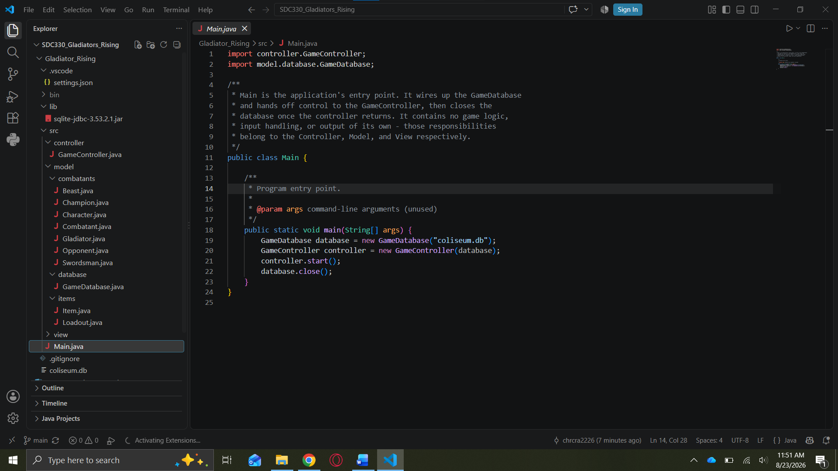
GitHub Link: https://github.com/chrcra2226/SDC330_Gladiators_Rising.git

