5.6 Course Project: Final Submission
Christopher Crayton
ECPI University
SDC330: Advanced Object-oriented Programming Using Java
Dr. Helio de Castro
August 28, 2026

5.6 Course Project: Final Submission
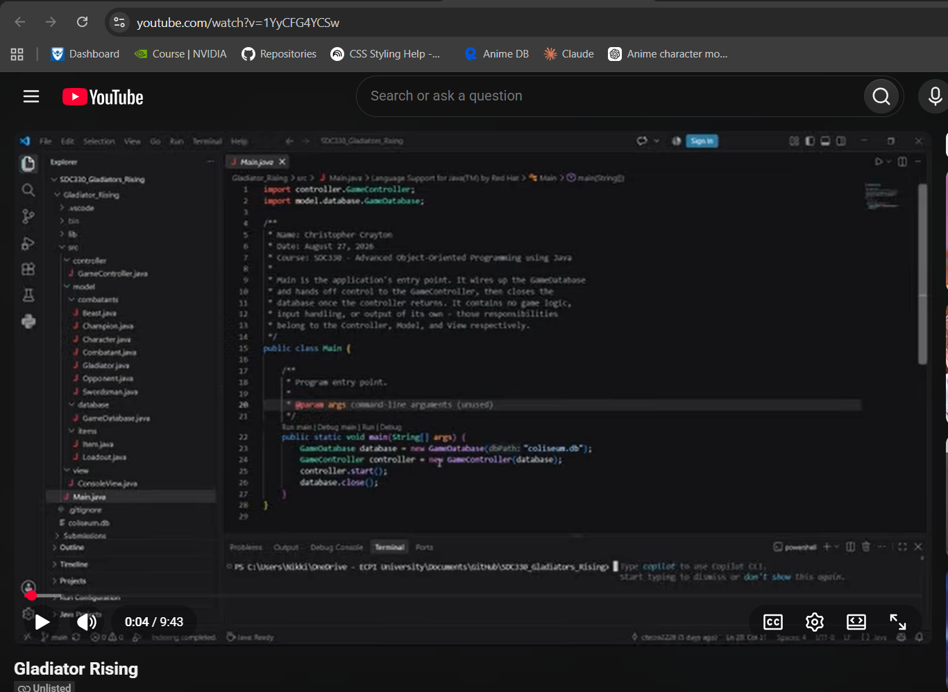
YouTube Video Link: https://youtu.be/1YyCFG4YCSw

GitHub Link: https://github.com/chrcra2226/Gladiators_Rising.git

