Acoustic evidence for an emerging binary sibilant system in Telugu

Charles Redmon,^{1,}a
¹ Department of Language and Linguistics, University of Essex, Colchester, CO4 3SQ, United Kingdom
c.redmon@essex.ac.uk

This paper presents production data and acoustic modelling from 16 speakers of Telugu showing that what has typically been described as a ternary distinction between alveolar, palatal, and retroflex sibilants is rather more accurately an emerging binary system, with the majority of speakers showing no distinction between the latter two postalveolar categories. The relative acoustic discriminability of the system (and ultimate support for merger patterns) was not, however, uniform and varied by position, vowel context, and lexical characteristics such as frequency, neighbourhood density, and the presence and number of sibilant competitors in the lexicon.

- Introduction
  - Prior work on Telugu
Telugu has typically been described as exhibiting a ternary sibilant distinction between alveolar (s; స), alveolo-palatal (ɕ; శ), and retroflex (ʂ; ష) places of articulation (Bhaskararao and Ray, 2017), though even from early descriptions linguists have noted variation in implementation according to formality, education, and dialect, among other social variables (Krishnamurti, 1978). Such a system represents a combination of the native Dravidian alveolar sibilant (historically derived internally from intervocalic plosive lenition) with two postalveolar sibilants borrowed from Indo-Aryan (primarily Sanskrit): one laminal and one apical and therefore retroflex (Krishnamurti, 1998).
This system was already attested in Old Telugu, though at this stage palatals and retroflexes were quite peripheral to the system as recent borrowings from Sanskrit (Ramanarasimham, 2020), and among Dravidian languages remains comparatively dense, with only Toda exhibiting a similar system in the modern language. Outside of Dravidian, contrasts between multiple postalveolar sibilants have disappeared in modern Indo-Aryan languages. To take just a few key examples, Hindi has merged the palatal/postalveolar and retroflex into a single postalveolar category, while Eastern Indo-Aryan languages like Bengali merged all three sibilants into a postalveolar. More broadly, systems of three or more sibilants are cross-linguistically rare, appearing in approximately 3% of languages in UPSID (Maddieson & Precoda, 1990).
While no prior study has sought to directly address the sibilant system in Telugu, numerous linguists have commented on the subject as part of wider descriptions and surveys of historical, regional, and social variation in the phonology of Telugu. And while the standard description of the system remains ternary in place of articulation (alveolar, palatal, retroflex), such as in the recent IPA Illustration of Bhaskararao and Ray (2017), a common observation in most of this work has been on the constrained and variable nature of the system when it comes to the borrowed sibilants, /ɕ/ (శ) and /ʂ/ (ష).
Krishnamurti (1957, 1978, 1998), for instance, has claimed throughout his work that while all three sibilants are present in the speech of “educated” Telugu speakers, among “uneducated” speakers all three are commonly merged into /s/. Sjoberg (1962) observes as well a stratification in the realisation of the sibilant system; however, unlike Krishnamurti, Sjoberg argues that all three sibilants are maintained at an informal level, but that /ɕ, ʂ/ are “more constrained” in their production and often arise as /s/ in the Telangana region, and /s, ɕ/ in the Coastal and Southern regions.
  - Typology of sibilant place contrasts
In general, phonological distinctions in sibilant place of articulation are not uncommon, though many languages only exhibit a single voiceless sibilant (45% of languages in UPSID, or 205), while a similar number exhibit two or more voiceless sibilants and thus do make a place distinction (40% in UPSID, or 182). However, among those distinguishing sibilant place, the vast majority (162 in UPSID) show a single binary distinction between a dental/alveolar and apostalveolar sibilant, where the postalveolar is largely laminal (only 4 languages in the UPSID set of binary distinctions involve a retroflex). There are, however, a number of languages with 3 sibilant places, with the most common set being that presumed for Telugu: alveolar, palatal, retroflex (9 languages). Thus while the general density of this system is cross-linguistically rare, among languages that do exhibit ternary sibilant place contrasts, Telugu’s is the expected system.
  - Acoustic correlates of sibilant place of articulation
Sibilant place contrasts are among the most salient phonological distinctions, not just among fricatives, but more broadly. The alveolar-postalveolar (s–ʃ) distinction which is present in English and many other languages is particularly well studied, and is marked by many acoustic features but primarily a difference in the concentration of energy in the spectrum (both as measured by spectral peak frequency and spectral mean/centre of gravity), where postalveolar sibilants show mid-frequency peaks around 3-4 kHz, while alveolars show concentrations much higher in the range: around 6-7 kHz (Jongman et al., 2000). Other characteristics, however, such as the spectral tilt (Shadle & Mair, 1998), spectral shape (Evers et al., 1998), and amplitude have been proposed as additional features of the contrast (McMurray & Jongman, 2011).
Retroflex sibilants, on the other hand, are less well studied, though one may find detailed acoustic studies on Polish (Bukmaier & Harrington, 2016; Żygis & Padgett, 2010) and Mandarin (Lee-Kim, 2014; Li, 2017), highlighting the general lowering of spectral peak frequencies as well as the importance of formant cues, particularly F3, in the preceding vowel (in cases like Polish with fewer phonotactic constraints). Therefore we might expect a system such as Telugu’s, with two postalveolar sibilants, to depend more on contextual cues such as F3 transitions than systems which can largely be distinguished on the basis of spectral characteristics of the noise.
  - Present study
The present study aims to provide for the first time detailed acoustic data on Telugu sibilant production, as well as quantitative modelling of the classification and discrimination of sibilant place of articulation in multivariate acoustic space. Further, interactions with indexical (gender, region) and lexical (word frequency, phonological neighbourhood structure) factors are considered in accounting for production patterns and the acoustic structure of the system. To this end native speakers of Telugu were recorded in a laboratory environment reading isolated words exhibiting each sibilant type in varying prosodic positions and vowel contexts. Further details on the materials and procedure are provided in the next section.

- Methods
  - Participants
Sixteen native speakers of Telugu (8F, 8M) were recruited from the English and Foreign Languages University in Hyderabad. All were students at the university (mean age: 25.5, range: 18–36), and were primarily from the Telangana region (14/16); further, the majority of participants from Telangana grew up in and around Hyderabad (9/14). Thus the sample is not regionally diverse but should provide a good estimate of the state of the sibilant system in Telangana and in Hyderabad in particular.
Regarding the multilingual background of participants, all but one participant was raised monolingually (Speaker M07 is a Telugu-Lambadi bilingual), though all speak English and Hindi as additional languages. Further, all participants had some experience in English-medium education (all at university, 14/16 at college, 8/16 at secondary school, and 8/16 at primary school), though there was a gender imbalance here as the vast majority of those with English-medium education before college (7/8) were women. Finally, no participant had lived outside of India for any period of their life at the time of recording. All participants were compensated Rs. 300 for their participation, and data collection proceeded under ethical approval from the University of Kansas Institutional Review Board.
  - Materials and procedure
A total of 120 words containing sibilant fricatives were recorded from each participant: 60 with the target sibilant in CV position (20 each of palatal, alveolar, and retroflex places), and 60 in VCV position. Consonant-vowel sequences were then distributed according to vowel context (the following vowel for CV position, the preceding vowel for VCV position) in the following manner: 10 items each of /aː/ context and 2 items each of /iː/, /eː/, /oː/ and /uː/ contexts. This distribution is broadly consistent with that found in the lexicon more broadly, though with some levelling out of non-/aː/ vowels. Each word was repeated twice (in a separate, randomised block), alongside a further 240 filler words containing no sibilant fricatives and otherwise matched for length (syllable count) and word frequency. Each word was then presented to participants on a separate slide, with the total trial sequence (including repetition) divided into 4 separate blocks with block order counterbalanced across participants. All recordings were made with a Shure SM-35 head-worn cardioid condenser microphone in the Phonetics Laboratory at the English and Foreign Languages University in Hyderabad, Telangana, India, and took less than 30 minutes each to complete.
  - Analysis
All consonant and adjacent vowel sequences (CV, VCV) were annotated and segmented in Praat (Boersma & Weenink, 2015), with acoustic measurements of two types then extracted: consonantal (RMS amplitude, AMP; spectral peak frequency, SPF; low- and high-frequency spectral tilt, LF TILT / HF TILT; and spectral moments μ1-μ4, all taken from 40 ms Hamming windows over the consonant midpoint), and vocalic (second and third formant transitions into/out of the neighbouring vowel). These measures were subsequently used both in independent statistical models of the relative overlap between the three POA categories along each acoustic dimension (as well as as a function of speaker and contextual characteristics), and in machine learning models (supervised and unsupervised) of category recognition in multivariate acoustic space.

- Results
  - Independent parameter discriminability
Figure 1 shows the posterior distributions of each consonantal parameter by Place of Articulation (alveolar, palatal, retroflex) and Position (VCV, CV). All estimates are obtained from models of the same structure (in R formula syntax):
y ~ POA*Position + Vowel + (1 + POA + Position | Speaker),
where y is one of the eight measured consonantal parameters, POA is the place of articulation (alveolar, palatal, retroflex), Vowel is one of three vowel subclasses (front = {i, e}, back = {u, o}, low = {a}), and per-Speaker random intercepts and slopes for POA and Position are introduced in the final random effects term.

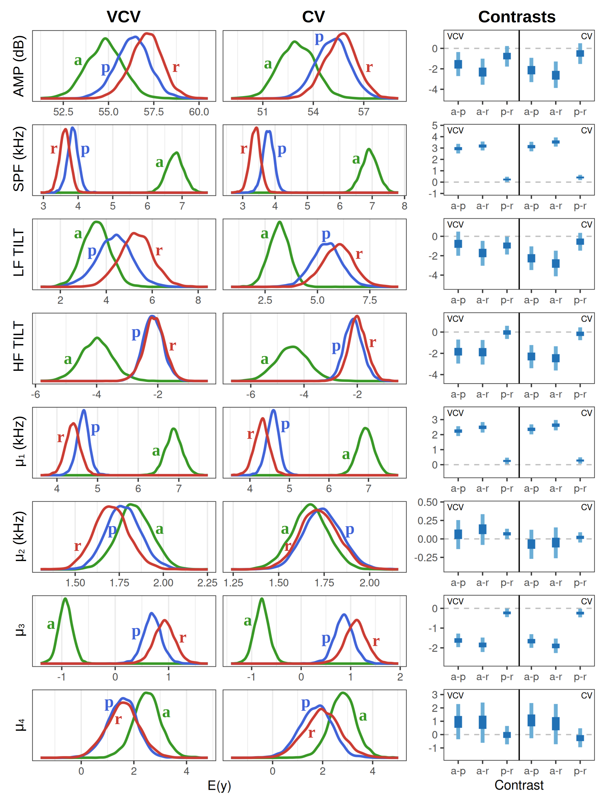
Fig 1. Posterior marginal means for each parameter in VCV and CV positions for each place of articulation (alveolar: green, palatal: blue, retroflex: red). Corresponding contrast distributions are shown in the panels on the right.

Among the consonantal parameters tested, nearly all distinguished alveolars from postalveolars robustly. Only the spectral shape parameters: dispersion, μ₂, and kurtosis, μ₄, showed no such distinction (palatals and retroflexes were similarly not well distinguished by these measures). Otherwise, alveolars could generally be distinguished acoustically along a variety of spectral dimensions, and even by amplitude (alveolars being relatively quieter).
Considering then the system as a whole, the most robust at distinguishing all three sibilants were the spectral mean, μ₁, and spectral skewness, μ₃, where alveolars were notably higher-frequency than the postalveolars, both intervocalically and word-initially, and palatals had a marginally higher spectral mean than retroflexes (see right-margin panels of Figure 1 for posterior contrasts; numerical details are provided in the Supplementary Material). Spectral skewness, which correlates strongly with spectral mean (ρ = −0.872), exhibits a similar set of relations: A << P, A << R, P < R. Further, much of the spectral mean effects are reflective of comparable differences in spectral peak frequency, both word-initially and intervocalically. However, in all such cases where there was an aggregate distinction between palatals and retroflexes, this only emerged in half or fewer speakers (5-8/16 showed the distinction for μ₁, μ₃, and SPF).
As for the palatal-retroflex distinction along other acoustic dimensions, the two postalveolars were generally acoustically indistinguishable, with the only parameters (outside of μ₁, μ₃, and SPF) showing a significant contrast on average being low-frequency spectral tilt and spectral dispersion in VCV position, and in both cases the majority of speakers did not show a distinction (15 and 12, respectively). Thus in terms of consonantal acoustic measures, while the alveolar-postalveolar distinction is quite robust, the palatal-retroflex contrast is much less reliable.
Turning then to vocalic information from formant transitions, Figure 2 shows the model-estimated F2 and F3 transitions in low-vowel /a/ contexts in CV and VC positions (this is the most common vocalic environment and one of the more robust, alongside the other back vowels /o/ and /u/, in terms of cues to consonantal place of articulation). All models of vowel formant transitions used a Generalised Additive Model (GAM), with fixed effects of place of articulation (POA), cubic-spline smooths for Time and POA with 3 basis functions, and ridge-penalised smooths for random effects of Speaker and Time by Speaker/POA. Separate models were run for each position (VC, CV) and vowel context (/i, e, a, o, u/). All models were estimated in R with the mgcv package (Woods, 2011), with uncertainty in model-estimated transitions modeled with Metropolis-Hastings sampling of the posterior distribution.
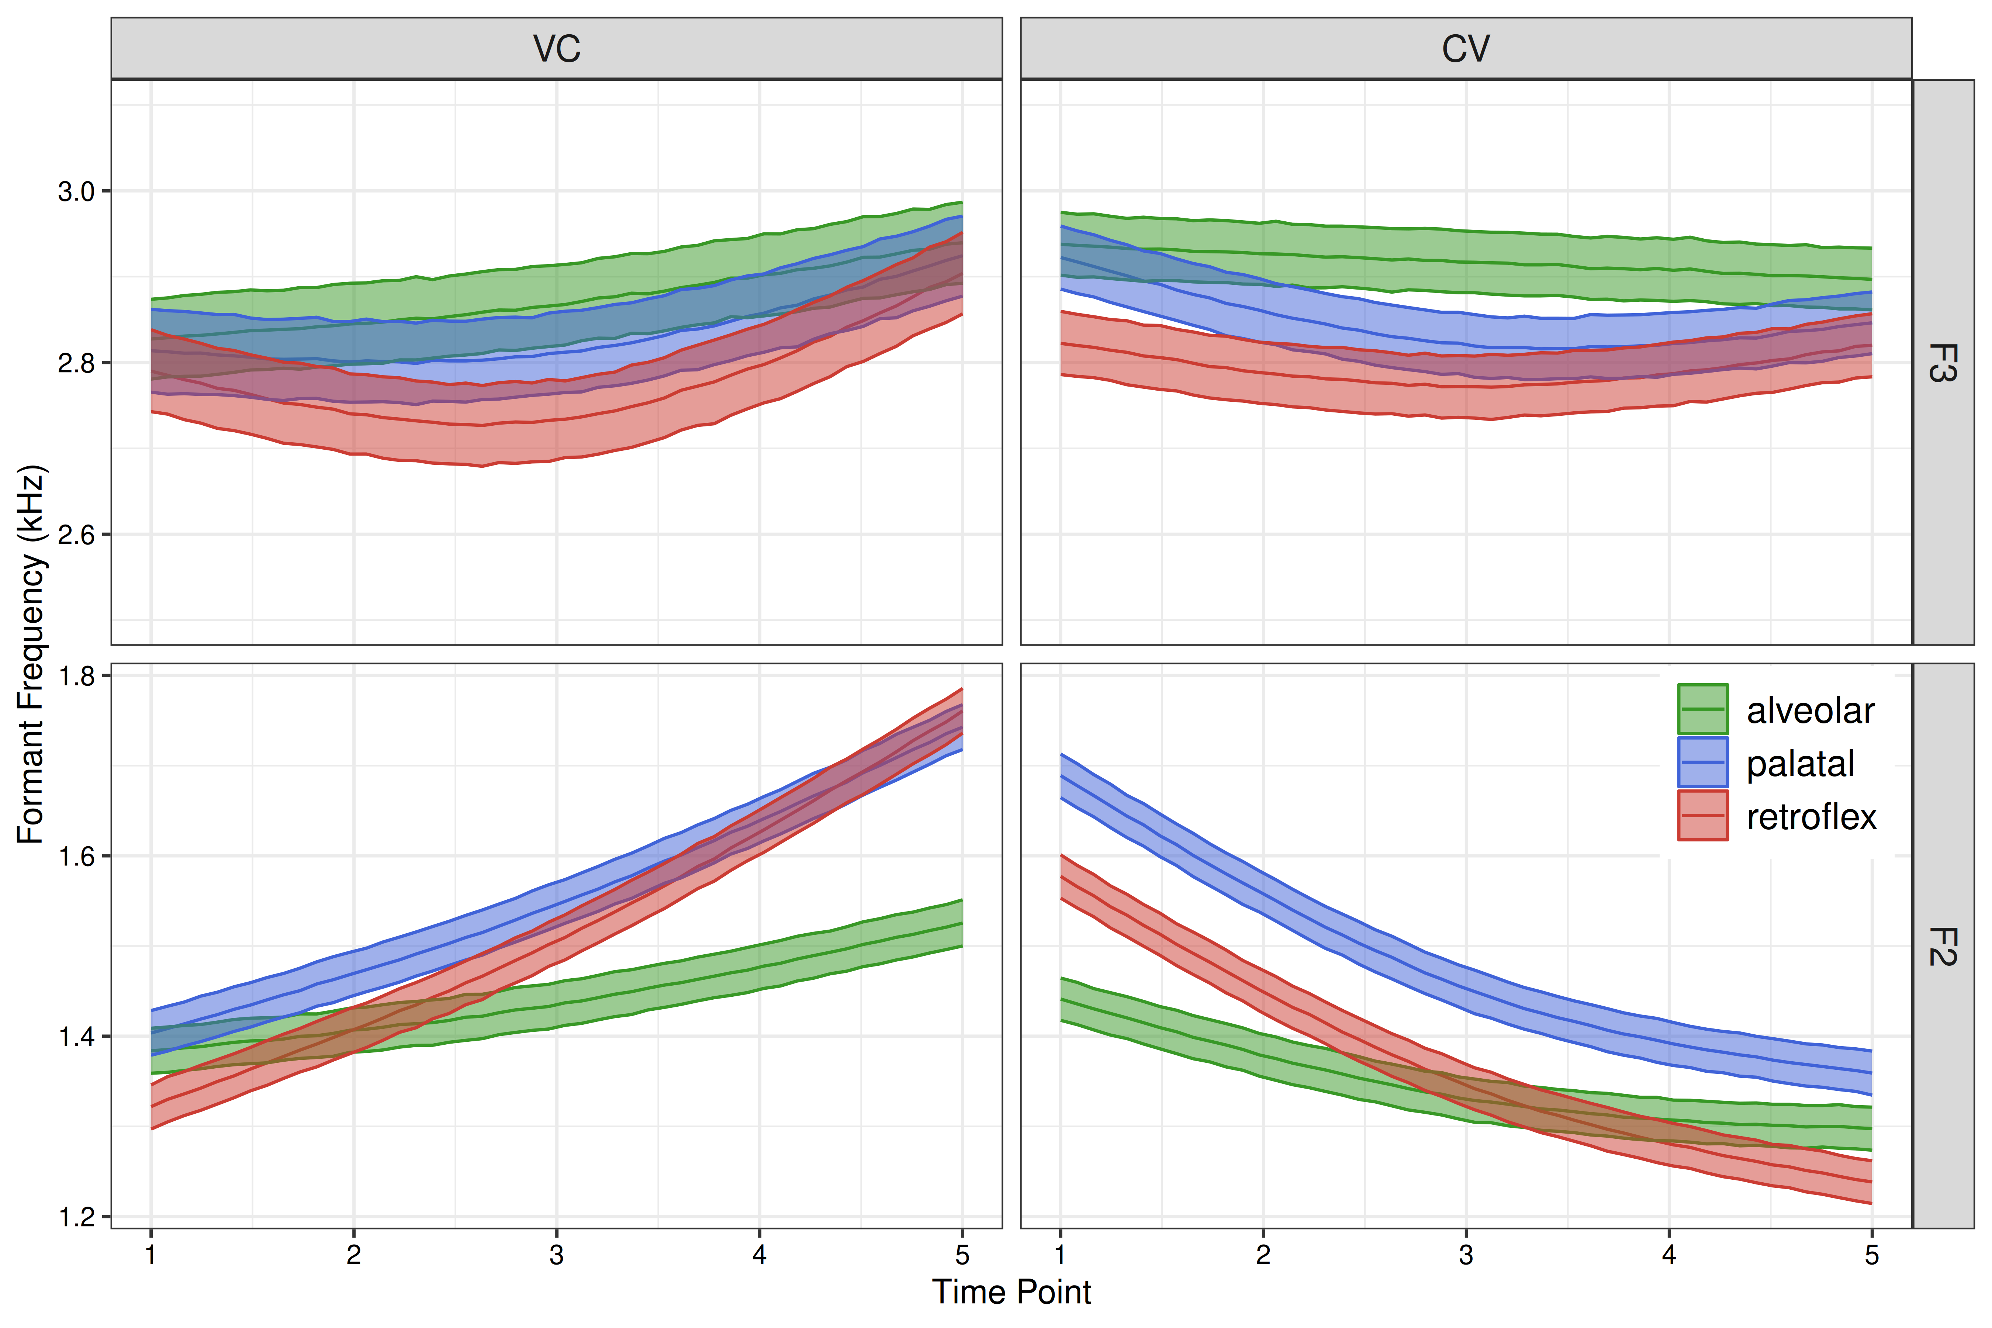
Fig 2. Model-estimated formant frequencies (F2 and F3) and posterior confidence intervals (50%) in VC and CV transitions in the low-vowel /a/ context. Time points are normalised to range from vowel midpoint (t=1 in VC, t=5 in CV) to offset/onset (t=5 in VC, t=1 in CV).

What we see from the formant transition data is that broadly the three sibilants can be distinguished from some combination of F2 and F3 transitions, either into or out of the consonant constriction. In VC position, alveolar transitions are significantly shallower than the postalveolars in F2 (i.e., had a lower offset/locus frequency, though transitions significantly diverge between alveolars and palatals by 30% before vowel offset, and 26% pre-offset between alveolars and retroflexes), but with no distinction in F3, whereas in CV position retroflexes are further distinct and intermediate in F2 locus frequency between alveolars and palatals (/s/ < /ɕ/ up to 35% of the vowel; /s/ < /ʂ/ up to 17%; /ʂ/ < /ɕ/ into at least vowel midpoint). Finally, F3 transitions in CV position, while not distinctive for contrasts with palatals, are distinctive for the alveolar-retroflex contrast, with retroflexes significantly lower in F3 further into the vowel (between 26 and 50%).
Turning then to the generalisability of these results to other vowel contexts, there is a notable distinction between front and back vowels, with front vowels showing no significant distinction between palatals and retroflexes, and only marginal distinctions between alveolars and postalveolars, primarily in F2 (/i/-context: /s/ < /ɕ/ F2 in VC from 86% of the vowel, /s/ < /ʂ/ F3 in VC from 75%; /e/-context: /s/ < /ɕ/ F2 in CV up to 23%, /s/ < /ʂ/ F2 in VC by 73% and CV up to 28%). These results are consistent with the observations of Li (2017), among others, that sibilants are acoustically less distinctive – acoustically, perceptually, and typologically – in front vowel contexts, particularly high-front.
Formant transitions into/out of back vowels, on the other hand, are generally robust. In the /o/-context palatals show a relatively flatter F2 trajectory than retroflexes (higher between midpoint and 61%, lower after 87%), with no distinction in F3. However in the /u/ context in addition to the lower and more dynamic F2 transition in VC position, retroflexes have a significantly lower F3 transition than palatals in the following vowel (from onset to near-midpoint at 47%). Alveolars are generally distinct in their formant transitions from postalveolars in both /o/ and /u/ contexts, with lower F2 transitions in VC and CV positions, particularly relative to palatals, and conversely higher-frequency F3 transitions relative to both palatals and retroflexes (see Supplementary Material for details).
  - Supervised category learning
In order to assess the degree to which the three sibilant categories can be distinguished on the basis of the full acoustic parameter set, a linear support vector machine (SVM) was trained with sibilant POA as the outcome (y) and the speaker- and vowel-residualised acoustic parameters (full consonantal set and F2/F3 values at onset/offset and midpoint) as predictors (i.e., the parameter values are assumed to be represented as offsets from speaker and vowel expectations, following the C-CuRE approach in McMurray & Jongman, 2011).
Model accuracy (from 10-fold cross-validation averaged over 5 repetitions) in CV position was 72.0%, and was moderately lower in VCV position at 67.4%. In terms of pairwise contrasts within the sibilant system, however, results were highly imbalanced (consistent with the parameter-wise analyses above). Performance on alveolars was notably more accurate than the remainder in both CV (/s/ = 89.3%; /s-ɕ/ = 92.7%, /s-ʂ/ = 96.8%) and VCV (/s/ = 73.5%; /s-ɕ/ = 81.5%, /s-ʂ/ = 93.0%) positions. Palatal-retroflex discrimination, on the other hand, was at chance (52.5% in CV, 50.2% in VCV). Errors between the two postalveolars were relatively balanced: /ɕ/ → /ʂ/ = 42% in CV, 37% in VCV; /ʂ/ → /ɕ/ = 43% in CV, 38% in VCV. These results are further robust across speakers, with model predictions on all 16 speakers’ data at or below 60% accuracy on palatals and retroflexes (/ɕ, ʂ/ error rates range from 21 to 50%).
Finally, we consider the extent to which these results are predictable from other lexical characteristics, such as the number and presence/absence of sibilant competitors in the lexical neighbourhood, the phonological neighbourhood density, and word frequency. In CV position all four variables significantly predicted model accuracy, where both the presence of a sibilant competitor (β = −0.781, z = −5.884, p < 0.001) and the number of competitors (β = −0.159, z = −8.375, p < 0.001) were negatively predicted model accuracy in a logistic regression (while controlling for the other lexical variables). General neighbourhood density, on the other hand, was positively associated with model accuracy (β = 0.007, z = 7.840, p < 0.001), as was lexical frequency (β = 0.601, z = 6.367, p < 0.001), suggesting that there are potential mediating factors to increase acoustic distinctiveness in cases where there is greater communicative pressure. In VC position, only neighbourhood density was predictive, with words from more dense neighbourhoods more accurately categorised from the acoustic data (β = 0.025, z = 4.918, p < 0.001).
  - Unsupervised category learning
Finally, we consider the extent to which sibilant categories can be learned from the data without prior knowledge of category assignment (i.e., we model the problem using unsupervised learning). For this purpose we use projection-based clustering (PBC) due to the high dimensionality of the data, testing both 2- and 3-cluster solutions for their alignment with the true categories. In 2-cluster models, alveolars showed a clear separation comprising 82% of one cluster in CV position, and 62% in VCV position; whereas, palatals and retroflexes equally comprised the other category in CV (at 41 and 42%, respectively) and VCV (41 and 49%). For 3-cluster models, in both CV and VCV the alveolars again primarily comprised one category (at 81 and 84%, respectively), with the palatals and retroflexes splitting another category (46/52% and 41/49%) and the third category evenly distributed across all three sibilants. Thus in the absence of prior categorisations, the alveolar-postalveolar distinction appears to be much more learnable than that between palatals and retroflexes.

- Discussion and conclusions
The present data, combined with the general sparsity of minimal and near-minimal pairs in the Telugu lexicon, point toward a sibilant system which is more reliably comprised of two categories than three, though some acoustic cues to the palatal-retroflex distinction remain, particularly in the vowel transitions. This result is consistent with earlier observations by Krishnamurti and Sjoberg (though note that both Krishnamurti and Sjoberg report mergers toward /s/, whereas the present study only found evidence for a postalveolar merger), among others, but crucially provides numerical evidence in support of such claims, while also providing greater specificity about differential merger patterns as a function of position, vowel context, and lexical characteristics.
Notably, while both earlier work and more recent work in Bhaskararao & Ray (2017) have described the three-way contrast as restricted to a higher register, ‘educated’ speech, or some related social dimension, in the present study all participants were primarily Masters or PhD students at a university who nevertheless showed little to no distinction among the postalveolars. Of course, this could be a consequence of bilingualism or limited formal education in Telugu, though in the latter case the male speakers were both more likely to have been educated in Telugu-medium schools and less likely to make a clear acoustic distinction between palatals and retroflexes. Further, at an informal level these numerical results are consistent with speakers’ intuitions. And while these intuitions were not probed systematically, in a debriefing following the recording many speakers, once informed of the purpose of the study, indicated that while they were taught three distinct pronunciations in school, they were only ever able to perceive or produce two.
Therefore, the acoustic data presented here indicates Telugu may more accurately be described as exhibiting a binary sibilant system, comprising an alveolar and a postalveolar (as in Hindi), with no further distinction among postalveolars. However, future research is needed to expand the regional and social distributions as well as to test for sibilant place categorisation and discrimination in perception.

Supplementary Material
See the supplementary material at https://github.com/chredmon/25-R-ACS_telugu-sibilants for all data, code, and more detailed results.

Author Declarations
Conflict of Interest
The author has no conflicts to disclose.
Ethics Approval
Ethical approval for this study was obtained from the Institutional Review Board at the University of Kansas.
Data Availability
Numeric data is available for download at https://github.com/chredmon/25-R-ACS_telugu-sibilants.

References
Bhaskararao, P., & Ray, A. (2017). Telugu. J. of the IPA, 47(2), 231–241.
Boersma, P., & Weenink, D. (2015). Praat: doing phonetics by computer [Computer program]. Version 6.0, retrieved 20 August 2015 from https://praat.org.
Bukmaier, V., & Harrington, J. (2016). The articulatory and acoustic characteristics of Polish sibilants and their consequences for diachronic change. J. of the IPA, 46(3), 311–329.
Evers, V., Reetz, H., & Lahiri, A. (1998). Crosslinguistic acoustic categorization of sibilants independent of phonological status. Journal of Phonetics, 26(4), 345–370.
Jongman, A., Wayland, R., & Wong, S. (2000). Acoustic characteristics of English fricatives. J. Acoust. Soc. Am., 108(3), 1252–1263.
Krishnamurti, B. (1957). Sandhi in modern colloquial Telugu. Indian Linguistics, 17. 178–188.
Krishnamurti, B. (1978). Language planning and development: The case of Telugu. Contributions to Asian Studies, 2, 37–56.
Krishnamurti, B. (1998). Telugu. In Steever, S. (Ed.), The Dravidian Languages, 1st Edition. Routledge: Abingdon.
Lee-Kim, S. I. (2014). Contrast neutralization and enhancement in phoneme inventories: Evidence from sibilant place contrasts and typology. Unpublished PhD Dissertation, New York University.
Li, M. (2017). Sibilant contrast: Perception, production, and sound change. Unpublished PhD Dissertation, University of Kansas.
Maddieson, I., & Precoda, K. (1990). Updating UPSID. UCLA Working Papers in Phonetics, 74, 104–111.
McMurray, B., & Jongman, A. (2011). What information is necessary for speech categorization? Harnessing variability in the speech signal by integrating cues computed relative to expectations. Psychological review, 118(2), 219–246.
Ramanarasimham, P. (2020). Old Telugu. In Steever, S. (Ed.), The Dravidian Languages, 2nd Edition. Routledge: Abingdon.
Shadle, C. H., & Mair, S. J. (1996). Quantifying spectral characteristics of fricatives. In ICSLP'96, 1521–1524. IEEE.
Sjoberg, A. (1962). Coexistent phonemic systems in Telugu: A socio-cultural perspective. Word, 18(1-3), 269–279.
Wood, S. N. (2011). Fast stable restricted maximum likelihood and marginal likelihood estimation of semiparametric generalized linear models. Journal of the Royal Statistical Society (B), 73(1), 3–36.
Żygis, M., & Padgett, J. (2010). A perceptual study of Polish fricatives, and its implications for historical sound change. Journal of Phonetics, 38(2), 207-226.

a Author to whom correspondence should be addressed.
Descriptions vary for this part of the system, with some describing the శ sound instead as palatal, others as alveolo-palatal, and still others postalveolar, though all agree on this sound being produced somewhere in the region between the palate and the alveolar ridge with a wide, laminal constriction; for simplicity we will refer to this sound in the remainder of the paper as palatal, though the alveolo-palatal symbol ɕ will be used as it is more appropriate for the place where this sound is produced.
Vowels were pooled into these larger subsets and interactions of sibilant place contrasts with vowel context were excluded because of insufficient data to model these more granular distinctions. Nevertheless we do expect given prior literature on the topic that the relative discriminability of sibilant contrasts may vary as a function of vowel context (e.g., being reduced in front and particularly high-front contexts).
All reports of significant divergences between formant transitions are based on intervals where the 95% median interval of the posterior contrast (e.g., palatal – retroflex) does not include zero.

