Parameter | Position | Alveolar – Palatal | Alveolar – Retroflex | Palatal – Retroflex
AMP (dB) | VCV | −1.552 [−2.7, −0.4]  Ss: P>A: 9; P=A: 6; A<P: 1 | −2.328 [−3.6, −1.0]  Ss: R>A: 11; A=R: 4; A>R: 1 | −0.747 [−1.8, 0.2]  Ss: P=R: 11; R>P: 4
 | CV | −2.124 [−3.4, −1.0]  Ss: P>A: 12; P=A: 3; A>P: 1 | −2.645 [−3.9, −1.3]  Ss: R>A: 13; A=R: 2; A>R: 1 | −0.486 [−1.5, 0.5]  Ss: P=R: 13; R>P: 3
SPF (kHz) | VCV | 2.947 [ 2.5, 3.4]  Ss: A>P: 16 | 3.181 [ 2.8, 3.6]  Ss: A>R: 16 | 0.229 [−0.0, 0.5]  Ss: P=R: 14; P>R: 2
 | CV | 3.123 [ 2.7, 3.5]  Ss: A>P: 16 | 3.535 [ 3.1, 3.9]  Ss: A>R: 16 | 0.407 [ 0.2, 0.6]  Ss: P>R: 8; P=R: 8
LF TILT | VCV | −0.769 [−2.0, 0.5]  Ss: P=A: 11; P>A: 4; A>P: 1 | −1.723 [−3.0, −0.4]  Ss: R=A: 9; R>A: 7 | −0.957 [−1.9, −0.1]  Ss: P=R: 15; R>P: 1
 | CV | −2.252 [−3.5, −1.0]  Ss: P>A: 8; P=A: 8 | −2.820 [−4.1, −1.5]  Ss: R>A: 10; R=A: 6 | −0.550 [−1.5, 0.4]  Ss: R=A: 16
HF TILT | VCV | −1.853 [−2.9, −0.7]  Ss: P>A: 9; P=A: 7 | −1.885 [−3.0, −0.7]  Ss: R>A: 9; R=A: 7 | −0.041 [−0.7, 0.6]  Ss: P=R: 16
 | CV | −2.301 [−3.3, −1.2]  Ss: P>A: 10; P=A: 6 | −2.464 [−3.6, −1.3]  Ss: R>A: 11; R=A: 5 | −0.162 [−0.8, 0.4]  Ss: P=R: 16
μ₁ (kHz) | VCV | 2.234 [ 1.9, 2.6]  Ss: A>P: 16 | 2.488 [ 2.1, 2.8]  Ss: A>R: 16 | 0.251 [ 0.0, 0.5]  Ss: P=R: 10; P>R: 6
 | CV | 2.351 [ 2.0, 2.7]  Ss: A>P: 16 | 2.631 [ 2.3, 3.0]  Ss: A>R: 16 | 0.276 [ 0.1, 0.5]  Ss: P=R: 9; P>R: 7
μ₂ (kHz) | VCV | 0.065 [−0.1, 0.3]  Ss: A>P: 6; P>A: 5; A=P: 5 | 0.133 [−0.1, 0.3]  Ss: A>R: 6; A=R: 6; R>A: 4 | 0.069 [ 0.0, 0.5]  Ss: P=R: 12; P>R: 4
 | CV | −0.069 [−0.3, 0.1]  Ss: P>A: 10; A>P: 5; A=P: 1 | −0.048 [−0.2, 0.2]  Ss: R>A: 10; A>R: 6 | 0.021 [−0.1, 0.1]  Ss: P=R: 12; P>R: 3; R>P: 1
μ₃ | VCV | −1.620 [−2.0, −1.3]  Ss: P>A: 16 | −1.851 [−2.2, −1.5]  Ss: R>A: 16 | −0.228 [−0.4, −0.0]  Ss: P=R: 11; R>P: 5
 | CV | −1.655 [−2.0, −1.3]  Ss: P>A: 16 | −1.898 [−2.3, −1.6]  Ss: R>A: 16 | −0.242 [−0.5, −0.0]  Ss: P=R: 11; R>P: 5
μ₄ | VCV | 0.953 [−0.4, 2.2]  Ss: A>P: 7; A=P: 5; P>A: 4 | 0.925 [−0.6, 2.4]  Ss: A>R: 8; R>A: 4; A=R: 4 | −0.025 [−0.7, 0.7]  Ss: P=R: 14; P>R: 1; R>P: 1
 | CV | 1.073 [−0.3, 2.4]  Ss: A>P: 7; A=P: 5; P>A: 4 | 0.816 [−0.7, 2.3]  Ss: A>R: 8; R>A: 4; A=R: 4 | −0.258 [−1.0, 0.4]  Ss: P=R: 14; P>R: 1; R>P: 1

/ i /
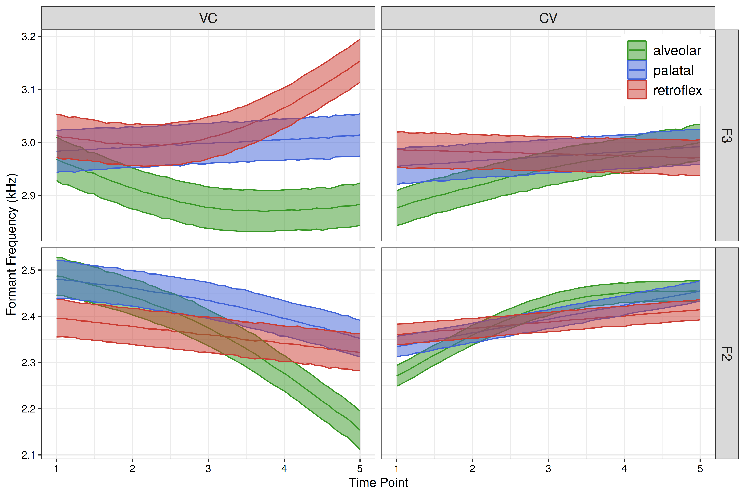
/ e /
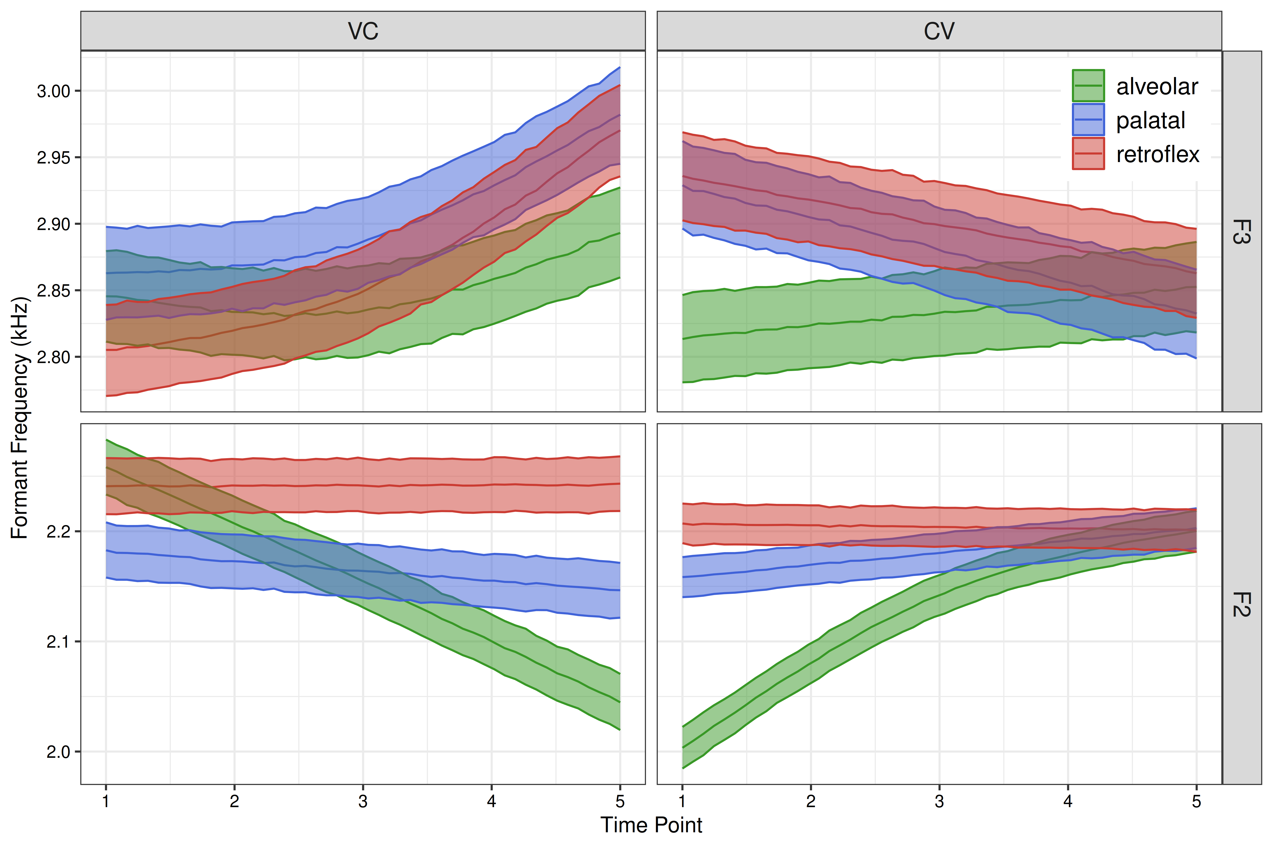
/ u /
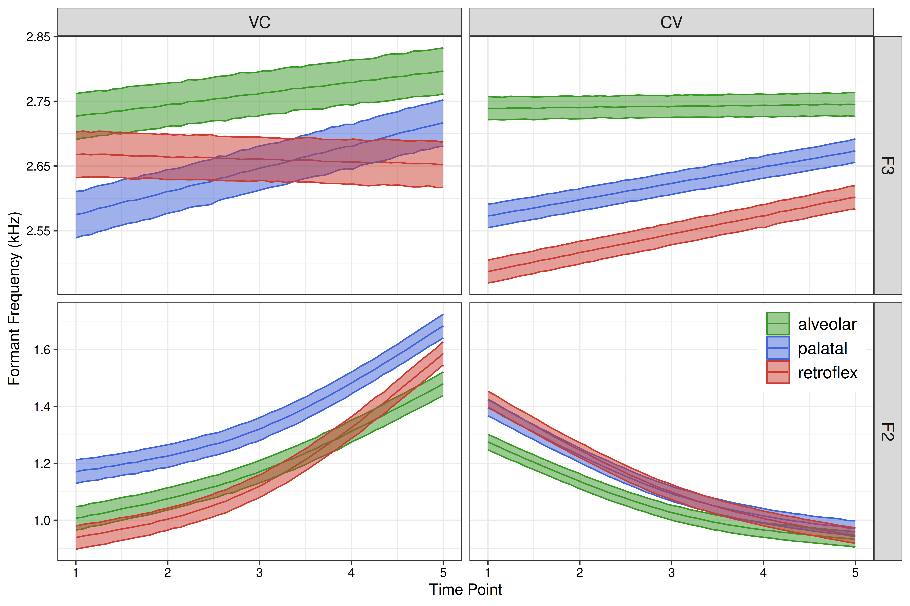
/ o /
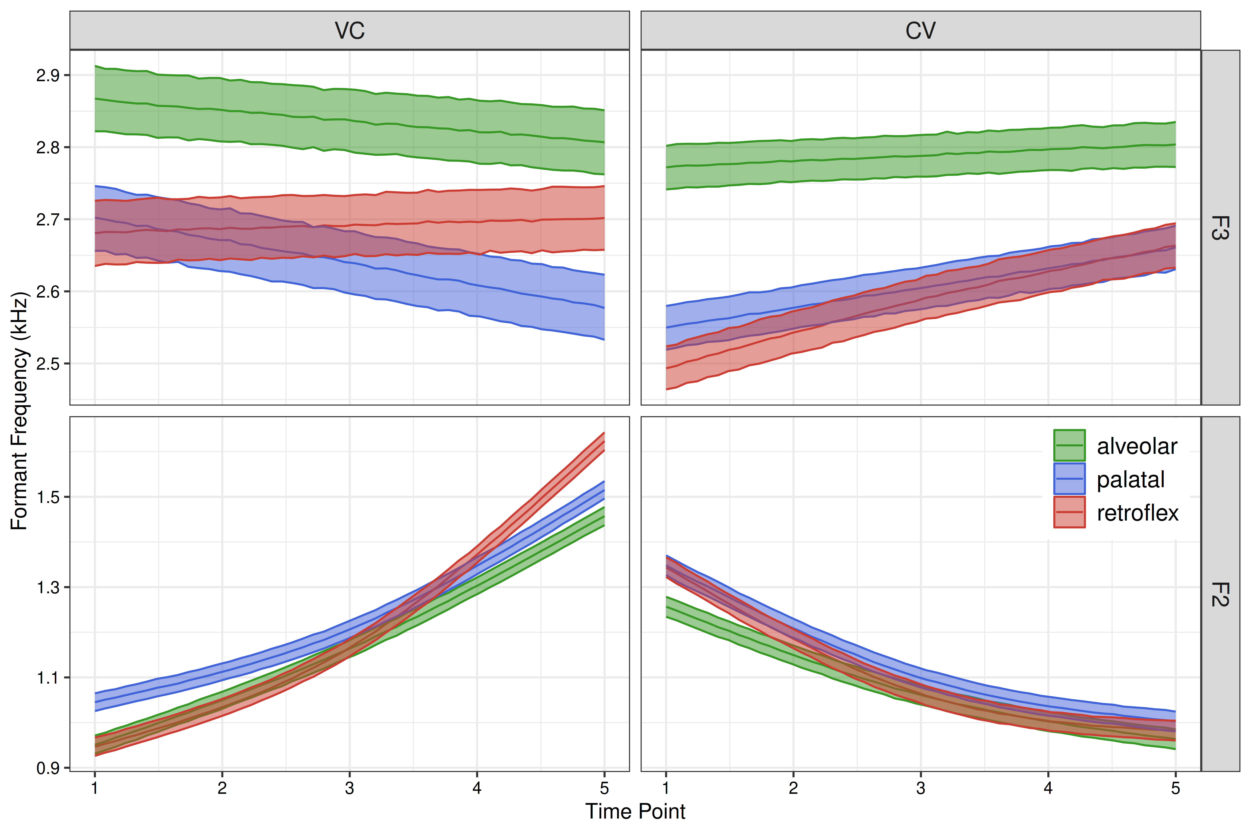
Time Periods of Significant Formant Contrasts
Vowel | Position | Formant | Alv. – Pal. | Alv – Ret. | Pal – Ret.
/i/ | VC | F2 | − (86-90) | ~ | ~
 |  | F3 | ~ | − (75-90) | ~
 | CV | F2 | ~ | ~ | ~
 |  | F3 | ~ | ~ | ~
/e/ | VC | F2 | ~ | − (73-90) | ~
 |  | F3 | ~ | ~ | ~
 | CV | F2 | − (10-23) | − (10-28) | ~
 |  | F3 | ~ | ~ | ~
/a/ | VC | F2 | − (70-90) | − (74-90) | ~
 |  | F3 | ~ | ~ | ~
 | CV | F2 | − (10-35) | − (10-17) | + (10-50)
 |  | F3 | ~ | + (26-50) | ~
/o/ | VC | F2 | − (50-56) | − (81-90) | + (50-61)  − (87-90)
 |  | F3 | + (57-90) | + (54-90) | ~
 | CV | F2 | − (10-11) | ~ | ~
 |  | F3 | + (10-50) | + (10-50) | ~
/u/ | VC | F2 | − (74-90) | ~ | + (50-79)
 |  | F3 | + (50-55) | ~ | ~
 | CV | F2 | − (10-14) | − (10-21) | ~
 |  | F3 | + (10-50) | + (10-50) | + (10-47)

Supervised Model Results (CV)

Speaker POA p_alv p_pal p_ret
F01 alveolar 87.6 6.6 5.8
F01 palatal 12.2 48.3 39.6
F01 retroflex 1.4 35.1 63.5
F02 alveolar 94.8 4.1 1.1
F02 palatal 2.8 54.6 42.6
F02 retroflex 3.2 42.7 54.2
F03 alveolar 95.3 3.9 0.8
F03 palatal 2.3 52.5 45.1
F03 retroflex 1.6 36.2 62.3
F04 alveolar 89.8 7.0 3.2
F04 palatal 3.6 56.4 40.1
F04 retroflex 2.7 42.1 55.2
F05 alveolar 82.6 12.1 5.3
F05 palatal 7.6 50.9 41.5
F05 retroflex 5.4 50.4 44.2
F06 alveolar 95.4 3.6 1.1
F06 palatal 2.1 52.7 45.2
F06 retroflex 2.7 39.0 58.3
F07 alveolar 71.6 15.0 13.4
F07 palatal 13.0 51.7 35.3
F07 retroflex 8.9 39.8 51.4
F08 alveolar 93.6 5.2 1.2
F08 palatal 3.6 50.7 45.7
F08 retroflex 2.5 43.5 53.9
M01 alveolar 95.3 3.4 1.3
M01 palatal 2.0 47.6 50.4
M01 retroflex 1.5 49.0 49.5
M02 alveolar 96.4 2.7 0.9
M02 palatal 1.6 47.1 51.3
M02 retroflex 1.9 44.7 53.4
M03 alveolar 77.7 16.0 6.2
M03 palatal 13.5 49.8 36.7
M03 retroflex 2.4 48.5 49.1
M04 alveolar 84.8 12.5 2.7
M04 palatal 10.7 48.1 41.2
M04 retroflex 5.8 43.9 50.3
M05 alveolar 91.7 6.4 1.9
M05 palatal 4.4 52.4 43.2
M05 retroflex 3.8 49.9 46.2
M06 alveolar 88.6 7.6 3.8
M06 palatal 3.3 51.4 45.3
M06 retroflex 4.4 45.7 49.9
M07 alveolar 96.2 2.8 0.9
M07 palatal 14.1 43.3 42.6
M07 retroflex 0.6 41.2 58.2
M08 alveolar 86.9 9.0 4.1
M08 palatal 17.9 56.4 25.6
M08 retroflex 1.1 34.1 64.9

Supervised Model Results (VCV)

Speaker POA p_alv p_pal p_ret
F01 alveolar 76.2 16.9 6.8
F01 palatal 32.1 34.4 33.5
F01 retroflex 1.5 31.1 67.4
F02 alveolar 77.0 18.8 4.3
F02 palatal 16.5 45.6 37.8
F02 retroflex 7.1 40.9 52.0
F03 alveolar 81.0 15.6 3.5
F03 palatal 11.1 42.5 46.4
F03 retroflex 7.5 33.9 58.6
F04 alveolar 75.3 15.3 9.4
F04 palatal 14.0 42.4 43.6
F04 retroflex 5.9 40.0 54.1
F05 alveolar 68.0 23.0 9.0
F05 palatal 25.1 44.8 30.1
F05 retroflex 5.7 38.5 55.8
F06 alveolar 70.9 23.1 6.0
F06 palatal 15.4 50.2 34.4
F06 retroflex 9.0 39.2 51.8
F07 alveolar 58.0 29.9 12.1
F07 palatal 24.8 42.5 32.7
F07 retroflex 12.1 37.6 50.3
F08 alveolar 84.6 12.6 2.7
F08 palatal 15.4 45.4 39.2
F08 retroflex 4.0 40.3 55.7
M01 alveolar 83.0 12.1 4.9
M01 palatal 10.1 51.7 38.2
M01 retroflex 5.2 40.4 54.4
M02 alveolar 80.8 14.2 5.0
M02 palatal 13.0 48.7 38.2
M02 retroflex 8.4 40.5 51.2
M03 alveolar 60.8 26.7 12.5
M03 palatal 20.9 48.6 30.6
M03 retroflex 10.0 38.8 51.2
M04 alveolar 70.6 21.2 8.2
M04 palatal 11.8 48.7 39.5
M04 retroflex 9.6 41.1 49.3
M05 alveolar 69.5 23.9 6.6
M05 palatal 12.8 51.3 36.0
M05 retroflex 7.9 39.7 52.4
M06 alveolar 73.6 17.9 8.5
M06 palatal 9.5 47.7 42.8
M06 retroflex 10.2 37.0 52.9
M07 alveolar 80.8 15.5 3.7
M07 palatal 17.6 42.2 40.2
M07 retroflex 4.2 39.3 56.5
M08 alveolar 67.8 22.8 9.5
M08 palatal 34.1 44.9 21.0
M08 retroflex 2.7 36.1 61.2

