Purpose / Scope:
To coordinate and control the team effort involved in the industrialization of injection molding tools, ensuring a smooth transition from engineering to production.

Authority/Responsibility:
- Process Engineering (Process Owner)
- Tool Engineer
- CSC

1. MRR (Mold Readiness Report) Rating

Overview:
The Mold Readiness Report (MRR) assesses the readiness of injection molding tools using two main criteria:

- Process Status (PS)
- Tool Status (TS)

  - Simplified Description

Each status is evaluated on a scale from C (critical) to A (ready for production).
This is a simplified version of the MRR Rating rules:

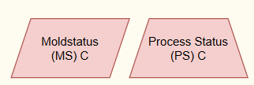

Root Causes for PS / TS = C (Critical):
- Tool has not yet run on the designated production line.
- CPm (Process Capability Index) < 1.67 for critical parameters (e.g., part weight or main SPC metrics).
- Calculated cycle time not achieved.
Next Steps:

- Identify and implement improvements to the injection molding process to ensure CPm ≥ 1.67.
- Once CPm is within acceptable range, upgrade Process Status to B.

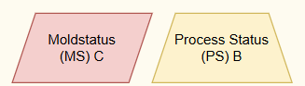

Root Causes for TS = C (Critical):
- Tool-related MRR topics not compliant with standards.
- Article quality does not meet specifications.
- Measurement corrections are necessary.
Next Steps:
- Resolve all tool- and gauge-related issues to comply with quality and dimensional standards.

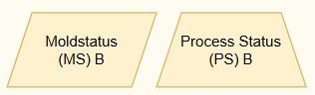

Root Causes for PS / TS = B (In Progress):
- Internal Run @ Rate not yet completed.
- Production-related issues still open.
Next Steps:
- Complete Internal Run @ Rate.
- Close all open production-related topics.
- Conduct operator training and initiate technical series handover to production.

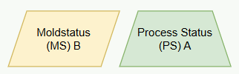 | The formal transfer of equipment ownership and responsibility from Engineering to Operations.

Root Causes for TS = B (In Progress):
- Minor measurement points are out of specification.
- Small equipment adjustments are required but do not hinder operations.
Next Steps:
- Finalize measurement corrections and minor tool adjustments.
- Ensure production readiness and full operational integration.

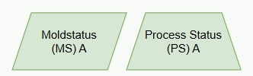 | All MRR items are closed, no further adjustments and support from Engineering and CSC needed. PAPA is green.

Final Criteria for MRR Status A (Ready):
- All MRR items are resolved.
- No further support from Engineering or SCS is required.
- PPAP status is green (fully approved for production).

1.2. Process Flow

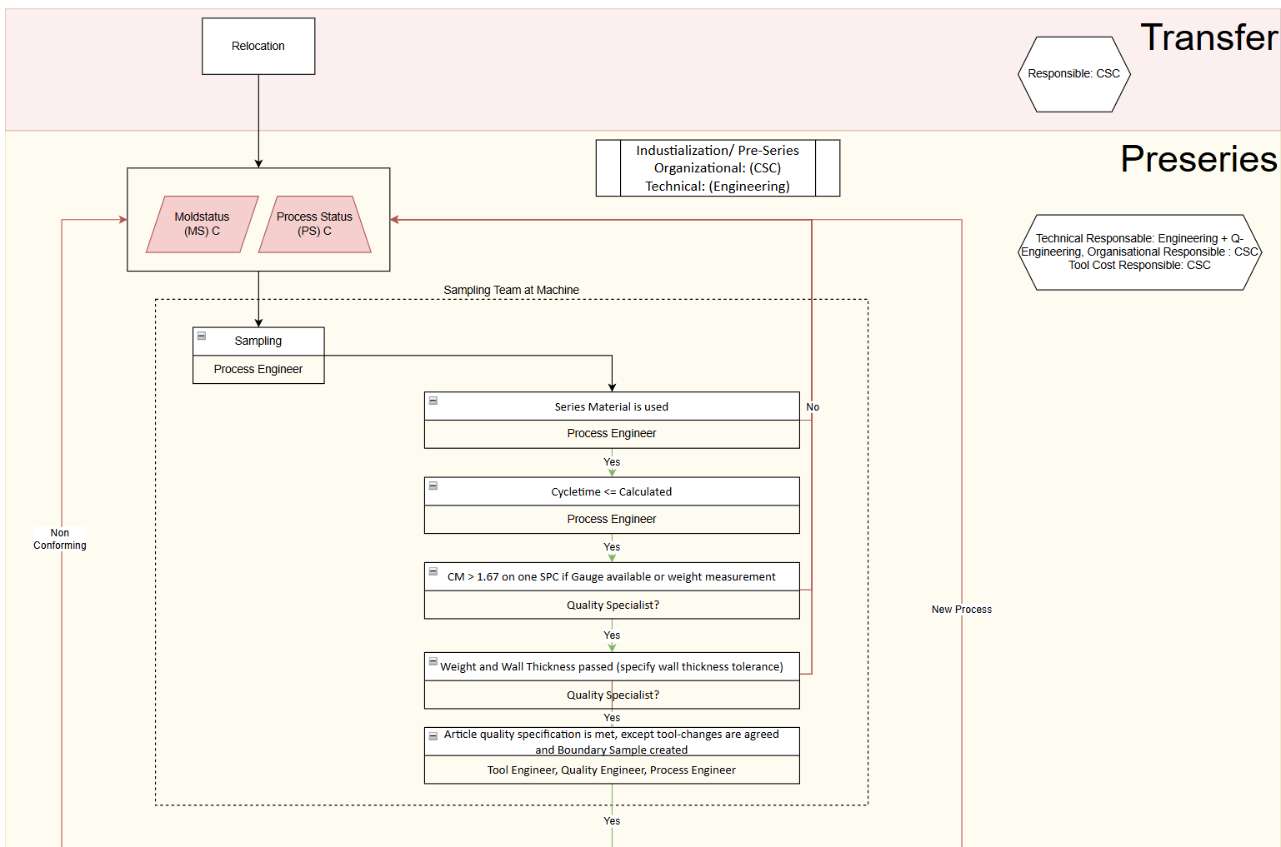
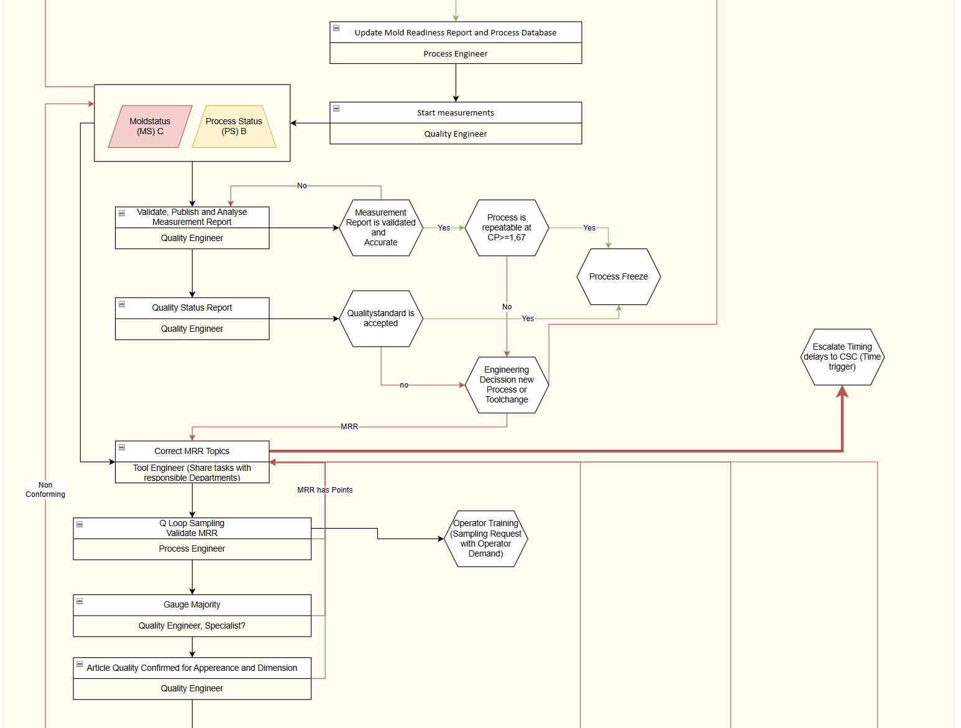
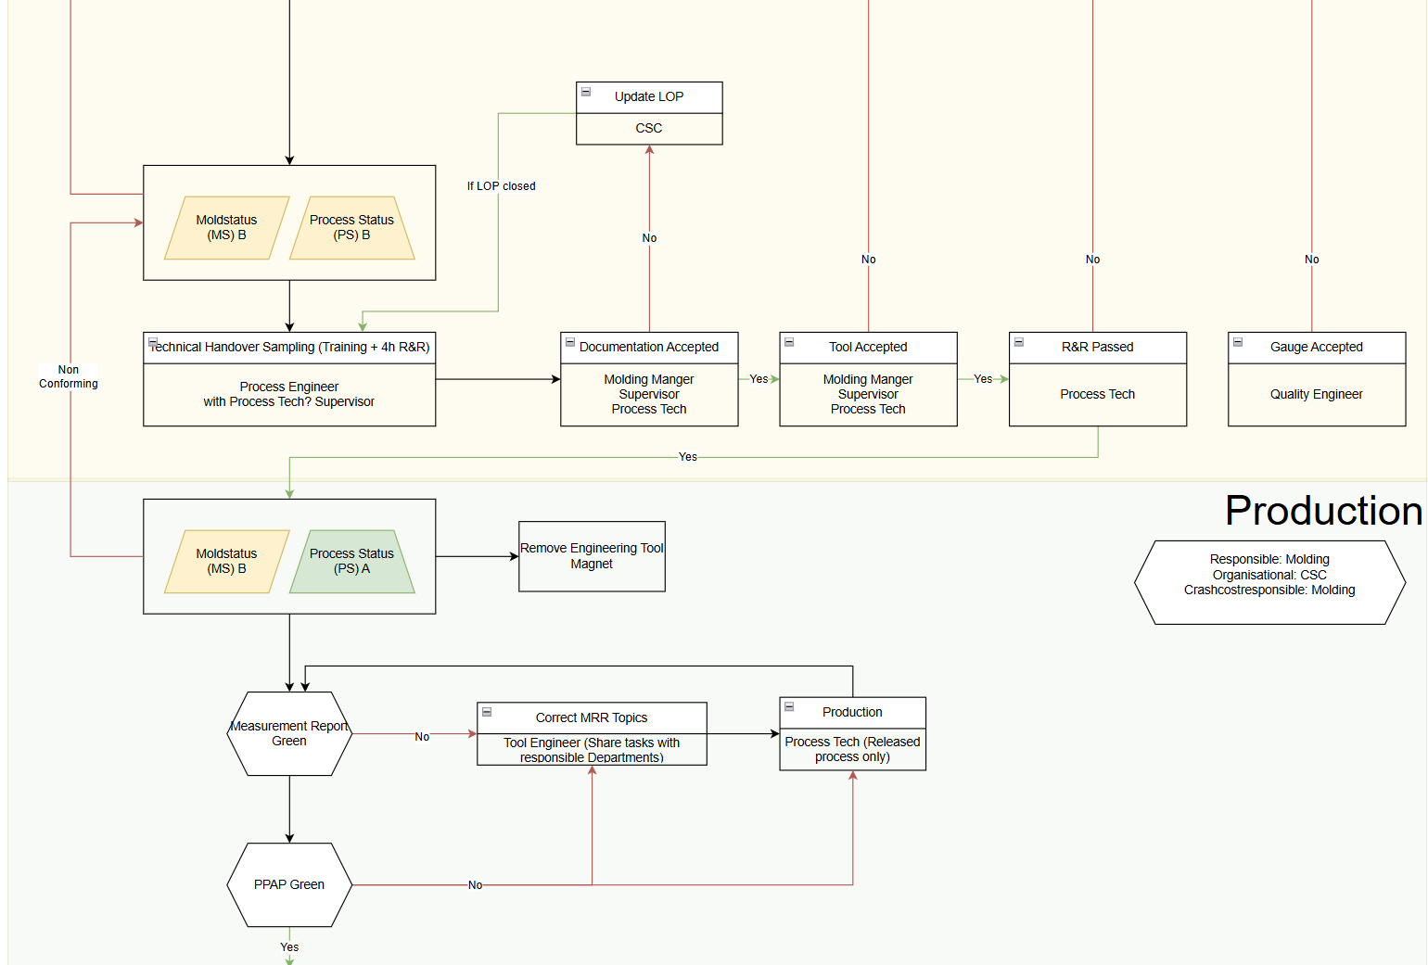
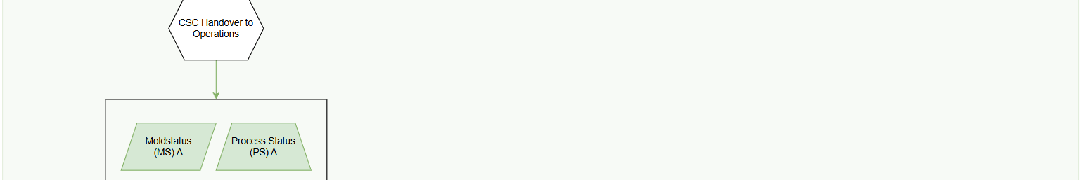
2. PDB (Process Database)
2.1. Location
https://ktxgroup.sharepoint.com/sites/USEngineering/


2.2. Access Levels

Following Access Levels are defined:

Position | Access Level
Admin | Full
Process Engineer (Process Owner) | Full
APQP | Work
Quality Eng | Work
Project Manager | View

Current Access Level can get reviewed on top of the scree. If Access Level is Empty, please consult the Admin.

Access Level description:

- Full:
  - Open and Close MRR Entries as Process Owner
  - Define Responsible departments and action
  - Upload Documents and files
- Work:
  - Define Responsible departments and action
  - Upload Documents and files
- View:
  - View Only
  - Upload Documents and files

2.3.1. Project MRR (Overall Project View)
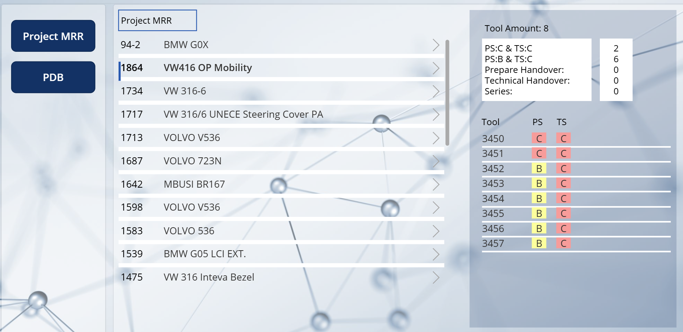
Select project for MRR Overview, will activate quick Overviw
Select to Navigate to detailed Project Overview
Select

2.3.2. Project MRR (Overall Project View)
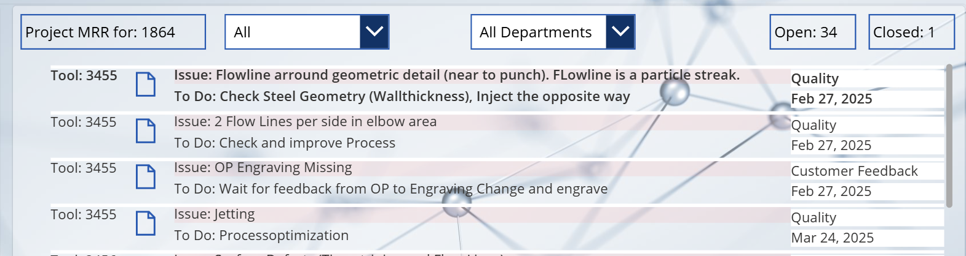

Filter open Topics per department
Filter to show open only or open and closed Topics (History)
Select to review uploaded documents
Responsible Department
Tool ID
Date issue was recorded,

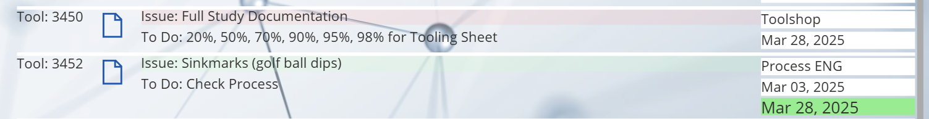
Red Entries are open topics, green entries are closed

If closed, closing date will show

Select Edit or View mode

2.4.1. PDB (Overview per tool, Access Rights for Full and Work)

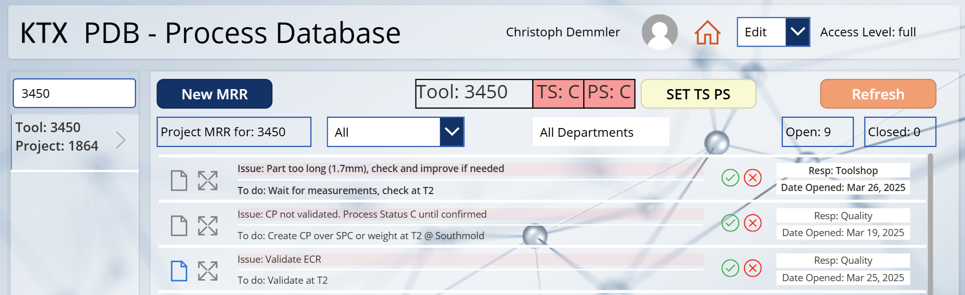
Process Engineer only: Create new MRR

Process Engineer only: Set TS/PS
Show or enter History
Upload Documents

Search equipment and select via triangle button
Process Engineer only: Delete or close MRR topics

2.4.2. MRR History Log (Work and Full access)

As soon as a task was completed a new entry can get submitted. Therefore, the next process owner needs to get defines. This serves as a history sheet on which actions got performed and what the next steps are. This helps the Process Engineer as main Process owner to identify needed or missed steps.
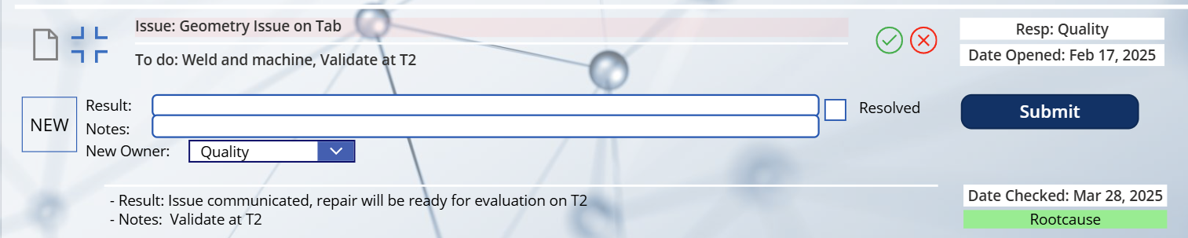
History Log
For new entries Define Result, Issue and new Owner. If the topic was resolved, click resolved button.

Revision History

Revision Date | Revision Level | Revision Detail

