静态代码定时检查
hudson、ant、sonar 安装使用

1.安装过程，测试人员可忽略该过程
安装hudson 选择安装的插件 hudson subversion post building
配置ant :
给bin下的文件授权：chmod +x *.int
安装sonar:配置数据库连接

2.Hudson设置：
- 访问地址：http://192.168.44.31:8080/hudson
- 进入系统管理-系统设置
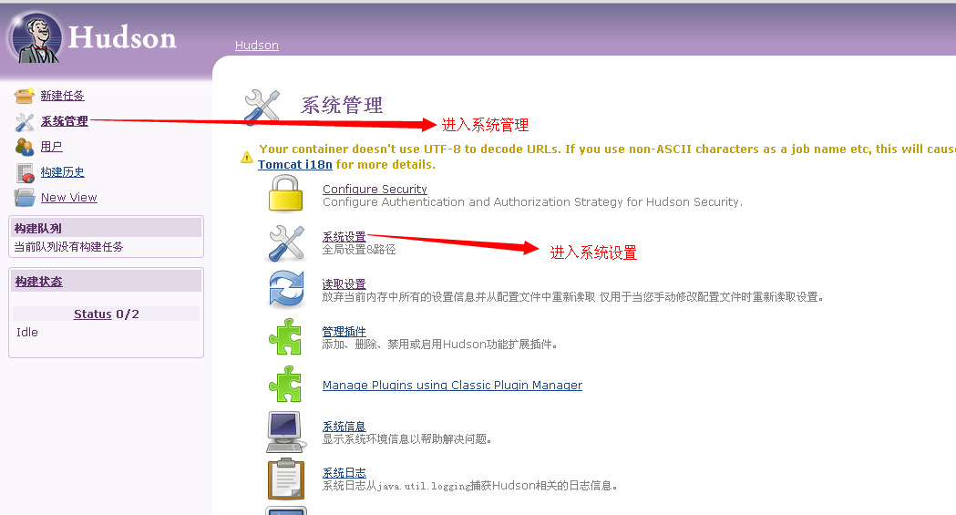
- 配置ant：
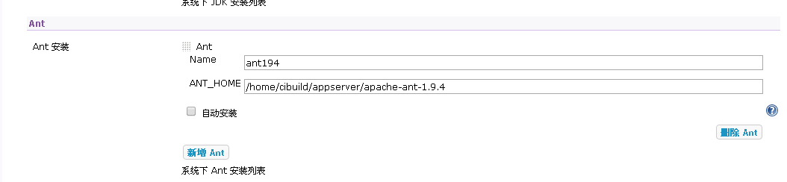
- 配置svn:
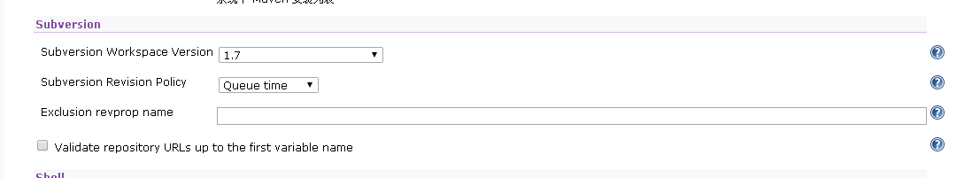
- 配置安全：

3.配置hudson任务：
- 创建一个新的任务：
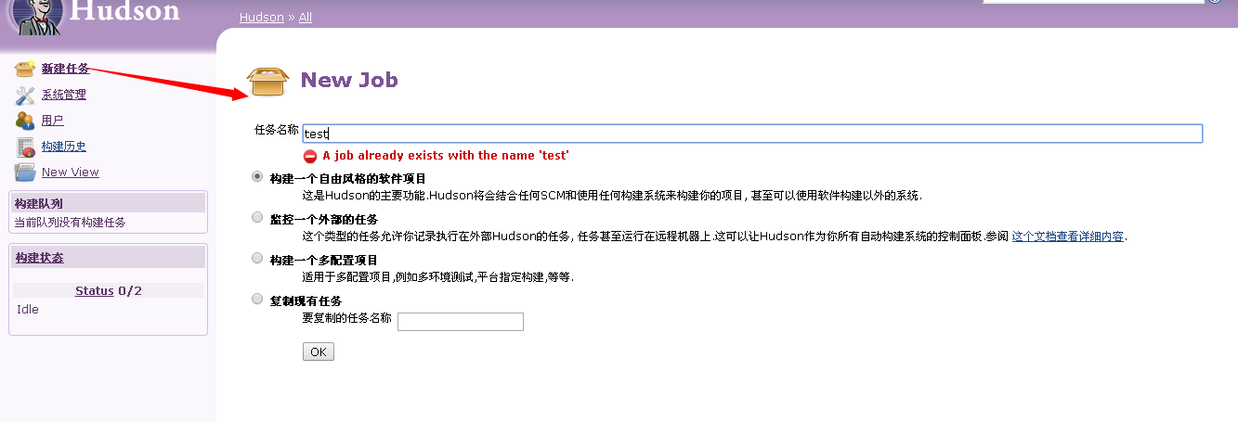
- 配置svn地址：
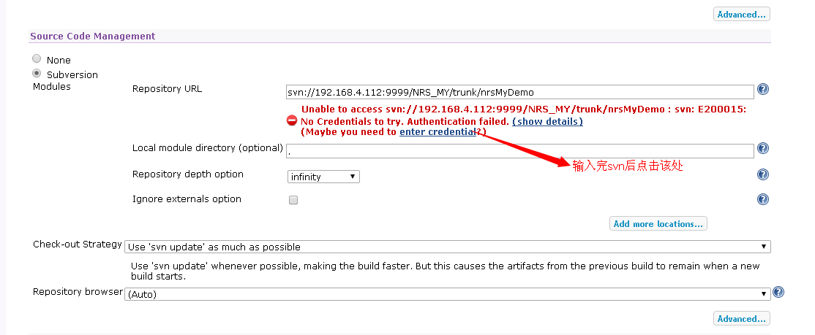
- 配置svn用户名密码：
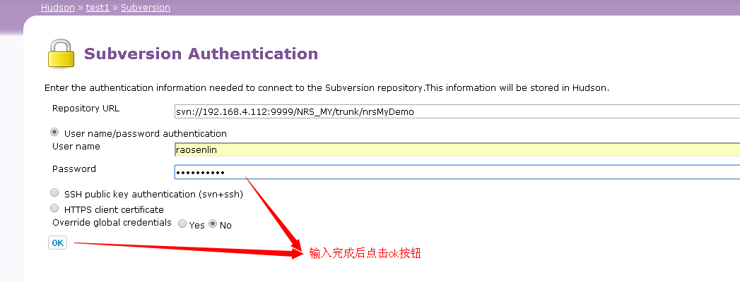
- 选择ant编译：
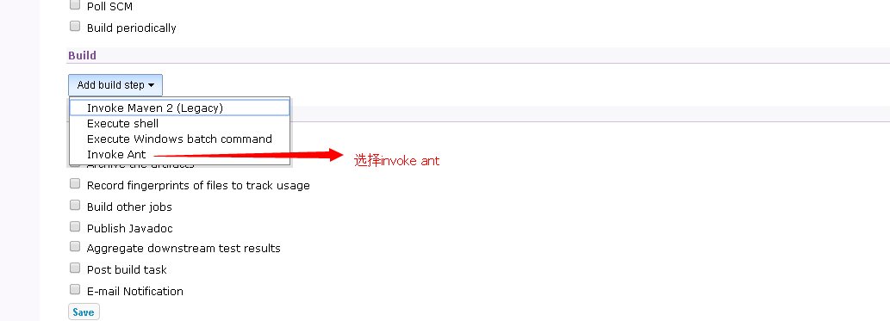
- 配置编译：
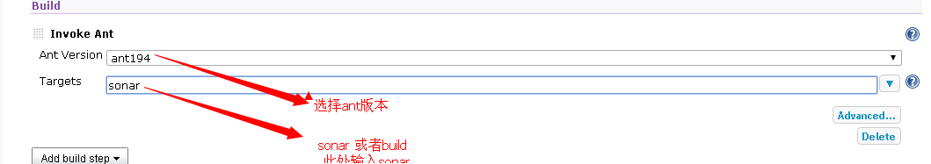
- 配置定时任务：
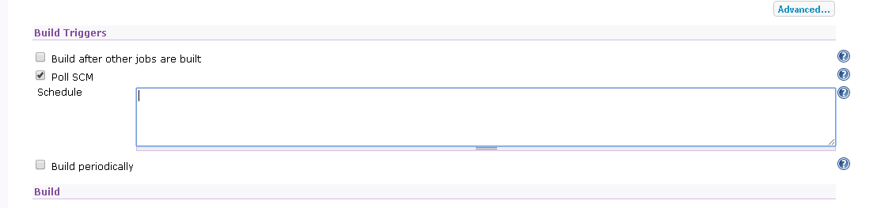

4.Sonar使用：
- 访问地址http://192.168.44.31:9000
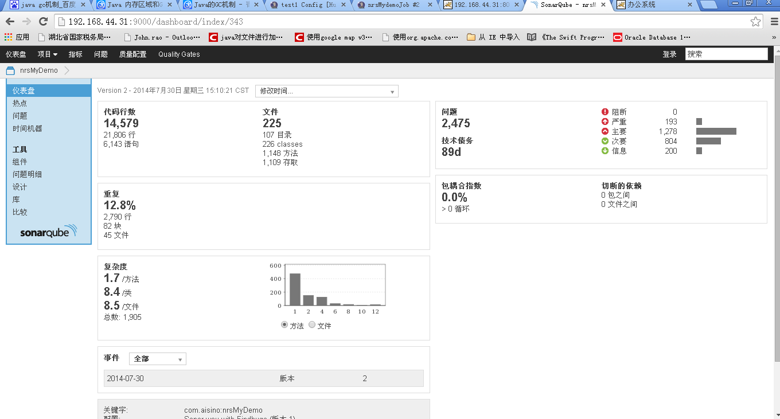
- 配置路径：
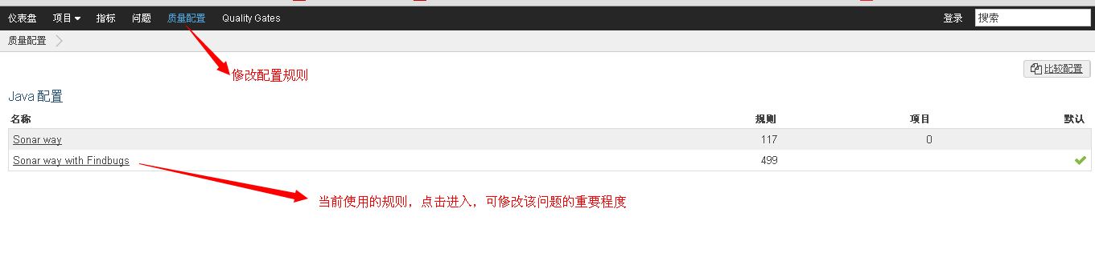

5.编写ant脚本（需要放置到工程下）
- Build.xml
<?xml version="1.0" encoding="UTF-8"?>
<project name="syzkmispro" basedir="." default="sonar" xmlns:sonar="antlib:org.sonar.ant">
<!--把参数写在build.properties中-->
<property file="build.properties"/>
<taskdef uri="antlib:org.sonar.ant" resource="org/sonar/ant/antlib.xml">
<classpath path="${j2ee.dir}/sonar-ant-task-2.2.jar"/>
</taskdef>

<path id="classpath">
<fileset dir="${lib.dir}">
<include name="**/*.jar"/>
</fileset>

<fileset dir="${j2ee.dir}">
<include name="**/*.jar"/>
</fileset>
</path>

<patternset id="available_file">
<include name="**/*.xml"/>
<include name="**/*.properties"/>
<include name="**/*.jsp"/>
<include name="**/*.js"/>
<include name="**/*.css"/>
<include name="**/*.jpg"/>
<include name="**/*.ico"/>
<include name="**/*.swf"/>
<include name="**/*.png"/>
<include name="**/*.gif"/>
<include name="**/*.bmp"/>
<include name="**/*.class"/>
<include name="**/*.tld"/>
<include name="**/*.html"/>
<include name="**/*.dtd"/>
<include name="**/*.jar"/>
<include name="**/*.xls"/>
<!--exclude name="**/validation-api-1.0.0.GA.jar"/>
<exclude name="**/jboss-logging-3.1.1.GA.jar"/>
<exclude name="**/jsoup-1.7.2.jar"/>
<exclude name="**/jstl-1.2.jar"/>
<exclude name="**/jta-1.1.jar"/>
<exclude name="**/spring*.jar"/>
<exclude name="**/ojdbc*.jar"/>
<exclude name="**/velocity*.jar"/>
<exclude name="**/hibernate-validator-4.3.1.Final.jar"/>
<exclude name="**/hibernate-validator-annotation-processor-4.3.1.Final.jar"/-->
</patternset>

<target name="init">
<tstamp>
<format property="today" pattern="yyyy-MM-dd hh:mm:ss"/>
</tstamp>
<echo message="${today}"/>
</target>

<target name="prepare" depends="init">
<delete dir="${classes.dir}"/>
<delete dir="${build.dir}"/>
<delete dir="${deploy.dir}"/>
<mkdir dir="${classes.dir}"/>
<mkdir dir="${web.lib.dir}"/>
<mkdir dir="${build.dir}"/>
<mkdir dir="${deploy.dir}"/>
</target>

<target name="compile" depends="prepare">
<javac srcdir="${src-project.dir}:${etc-project.dir}"
destdir="${classes.dir}"
debug="${debug}"
optimize="${optimize}"
deprecation="${deprecation}"
executable="${jdk.home}/bin/javac"
fork="${folk}"
encoding="${encoding}"
source="${version}"
failonerror="false"
>
<classpath>
<path refid="classpath"/>
</classpath>
<compilerarg line="${compiler.args}"/>
<include name="**/*.java"/>
</javac>
<copy todir="${classes.dir}">
<fileset dir="${src-project.dir}">
<patternset refid="available_file"/>
</fileset>
<fileset dir="${etc-project.dir}">
<patternset refid="available_file"/>
</fileset>
</copy>
</target>

<target name="build" depends="compile">
<tstamp/>
<jar jarfile="${deploy.dir}/${project.name}.war" basedir="${build.dir}"/>
</target>

<target name="sonar" depends="build">
<property name="sonar.sources" value="src"/>
<property name="sonar.jdbc.url"
value="jdbc:mysql://192.168.44.31:3306/sonardb?useUnicode=true&amp;characterEncoding=utf8"/>
<property name="sonar.jdbc.driverClassName" value="com.mysql.jdbc.Driver"/>
<property name="sonar.jdbc.username" value="sonardba"/>
<property name="sonar.jdbc.password" value="sonardba"/>
<property name="sonar.login" value="admin"/>
<property name="sonar.password" value="admin"/>
<property name="sonar.sourceEncoding" value="${encoding}"/>
<property name="sonar.host.url" value="http://192.168.44.31:9000"/>
<property name="sonar.projectName" value="${project.name}"/>

<property name="sonar.projectKey" value="com.aisino:${project.name}"/>
<property name="sonar.projectVersion" value="2"/>
<property name="sonar.binaries" value="${classes.dir}"/>
<property name="sonar.java.source" value="${version}"/>

<sonar:sonar/>

<delete dir="${classes.dir}"/>
<delete dir="${build.dir}"/>
</target>
</project>

- Build.properties

# The project name and version will be combined to name the jar file.
project.name = mlxydemo
project.version = 2.0

# Where source files are found
project.dir = ./
src-project.dir = ${project.dir}/src/main/java
etc-project.dir = ${project.dir}/src/main/resources

#build options.
build.dir = ${project.dir}/build

#deploy options.
deploy.dir = ${project.dir}/deploy

#web options.
web.dir = ${project.dir}/src/main/webapp

# Where jar files are found. Each jar to be included in the
# classpath should be explicitly listed in the dep.list file.
lib.dir = ${project.dir}/target/office-0.0.1-SNAPSHOT/WEB-INF/lib

# Intermediate directory for building class files.
classes.dir = ${project.dir}/target/office-0.0.1-SNAPSHOT/WEB-INF/classes
web.lib.dir = ${project.dir}/target/office-0.0.1-SNAPSHOT/WEB-INF/lib
#defin yuicompressor
#js.build.dir=${web.dir}/staticmedia/scripts/customer
#js-min.dir= ${build.dir}/staticmedia/scripts/customer

#window
#j2ee.dir =E:/worksp/buildlib

#linux
j2ee.dir =/usr/local/appserver/buildlib

#google.jscompiler=/usr/local/appserver/buildlib/compiler.jar

#window
#google.jscompiler=D:\\devhome\\Google\\compiler\\compiler.jar

# Compiler options.
# *********** modify jdk.home for your setting **************
#window
#jdk.home =D:\\devhome\\oracle\\oracle\\Java\\jdk1.7.0_10
#linux
#jdk.home=/usr/java/default

#jdk 7
jdk.home=/usr/local/ssici/java/jdk1.7.0_09/
compiler.args =
debug = on
optimize = on
deprecation = off
packagename = com.aisino
encoding = UTF-8
folk = true
version = 1.6

# Javadoc options.

javadoc.author = true
javadoc.private = true
javadoc.use = true
javadoc.version = true

