1 引言

1.1 编写目的
帮助新进入项目开发者快速了解系统结构，便于开发。

1.2 背景
RTFM 暂无官方技术文档

1.3 定义
srs基础bean，srsw页面servlet、util工具类，srsa安卓客户端(srsa所需要的server端srsp已经整合到srsw里面)。Common包含工程所需的各种第三方的jar包。Util为工具包。

1.4 参考资料
Aramark wiki:
https://alm.aramark.eu/redmine/projects/3ed700ae-593c-4b62-aee0-14075dd53eb6/wiki
本地help文档包/srshelp. URL：http://10.10.2.231:8080/srshelp/admin/Real_Time_FM.htm

2 程序系统的结构
2.1 SRSW web结构：com.spokesoft.http.servlet 下面是大部分页面对应的servlet类，通过注解方式设置servlet-mapping，大部分页面的url都通过(Navigator)数字自增格式生成的url后缀来对应到servlet中 (com.spokesoft.http.navigator.Navigator.Context.options<String, Command>)，例如：
http://localhost:8080/srs/Dispatcher?nvcm=RootContext_23。
2.1.1每个页面对应一个Servlet，多数采用注解方式声明name呵mapping，主要是：
@web:servlet name="DisplayAttachment" display-name="DisplayAttachment"
@web:servlet-mapping url-pattern="/DisplayAttachment"
部分独立的页面采用xml配置方式srs/xdoclet/servlet.xml&servlet-mappings.xml ，Build之后自动合成标准的web工程web.xml配置文件。
主页面的menu对应com.spokesoft.http.menu下面MenuTree.java,各个一级链接(有icon图标的)以“MenuItem”结尾，例如：SearchTaskMenuItem。
MenuItem对应的首页的一级标签，例如：SearchTaskMenuItem是搜索Task的一级链接。
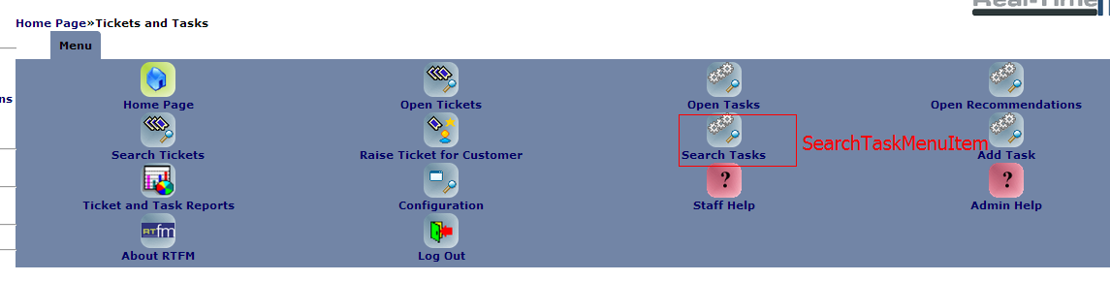
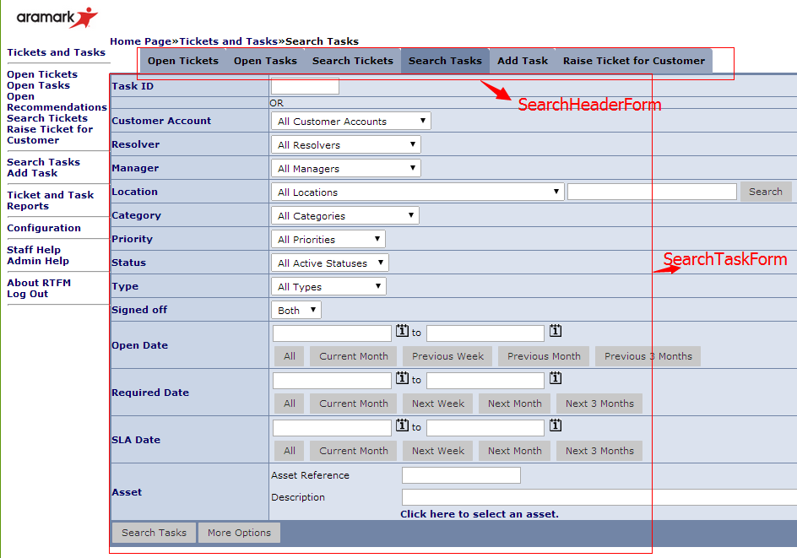
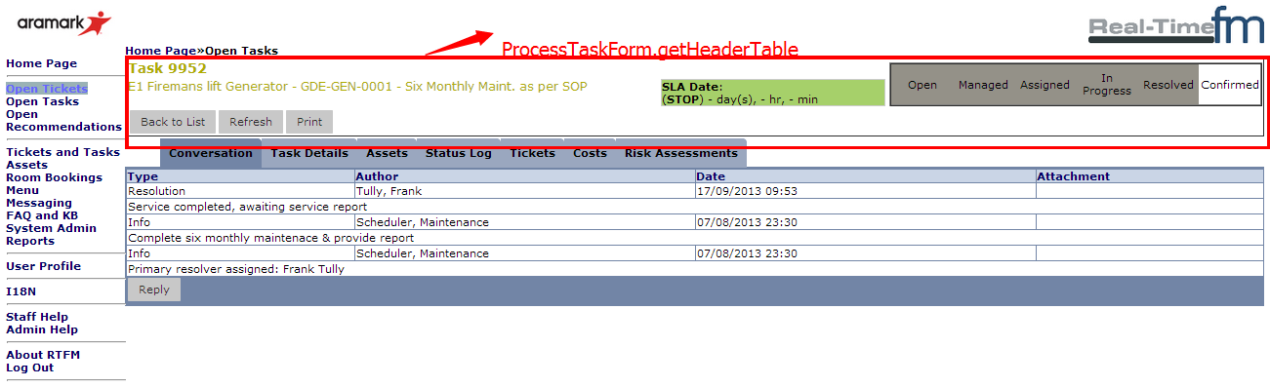
SearchTaskMenuItem
|-MenuCommand：构成子页面，mode表示进入后的初始化方法。
|-SearchHeaderForm
|-getTabList ：Tab标签头的初始化
|-SearchTaskForm
|-doSecurityCheck：权限验证
|-printContent：以apache的ecs标签填充页面
|-TaskResultsForm:搜索结果页面
|-doAfterSelect：点击页面链接后的动作(Command负责点击后跳转到的目的servlet)
ProcessTaskForm：List列表数据向详细信息页面的中转页面
|-getHeaderTable：页面Header标签
|-getTabList: 标签头

TaskListModel(Extends ListModel)
|-executeSearch: 执行getModelIdentifier(), fillList(), sort()
|-initFields: 根据TaskGraph提供的资源初始化Task查询结果Table列。
|-getComparator: 排序规则
|-fillList: 执行查询,->TaskListView遍历查询结果->TaskGraph初始化列名等相关资源
|-doListOpenTasks: 执行其他地方条转过来的Command。其他地方url跳转过来的Command将先执行Command.getMode()
例：TabCommand openTasks = new TabCommand(SearchHeaderForm.SERVLET_NAME, TaskResultsForm.SERVLET_NAME, "doListOpenTasks");

Tab类的Form多数继承自StandardMainForm(加载js、css、logo等初始化工作)
表单的Form类多数继承自TabServlet(定义了一些动作ModeManager对应的方法)
*ResultsForm对应Search之类的查询结果页面form。

2.2 报表设计相关：
2.2.1报表的模板文件都在srsr工程下面，与资源文件的对应关系在reports表里面体现。
SELECT DATA_SOURCE_CLASS_NAME， DESIGN_CLASS_NAME，FROM reports
其中DATA_SOURCE_CLASS_NAME表示资源文件，DESIGN_CLASS_NAME为模板文件。
2.2.2报表的设计流程为：1.创建DataRequest类(如PMManagementDataExtractDR)，初始化需要用到的数据库表字段(field)，以及页面筛选字段的确定；2.创建Datasource类，负责与模板的关联，及对数据库查询结果数据的二次加工(添加字段、排序等等)。3.添加关联关系到reports表，Add relationship to table reports, such as:
INSERT INTO reports ( ORG, KEY_ID, LASTUPDATED, VERSION, NAME, DESCRIPTION, REPORT_GROUP, OUTPUT_FILE_NAME, DESIGN_CLASS_NAME, DATA_SOURCE_CLASS_NAME, ACTIVE, CAN_PDF, CAN_CSV, CAN_HTML, IS_EDIT_LOCKED, ROLES, IS_ROLES_LOGIC_OR)
VALUES ( 'aspdefault', 5426, '2014-07-28 08:08:08', 1, 'Reactive maintenance management', 'Reactive maintenance management data extract(XLS)', 'Monthly Reporting', 'ReactiveMaintenanceManagementDataExtract', 'com/spokesoft/jasper/ReactiveMManagementDataExtract.jasper', 'com.spokesoft.reporting.datasources.task.ReactiveMaintenanceManagementDataExtractJRDS', 1, 0, 1, 0, 1, '1', 1);
“ORG=’aspdefault’” means that the report model and datasource can be used by all orgs。
2.2.4 *DR.java注释：
|-setupFields:1.添加数据库要查询出来的字段，add之后的fields如果不进行joinField则默认是sourceTable的字段，如果是join表的字段则需要joinField设置，如果没有override父类的方法，则默认为父类的DataRequestField。
|-setupRelationships 1.1当setupFields中add的field不是当前DR父类中字段时，则需要joinField添加关联关系表。
|-setupParameters：2.设置页面要filters的字段参数，只有addField的字段(setupFields或父类setupFields中添加的DataRequestFields)才可以link,link后才可以在页面展示，展示顺序由Collections.sort(displayParameters, DataRequestParameterComparators.BY_PARAMETERLABEL)决定。下拉框的筛选条件在Parameters对应的*DRP.java中设置。最终由遍历DataRequestParameter生成Form页面。
|-setupSorting: 设置排序字段
*JRDS.java 注意父类SrsJRDataSource2.prepareData里面方法的顺序
:loadData()查询数据;processData()加工数据;sort()排序;
|-initialiseDataRequest() 初始化DR，变相的初始化查询sql。
|-processData() 对数据库查询出来的数据进行二次加工。
|-sort() 对process之后的数据排序
2.2.5 Jrxml开发步骤：1.用iReport设计软件打开jrxml源文件，可视化编辑jrxml。编辑完成后拷贝jrxml源文件到工程对应的文件里，编译验证。2.类DataRequestField初始化参数(fieldClass, tableFieldName, labelName)，TableFieldName是数据库表的真是列名,labelName是自定义的别名(页面Parameter展示采用labelName)，jrxml里面field利用DataRequestField关联的drFieldName取值。3.生成report测试。4.jrxml的field定义和drFieldName一一对应，用$F{fieldName}取值,variable是自定义变量，用$V{variableName}取值。
2.2.5 ReportUtilities 负责生成报表文档。GeneralSqlVisitor负责拼接sql脚本，joinFild的Relationships保存在TreeSet里面，并按照table的别名进行排序，与joinField顺序无关。
2.2.6 JasperReporterForm.java 为filter页面Form。通过遍历DataRequestParameter展示Report所需Parameters。
2.3 Single jsp page adding.
- Add jsp page to srsw\webfiles\.
- It’s a better idea to create a servlet class in dirctory ‘srsw\com.spokesoft.http.servlet’ and extends HttpServlet.
- Add router relationship to ‘srsw\xdoclet\servlets.xml&servlet-mappings.xml’.
3. Linxu常用命令：
- RTFM测试服务器(Ubuntu Server Edition)地址:10.10.2.231,User:administrator, pwd:Aa123456, Port:22.
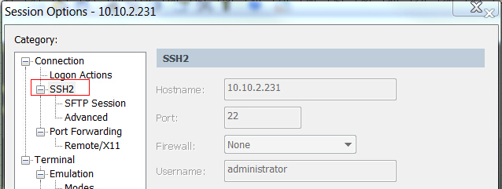

- 打开SFTP界面，设置SFTP Session Options,进行文件传输：
put fileName：上传文件
pwd: 查看当前sftp位置(第一次设置完sftp session需重新打开标签，设置才能生效)
lpwd：查看远程sftp位置
包命名规则：spk-srs_主版本号5.2.Team版本01_b/a/rc.内部版本00.ear,可参考 ll ./temp/ 最后一个包名递增。
如：spk-srs_5.4.02b08.ear ：5.4为主版本号，02为team版本号，a:alpha版(发到本地231测试的版本)，b:beta版(发布到QA、UAT环境的版本)，rc：
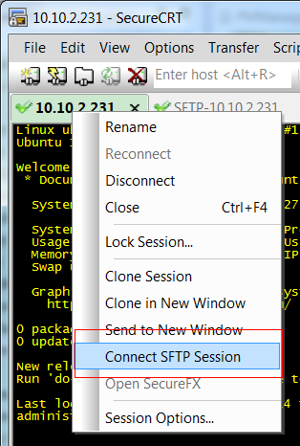
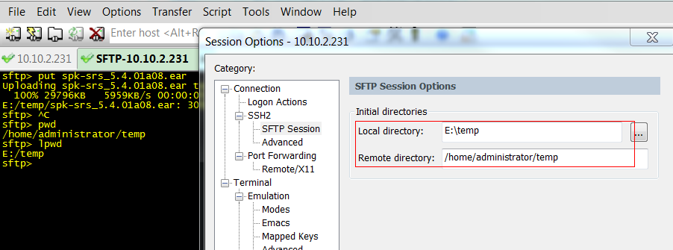
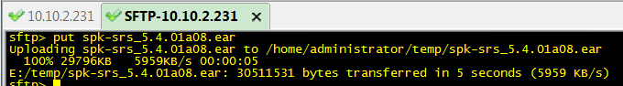
(从Linux往本地下载文件命令为：get fileName)
- 拷贝文件到服务器目录：
cp ./temp/spk-srs_5.4.01a08.ear ./soft/jboss/server/default/deploy/spk-srs.ear
- Jboss默认热部署(cp完最新的包到deploy下等待约3分钟热启动即可完成)，无需重启。如需重启需要以下命令：
关闭：./soft/jboss/bin/shutdown.sh -S 关闭之后用ps -ef|grep jboss确认jboss是否依然在运行(关闭需要一定的时间，如果刚刚部署了新的ear包，jboss会启动热部署，此时用shutdown命令关闭会有一定的延时)，并跟踪jboss日志，确定日志里面已成功关闭后再用ps命令查看是否进程还在运行，如果等待时间超过3分钟jboss进程还在运行，可以考虑kill processID(必要的时候kill -9 processID) 干掉它。
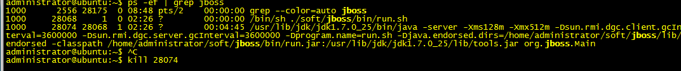
启动：./soft/jboss/bin/run.sh &，&符号使run.sh可作为后台服务运行，避免ssh客户端关闭后进程被杀，如果关闭ssh客户端后发现进程依旧停止了，可以考虑用exit安全命令退出ssh客户端。
- 跟踪日志： tail -f ./soft/jboss/server/default/log/server.log
- 部署完成后自己先去231检验最新的更改是否已经生效，确定无误后通知QA测试验收。
4.Release ear package to QA/UAT:
4.1 Synchronize with repository to get the latest codes.
4.2 Build ear package by ant.
4.3 Name the package following the naming standord.
4.4 Check the QA/UAT address according to ‘RealTime-FM_MobileGateway_EDC_Map.pdf’.(user:adm-orchestrall pwd:80qvnqz7)
4.5 Put the package to UAT server(Current address is 161.195.143.78) through sftp.
4.6 (RTFM_DEV_Environment_Guide_20141110Updated.docx -- Menu 4.Database upgrade utility) Update database when necessary. Add current build version to ‘com.spokesoft.dbupgrade.UpgradeFactory.createUpgrade’. Before building dbutil\build.xml, it’s better to comment ‘srsw\com.spokesoft.http.servlet.label.MessageHelper line68~73’ and build srs\projectbuild.xml. The ant configuration file still is ‘/srs/build-4.7.0.properties’;
4.6.1 Create new upgrade class to meet the current version of ‘/srs/build-4.7.0.properties.$product.version’ (Upgrade550.java, Upgrade540.java etc...) . Add matching switch case to UpgradeFactory.createUpgrade().
If there’s upgrading of table structure, the function should be added to ‘dbutil\webfiles\resources\schema.csv’. Other function such as adding or updating data locate ‘dbutil\webfiles\resources\’ sub directories.
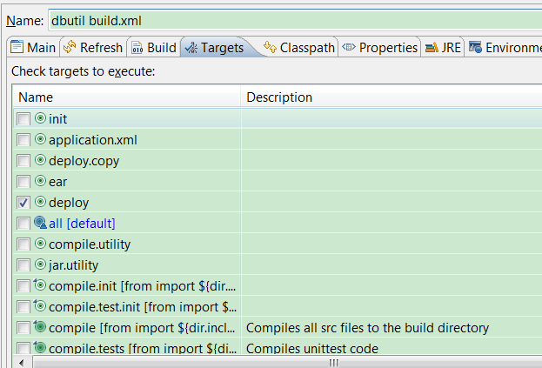
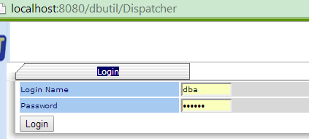 dba/spokey
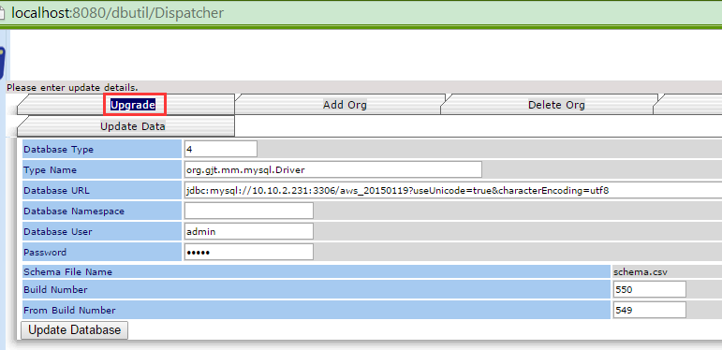
Database Type:Reference to ‘DBUpgradeUtilFactory.java’, 4 means mysql. Build Number: The current build number. From Build Number: The build number strating from.
4.7.1 After copy the ear package to the directory’/opt/jboss/server/default/deploy/’, tail the log of jboss(tail -f /opt/jboss/server/default/log/server.log) until the ‘Started in XXXs’ was printed. Restart jboss if necessary(sudo service jboss restart/stop/start).
4.7.2 Remote copy the ear package from UAT to QA server
(sudo scp ~/temp/spk-srs_5.4.08b09.ear adm-orchestrall@BEMAC0RFMAPPQ1:/home/adm-orchestrall/temp).
Connect to QA server by SSH(ssh adm-orchestrall@172.25.18.33 OR ssh adm-orchestrall@BEMAC0RFMAPPQ1). Repeat step 4.7.1 on QA server.

5.Taskman
5.1 Taskman synchronize with RTFM by ‘com.spokesoft.mobile.android.srsa.amg.SyncService.onPerformSync()’, and convert task list to local database format by
‘convertTSynchTaskToModelTask’.

5.2 RTFM receive data from taskman by ‘TSynchOperationServlet’ and process command from taskman by ‘DeviceOperationHandler.handleTSynchRequest()’;
6. Jboss Email Server Configuration
6.1 EmailManagerBean.java InboxMonitorBean.java OutboxMonitorBean.java All of three class reference “MailResource”, the configuratiron like this: “
* @ejb:resource-ref res-name="MailResource" res-type="javax.mail.Session"
* res-auth="Container"
* @jboss:resource-manager res-man-class="javax.mail.Session"
* res-man-name="MailResource"
* res-man-jndi-name="java:/MailResource"
”
The jboss mail configuration file locate “JBOSS_HOME/server/default/deploy/mail-service.xml”. When jboss started ,the “MailResource” would be bound, so the MailBean can lookup the “MailResource”.
Following is gmail server configuration:
<?xml version="1.0" encoding="UTF-8"?>
<!DOCTYPE server>
<!-- $Id: mail-service.xml,v 1.5.6.1 2005/06/01 06:20:43 starksm Exp $ -->
<server>
<mbean code="org.jboss.mail.MailService"
name="jboss:service=Mail">
<attribute name="JNDIName">java:/MailResource</attribute>
<attribute name="User">vince.fengjiangtao@gmail.com</attribute>
<attribute name="Password">123Qwert</attribute>
<attribute name="Configuration">
<!-- Test -->
<configuration>
<!-- Change to your mail server prototocol -->
<property name="mail.store.protocol" value="pop3"/>
<property name="mail.transport.protocol" value="smtp"/>

<!-- Change to the user who will receive mail -->
<property name="mail.user" value="nobody"/>

<!-- Change to the mail server -->
<property name="mail.pop3.host" value="pop.gmail.com"/>

<!-- Change to the SMTP gateway server -->
<property name="mail.smtp.user" value="vince.fengjiangtao@gmail.com" />
<property name="mail.smtp.password" value="123Qwert" />
<property name="mail.smtp.host" value="smtp.gmail.com" />
<property name="mail.smtp.auth" value="true" />
<property name="mail.smtp.ssl.enable" value="true" />
<property name="mail.smtp.starttls.enable" value="true" />
<property name="mail.smtp.socketFactory.class" value="javax.net.ssl.SSLSocketFactory" />
<!-- The mail server port -->
<property name="mail.smtp.port" value="465" />

<!-- Change to the address mail will be from -->
<property name="mail.from" value="vince.fengjiangtao@gmail.com"/>

<!-- Enable debugging output from the javamail classes -->
<property name="mail.debug" value="false"/>
</configuration>
</attribute>
</mbean>
</server>
Sina email configuration:
<?xml version="1.0" encoding="UTF-8"?>
<!DOCTYPE server>
<!-- $Id: mail-service.xml,v 1.5.6.1 2005/06/01 06:20:43 starksm Exp $ -->
<server>
<mbean code="org.jboss.mail.MailService"
name="jboss:service=Mail">
<attribute name="JNDIName">java:/MailResource</attribute>
<attribute name="User">test_safesoft@sina.com</attribute>
<attribute name="Password">123Qwert</attribute>
<attribute name="Configuration">
<!-- Test -->
<configuration>
<!-- Change to your mail server prototocol -->
<property name="mail.store.protocol" value="pop3"/>
<property name="mail.transport.protocol" value="smtp"/>

<!-- Change to the user who will receive mail -->
<property name="mail.user" value="nobody"/>

<!-- Change to the mail server -->
<property name="mail.pop3.host" value="pop.sina.com"/>

<!-- Change to the SMTP gateway server -->
<property name="mail.smtp.user" value="test_safesoft@sina.com" />
<property name="mail.smtp.password" value="123Qwert" />
<property name="mail.smtp.host" value="smtp.sina.com" />
<property name="mail.smtp.auth" value="true" />

<!-- Change to the address mail will be from -->
<property name="mail.from" value="test_safesoft@sina.com"/>

<!-- Enable debugging output from the javamail classes -->
<property name="mail.debug" value="false"/>

</configuration>
</attribute>
</mbean>
</server>
Safesoft local Exchange server email configuration:
<server>
<mbean code="org.jboss.mail.MailService"
name="jboss:service=Mail">
<attribute name="JNDIName">java:/MailResource</attribute>
<attribute name="User">devtest@orchestrallinc.cn</attribute>
<attribute name="Password">Dev!test</attribute>
<attribute name="Configuration">
<!-- Test -->
<configuration>
<!-- Change to your mail server prototocol -->
<property name="mail.store.protocol" value="pop3"/>
<property name="mail.transport.protocol" value="smtp"/>

<!-- Change to the user who will receive mail -->
<property name="mail.user" value="nobody"/>

<!-- Change to the SMTP gateway server -->
<property name="mail.smtp.user" value="devtest@orchestrallinc.cn" />
<property name="mail.smtp.password" value="Dev!test" />
<!-- Microsoft Exchange server. -->
<property name="mail.smtp.host" value="edgeexc.ssicn.com" />
<property name="mail.smtp.auth" value="true" />

<!-- Change to the address mail will be from -->
<property name="mail.from" value="devtest@orchestrallinc.cn"/>

<!-- Enable debugging output from the javamail classes -->
<property name="mail.debug" value="true"/>

</configuration>
</attribute>
</mbean>

</server>

7.Planned maintenance scheduler automation & manual. (SchedulerDelegate implements org.quartz.Job and CreateOrgUtil set the job configuration )
SchedulerManagerBean.processRule search scheduleRules by org and active. The job was started by ‘ServiceManager.initServices()’
8.CI
Reference: http://jenkins-ci.org/
Local CI: http://10.10.2.231:8080/jenkins/
Local CI was deployed at “jboss/server/default/deploy/jenkins.war”.
User local repository: “.savant_repository/”(Contains all needed jars as local.)
Main configuration:
- Source Control(源码管理): CVS
- CVSROOT::extssh:lqin@alm.aramark.eu:/var/cvsroot/
2.1 √This Connection Requires A Password
Pasword: m2ryb6u6
2.2Location: Head(Default)
2.3Modules(All needed modules)
2.3.1 Remote Name: dbutil
2.3.2 Remote Name: util
2.3.3 Remote Name: srs
2.3.4 Remote Name: srsa
2.3.5 Remote Name: srsa-shared
2.3.6 Remote Name: httptest
2.3.7 Remote Name: srsi-shared
2.3.8 Remote Name: srsw
2.3.9 Remote Name: srsr
2.4Use Update: √
2.5Prune Empty Directories: X
2.6Legacy Mode: √
2.7Skip Changelog: √
2.8Show all CVS output: √
2.9Perform clean checkout on failed update: X
2.10Force Clean copy for locally modified files: X
The following “Building trigger(构建触发器)” and “Configuration Matris” was not set at present.
- Build(构建)
3.1Execute shell
Command: ant -d -v -l /home/administrator/log/ant/ant.log -f /home/administrator/.jenkins/jobs/RTFM00/workspace/srs/projectBuild.xml -Dbuild.properties=/home/administrator/devel/build/build.properties
- Save
- Build now.
Press “Build now” to build the project manually.

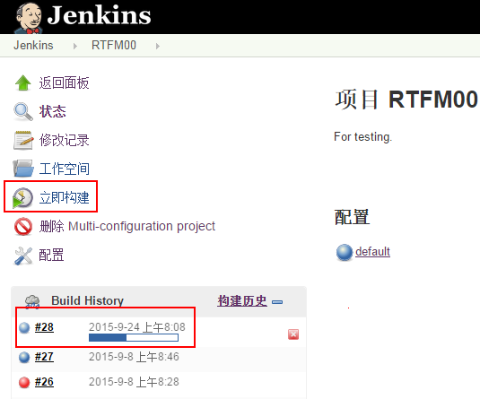
The configuration details are as follow print screens.

新增/配置item
