# 1201 物资采购有余额

发现有发票未进入存货核算

select

--a.cPBVCode,c.cCode ,a.dSDate ,a.dPBVDate , b.id,c.autoid ,b.cInvCode

-- ,b.iOriMoney,c.iPrice,ia.iAInPrice

sum(b.iOriMoney) as iOriMoney,sum(c.iPrice) as iPrice,sum(ia.iAInPrice) as iAInPrice

--,ia.*

from PurBillVouch a inner join PurBillVouchs b on a.pbvid = b.pbvid

inner join (

select b.autoid,iPrice ,a.cCode,b.iQuantity

from RdRecord01 a inner join rdrecords01 b on a.id = b.id

where cBusType = '普通采购'

--and a.dDate >= '2017-01-01' and a.dDate < '2017-02-01' -- 本月到票

and a.dDate < '2017-01-01' -- 蓝字回冲

)c on b.RdsID = c.autoid

left join (

select * from Ia_Subsidiary ia

where ia.iyear = 2017 and ia.imonth = 1 and ia.cBusType = '普通采购'

--and ia.cPZdigest = '采购本月到票'

) ia on c.autoid = ia.id

where a.cBusType = '普通采购'

and a.dPBVDate >= '2017-01-01' and a.dPBVDate < '2017-02-01'

--and b.iOriMoney <> isnull(ia.iAInPrice,0)

and a.cPBVCode in ('00037069/70','PSI170100004','00381629')

select (a.iAInPrice) as iAInPrice,(rds.iPrice) as iPrice

from Ia_Subsidiary a

left join rdrecords01 rds on a.id = rds.autoid

where a.iyear = 2017 and a.imonth = 1

and a.cBusType = '普通采购'

and a.cPZdigest = '蓝字回冲单'

and a.iAInPrice <> rds.iPrice

select ID

from PurBillVouch a inner join PurBillVouchs b on a.pbvid = b.pbvid

# 125101材料费与委外材料余额表不一致

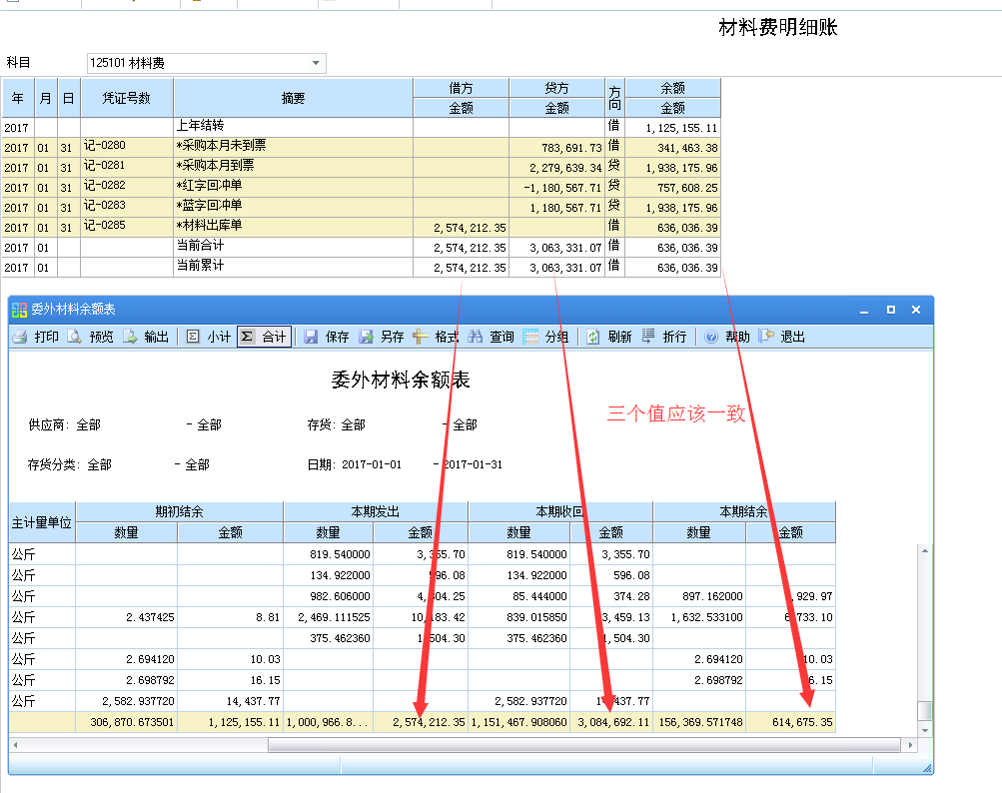

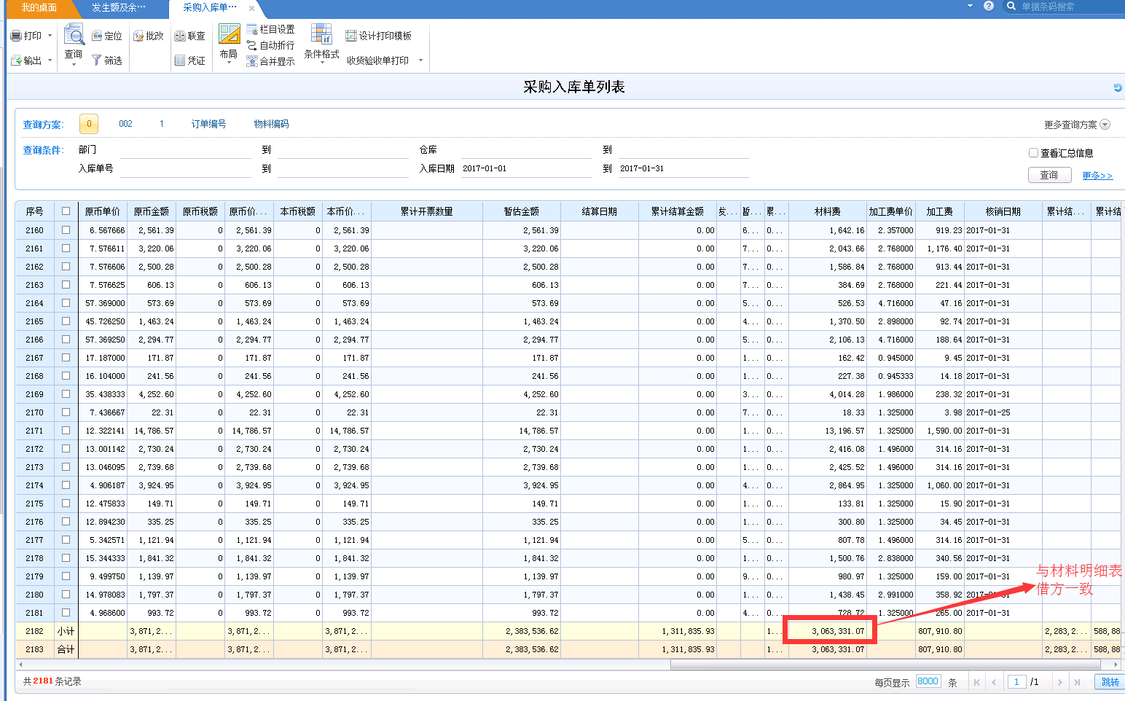

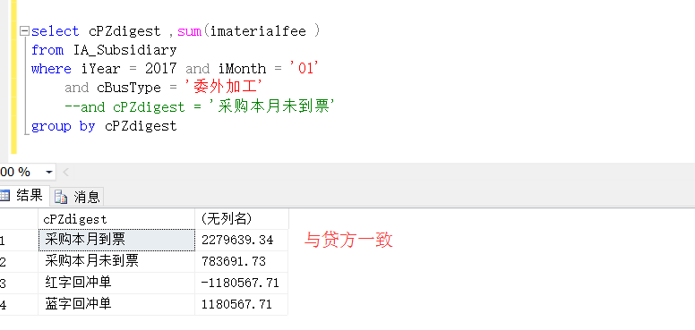

select cPZdigest ,sum(imaterialfee )

from IA_Subsidiary

where iYear = 2017 and iMonth = '01'

and cBusType = '委外加工'

--and cPZdigest = '采购本月未到票'

group by cPZdigest

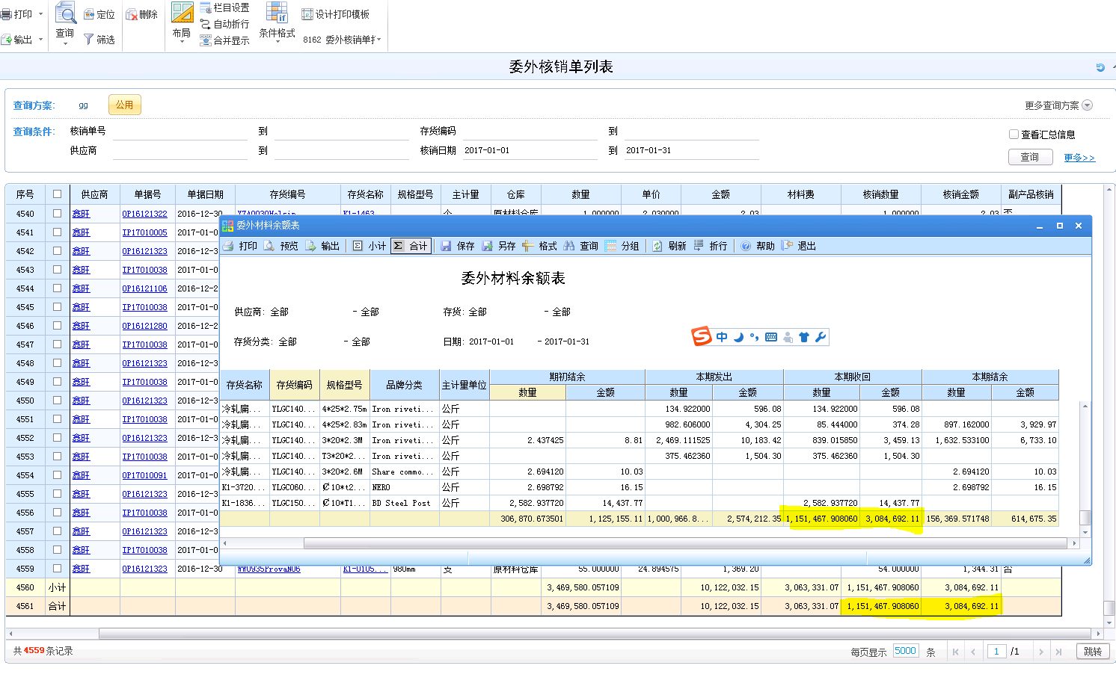

发现核销单未将材料费写入

修改

1. OM_MatSettleVouchs材料费
2. RdRecords01 材料费
3. IA_Subsidiary材料费（需要 iAInPrice = iProcessFee + imaterialfee）