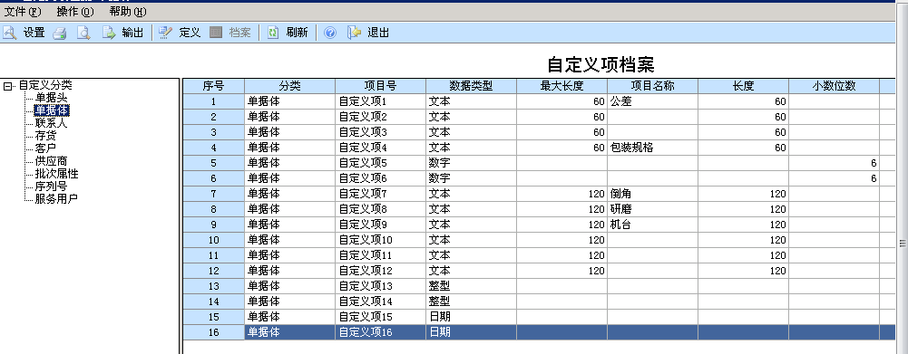

生产订单用的是自定义4 包装规格

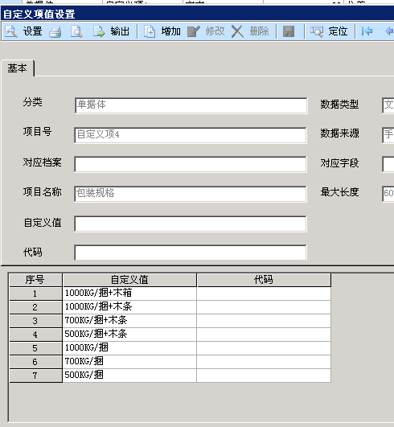

取/ 前面的为 该订单得净重信息

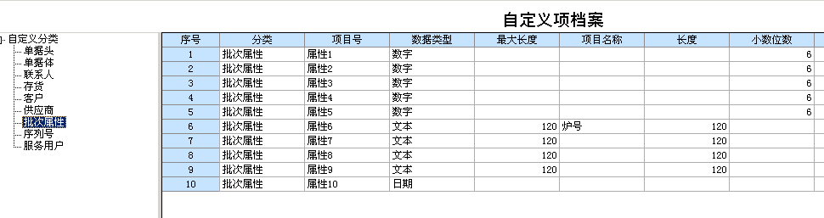

炉号信息 为批次属性6 AA_BatchProperty .cBatchProperty6

CREATE view v_currstock as

select currentstock.cinvcode as 原料,LEFT(currentstock.cbatch,len(currentstock.cbatch)-3) as 批号,cwhcode as 仓库,SUM(iquantity) as 结存数量, MAX(cBatchProperty6) as 炉号

from currentstock join AA_BatchProperty on currentstock.cInvCode=AA_BatchProperty.cInvCode and currentstock.cbatch=AA_BatchProperty.cbatch

where currentstock.cInvCode like 'Y%'

group by currentstock.cinvcode,LEFT(currentstock.cbatch,len(currentstock.cbatch)-3),cwhcode

having SUM(iquantity) <>0