1. 增加存货扩展自定义项

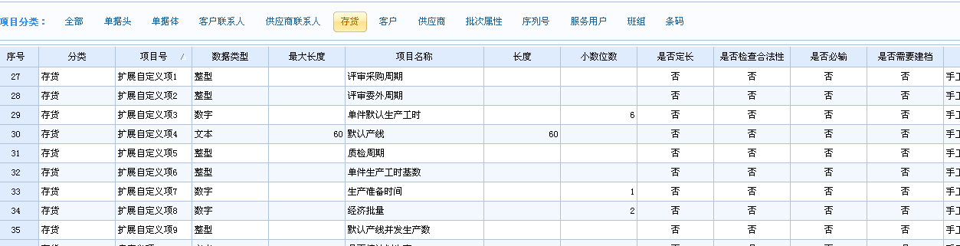

单件生产工时基数：单件默认生产工时只能使用6位小数，为增加小数位，增加单件生产工时基数栏位。

单件默认生产工时 = 单件默认生产工时（扩展自定义项3） / 单件生产工时基数（扩展自定义项6）

1. 增加销售订单表体扩展自定义项1,标记是否排产

数据说明:0 未排产;1 已排产,2 标记关闭(不需要排产)

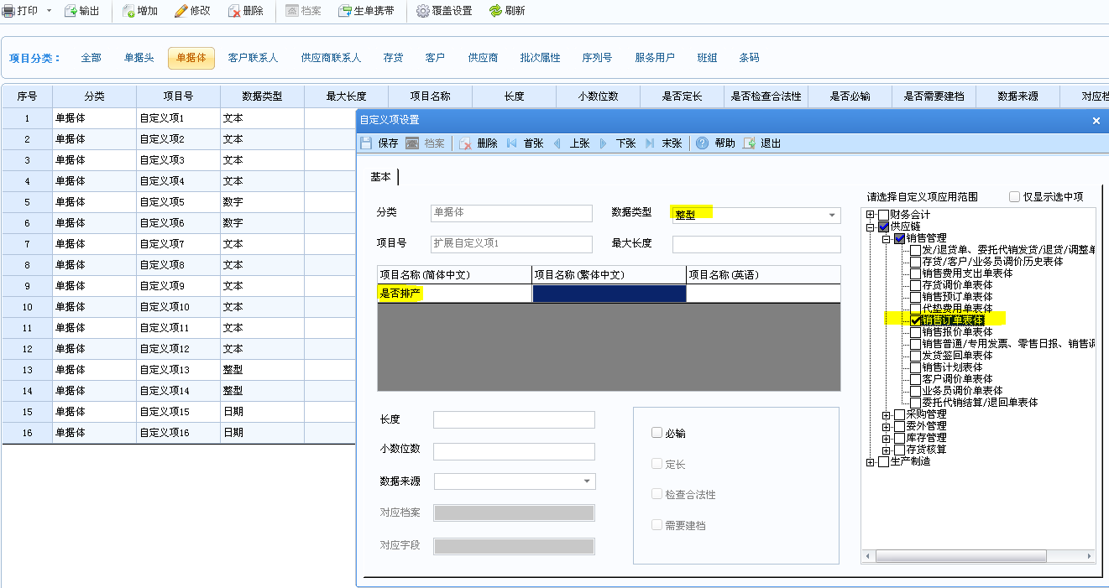

1. 增加销售订单表体扩展自定义项2,保存交货期,默认销售订单交货期

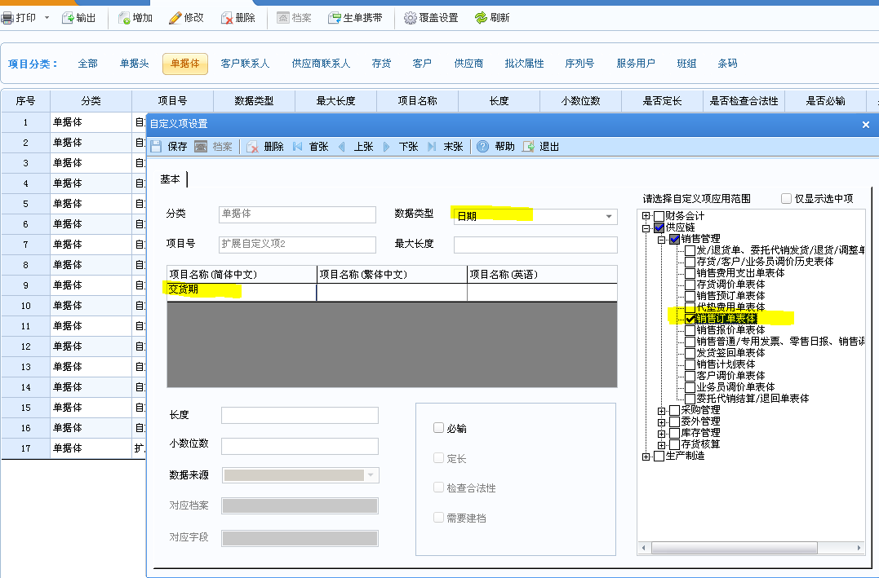

1. 将外挂数据库中存货生产档案导入帐套扩展自定义项中

update UFDATA_101_2014..Inventory_extradefine set cidefine1 = PurchaseCycle,cidefine2 = ProxyForeignCycle,cidefine3 = SelfCycle

,cidefine4 = [LineNo],cidefine5 = QualityCycle,cidefine6 = SelfCycleB,cidefine7 = SelfSetupCycle

from InvLineCycle b

where b.cInvCode = UFDATA_101_2014..Inventory_extradefine.cInvCode

insert into UFDATA_101_2014..Inventory_extradefine

select cInvCode ,PurchaseCycle,ProxyForeignCycle,SelfCycle,[LineNo],QualityCycle,SelfCycleB,SelfSetupCycle,null,null

from dbo.InvLineCycle

where isnull(Priority,0) = 1 and cInvCode not in (select cInvCode from UFDATA_101_2014..Inventory_extradefine)

1. 增加存储过程 _Get供需分析

USE [UFDATA_001_2014]

GO

/****** Object: StoredProcedure [dbo].[_Get供需分析] Script Date: 07/04/2014 16:27:12 ******/

SET ANSI_NULLS ON

GO

SET QUOTED_IDENTIFIER ON

GO

-- [_Get供需分析] 'YZA0042Inolin','200','2013','1310726-j'

-- drop table Get供需分析

--1. 采购入库 (请购单，采购订单，采购到货单，采购退货单，到货拒收单,采购入库单)

--2. 委外入库 (请购单，委外订单，委外到货单，委外退货单，到货拒收单，委外入库单)

--3. 生产入库 (生产订单,材料出库单)

--4. 生产材料出库 (生产订单,材料出库单)

--5. 委外材料出库 (委外订单,材料出库单)

--6. 销售出库

--7. 其他入库

--8. 其他出库

--declare @cInvCode varchar(50)

----set @cInvCode = '1BEB851100600' -- 采购

----set @cInvCode = '153167401' -- 委外

----set @cInvCode = '1BF0210000711' -- 生产

----set @cInvCode = '5312212100601' -- 生产材料出库

----set @cInvCode = '1BF2211101600' --委外材料出库

--set @cInvCode = 'A53113201'

-- _Get供需分析'A53113201'

-- select * from Get供需分析

ALTER proc [dbo].[_Get供需分析](@cInvCode varchar(50),@cSoCode varchar(50),@iRow int)

as

if exists (select 1 from sysobjects where id = object_id('dbo.[Get供需分析]') and type = 'U')

TRUNCATE table Get供需分析

else

CREATE TABLE [Get供需分析](

[存货编码] [nvarchar](50) NULL,

[现存量] [decimal](38, 6) NULL,

[供需类型] [nvarchar](28) NULL,

[单据类型] [nvarchar](50) NULL,

[单据号] [nvarchar](50) NULL,

[单据行号] [nvarchar](50) NULL,

[单据数] [decimal](16, 6) NULL,

[待入库] [decimal](16, 6) NULL,

[待出库] [decimal](16, 6) NULL,

[供需日期] [datetime] NULL,

[销售订单号] [nvarchar](50) NULL,

[销售订单行号] [nvarchar](50) NULL

)

insert into Get供需分析(存货编码,现存量,供需类型,[单据类型])

select cInvCode,iQuantity,'现存量',cWhCode

from CurrentStock

where cWhCode in(select cWhCode from warehouse where isnull(bMRP ,0) = 1)

and cInvCode = @cInvCode

--已下请购(已审核)，但未完全下采购订单/委外订单

insert into Get供需分析(存货编码,供需类型,[单据类型],单据号,[单据数],待入库,供需日期)

select ps.cInvCode,'请购未完全下订单','请购单-' + c.cPTName

,p.cCode,ps.fQuantity,isnull(ps.fQuantity,0)- isnull(ps.iReceivedQTY,0),dArriveDate

from PU_AppVouch p left join PU_AppVouchs ps on p.ID = ps.ID

left join PurchaseType c on p.cPTCode = c.cPTCode

where p.cVerifier is not null and p.cCloser is null and ps.cbcloser is null

and isnull(ps.fQuantity,0)- isnull(ps.iReceivedQTY,0) > 0 and (isnull(ps.fNum,0)-isnull(ps.iReceivedNum,0) > 0 or cUnitID is null)

and ps.cInvCode = @cInvCode

--采购订单未到货(审核，未审核均参与运算，关闭后不参与运算）

insert into Get供需分析(存货编码,供需类型,[单据类型],单据号,[单据数],待入库,供需日期)

select b.cInvCode,'采购未完全到货','采购订单',a.cPOID,b.iQuantity,b.iQuantity - isnull(b.iArrQTY,0) - isnull(b.iReceivedQTY,0) as 待入库

,b.dArriveDate as 供需日期

from PO_Pomain a inner join PO_Podetails b on a.POID = b.POID

where isnull(b.cbCloser,'') = '' and b.cInvCode = @cInvCode

and iQuantity - isnull(iArrQTY,0) - isnull(iReceivedQTY,0)>0

--委外订单未到货(审核，未审核均参与运算，关闭后不参与运算）

insert into Get供需分析(存货编码,供需类型,[单据类型],单据号,[单据数],待入库,供需日期)

select b.cInvCode,'委外未完全到货','委外订单',a.cCode,b.iQuantity,b.iQuantity - isnull(b.iArrQTY,0) - isnull(b.iReceivedQTY,0) as 待入库

,b.dArriveDate as 供需日期

from OM_MOMain a inner join OM_MODetails b on a.MOID = b.MOID

where isnull(a.cCloser,'') = '' and isnull(b.cbCloser,'') = '' and b.cInvCode = @cInvCode

and iQuantity - isnull(iArrQTY,0) - isnull(iReceivedQTY,0)>0

--采购到货未入库(审核，未审核均参与运算，关闭后不参与运算）

insert into Get供需分析(存货编码,供需类型,[单据类型],单据号,[单据数],待入库)

select c.cInvCode,'到货未完全入库'

,case when d.iBillType = 0 then '到货单' when d.iBillType = 1 then '退货单' when d.iBillType = 2 then '拒收单' end + '-' + e.cPTName

,d.cCode ,c.iQuantity,c.iQuantity - isnull(fValidInQuan,0) as 待入库

from PU_ArrivalVouchs c inner join PU_ArrivalVouch d on c.id = d.id

left join PurchaseType e on e.cPTCode = d.cPTCode

where isnull(d.ccloser,'') = '' and isnull(c.dlineclosedate,'') = ''

and c.cInvCode = @cInvCode

and c.iQuantity - isnull(c.fRefuseQuantity,0) - isnull(fValidInQuan,0) <> 0

--采购/委外入库未审核(库存管理设定审核修改现存量时加载此语句) -- ?? 出库是否同样语句待验证

declare @RdAudit bit

select @RdAudit = cValue from AccInformation where cSysID = 'ST' and cID = '246'

if(@RdAudit = 1)

begin

insert into Get供需分析(存货编码,供需类型,[单据类型],单据号,[单据数],待入库)

select cInvCode,'入库未审核',c.cPTName,a.cCode,b.iQuantity,b.iQuantity

from RdRecord01 a inner join RdRecords01 b on a.id = b.id

left join PurchaseType c on a.cPTCode = c.cPTCode

where isnull(a.cHandler ,'') = ''

and b.cInvCode = @cInvCode

end

--生产待入库

insert into Get供需分析(存货编码,供需类型,[单据类型],单据号,[单据数],待入库,供需日期)

select b.InvCode,'生产待入库','生产订单',c.MoCode,cast(null as decimal(16,6)) as 委外数

,sum(b.Qty - isnull(b.QualifiedInQty,0)) as 待入库 ,d.DueDate as 供需日期

from mom_orderdetail b inner join mom_order c on b.moid = c.moid

inner join mom_morder d on d.MoDId = b.MoDId

where b.InvCode = @cInvCode and b.Qty > isnull(b.QualifiedInQty,0) and b.Status = 3

group by b.InvCode,d.DueDate,c.MoCode,b.SoCode

--产成品入库未审核

select @RdAudit = cValue from AccInformation where cSysID = 'ST' and cID = '249'

if(@RdAudit = 1)

begin

insert into Get供需分析(存货编码,供需类型,[单据类型],单据号,[单据数],待入库)

select cInvCode,'产品入库未审核','产成品入库单',a.cCode,b.iQuantity,b.iQuantity

from rdrecord10 a inner join rdrecords10 b on a.id = b.id

where isnull(a.cHandler ,'') = ''

and b.cInvCode = @cInvCode

end

----生产待领料(材料出库单)

insert into Get供需分析(存货编码,供需类型,[单据类型],单据号,单据数,待出库,供需日期)

select a.InvCode,'生产领料' ,'生产订单领料',c.MoCode,a.Qty ,a.Qty - isnull(a.IssQty,0) ,a.StartDemDate as 供需日期

from mom_moallocate a inner join mom_orderdetail b on a.MoDId = b.MoDId

inner join mom_order c on b.moid = c.moid

where a.InvCode = @cInvCode and b.Status = 3 and a.Qty > isnull(a.IssQty,0)

--委外材料出库

insert into Get供需分析(存货编码,供需类型,[单据类型],单据号,单据行号,单据数,待出库)

select c.cInvCode,'委外发料','委外订单',a.cCode,b.iVouchRowNo,c.iQuantity,c.iQuantity - isnull(c.iSendQTY ,0)

from OM_MOMain a inner join OM_MODetails b on a.MOID = b.MOID

INNER JOIN OM_MOMaterials c on b.MoDetailsID = c.MoDetailsID

where isnull(b.cbCloser,'') = '' and c.cInvCode = @cInvCode

--材料出库未审核(生产,委外)

select @RdAudit = cValue from AccInformation where cSysID = 'ST' and cID = '248'

if(@RdAudit = 1)

begin

insert into Get供需分析(存货编码,供需类型,[单据类型],单据号,[单据数],待出库)

select cInvCode,'材料出库未审核',c.cPTName,a.cCode,b.iQuantity,b.iQuantity

from RdRecord11 a inner join RdRecords11 b on a.id = b.id

left join PurchaseType c on a.cPTCode = c.cPTCode

where isnull(a.cHandler ,'') = ''

and b.cInvCode = @cInvCode

end

--销售待发货(参与评审的单据才加入计算)

insert into Get供需分析(存货编码,供需类型,[单据类型],单据号,单据行号,[单据数],待出库,供需日期)

select b.cInvCode as 存货编码,'销售待发货','销售订单',a.cSOCode as 单据号,b.iRowNo,b.iQuantity ,b.iQuantity - isnull(b.foutquantity,0) as 待出库

,b.dPreDate as 供需日期

from SO_SOMain a inner join SO_SODetails b on a.id = b.id

inner join SystemDB_SY.dbo.订单评审 c on c.销售订单号 = a.cSOCode and c.行号 = b.iRowNo

where isnull(b.cSCloser ,'') = '' and b.cInvCode = @cInvCode

--and a.cSOCode <> @cSoCode and b.iRowNo <> @iRow

--评审产品待入库(销售订单上的物料)

insert into Get供需分析(存货编码,供需类型,[单据类型],单据号,单据行号,待入库,供需日期)

select a.产品编码,'评审产品待入库','评审单',a.评审单据号,null,b.本单需求数量,b.结束日期

from SystemDB_SY..订单评审 a inner join SystemDB_SY..订单评审明细 b on a.[Guid] = b.GuidHead and b.母件编码 = '--'

where isnull(关闭人,'') = '' and a.产品编码 = @cInvCode

--and a.销售订单号<> @cSoCode and a.行号<> @iRow

--销售出库待审核

select @RdAudit = cValue from AccInformation where cSysID = 'ST' and cID = '247'

if(@RdAudit = 1)

begin

insert into Get供需分析(存货编码,供需类型,[单据类型],单据号,[单据数],待出库)

select cInvCode,'销售出库','销售出库单',a.cCode,b.iQuantity,b.iQuantity

from rdrecord32 a inner join rdrecords32 b on a.id = b.id

where isnull(a.cHandler ,'') = ''

and b.cInvCode = @cInvCode

end

--其他入库

select @RdAudit = cValue from AccInformation where cSysID = 'ST' and cID = '250'

if(@RdAudit = 1)

begin

insert into Get供需分析(存货编码,供需类型,[单据类型],单据号,[单据数],待入库)

select cInvCode,'其他入库','其他入库单',a.cCode,b.iQuantity,b.iQuantity

from RdRecord08 a inner join RdRecords08 b on a.id = b.id

where isnull(a.cHandler ,'') = ''

and b.cInvCode = @cInvCode

end

--其他出库

select @RdAudit = cValue from AccInformation where cSysID = 'ST' and cID = '251'

if(@RdAudit = 1)

begin

insert into Get供需分析(存货编码,供需类型,[单据类型],单据号,[单据数],待出库)

select cInvCode,'其他入库','其他入库单',a.cCode,b.iQuantity,b.iQuantity

from RdRecord09 a inner join RdRecords09 b on a.id = b.id

where isnull(a.cHandler ,'') = ''

and b.cInvCode = @cInvCode

end

1. 增加单据体自定义项13用于跟踪生产计划下达生产订单情况（保存生产计划的iID）

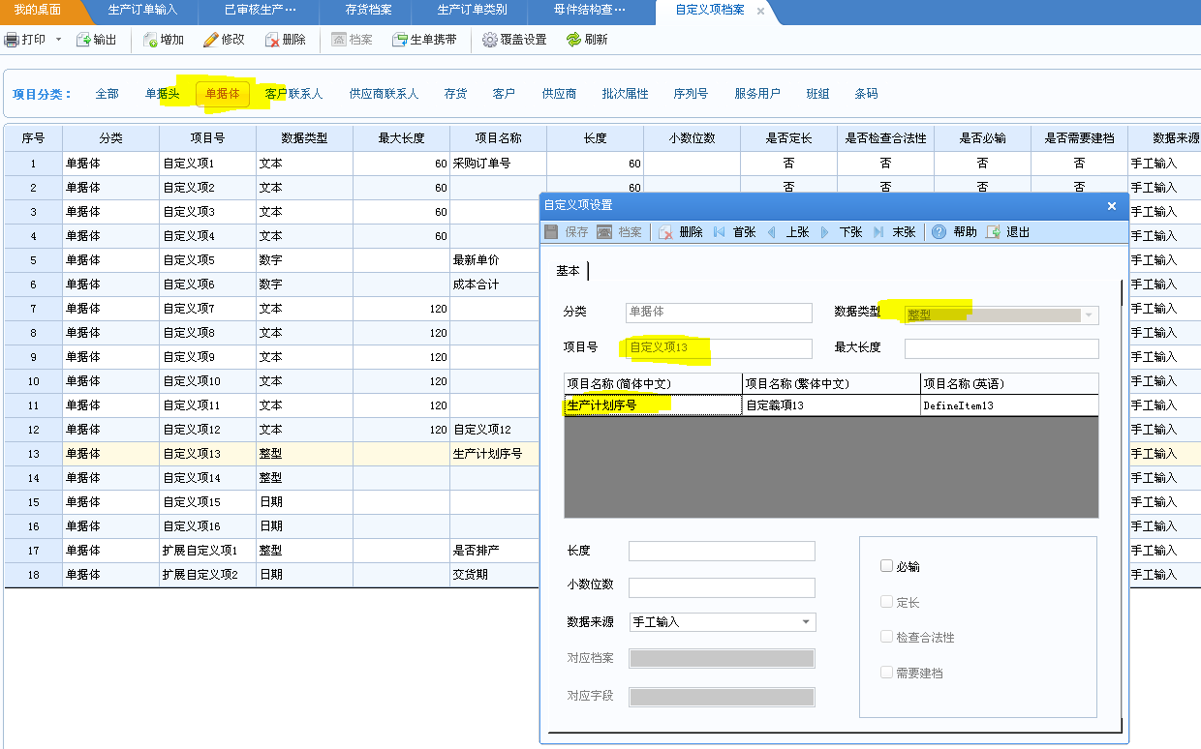

1. 增加单据体自定义项7用于跟踪生产计划生产线编码

