1. 通过存货自定义项 4 作为存货类型区分：板，棒

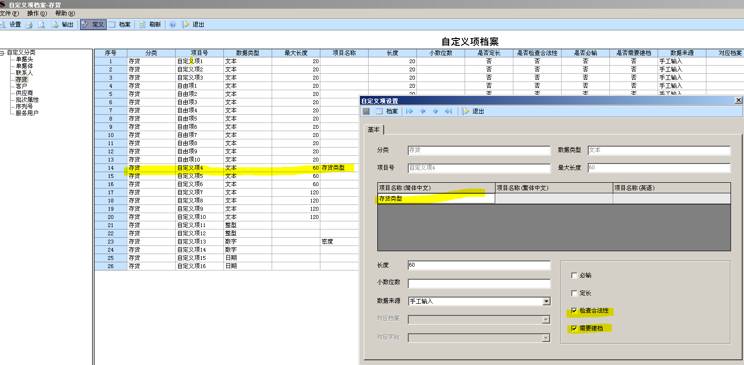

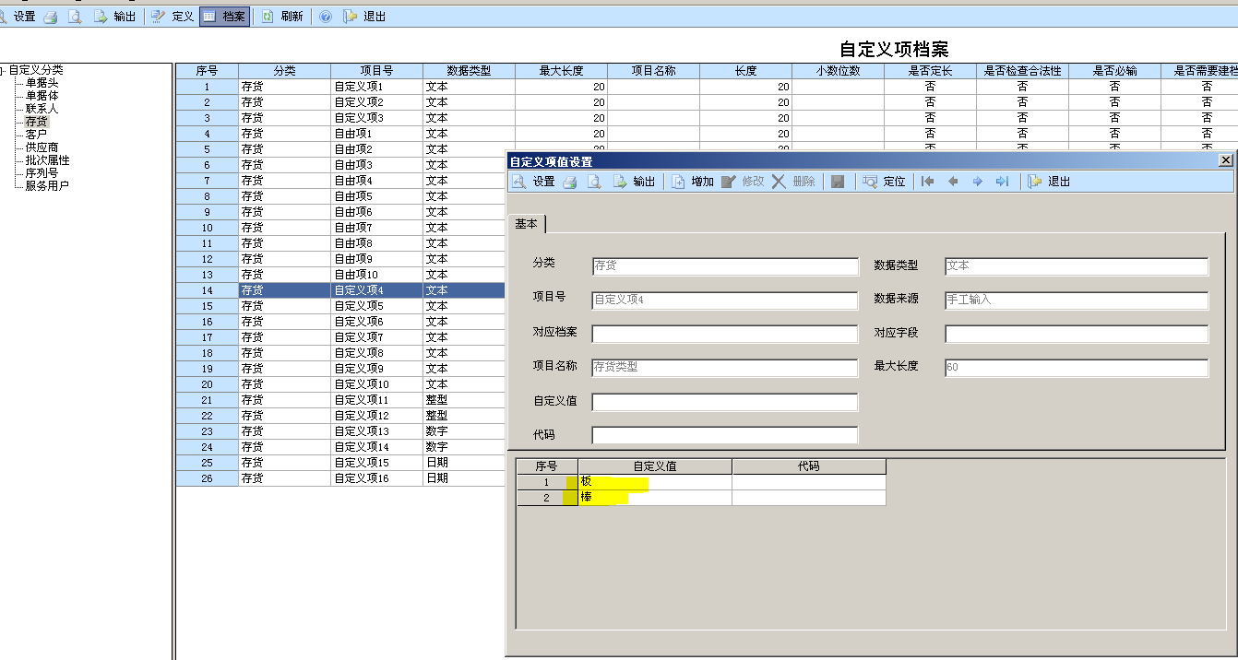

1. 修改触发器（当存货档案设定为”棒”时，重量计算使用 圆柱体积计算方式—销售订单中填写的是直径需要除以2；当不是棒时采用长*宽*高的方式计算体积，当数据填写错误程序不做检查）





ALTER TRIGGER [dbo].[_TH_CountQTY]

on [dbo].[SO_SODetails]

for insert,update

as

declare @尺寸 nvarchar(200)

declare @密度 nvarchar(200)

declare @语句 nvarchar(800)

declare @件数 nvarchar(200)

declare @autoID nvarchar(20)

declare @材料类型 nvarchar(20)

select @autoID = autoID from inserted

select @autoID = cast(a.AutoID as varchar(10)),@件数=a.cDefine34,@尺寸=a.cDefine28,@密度=a.cDefine33,@材料类型 = isnull(b.cInvDefine4 ,'')

from SO_SODetails a inner join Inventory b on a.cInvCode = b.cInvCode

where AutoID = @autoID

if(@材料类型 = '棒')

begin

-- 棒子体积计算方式

IF EXISTS (SELECT * FROM sys.objects WHERE object_id = OBJECT_ID(N'[dbo].[TH_ta]') AND type in (N'U'))

DROP TABLE [dbo].TH_ta

IF EXISTS (SELECT * FROM sys.objects WHERE object_id = OBJECT_ID(N'[dbo].[TH_tb]') AND type in (N'U'))

DROP TABLE [dbo].TH_tb

IF EXISTS (SELECT * FROM sys.objects WHERE object_id = OBJECT_ID(N'[dbo].[TH_TAC]') AND type in (N'U'))

DROP TABLE [dbo].TH_TAC

create table TH_ta

(

id int,

id_value varchar(30)

)

insert into TH_ta

select 1 ,@尺寸

select

top 4000 ix = identity(int, 1, 1)

into TH_tb

from sys.objects a, sys.objects b

select

id, id_value = substring(id_value,ix,charindex('*',id_value + '*',ix) - ix) ,ROW_NUMBER() OVER(ORDER BY a.id) AS rowNumber

into TH_TAC

FROM TH_ta as A, TH_tb as B

WHERE SUBSTRING( '*' + id_value, ix, 1) = '*'

declare @max int

select @max = MAX(rowNumber) from TH_TAC

declare @rowNo int

set @rowNo=1

declare @直径 decimal(16,6)

declare @长度 decimal(16,6)

declare @重量 decimal(16,6)

select @直径 = id_value from TH_TAC where rowNumber = 1

select @长度 = id_value from TH_TAC where rowNumber = 2

set @重量 = cast(@件数 as decimal(16,6)) * cast(@密度 as decimal(16,6)) * 3.14 * (@直径/2)* (@直径/2) * @长度 /1000000

update SO_SODetails set cDefine22 = cast(@重量 as varchar(50)) where AutoID = @autoID

end

else

begin

set @语句 = ' update SO_SODetails set cDefine22 = cast(cast(' + @尺寸 + '*' + @密度 + '*' + @件数 + '/1000000 as decimal(16,2)) as varchar(10)) where autoid =' + @autoID

end

exec sp_executesql @语句

1. 材料入库单表头增加列“材料类型”，并重新保存表列信息

