<https://blog.csdn.net/test1280/article/details/70859797>

注：如果很着急安装，可以直接看第二种方式；如果不着急，还想要体验一把“依赖”的酸爽，可以慢慢看下面的步骤。

环境：

CentOS 6.8：

[root@localhost ~]# uname -a

Linux localhost.localdomain 2.6.32-642.el6.x86_64 #1 SMP Tue May 10 17:27:01 UTC 2016 x86_64 x86_64 x86_64 GNU/Linux

一、从官网获取源码包

http://subversion.apache.org/

二、上传源码包至/usr/local/src下

[root@localhost ~]# cd /usr/local/src/

[root@localhost src]# pwd

/usr/local/src

[root@localhost src]# ll

total 10368

-rw-r--r--. 1 root root 10615674 Apr 27 08:33 subversion-1.9.5.tar.gz

三、解压缩

[root@localhost src]# tar zxf subversion-1.9.5.tar.gz

[root@localhost src]# ll

total 10372

drwxrwxr-x. 6 1000 1000 4096 Nov 21 05:57 subversion-1.9.5

-rw-r--r--. 1 root root 10615674 Apr 27 08:33 subversion-1.9.5.tar.gz

四、看看INSTALL文件

注意有以下内容：

II. INSTALLATION

============

A. Building from a Tarball

------------------------------

1. Building from a Tarball

Download the most recent distribution tarball from:

http://subversion.apache.org/download/

Unpack it, and use the standard GNU procedure to compile:

$ ./configure

$ make

# make install

You can also run the full test suite by running 'make check'. Even

in successful runs, some tests will report XFAIL; that is normal.

Failed runs are indicated by FAIL or XPASS results, or a non-zero exit

code from "make check".

……我觉得我的博客都不用再写了。。

五、我的安装过程

[root@localhost subversion-1.9.5]# ./configure --prefix=/usr/local/subversion

configure: Configuring Subversion 1.9.5

configure: creating config.nice

checking for gcc... gcc

checking whether the C compiler works... yes

checking for C compiler default output file name... a.out

……

checking for APR... no

configure: WARNING: APR not found

The Apache Portable Runtime (APR) library cannot be found.

Please install APR on this system and configure Subversion

with the appropriate --with-apr option.

You probably need to do something similar with the Apache

Portable Runtime Utility (APRUTIL) library and then configure

Subversion with both the --with-apr and --with-apr-util options.

configure: error: no suitable APR found

没有APR。

说的很明白了，没找到APR库，检查–with-apr是不是有问题。

好吧，现在开始安装APR。

http://apr.apache.org/

我下载的是：

apr-1.5.2.tar.gz

同理上传到：

/usr/local/src

[root@localhost ~]# cd /usr/local/src/

[root@localhost src]# pwd

/usr/local/src

[root@localhost src]# ll

total 11380

-rw-r--r--. 1 root root 1031613 Apr 27 08:38 apr-1.5.2.tar.gz

drwxrwxr-x. 6 1000 1000 4096 Apr 27 08:35 subversion-1.9.5

-rw-r--r--. 1 root root 10615674 Apr 27 08:33 subversion-1.9.5.tar.gz

[root@localhost src]# tar zxf apr-1.5.2.tar.gz

[root@localhost src]# ll

total 11384

drwxr-xr-x. 27 1000 1000 4096 Apr 25 2015 apr-1.5.2

-rw-r--r--. 1 root root 1031613 Apr 27 08:38 apr-1.5.2.tar.gz

drwxrwxr-x. 6 1000 1000 4096 Apr 27 08:35 subversion-1.9.5

-rw-r--r--. 1 root root 10615674 Apr 27 08:33 subversion-1.9.5.tar.gz

[root@localhost apr-1.5.2]# ./configure --prefix=/usr/local/apr

……

[root@localhost apr-1.5.2]# make && make install

……

----------------------------------------------------------------------

Libraries have been installed in:

/usr/local/apr/lib

If you ever happen to want to link against installed libraries

in a given directory, LIBDIR, you must either use libtool, and

specify the full pathname of the library, or use the `-LLIBDIR'

flag during linking and do at least one of the following:

- add LIBDIR to the `LD_LIBRARY_PATH' environment variable

during execution

- add LIBDIR to the `LD_RUN_PATH' environment variable

during linking

- use the `-Wl,-rpath -Wl,LIBDIR' linker flag

- have your system administrator add LIBDIR to `/etc/ld.so.conf'

See any operating system documentation about shared libraries for

more information, such as the ld(1) and ld.so(8) manual pages.

----------------------------------------------------------------------

……

[root@localhost local]# pwd

/usr/local

[root@localhost local]# ll

total 44

drwxr-xr-x. 6 root root 4096 Apr 27 08:41 apr

drwxr-xr-x. 2 root root 4096 Sep 23 2011 bin

drwxr-xr-x. 2 root root 4096 Sep 23 2011 etc

drwxr-xr-x. 2 root root 4096 Sep 23 2011 games

drwxr-xr-x. 2 root root 4096 Sep 23 2011 include

drwxr-xr-x. 2 root root 4096 Sep 23 2011 lib

drwxr-xr-x. 2 root root 4096 Sep 23 2011 lib64

drwxr-xr-x. 2 root root 4096 Sep 23 2011 libexec

drwxr-xr-x. 2 root root 4096 Sep 23 2011 sbin

drwxr-xr-x. 5 root root 4096 Apr 26 14:41 share

drwxr-xr-x. 4 root root 4096 Apr 27 08:38 src

可以看到已经有了apr目录。

[root@localhost local]# pwd

/usr/local

[root@localhost local]# cd apr/

[root@localhost apr]# pwd

/usr/local/apr

[root@localhost apr]# ll

total 16

drwxr-xr-x. 2 root root 4096 Apr 27 08:41 bin

drwxr-xr-x. 2 root root 4096 Apr 27 08:41 build-1

drwxr-xr-x. 3 root root 4096 Apr 27 08:41 include

drwxr-xr-x. 3 root root 4096 Apr 27 08:41 lib

[root@localhost apr]# cd bin/

[root@localhost bin]# ll

total 8

-rwxr-xr-x. 1 root root 6946 Apr 27 08:41 apr-1-config

建立一个软链接：

[root@localhost bin]# ln -s /usr/local/apr/bin/apr-1-config /usr/bin/apr-1-config

[root@localhost bin]# which apr-1-config

/usr/bin/apr-1-config

这回应该可以了吧？

[root@localhost subversion-1.9.5]# ./configure --prefix=/usr/local/subversion

……

configure: Apache Portable Runtime (APR) library configuration

checking for APR... yes

checking APR version... 1.5.2

configure: Apache Portable Runtime Utility (APRUTIL) library configuration

checking for APR-util... no

configure: WARNING: APRUTIL not found

The Apache Portable Runtime Utility (APRUTIL) library cannot be found.

Install APRUTIL on this system and configure Subversion with the

appropriate --with-apr-util option.

configure: error: no suitable APRUTIL found

可以看到，检查APR已经OK了，但是APR-util没找到。

再去安装APR-util吧。

依然是上面的官网：

http://apr.apache.org

下载，上传，解压缩…

[root@localhost src]# cd

[root@localhost ~]# cd /usr/local/src/

[root@localhost src]# ll

total 12232

drwxr-xr-x. 28 1000 1000 4096 Apr 27 08:41 apr-1.5.2

-rw-r--r--. 1 root root 1031613 Apr 27 08:38 apr-1.5.2.tar.gz

-rw-r--r--. 1 root root 867573 Apr 27 08:54 apr-util-1.5.2.tar.gz

drwxrwxr-x. 6 1000 1000 4096 Apr 27 08:46 subversion-1.9.5

-rw-r--r--. 1 root root 10615674 Apr 27 08:33 subversion-1.9.5.tar.gz

[root@localhost src]# tar zxf apr-util-1.5.2.tar.gz

[root@localhost src]# ll

total 12236

drwxr-xr-x. 28 1000 1000 4096 Apr 27 08:41 apr-1.5.2

-rw-r--r--. 1 root root 1031613 Apr 27 08:38 apr-1.5.2.tar.gz

drwxr-xr-x. 19 1000 1000 4096 Mar 30 2013 apr-util-1.5.2

-rw-r--r--. 1 root root 867573 Apr 27 08:54 apr-util-1.5.2.tar.gz

drwxrwxr-x. 6 1000 1000 4096 Apr 27 08:46 subversion-1.9.5

-rw-r--r--. 1 root root 10615674 Apr 27 08:33 subversion-1.9.5.tar.gz

[root@localhost apr-util-1.5.2]# ./configure --prefix=/usr/local/apr-util

checking build system type... x86_64-unknown-linux-gnu

checking host system type... x86_64-unknown-linux-gnu

checking target system type... x86_64-unknown-linux-gnu

checking for a BSD-compatible install... /usr/bin/install -c

checking for working mkdir -p... yes

APR-util Version: 1.5.2

checking for chosen layout... apr-util

checking for gcc... gcc

checking whether the C compiler works... yes

checking for C compiler default output file name... a.out

checking for suffix of executables...

checking whether we are cross compiling... no

checking for suffix of object files... o

checking whether we are using the GNU C compiler... yes

checking whether gcc accepts -g... yes

checking for gcc option to accept ISO C89... none needed

Applying apr-util hints file rules for x86_64-unknown-linux-gnu

checking for APR... no

configure: error: APR could not be located. Please use the --with-apr option.

指定一下apr的位置。

[root@localhost apr-util-1.5.2]# ./configure --prefix=/usr/local/apr-util --with-apr=/usr/local/apr

……

[root@localhost apr-util-1.5.2]# make && make install

……

----------------------------------------------------------------------

Libraries have been installed in:

/usr/local/apr-util/lib

If you ever happen to want to link against installed libraries

in a given directory, LIBDIR, you must either use libtool, and

specify the full pathname of the library, or use the `-LLIBDIR'

flag during linking and do at least one of the following:

- add LIBDIR to the `LD_LIBRARY_PATH' environment variable

during execution

- add LIBDIR to the `LD_RUN_PATH' environment variable

during linking

- use the `-Wl,-rpath -Wl,LIBDIR' linker flag

- have your system administrator add LIBDIR to `/etc/ld.so.conf'

See any operating system documentation about shared libraries for

more information, such as the ld(1) and ld.so(8) manual pages.

----------------------------------------------------------------------

……

[root@localhost apr-util-1.5.2]# cd /usr/local/apr-util/

[root@localhost apr-util]# ll

total 12

drwxr-xr-x. 2 root root 4096 Apr 27 08:57 bin

drwxr-xr-x. 3 root root 4096 Apr 27 08:57 include

drwxr-xr-x. 3 root root 4096 Apr 27 08:57 lib

[root@localhost apr-util]# cd bin/

[root@localhost bin]# ll

total 8

-rwxr-xr-x. 1 root root 6542 Apr 27 08:57 apu-1-config

[root@localhost bin]# ln -s /usr/local/apr-util/bin/apu-1-config /usr/bin/apu-1-config

[root@localhost bin]# which apu-1-config

/usr/bin/apu-1-config

这下子可以在subversion中执行configure了吧？

[root@localhost bin]# cd /usr/local/src/subversion-1.9.5/

[root@localhost subversion-1.9.5]# ./configure --prefix=/usr/local/subversion

……

configure: checking sqlite library

checking sqlite amalgamation... no

checking sqlite amalgamation... no

checking sqlite3.h usability... no

checking sqlite3.h presence... no

checking for sqlite3.h... no

checking sqlite library version (via pkg-config)... no

An appropriate version of sqlite could not be found. We recommmend

3.7.15.1, but require at least 3.7.12.

Please either install a newer sqlite on this system

or

get the sqlite 3.7.15.1 amalgamation from:

http://www.sqlite.org/sqlite-amalgamation-3071501.zip

unpack the archive using unzip and rename the resulting

directory to:

/usr/local/src/subversion-1.9.5/sqlite-amalgamation

configure: error: Subversion requires SQLite

步骤说的很明白了。

首先下载

http://www.sqlite.org/sqlite-amalgamation-3071501.zip

然后解压缩到指定目录即可。

[root@localhost subversion-1.9.5]# cd

[root@localhost ~]# pwd

/root

[root@localhost ~]# cd /usr/local/src/subversion-1.9.5/

[root@localhost subversion-1.9.5]# ll

total 3752

……

-rw-r--r--. 1 root root 1396268 Apr 27 09:03 sqlite-amalgamation-3071501.zip

drwxrwxr-x. 36 1000 1000 4096 Nov 21 05:57 subversion

……

[root@localhost subversion-1.9.5]# unzip sqlite-amalgamation-3071501.zip

Archive: sqlite-amalgamation-3071501.zip

creating: sqlite-amalgamation-3071501/

inflating: sqlite-amalgamation-3071501/sqlite3.h

inflating: sqlite-amalgamation-3071501/shell.c

inflating: sqlite-amalgamation-3071501/sqlite3ext.h

inflating: sqlite-amalgamation-3071501/sqlite3.c

[root@localhost subversion-1.9.5]# rm sqlite-amalgamation-3071501.zip

rm: remove regular file `sqlite-amalgamation-3071501.zip'? y

[root@localhost subversion-1.9.5]# ll

total 2392

……

-rw-rw-r--. 1 1000 1000 2303 May 31 2016 README

drwxr-xr-x. 2 root root 4096 Dec 19 2012 sqlite-amalgamation-3071501

drwxrwxr-x. 36 1000 1000 4096 Nov 21 05:57 subversion

……

[root@localhost subversion-1.9.5]# mv sqlite-amalgamation-3071501 sqlite-amalgamation

最后一步别忘记按照人家的提示重命名呀！

[root@localhost subversion-1.9.5]# ./configure --prefix=/usr/local/subversion

……

configure: zlib library configuration via pkg-config

checking for zlib library... no

configure: zlib library configuration

checking zlib.h usability... no

checking zlib.h presence... no

checking for zlib.h... no

configure: error: subversion requires zlib

安装zlib。

http://www.zlib.net/

zlib-1.2.11.tar.gz

[root@localhost src]# ll zlib* -d

drwxr-xr-x. 14 test1280 games 4096 Jan 15 09:36 zlib-1.2.11

-rw-r--r--. 1 root root 607698 Apr 27 09:10 zlib-1.2.11.tar.gz

[root@localhost zlib-1.2.11]# ./configure

Checking for gcc...

Checking for shared library support...

Building shared library libz.so.1.2.11 with gcc.

Checking for size_t... Yes.

Checking for off64_t... Yes.

Checking for fseeko... Yes.

Checking for strerror... Yes.

Checking for unistd.h... Yes.

Checking for stdarg.h... Yes.

Checking whether to use vs[n]printf() or s[n]printf()... using vs[n]printf().

Checking for vsnprintf() in stdio.h... Yes.

Checking for return value of vsnprintf()... Yes.

Checking for attribute(visibility) support... Yes.

[root@localhost zlib-1.2.11]# make && make install

……

再次在subversion中configure：

[root@localhost subversion-1.9.5]# ./configure --prefix=/usr/local/subversion

……

执行成功。

[root@localhost subversion-1.9.5]# make && make install

……

得执行好一阵~

[root@localhost ~]# cd /usr/local/subversion/

[root@localhost subversion]# ll

total 16

drwxr-xr-x. 2 root root 4096 Apr 27 09:17 bin

drwxr-xr-x. 3 root root 4096 Apr 27 09:17 include

drwxr-xr-x. 2 root root 4096 Apr 27 09:17 lib

drwxr-xr-x. 4 root root 4096 Apr 27 09:17 share

[root@localhost subversion]# ll bin/

total 2632

-rwxr-xr-x. 1 root root 1174906 Apr 27 09:17 svn

-rwxr-xr-x. 1 root root 171860 Apr 27 09:17 svnadmin

-rwxr-xr-x. 1 root root 225211 Apr 27 09:17 svnbench

-rwxr-xr-x. 1 root root 92387 Apr 27 09:17 svndumpfilter

-rwxr-xr-x. 1 root root 100064 Apr 27 09:17 svnfsfs

-rwxr-xr-x. 1 root root 161796 Apr 27 09:17 svnlook

-rwxr-xr-x. 1 root root 88406 Apr 27 09:17 svnmucc

-rwxr-xr-x. 1 root root 184701 Apr 27 09:17 svnrdump

-rwxr-xr-x. 1 root root 286996 Apr 27 09:17 svnserve

-rwxr-xr-x. 1 root root 148724 Apr 27 09:17 svnsync

-rwxr-xr-x. 1 root root 38888 Apr 27 09:17 svnversion

[root@localhost subversion]# which svn

/usr/bin/which: no svn in (/usr/local/sbin:/usr/local/bin:/sbin:/bin:/usr/sbin:/usr/bin:/root/bin)

[root@localhost subversion]# ln -s /usr/local/subversion/bin/svn /usr/bin/svn

[root@localhost subversion]# which svn

/usr/bin/svn

简直太麻烦了！！！

注：

相关的代码包可以从我的个人资源里面下载。

———————————-分割线—————————————-

上面的是直接源码安装，是在是各种依赖各种安装。。

其实有很简单的方式就能安装好svn.

官网中很明确地说了：

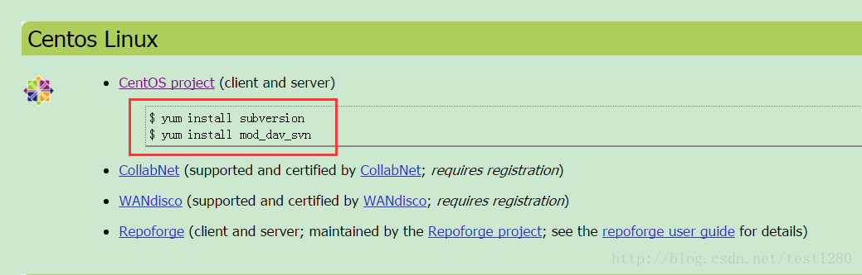

下面的是一样一样的机器（VM），我直接按照官网yum来去做：

首先执行：

yum install subversion

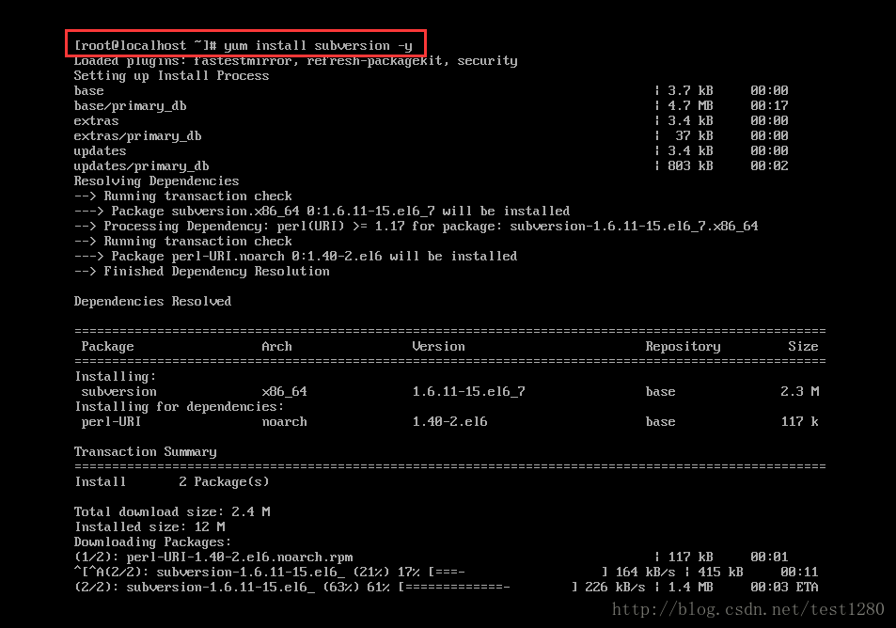

结果是：

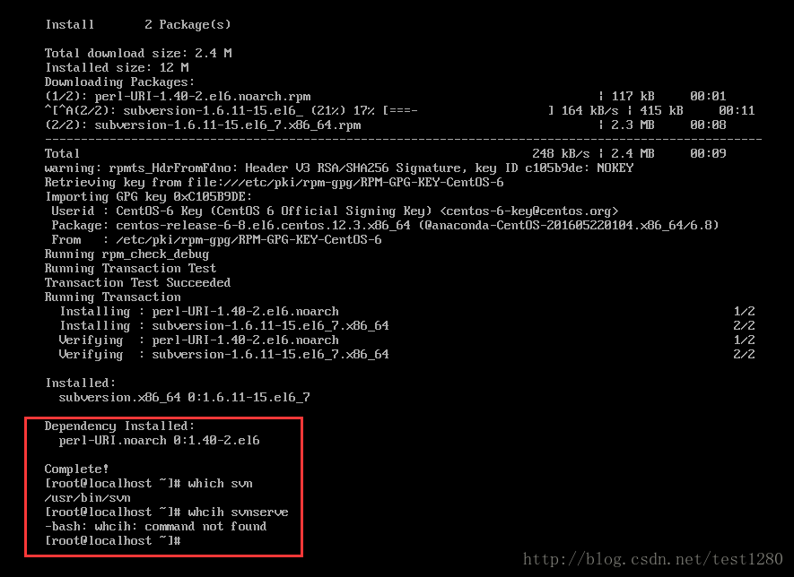

有客户端（svn），但是无svnserve。

执行：

yum install mod_dav_svn

结果是：

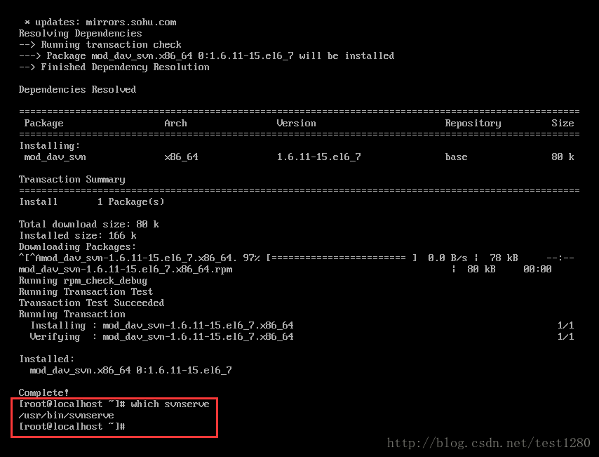

安装完毕后即可看到svnserve。

最后带上个链接：

<http://blog.csdn.net/fengyily/article/details/36649711>

个人认为这个写的很不错~很有参考价值。

需要注意的是，这个版本比较旧，有两个包，其中一个是deps。

而在我上面介绍的源码安装只有一个包，对此，官网给的解释是：

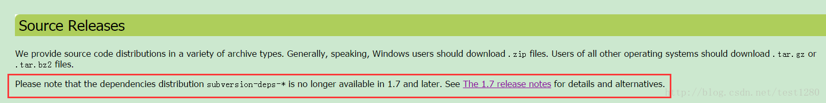

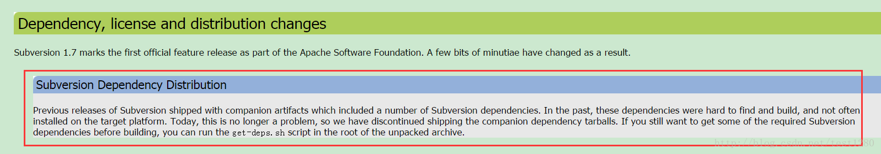

不再使用deps！

版权声明：本文为博主原创文章，未经博主允许不得转载。 https://blog.csdn.net/test1280/article/details/70859797