<http://www.jb51.net/article/60041.htm>

这里用一个实例来演示PostgreSQL存储过程如何返回数据集。

**1、首先准备数据表**

复制代码代码如下:

//member_category  
create table member_category(id serial, name text, discount_rate real, base_integral integer);  
alter table member_category add primary key(id);  
alter table member_category add check(name<>'');

//member  
create table member(id serial, member_num text, name text, category_id integer, account numeric(16,2), integral integer, phone text, birthday date, qq integer, email text, status integer, address text, tip text, start_date date, valid_date integer, password text, creator integer, store_name text);  
alter table member add primary key(id);  
alter table member add foreign key(creator) references employee;  
alter table member add foreign key(category_id) references member_category;  
alter table member add  onaccount int;

alter table member add  onaccount int;  
alter table member add  store_name text;

**2、插入测试数据**

复制代码代码如下:

insert into member_category(name, discount_rate, base_integral) values('白金会员', 6.5, 10000);  
insert into member_category(name, discount_rate, base_integral) values('高级会员', 7.5, 1000);  
insert into member_category(name, discount_rate, base_integral) values('中级会员', 8.5, 100);  
insert into member_category(name, discount_rate, base_integral) values('普通会员', 9.5, 10);

insert into member(member_num, name, category_id, account, integral, phone, birthday, qq, email, onaccount, status, address, tip, start_date, valid_date, password, store_name) values('1000001', 'wuyilun', 1, 100000.00, 100000, 18814117777, '1990-12-12', 12345678, '123456@qq.com', 0, 1, 'B3-440', '超白金会员,一切免单', '2014-01-15', 1000000, 12345, '华南理工门店');  
insert into member(member_num, name, category_id, account, integral, phone, birthday, qq, email, onaccount, status, address, tip, start_date, valid_date, password, store_name) values('1000002', '李小路', 2, 1000.00, 100000, 188141177234, '1990-12-12', 12345678, '123456@qq.com', 0, 1, 'B3-444', '...', '2014-01-15', 1000000, 12345, '华南理工门店');  
insert into member(member_num, name, category_id, account, integral, phone, birthday, qq, email, onaccount, status, address, tip, start_date, valid_date, password, store_name) values('1000003', '洪金包', 3, 1000.00, 100000, 18814117234, '1990-12-12', 12345678, '123456@qq.com', 0, 1, 'B3-443', '...', '2014-01-15', 1000000, 12345, '华南理工门店');  
insert into member(member_num, name, category_id, account, integral, phone, birthday, qq, email, onaccount, status, address, tip, start_date, valid_date, password, store_name) values('1000004', '成龙', 4, 100.00, 100000, 18814117723, '1990-12-12', 12345678, '123456@qq.com', 0, 1, 'B3-442', '...', '2014-01-15', 1000000, 12345, '华南理工门店');  
insert into member(member_num, name, category_id, account, integral, phone, birthday, qq, email, onaccount, status, address, tip, start_date, valid_date, password, store_name) values('1000005', '范兵兵', 4, 100.00, 100000, 18814117327, '1990-12-12', 12345678, '123456@qq.com', 0, 1, 'B3-441', '...', '2014-01-15', 1000000, 12345, '华南理工门店');

**3、创建存储过程**

复制代码代码如下:

--调用存储过程f_get_member_info, 返回会员的所有信息  
--memberType:会员类型 status:会员状态  findCondition:查询条件(卡号/电话/姓名)  store_name:商店名称     
create or replace function f_get_member_info(memberType int, status int, findCondition text, store_name text) returns setof record as  
$$  
declare  
rec record;  
begin  
  for rec in EXECUTE 'select m.member_num, m.name, m_t.name, m_t.discount_rate, m.account,  m.integral, m.phone, m.birthday, m.qq, m.email, m.onAccount, m.status, m.address, m.tip, m.start_date, m.valid_date, m.store_name from member m, member_category m_t where m.category_id = m_t.id and m_t.id = '|| memberType ||' and m.status = '|| status ||' and m.store_name = '''|| store_name ||''' and (m.member_num like ''%'|| findCondition ||'%'' or m.name like ''%'|| findCondition ||'%'' or m.phone like ''%'|| findCondition ||'%'');' loop  
    return next rec;  
  end loop;  
return;  
end  
$$  
language 'plpgsql';

**4、调用存储过程**

复制代码代码如下:

--调用存储过程f_get_member_info示例  
select * from f_get_member_info(4, 1, '', '华南理工门店') as member(member_num text,mname text,name text,discount_rate real,account numeric(16,2),integral int,phone text,birthday date,qq int,email text,onAccount int,status int,address text,tip text,start_date date,valid_date int,store_nam text);

**5、测试结果**

[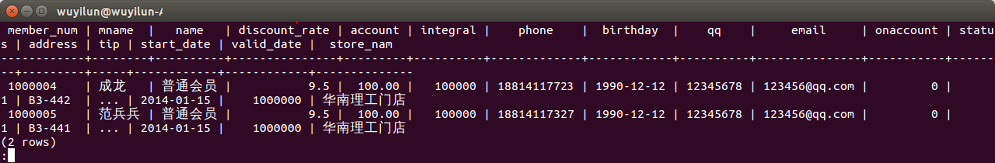](http://files.jb51.net/file_images/article/201501/2015119110432187.png?201501911449)