## 短信数据查询说明

蒙冠州

1.日期格式yyyyMMdd，如2018年1月30日为20180130

2.查询方式：

总共有七个表，查询示例：

宾阳虚商*：select * from wx.tb_sms_by_xs201712 where day_id = '27' order by send_cnt desc;*

宾阳省内：*select * from wx.tb_sms_by_gx201801 where day_id = '27' order by send_cnt desc;*

宾阳省外：*select * from wx.tb_sms_by_cn201801 where day_id = '27' order by send_cnt desc;*

宾阳cgi：*select * from wx. tb_sms_by_cgi201801 where day_id = '27' order by send_cnt desc;*

南宁imei:*select * from wx.tb_sms_nn_imei201712 where day_id = '27' order by send_cnt desc;*

南宁号码：*select * from wx.tb_sms_nn_number201801 where day_id = '27' order by send_cnt desc;*

南宁cgi:*select * from wx.tb_sms_nn_cgi201801 where day_id = '27' order by send_cnt desc;*

查询语句说明：

select * from wx.tb_sms_nn(南宁)/by(宾阳)_表名年月 where day_id = ‘日’ order by send_cnt desc;

字段说明：

nn 南宁

by 宾阳

number 号码

gx 广西

cn 省外（中国）

xs 虚商

字段码表，字段说明：

select * from wx.tb_code_sms;

4A导出excel:

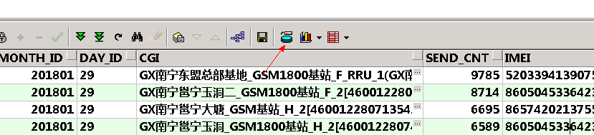

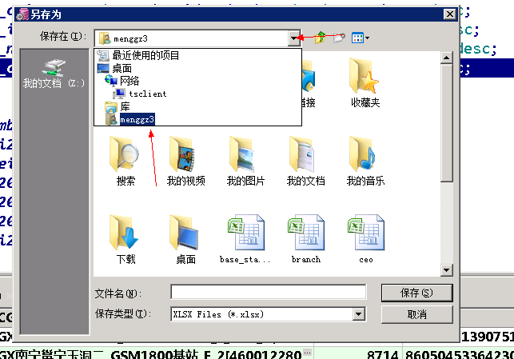

选中自己工号的文件夹导出

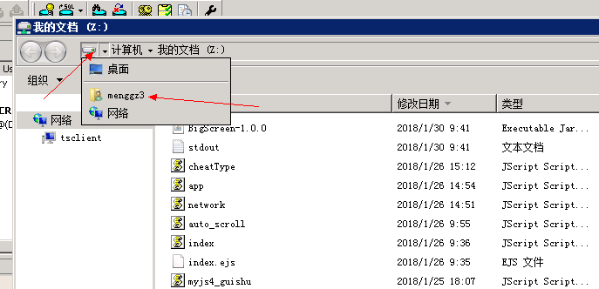

导出后打开我的文档，从这里进入工号文件夹

然后将表复制，到自己电脑桌面粘贴即可