**Nexus搭建Maven私服**

**一．下载tar版Nexus3**

上传到centos7 服务器tar -vzxf 解压Nexus3

cd /usr/local/nexus3

运行nexus3

./nexus run &

开放端口

firewall-cmd --zone=public --add-port=8081/tcp --permanent

firewall-cmd --reload

浏览器 访问nexus

例如：192.168.5.58:8081初始密码admin admin123

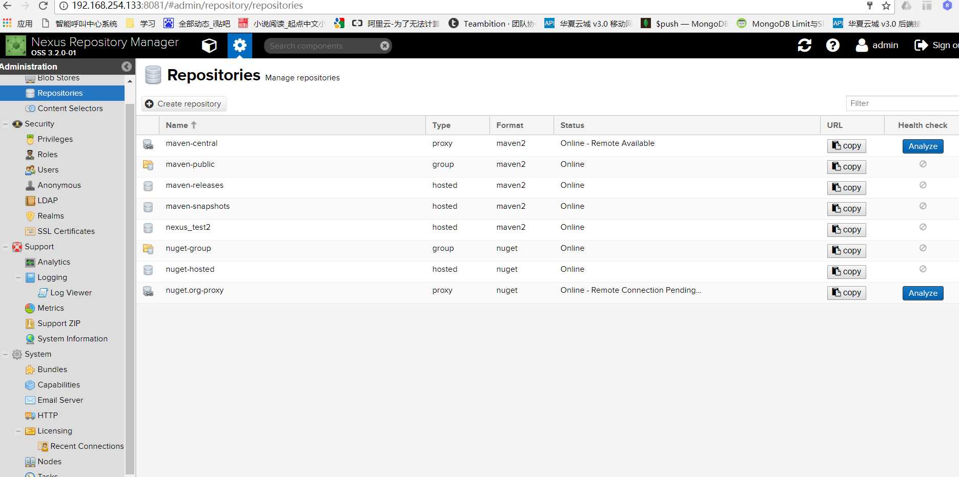

**二．配置myeclipse maven**

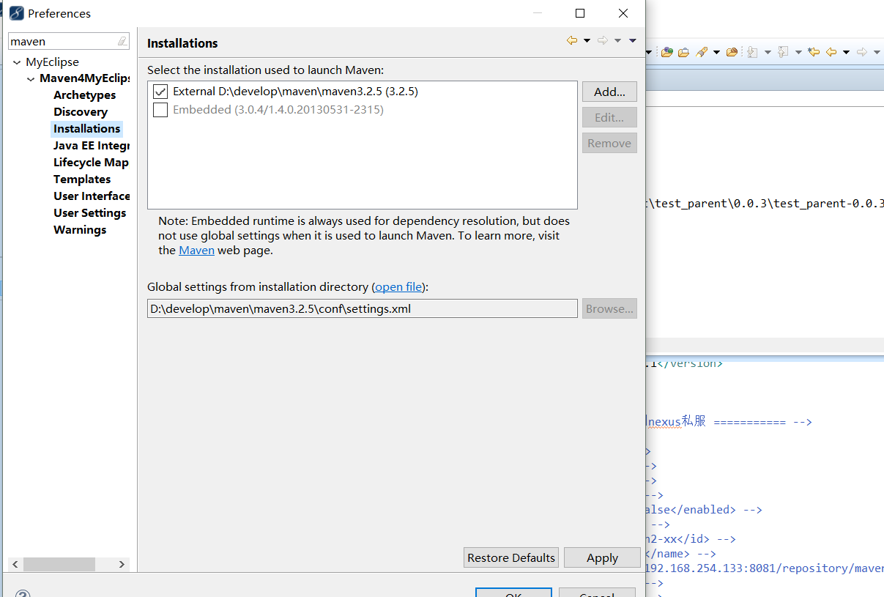

找到本地maven配置文件

找到节点<servers>添加如下

<server>

<id>test_mavn2_r</id> <!—名字随意，但是需要在pop.xml文件中使用 -->

<username>admin</username>

<password>admin123</password>

</server>

找到pop.xml文件

上传jar到nexus配置

<project xmlns=*"http://maven.apache.org/POM/4.0.0"* xmlns:xsi=*"http://www.w3.org/2001/XMLSchema-instance"* xsi:schemaLocation=*"http://maven.apache.org/POM/4.0.0 http://maven.apache.org/xsd/maven-4.0.0.xsd"*>

<modelVersion>4.0.0</modelVersion>

<groupId>com.test.ttt</groupId>

<artifactId>test_parent</artifactId>

<version>0.0.3-SNAPSHOT </version>

<packaging>pom</packaging>

<name>TestWeb</name>

<description/>

<properties>

<webVersion>3.1</webVersion>

<project.build.sourceEncoding>UTF-8</project.build.sourceEncoding>

</properties>

<dependencies>

</dependencies>

<!-- 设置deploy的地址 -->

<distributionManagement>

<!-- releases 提交，版本version中不能带有-SNAPSHOT 标记，否则会报错400 -->

<!-- <repository> -->

<!-- <id>test_mavn2_r</id> --> <!—setting中id名称 -->

<!-- <name>public release resp</name> -->

<!-- <url>http://192.168.254.133:8081/repository/maven-releases/</url> -->

<!-- </repository> -->

<!-- snapshot 提交，版本version中必须带有-SNAPSHOT 标记，否则会报错400 -->

<snapshotRepository>

<id>test_mavn2_s</id><!—setting中id名称 -->

<name>public snapshot resp</name>

<url>[http://192.168.254.133:8081/repository/nexus_test2/</url><!—](http://192.168.254.133:8081/repository/nexus_test2/%3c/url%3e%3c!—) Nexus中hostl地址 -->

</snapshotRepository>

</distributionManagement>

<build>

</build>

</project>

**这里复制地址**

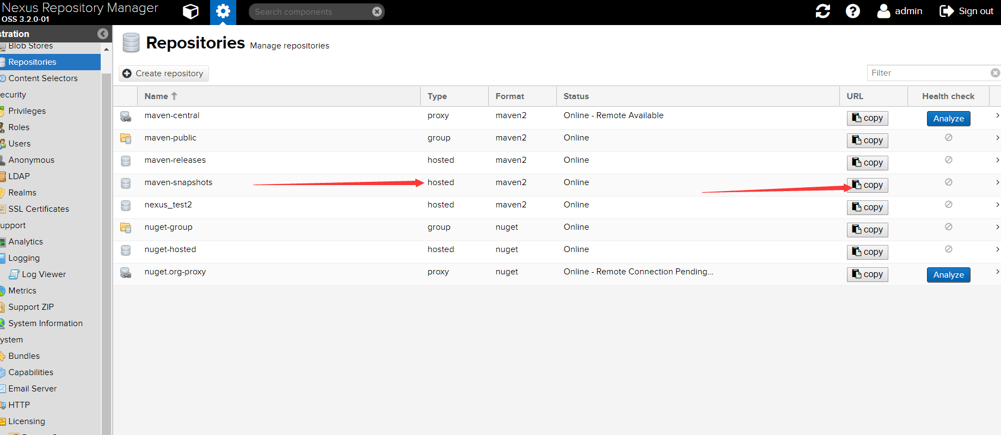

下载jar到本地配置

项目pom文件添加配置

<repositories>

<repository>

<id>nexus</id>

<name>nexus</name>

<url>http://222.85.134.64:9038/repository/jky/</url>

<releases>

<enabled>true</enabled>

</releases>

<snapshots>

<enabled>true</enabled>

</snapshots>

</repository>

</repositories>

Myeclipse 设置maven上传项目到nexus

配置maven build 参数deploy -e