Specification Confirmation Sheet

Specification Submit Date: August 23, 2004
Type of Specification (Please tick the appropriate):
(X) Customization ( ) MFG/PRO Data Conversion ( ) MFG/PRO CIM Load
( ) System Installation ( ) Others (Please Specify)
Customer | Eastar (H.K.) Ltd.
Specification No. | EAS048 | Version | A
Title | Normal Sales Invoice Print
O.S. Version | Linux | MFG/PRO  Version | eB(SP5) | Database Type | Progress 9.1D
Please kindly confirm on the customization specification and fax to us within 5 days from the ‘Submit Date’. This confirmation serves as a formal approval to proceed on the program coding.
Prepared By: Ricky Ho
(Technical Consultant)
Signature:
Date:
Endorsed By: Ricky Ho
(Programmer / Technical Consultant)
Signature:
Date:

Confirmed By:
(Customer)
Signature:

Date:

Objectives
The main objective of this program enhance Normal Sales Invoice Print base on EAS044.

Modification Reference
The customization is based on Progress version 9.1D, MFG/PRO Version eB SP5 Char, on Linux 7.2 server.
All corresponding references to this modification will be under the Ref No.EAS048A

Language
This Modification is for US/TW Character Mode only.

System Flow
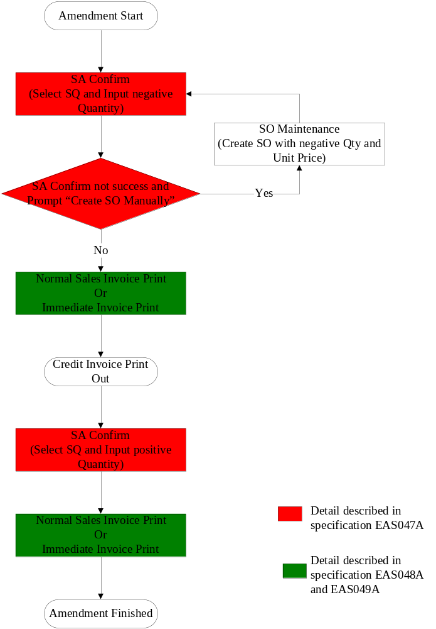

Program Function Summary
- The Program ID is xxnmlinvpt.p
- Let user to print credit normal sales invoice.
- No other invoice can be printed out if credit invoice not yet print out. That means if the program find out there are some credit invoice not yet printed, it should print credit invoice first before print debit normal sales invoice.
- Do not combine credit invoice quantity with other invoice quantity.
- After printed credit normal invoice, record field shad_crd_ni as credit invoice number, and if the field shad_crd_ii not blank, then set shad_crd_qty to zero.
- Report format is based on Customer existing Normal Sales Invoice layout and have some changes as requested by Customer.
- User can select the types of invoice to be printed. If selection = “1”, then separate invoice will be printed by Customer PO/Item. If selection = “2”, then separate invoice will be printed by Shipping Advise number.
- User can select the option to print Company Address Lines on invoice by enter “Yes” of “Print Company Address” parameter. If enter “No”, then system will not print address lines on invoice.
- System should generate Normal Invoice number automatically by Prefix “3YY”, where “3” is hard-coded and “YY” is the last 2 digits of current year.
- After the printing of Normal Sales Invoice, system should send message “Normal Sales Invoice Print accepted? Yes”, if user feedback = No, then system should fall back selected SA to un-print status.
- Once user confirm accept printed normal sales invoice, system will update normal invoice number into SA header file to indicate Normal Invoice being printed.
- If “Print Service Charge Statement = YES”, the “Service Charge Percentage” MUST greater than zero and print the corresponding statement.
- If “Print Return & Claims Statement = YES”, the “No. of Claim Days” MUST greater than zero and print the corresponding statement.
- The followings will be printed on every page: -
  - Company name and address lines (when Print Company Address = YES), report title (Invoice), Invoice Number, Date, Credit Terms, Page no., Ship To Name and Address, Ship-To Attention Name, Bill-To Name and Address, Bill-To Attention Name, Column heading (Part No., P/O #, Description, QTY, U/M, U/Price, U/Price Currency Code, Amount, Amount Currency Code, page continue indicator (….Cont.)
- The followings will be printed during the last page: -
  - Column totals of Amount, Shipper Co (SEA), Vessel Name(SEA), Air Forwarder(AIR), Housing AWB(AIR), Master AWB(AIR), Flight No.(AIR), B/L No., ETD HK, ETA, Container no(SEA). Country of ORIGIN (SEA).
- The detail printing sequence for SEA and AIR order is firstly by Customer PO Number in ascending sequence, then, Part Number sequence.

- Input Screen/Criteria

0 10 20 30 40 50 60 70 80
|--------|---------|---------|---------|---------|---------|---------|---------|
12345678901234567890123456789012345678901234567890123456789012345678901234567890
|xxnmlinvpt.p Normal Sales Invoice Print 99/99/99|
|------------------------------------------------------------------------------| | Shipping Advise No.: xxxxxxxx To: xxxxxxxx |
| Invoice Print by : 9 1 – Customer PO / Item |
| 2 – Shipping Advise |
19
| |
| Print Service Charge statement : yes Service Charge Percentage: 99 |
| Print Return & Claims statement: yes No. of Days: 99 |
28
| Print Company Address : yes |
| |
| |
| Output: |
| Batch ID: |
| |
12345678901234567890123456789012345678901234567890123456789012345678901234567890
+------------------------------------------------------------------------------+

- Normal Sales Invoice Layout – By SEA

012345678901234567890123456789012345678901234567890123456789012345678901234567890
+ 10 20 30 40 50 60 70 80
+---------|---------|---------|---------|---------|---------|---------|---------+
| |
|E A S T A R (HK) L I M I T E D |
|UNIT G, 19/F.,WORLD TECH CENTRE, 95 HOW MING STREET,KWUN TONG,HONG KONG Print|company = YES
|TEL:(852)2342-7688 FAX:(852)3101-9202 |
| |
| |
| I N V O I C E |
06
01
| |
|-------------------------------------------------------------------------------|
05
02
|TERMS:xxxxxxxxxxxxxxxxxxxxxxxx DATE:99MMMYYYY INVOICE NO:2YY99999 PAGE:999 |
|-------------------------------------------------------------------------------|
03
07
| |
|BILL To : XXXXXXXXXXXXXXXXXXXXXXXXXXXX SHIP To : XXXXXXXXXXXXXXXXXXXXXXXXXXXX |
| XXXXXXXXXXXXXXXXXXXXXXXXXXXX XXXXXXXXXXXXXXXXXXXXXXXXXXXX |每一頁列印
| XXXXXXXXXXXXXXXXXXXXXXXXXXXX XXXXXXXXXXXXXXXXXXXXXXXXXXXX |
| XXXXXXXXXXXXXXXXXXXXXXXXXXXX XXXXXXXXXXXXXXXXXXXXXXXXXXXX |
| XXXXXXXXXXXXXXXXXXXX XXXXXXXXXXXXXXXXXXXX |
04
|ATTN : XXXXXXXXXXXXXXXXXXXXXXXXXXXX ATTN : XXXXXXXXXXXXXXXXXXXXXXXXXXXX |
08
| |
10
| |
09
| PART NO |
|CUSTOMER PO DESCRIPTION QTY U/M U/PRICE(CUR) AMOUNT(CUR)|
15
|-------------------------------------------------------------------------------|
12
13
|XXXXXXXXXXXX XXXXXXXXXXXXXXXXXX ->,>>>,>>9.99 EA >>>,>>9.9999 ->>>,>>9.9999|
14
16
17
18
| XXXXXXXXXXXXXXXXXXXXXXXX |
| XXXXXXXXXXXXXXXXXXXXXXXX |
| XXXXXXXXXXXXXXXXXXXXXXXX |
| XXXXXXXXXXXXXXXXXXXXXXXX |
| |
|XXXXXXXXXXXX XXXXXXXXXXXXXXXXXX ->,>>>,>>9.99 EA >>>,>>9.9999 ->>>,>>9.9999|每一頁列印
| XXXXXXXXXXXXXXXXXXXXXXXX |
| XXXXXXXXXXXXXXXXXXXXXXXX |
| XXXXXXXXXXXXXXXXXXXXXXXX |
| XXXXXXXXXXXXXXXXXXXXXXXX |
| |
|XXXXXXXXXXXX XXXXXXXXXXXXXXXXXX ->,>>>,>>9.99 EA >>>,>>9.9999 ->>>,>>9.9999|
| XXXXXXXXXXXXXXXXXXXXXXXX |
| XXXXXXXXXXXXXXXXXXXXXXXX |
| XXXXXXXXXXXXXXXXXXXXXXXX |
| XXXXXXXXXXXXXXXXXXXXXXXX |
| |
20
| ----------------|
| 最後一頁才列印 ➔ Total:->,>>>,>>9.9999|
| ================|
| Print service charge statement = YES PAST DUE ACCOUNTS MAY BE ASSESSED |
| A SERVICE CHARGE OF ??% PER MONTH |
| |
19
22
| |
23
| SHIPPING CO : XXXXXXXXXXXXXXXXXXXX |
| VESSEL NAME : XXXXXXXXXXXXXXXXXXXXXXXXXXXXXX 最後一頁才列印 | | B/L NO. : XXXXXXXXXXXXXXXXXXXXXXXXXXXXXX |
24
| COUNTRY OF ORIGIN: XXXXXXXXXXXXXXXXXXXXXXXXXXXXXX |
25
| ETD HK : 99 MMM YYYY |
26
27
| CONTAINER NO. : XXXXXXXXXXXXXXXXXXXXXXXXXXXXXX |
| |
|NO RETURNS ACCEPTED UNLESS AUTHORIZED BY EASTAR (HK) LIMITED Print return & cla|im statement = YES
|ALL CLAIMS MUST BE MADE WITHIN ??DAYS UPON GOODS RECEIVED |
28
| |
| |
| ***** END *****最後一頁才列印 Continue…. |
| |
|THIS IS A COMPUTER-GENERATED DOCUMENT AND NO SIGNATURE REQUIRED |
+---------------------------------------------------------------+

- Normal Sales Invoice Layout – By AIR

012345678901234567890123456789012345678901234567890123456789012345678901234567890
+ 10 20 30 40 50 60 70 80
+---------|---------|---------|---------|---------|---------|---------|---------+
| |
| |
|E A S T A R (HONG KONG) L I M I T E D |
|UNIT G, 19/F.,WORLD TECH CENTRE, 95 HOW MING STREET,KWUN TONG,HONG KONG Print|company = YES
|TEL:(852)2342-7688 FAX:(852)3101-9202 |
| |
| |
| I N V O I C E |
| |
|-------------------------------------------------------------------------------|
|TERMS:xxxxxxxxxxxxxxxxxxxxxxxx DATE:99MMMYYYY INVOICE NO:2YY99999 PAGE:999 |
|-------------------------------------------------------------------------------|
| |
|BILL To : XXXXXXXXXXXXXXXXXXXXXXXXXXXX SHIP To : XXXXXXXXXXXXXXXXXXXXXXXXXXXX |
| XXXXXXXXXXXXXXXXXXXXXXXXXXXX XXXXXXXXXXXXXXXXXXXXXXXXXXXX |每一頁列印
| XXXXXXXXXXXXXXXXXXXXXXXXXXXX XXXXXXXXXXXXXXXXXXXXXXXXXXXX |
| XXXXXXXXXXXXXXXXXXXXXXXXXXXX XXXXXXXXXXXXXXXXXXXXXXXXXXXX |
| XXXXXXXXXXXXXXXXXXXX XXXXXXXXXXXXXXXXXXXX |
|ATTN : XXXXXXXXXXXXXXXXXXXXXXXXXXXX ATTN : XXXXXXXXXXXXXXXXXXXXXXXXXXXX|
| |
| |
| PART NO |
|CUSTOMER PO DESCRIPTION QTY U/M U/PRICE(CUR) AMOUNT(CUR)|
|-------------------------------------------------------------------------------|
|XXXXXXXXXXXX XXXXXXXXXXXXXXXXXX ->,>>>,>>9.99 EA >>>,>>9.9999 ->>>,>>9.9999|
| XXXXXXXXXXXXXXXXXXXXXXXX |
| XXXXXXXXXXXXXXXXXXXXXXXX |
| XXXXXXXXXXXXXXXXXXXXXXXX |
| XXXXXXXXXXXXXXXXXXXXXXXX |
| |
|XXXXXXXXXXXX XXXXXXXXXXXXXXXXXX ->,>>>,>>9.99 EA >>>,>>9.9999 ->>>,>>9.9999|每一頁列印
| XXXXXXXXXXXXXXXXXXXXXXXX |
| XXXXXXXXXXXXXXXXXXXXXXXX |
| XXXXXXXXXXXXXXXXXXXXXXXX |
| XXXXXXXXXXXXXXXXXXXXXXXX |
| |
|XXXXXXXXXXXX XXXXXXXXXXXXXXXXXX ->,>>>,>>9.99 EA >>>,>>9.9999 ->>>,>>9.9999|
| XXXXXXXXXXXXXXXXXXXXXXXX |
| XXXXXXXXXXXXXXXXXXXXXXXX |
| XXXXXXXXXXXXXXXXXXXXXXXX |
| XXXXXXXXXXXXXXXXXXXXXXXX |
| |
| ----------------|
| 最後一頁才列印 ➔ Total:->,>>>,>>9.9999|
| ================|
| PAST DUE ACCOUNTS MAY BE ASSESSED |
| A SERVICE CHARGE OF ??% PER MONTH |
| |
| |
30
29
| AIR FORWARDER: XXXXXXXXXXXXXXXXXXXX |
| HOUSING AWB# : XXXXXXXXXXXXXXXXXXXXXXXXXXXXXX | | MASTER AWB# : XXXXXXXXXXXXXXXXXXXXXXXXXXXXXX |最後一頁才列印
31
| FLIGHT NO. : XXXXXXXXXXXXXXXXXXXXXXXXXXXXXX |
| ETD HK : 99 MMM YYYY |
32
| |
|NO RETURNS ACCEPTED UNLESS AUTHORIZED BY EASTAR (HK) LIMITED |
|ALL CLAIMS MUST BE MADE WITHIN ??DAYS UPON GOODS RECEIVED |
| |
| |
| ***** END *****最後一頁才列印 Continue…. |
| |
|THIS IS A COMPUTER-GENERATED DOCUMENT AND NO SIGNATURE REQUIRED |
+---------------------------------------------------------------+

Seq | Label | Field Name | Format | Type | Remark
1 | Date | shad_inv_date | DATE | D | Invoice Date
2 | Invoice No. | Variable Define | x(8) | D | Normal Sales Invoice Number
3 | Ship To | Variable Define |  | D | Customer Name (Ship To)  1st line = customer ship-to name  2nd line = customer ship-to address line 1  3rd line = customer ship-to address line 2  4th line = customer ship-to address line 3  5th line = customer ship-to address city
4 | Attn | ad_attn | x(24) | D | Customer Ship To Attention Name
5 | Terms |  | x(24) | D | Credit Terms Description. Credit Terms Code from Sales Order
6 | PAGE | Variable Define | >>9 | D | Page number
7 | Bill To | Variable Define |  | D | Customer Name (Bill To)  1st line = customer bill-to name  2nd line = customer bill-to address line 1  3rd line = customer bill-to address line 2  4th line = customer bill-to address line 3  5th line = customer bill-to address city
8 |  | ad_attn | x(24) | D | Customer Bill To Attention Name
9 |  | so_curr | x(3) | D | Currency Code
10 |  | so_curr | x(3) | D | Currency Code
11
12 | Part No. | shad_part | x(18) | D | Item number
13 | PO # | shad_ponbr | x(12) | D | Cust PO number
14 | Description | sod_desc | x(24) | D | Item Description in Sales Order Details  1st line = description <> BLANK  2nd line = description <> BLANK  3rd line = description <> BLANK  4th line = description <> BLANK
15 | QTY | shad_ext_qty or shad_crd_qty | ->>,>>>,>>9.9< | D | Extended Quantity
16 | U/M | sod_um | x(2) | D | Unit of Measure
17 | U/Price | sod_list_pr | >>>,>>9.9<<< | D | Unit Price
18 | Amount | Variable Define | ->>>,>>9.9<<< | D | Net Amount = QTY * U/Price
19 |  | Variable Define | >9 | C | Service charge percentage
20 |  | Variable Define | ->>,>>>,>>9.9< | D | Total Invoice Amount. = Sum of Net Amount
21
22 | Shipping CO | shad_forwarder | x(20) | D | Forwarder
23 | Vessel Name | shad_desc_line1 | x(30) | D | Vessel Name
24 | B/L No. | shad_desc_line2 | x(30) | D | B/L number
25 | Country of Origin | shad_desc_line3 | x(30) | D | Country of ORIGIN
26 | ETD-HK | shad_etdhk | DATE | D | ETD HK Date
27 | Container | shad_container | x(24) | D | Container Number
28 |  | Variable Define | >9 | C | No. of Claim Days
29 | Air Forwarder | shad_forwarder | x(20) | D | Forwarder
30 | Housing AWB | shad_desc_line1 | x(30) | D | Housing AWB
31 | Master AWB | shad_desc_line2 | x(30) | D | Master AWB
32 | Flight No. | shad_desc_line4 | x(30) | D | Flight Numebr

Type: “M” = Mandatory; “O” = Optional, “D” = Display, “C” = Conditional.

<END>

