Specification Confirmation Sheet

Specification Submit Date: August 23, 2004
Type of Specification (Please tick the appropriate):
(X) Customization ( ) MFG/PRO Data Conversion ( ) MFG/PRO CIM Load
( ) System Installation ( ) Others (Please Specify)
Customer | Eastar (H.K.) Ltd.
Specification No. | EAS049 | Version | A
Title | Immediate Invoice Print
O.S. Version | Linux | MFG/PRO  Version | eB(SP5) | Database Type | Progress 9.1D
Please kindly confirm on the customization specification and fax to us within 5 days from the ‘Submit Date’. This confirmation serves as a formal approval to proceed on the program coding.
Prepared By: Ricky Ho
(Technical Consultant)
Signature:
Date:
Endorsed By: Ricky Ho
(Programmer / Technical Consultant)
Signature:
Date:

Confirmed By:
(Customer)
Signature:

Date:

Objectives
The main objective of this program is to enhance Immediate Invoice print base on EAS045.

Modification Reference
The customization is based on Progress version 9.1D, MFG/PRO Version eB SP5 Char, on Linux 7.2 server.
All corresponding references to this modification will be under the Ref No.EAS049A.

Language
This Modification is for US/TW Character Mode only.

System flow
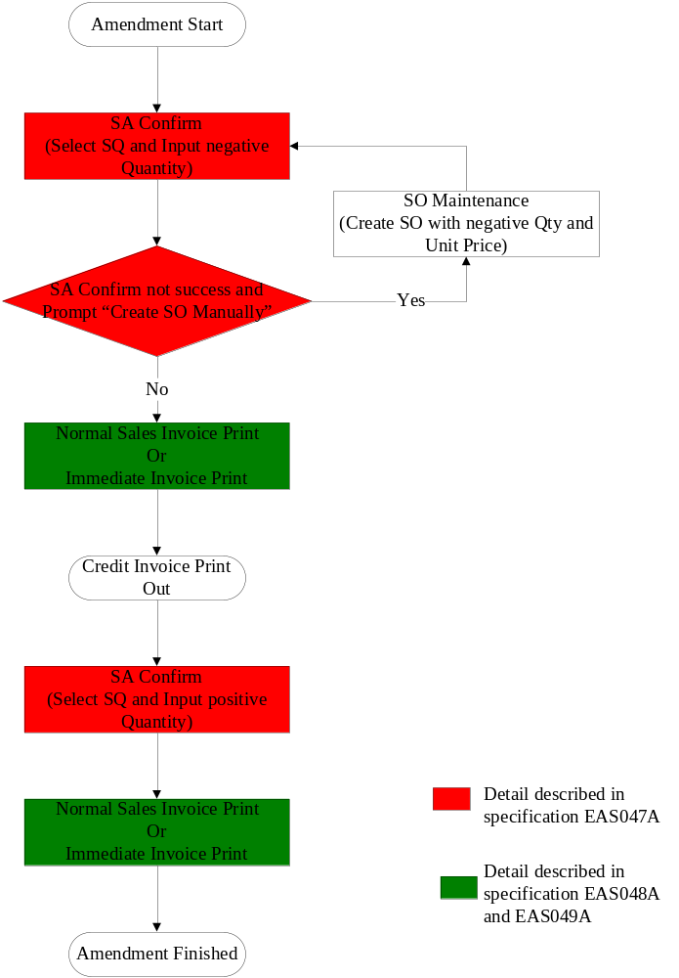.

Program Function Summary
- The Program ID is xximdinvpt.p
- Let user to print credit immediate invoice.
- No other invoice can be printed out if credit invoice not yet print out. That means if the program find out there are some credit invoice not yet printed, it should print credit invoice first before print debit immediate sales invoice.
- Do not combine credit invoice quantity with other invoice quantity.
- After printed credit immediate invoice, record field shad_crd_ii as credit invoice number, and if the field shad_crd_ni not blank, then set shad_crd_qty to zero.
- Report format is based on Customer existing Immediate Invoice layout and have some changes as requested by Customer.
- User can select the types of invoice to be printed. If selection = “1”, then separate invoice will be printed by Customer PO/Item. If selection = “2”, then separate invoice will be printed by Shipping Advise number.
- User can select the option to print Company Address Lines on invoice by enter “Yes” of “Print Company Address” parameter. If enter “No”, then system will not print address lines on invoice.
- System should generate Immediate Invoice number automatically by Prefix “4YY”, where “4” is hard-coded and “YY” is the last 2 digits of current year.
- After the printing of Immediate Invoice, system should send message “Immediate Invoice Print accepted? Yes”, if user feedback = No, then system should fall back selected SA to un-print status.
- Once user confirm accept printed immediate invoice, system will update immediate invoice number into SA header file to indicate Immediate Invoice being printed.
- If “Print Service Charge Statement = YES”, the “Service Charge Percentage” MUST greater than zero and print the corresponding statement.
- If “Print Return & Claims Statement = YES”, the “No. of Claim Days” MUST greater than zero and print the corresponding statement.
- The followings will be printed on every page: -
  - Company name and address lines (when Print Company Address = YES), report title (Invoice), Invoice Number, Date, Credit Terms, Page no., Ship To Name and Address, Ship-To Attention Name, Bill-To Name and Address, Bill-To Attention Name, Column heading (Part No., P/O #, Description, QTY, U/M, U/Price, U/Price Currency Code, Amount, Amount Currency Code, page continue indicator (….Cont.)
- The followings will be printed during the last page: -
  - Column totals of Amount.
- The detail printing sequence is firstly by Customer PO Number in ascending sequence, then, Part Number sequence.

- Input Screen/Criteria

0 10 20 30 40 50 60 70 80
|--------|---------|---------|---------|---------|---------|---------|---------|
12345678901234567890123456789012345678901234567890123456789012345678901234567890
|xximdinvpt.p Immediate Invoice Print 99/99/99|
|------------------------------------------------------------------------------| | Shipping Advise No.: xxxxxxxx To: xxxxxxxx |
| Invoice Print by : 9 1 – Customer PO / Item |
| 2 – Shipping Advise |
19
| |
| Print Service Charge statement : yes Service Charge Percentage: 99 |
| Print Return & Claims statement: yes No. of Days: 99 |
21
| Print Company Address : yes |
| |
| |
| Output: |
| Batch ID: |
| |
12345678901234567890123456789012345678901234567890123456789012345678901234567890
+------------------------------------------------------------------------------+

- Immediate Invoice Layout

012345678901234567890123456789012345678901234567890123456789012345678901234567890
+ 10 20 30 40 50 60 70 80
+---------|---------|---------|---------|---------|---------|---------|---------+
| |
|E A S T A R (HK) L I M I T E D |
|UNIT G, 19/F.,WORLD TECH CENTRE, 95 HOW MING STREET,KWUN TONG,HONG KONG Print|company = YES
|TEL:(852)2342-7688 FAX:(852)3101-9202 |
| |
| I N V O I C E |
06
02
01
| |
|-------------------------------------------------------------------------------|
05
|TERMS:xxxxxxxxxxxxxxxxxxxxxxxx DATE:99MMMYYYY INVOICE NO:4YY99999 PAGE:999 |
|-------------------------------------------------------------------------------|
03
07
| |
|BILL To : XXXXXXXXXXXXXXXXXXXXXXXXXXXX SHIP To : XXXXXXXXXXXXXXXXXXXXXXXXXXXX |
| XXXXXXXXXXXXXXXXXXXXXXXXXXXX XXXXXXXXXXXXXXXXXXXXXXXXXXXX |每一頁列印
| XXXXXXXXXXXXXXXXXXXXXXXXXXXX XXXXXXXXXXXXXXXXXXXXXXXXXXXX |
| XXXXXXXXXXXXXXXXXXXXXXXXXXXX XXXXXXXXXXXXXXXXXXXXXXXXXXXX |
| XXXXXXXXXXXXXXXXXXXX XXXXXXXXXXXXXXXXXXXX |
04
|ATTN : XXXXXXXXXXXXXXXXXXXXXXXXXXXX ATTN : XXXXXXXXXXXXXXXXXXXXXXXXXXXX |
08
| |
10
| |
09
| PART NO |
|CUSTOMER PO DESCRIPTION QTY U/M U/PRICE(CUR) AMOUNT(CUR)|
15
|-------------------------------------------------------------------------------|
12
13
|XXXXXXXXXXXX XXXXXXXXXXXXXXXXXX ->,>>>,>>9.99 EA >>>,>>9.9999 ->>>,>>9.9999|
14
16
17
18
| XXXXXXXXXXXXXXXXXXXXXXXX |
| XXXXXXXXXXXXXXXXXXXXXXXX |
| XXXXXXXXXXXXXXXXXXXXXXXX |
| XXXXXXXXXXXXXXXXXXXXXXXX |
| |
|XXXXXXXXXXXX XXXXXXXXXXXXXXXXXX ->,>>>,>>9.99 EA >>>,>>9.9999 ->>>,>>9.9999|每一頁列印
| XXXXXXXXXXXXXXXXXXXXXXXX |
| XXXXXXXXXXXXXXXXXXXXXXXX |
| XXXXXXXXXXXXXXXXXXXXXXXX |
| XXXXXXXXXXXXXXXXXXXXXXXX |
| |
|XXXXXXXXXXXX XXXXXXXXXXXXXXXXXX ->,>>>,>>9.99 EA >>>,>>9.9999 ->>>,>>9.9999|
| XXXXXXXXXXXXXXXXXXXXXXXX |
| XXXXXXXXXXXXXXXXXXXXXXXX |
| XXXXXXXXXXXXXXXXXXXXXXXX |
| XXXXXXXXXXXXXXXXXXXXXXXX |
| |
| |
20
| ----------------|
| 最後一頁才列印 ➔ Total: ->,>>>,>>9.9999|
| ================|
| Print service charge statement = YES PAST DUE ACCOUNTS MAY BE ASSESSED |
| A SERVICE CHARGE OF ??% PER MONTH |
| |
19
| |
|NO RETURNS ACCEPTED UNLESS AUTHORIZED BY EASTAR (HK) LIMITED Print return & cla|im statement = YES
|ALL CLAIMS MUST BE MADE WITHIN ??DAYS UPON GOODS RECEIVED |
21
| |
| |
| ***** END *****最後一頁才列印 Continue…. |
| |
|THIS IS A COMPUTER-GENERATED DOCUMENT AND NO SIGNATURE REQUIRED |
+---------------------------------------------------------------+

Seq | Label | Field Name | Format | Type | Remark
1 | Date | shad_inv_date | DATE | D | Invoice Date
2 | Invoice No. | Variable Define | x(8) | D | Immediate Invoice Number
3 | Ship To | Variable Define |  | D | Customer Name (Ship To)  1st line = customer ship-to name  2nd line = customer ship-to address line 1  3rd line = customer ship-to address line 2  4th line = customer ship-to address line 3  5th line = customer ship-to address city
4 | Attn | ad_attn | x(24) | D | Customer Ship To Attention Name
5 | Terms |  | x(24) | D | Credit Terms Description. Credit Terms Code from Sales Order
6 | PAGE | Variable Define | >>9 | D | Page number
7 | Bill To | Variable Define |  | D | Customer Name (Bill To)  1st line = customer bill-to name  2nd line = customer bill-to address line 1  3rd line = customer bill-to address line 2  4th line = customer bill-to address line 3  5th line = customer bill-to address city
8 |  | ad_attn | x(24) | D | Customer Bill To Attention Name
9 |  | so_curr | x(3) | D | Currency Code
10 |  | so_curr | x(3) | D | Currency Code
11
12 | Part No. | shad_part | x(18) | D | Item number
13 | PO # | shad_ponbr | x(12) | D | Cust PO number
14 | Description | sod_desc | x(24) | D | Item Description in Sales Order Details  1st line = description <> BLANK  2nd line = description <> BLANK  3rd line = description <> BLANK  4th line = description <> BLANK
15 | QTY | shad_ext_qty or shad_crd_qty | ->>,>>>,>>9.9< | D | Extended Quantity
16 | U/M | sod_um | x(2) | D | Unit of Measure
17 | U/Price | sod_list_pr | >>>,>>9.9<<< | D | Unit Price
18 | Amount | Variable Define | ->>>,>>9.9<<< | D | Net Amount = QTY * U/Price
19 |  | Variable Define | >9 | C | Service charge percentage
20 |  | Variable Define | ->>,>>>,>>9.9< | D | Total Invoice Amount. = Sum of Net Amount
21 |  | Variable Define | >9 | C | No. of Claim Days

Type: “M” = Mandatory; “O” = Optional, “D” = Display, “C” = Conditional.

<END>

