Specification Confirmation Sheet

Specification Submit Date: Mar 27, 2006
Type of Specification (Please tick the appropriate):
(X) Customization ( ) MFG/PRO Data Conversion ( ) MFG/PRO CIM Load
( ) System Installation ( ) Others (Please Specify)
Customer | Eastar (H.K.) Ltd.
Specification No. | EAS054 | Version | A
Title | WO Issue
O.S. Version | Linux | MFG/PRO  Version | eB(SP5) | Database Type | Progress 9.1D
Please kindly confirm on the customization specification and fax to us within 5 days from the ‘Submit Date’. This confirmation serves as a formal approval to proceed on the program coding.
Prepared By: Davild Xu
(Technical Consultant)
Signature:
Date:
Endorsed By: Davild Xu
(Programmer / Technical Consultant)
Signature:
Date:

Confirmed By:
(Customer)
Signature:

Date:

- 目標
修改Planned Purchase Order Approval(23.11)程式（使得用戶可以修改數量、下達日期及到期日）。

- 程式修改參考
程式修改是根據MFG/PRO版本eB SP5 Char 模式，Linux 平臺｡
所有相應的修改將詳於列於程式修改參考編號.EAS0054A.

- 語言: US

Input Screen/Criteria

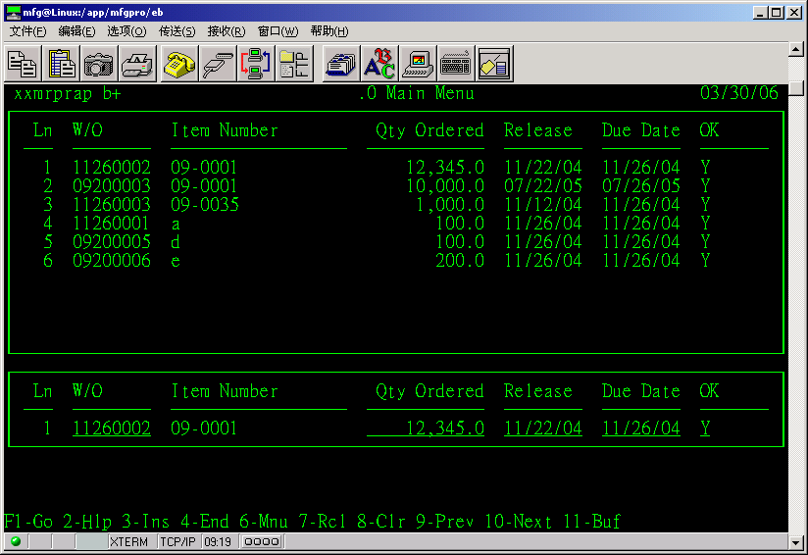

修改內容
主程序編號: xxmrprap.p 、xxmrprapa.p
使用上麵2個程序的時候,當輸入確認PO時，系統同時可以修改數量、下達日期及到期日。.
其他使用標準邏輯.

<END>

