- 1.4.1 Maintain three item:
Testtt: Issue Policy:Yes
Testt1:Issue Policy:Yes
Test-11:Issue Policy:No
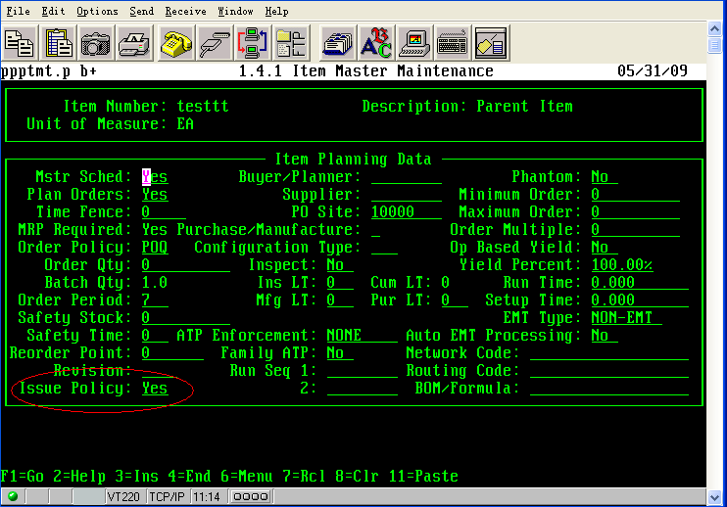

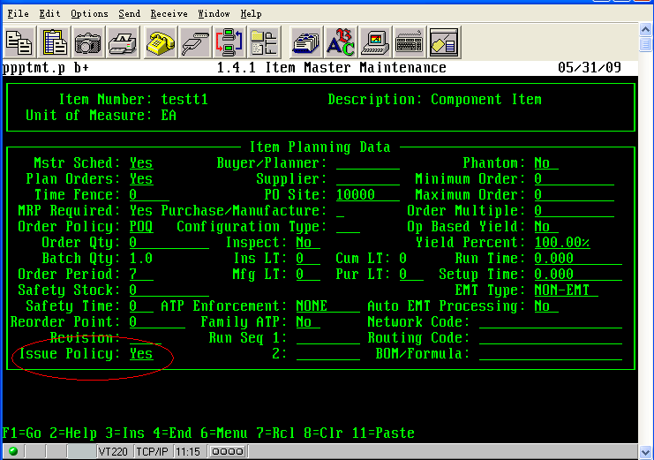
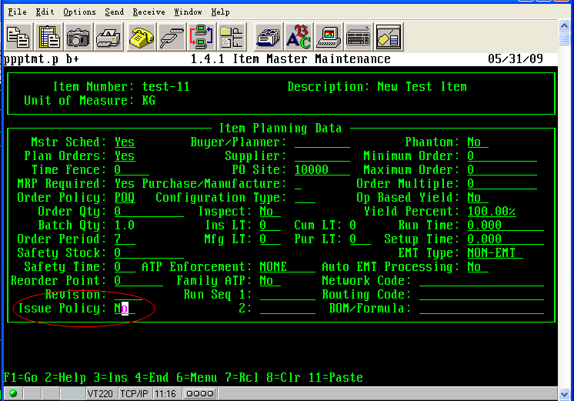

- 13.5 Maintain BOM:
Parent Item:testtt
Component Item:testt1
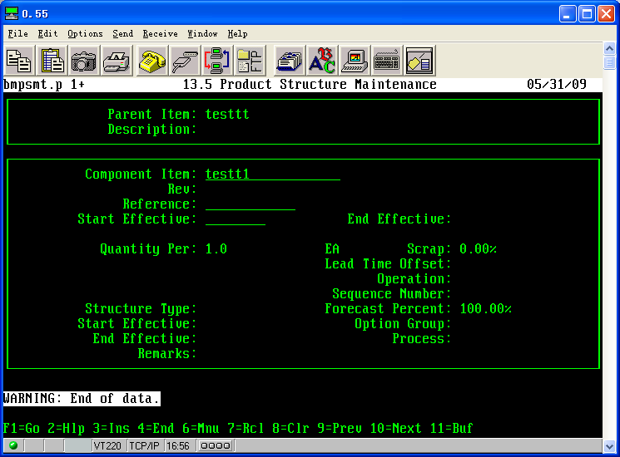

- 16.1 Maintain Work Order:400837
Work Order Status:A
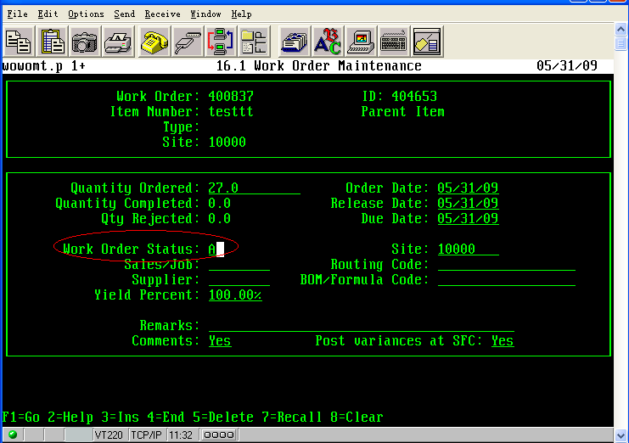

- 16.13.1
Add Component Item:test-11
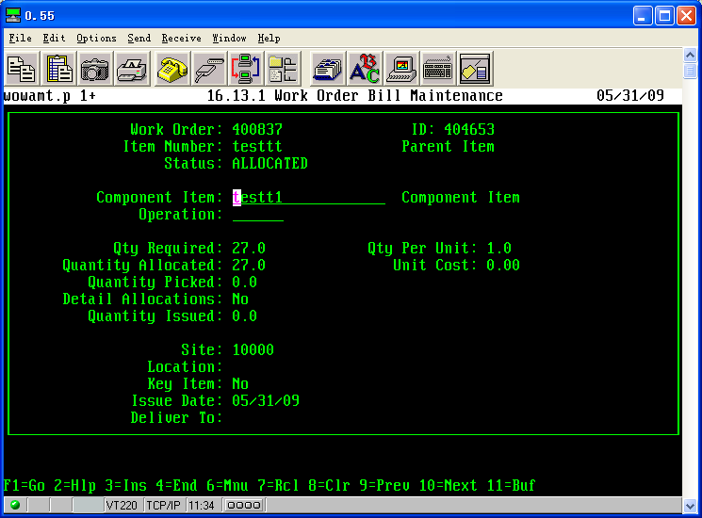

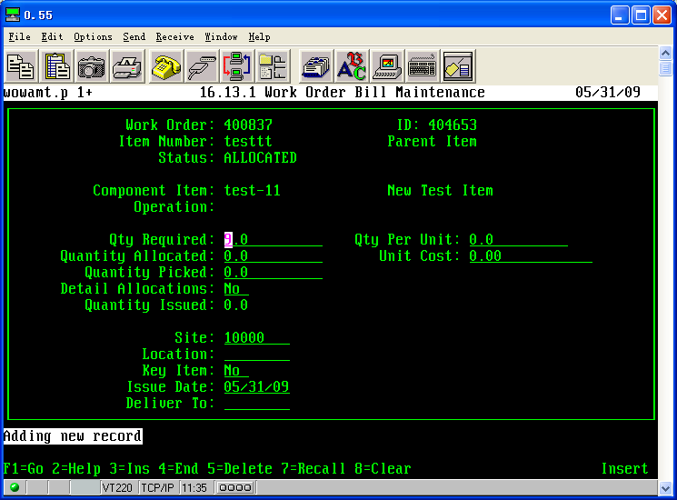

- 16.6 Work Order Release/Print:400837
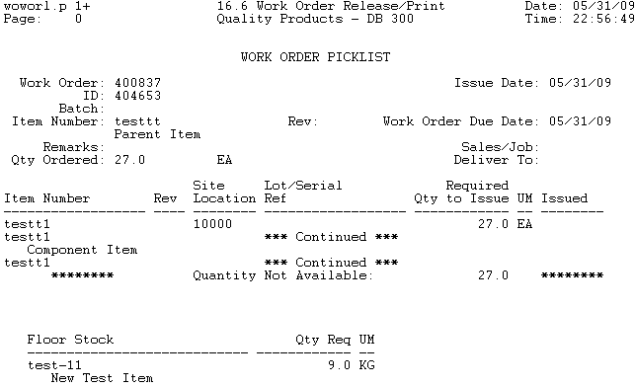

- 16.10 Work Order Component Issue
Test-11:2

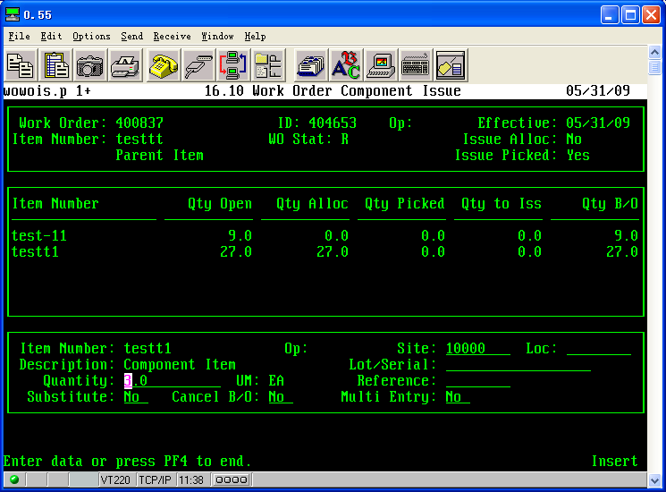

- 16.17 Work Order Bill Shortage by Item: different condition
1.
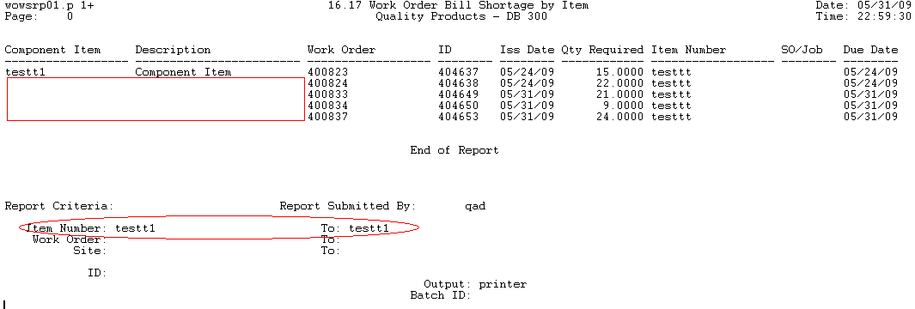
2.
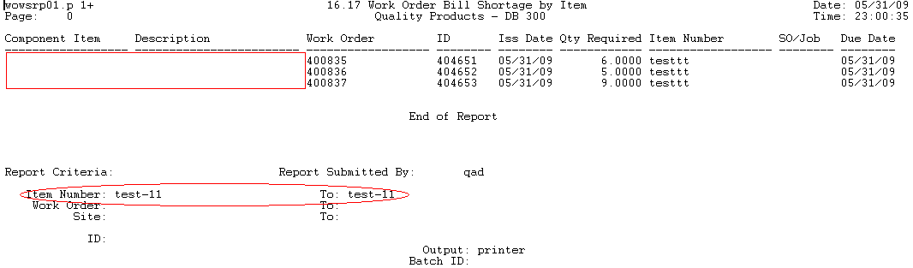

3.
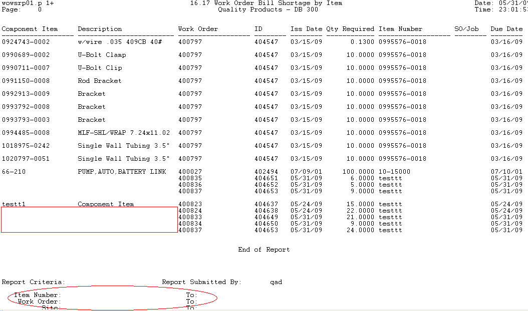

4.
