ShopFloor System安装手册
Prepared By :Roger_Xiao
Rev:2008-11-27
1.在原BC系统目录下新增目录: sfc(与tmp,xs,等同级) ,所有sfc源程式放这里
2.新增table: xxwrd_det xxprn_hist .
3.新增scripts: client.SFC** (由client.BC**修改, $xs=/*/sfc , $bc/xs, xsmfa.p-->xsmfb.p)
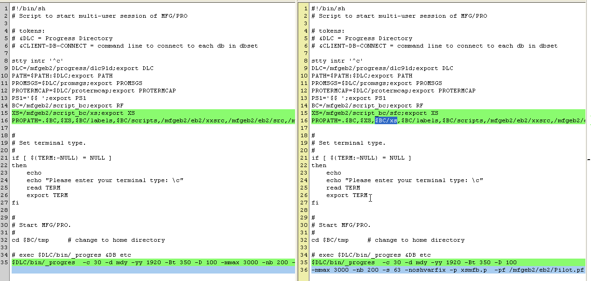
4.新建用户profile, (复制其他已有用户的即可)
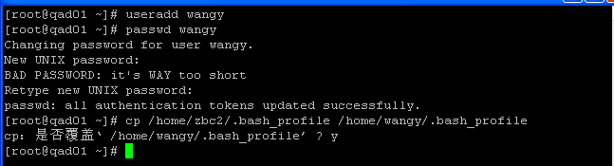
/************************* profile _start************************************/
# .bash_profile
# Get the aliases and functions
if [ -f ~/.bashrc ]; then
. ~/.bashrc
fi
# User specific environment and startup programs
PATH=$PATH:$HOME/bin
export PATH
unset USERNAME
/mfgeb2/script_bc/scripts/client.client.SFCPlt
exit
/************************* profile_end ************************************/

5. 待整理
6. 待整理
7. 待整理

