Specification Confirmation Sheet

Specification Submit Date: 03 06, 2008
Type of Specification (Please tick the appropriate):
(X) Customization ( ) MFG/PRO Data Conversion ( ) MFG/PRO CIM Load
( ) System Installation ( ) Others (Please Specify)
Customer | 隆鑫四轮车
Specification No. | Loncin10052401 |  | Version |  | A
Title | Work order with picture
O.S. Version | AIX | MFG/PRO  Version |  | EB21SP5 |  | Database Type | Progress
Please kindly confirm on the customization specification and fax to us within 5 days from the ‘Submit Date’. This confirmation serves as a formal approval to proceed on the program coding.
Prepared By: ken chen
(Technical Consultant)
Signature: ken chen
Date: 05 24, 2010
Endorsed By: Ken
(Programmer / Technical Consultant)
Signature: Ken
Date: 2010/05/24

Confirmed By:
(Customer)
Signature:

Date:

- 目标
在系统中实现转仓审批的流程
流程:
售后做转仓申请→售后打印申请单(相关主管签字后提交给相关部门,可以多联)->
->相关部门批准(系统自动做转仓)->结束
In-Scope Functionality☹范围内的功能):
- 转仓单申请维护
- 转仓单打印
- 转仓单批准
- 通过菜单权限控制安全性
Out-off scope Functionality (不在范围内的)：
- 多层申请
- 零件安全，库位安全
- 程式修改參考
无
- 語言: CH,US
CH

內容
1. 新增程序
（1） 转仓申请维护
+------------------------------------------------------------------------------+
| 转仓单: 1312 From地点: AVG01 库位: AVG01-WP |
| 生效日期: 10/01/08 To地点: STD01 库位: AVG01-FN |
+------------------------------------------------------------------------------+
+------------------------------------------------------------------------------+
|Ln Item Number Lot/Serial Reference Transfer Qty UM |
|--- ------------------ ------------------ --------- ------------- -- |
| |
| |
| |
| |
| |
+------------------------------------------------------------------------------+
+------------------------------------------------------------------------------+
| 产品线: |
| 物料号: |
| 说明: 批/序号: |
|lotser_from_qty: UM: 参考: |
+------------------------------------------------------------------------------+

(2) 转仓单打印
格式模板如下,把”发料单”改为”转仓单”，
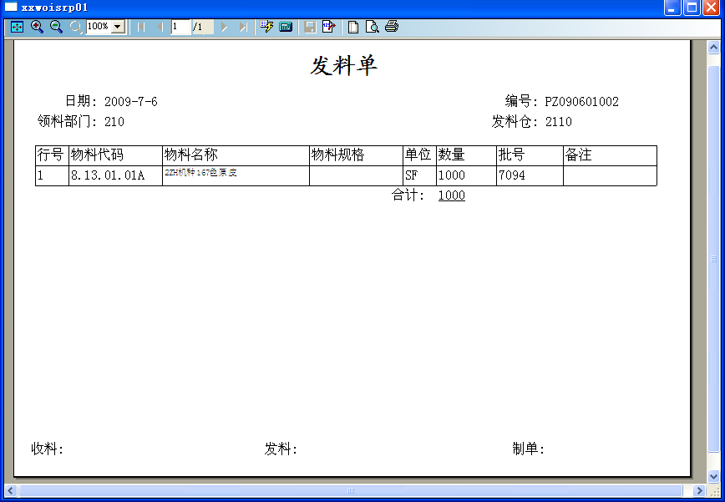
（3）转仓申请批准
+------------------------------------------------------------------------------+
| 转仓单: 112 地点: AVG01 库位: AVG01-FN |
| 生效日期: 10/01/08 库位: AVG01-RW |
+------------------------------------------------------------------------------+
+------------------------------------------------------------------------------+
|Ln Item Number Lot/Serial Reference Transfer Qty UM |
|--- ------------------ ------------------ --------- ------------- -- |
| 1 L-02 111.0000 EA |
| |
| |
| |
| |
| |
| |
| |
| |
| |
| |
| |
+------------------------------------------------------------------------------+
Hash Total: 111.0000
所有信息是否正确? Yes

审批只要输入转仓单号,自动带出明细，并不能修改。
V． 说明.
此单据做为本次程序修改和验收的标准,签字后生效.
<END>

