Customization Type: | Customized reports
Program Name: | Xxppptrp03.p
Menu Name /
Description:
Customiztion Description | 找出一段期间内的成本变更前后的成本变动记录和对应的总帐参考号  用于支持对成本变动的说明
Complexity: | Medium
Date Required:

Requestor
Name: | Willy Song
Confirmation Date: | Feb.07,2007
Signature:

Consultant Assignment
Functional: | Willy Song
Technical:

Functional Specification
找出一段期间内的标准成本变更前后的成本变动详细记录和对应的总帐参考号

Dependencies
<This section describes any dependency in which this program should be run. For example, the program should only be run after the execution of another program>

Output Layout
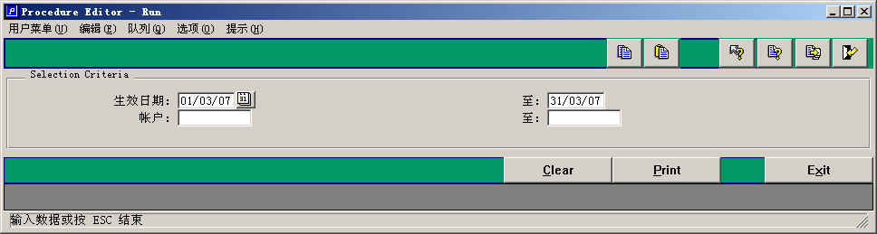
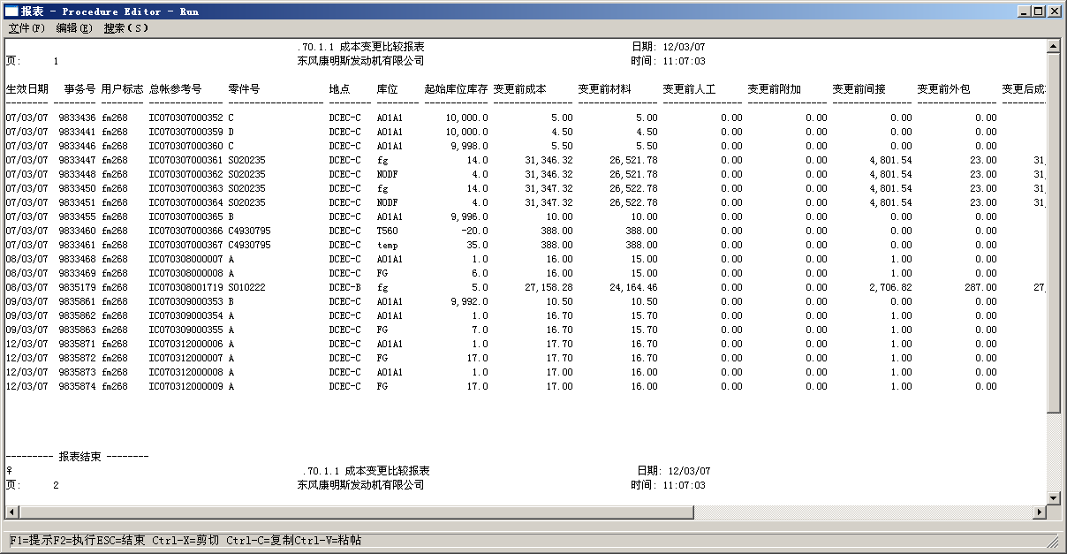
显示内容
"生效日期" "事务ID" "用户代码" "总帐参考号" “零件号" "地点" “库位" "数量" "变更前成本"
"变更前材料" "变更前人工" "变更前附加" "变更前间接" "变更前外包" "变更后成本" "变更后材料" "变更后人工" "变更后附加" "变更后间接" "变更后外包" "前后差异"

Program Logic

Technical Specification
<How the program should do the job Include selection screen, output, tables and key selection statement >

Program Attributes
Type:
Application:
Development Class:
Logical Database:

Selection Screen Fields
<This section is to enter the Field name text, the variable, type of input (range, single, radio button, checkbox etc.), default value. >
Field Variable | Field Text | Input type | Default value

Sorting Criteria & Paging

Table of Access
Table | Field | Description

Field Mappings
<This section describes any field mappings that is required from an external system into QAD and vice-versa. >
QAD Field | External System Field

