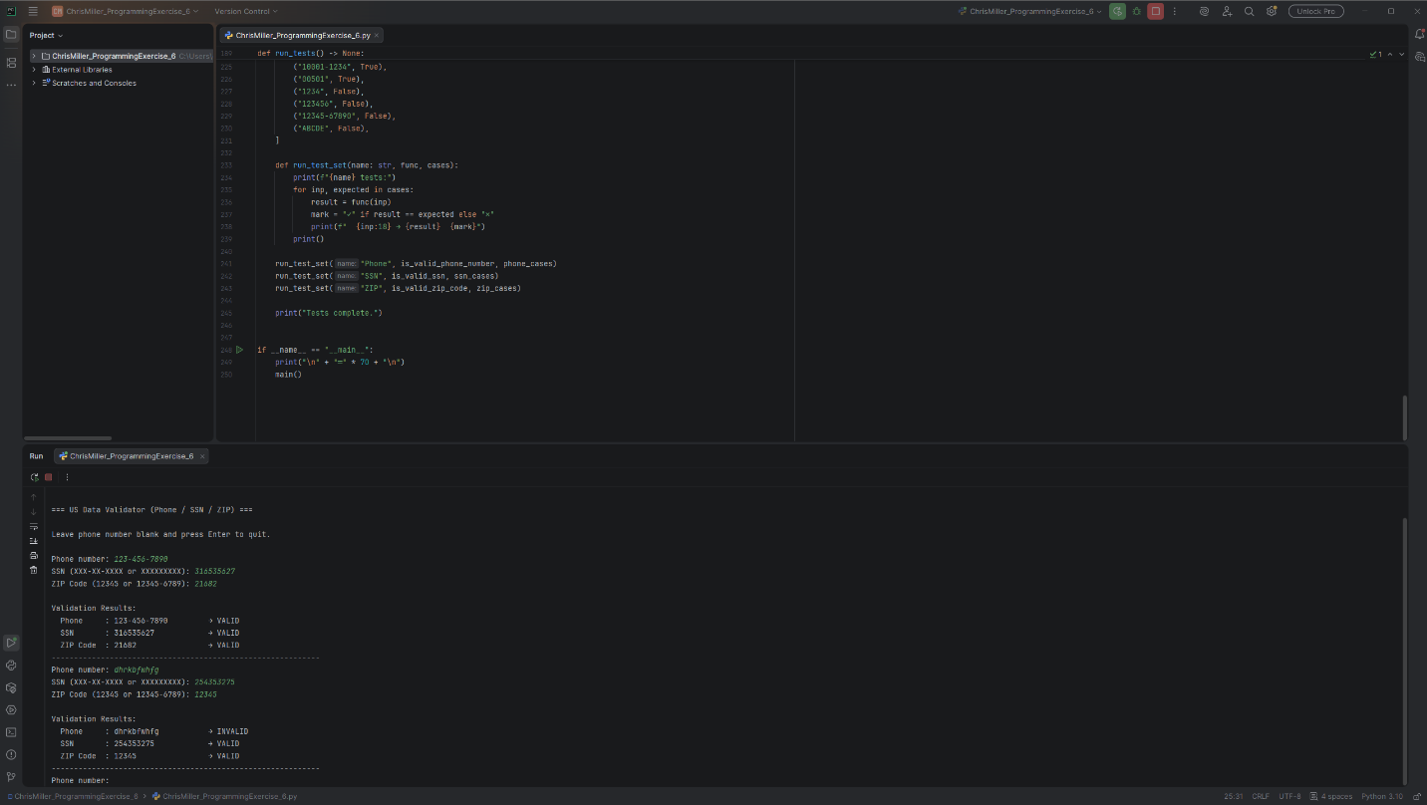
# Technical Design Document: ChrisMiller_ProgrammingExercise_6

# Name: Chris Miller
# Date: March 2, 2026
# Program Description: validates phone numbers, social security numbers and zip codes.

## Function: is_valid_phone_number
Validate a US phone number using a flexible regular expression.

Accepts common North American formats including:
- 123-456-7890
- (123) 456-7890
- 1234567890
- 123.456.7890
- +1 123-456-7890
- 1-123-456-7890
- (123)456-7890

Parameters
----------
phone : str
The phone number string to validate (may contain spaces, parentheses, dots, dashes)

Returns
-------
bool
True if the input matches a valid US phone number pattern, False otherwise

Examples
--------
>>> is_valid_phone_number("123-456-7890")
True
>>> is_valid_phone_number("+1 (555) 123-4567")
True
>>> is_valid_phone_number("1234567890")
True
>>> is_valid_phone_number("123-45-6789") # looks like SSN
False
>>> is_valid_phone_number("+44 20 7946 0958") # UK number
False

#Link to repository: https://github.com/chridmill/Chris-M.-Programming-Concepts-II## Function: is_valid_ssn
Validate a United States Social Security Number (SSN) format and basic rules.

Supports:
- XXX-XX-XXXX
- XXXXXXXXX
- XXX XX XXXX (spaces)

Invalid cases caught:
- Area numbers 000, 666, 900–999
- Group number 00
- Serial number 0000

Parameters
----------
ssn : str
The SSN string to validate

Returns
-------
bool
True if format and basic validity rules are satisfied, False otherwise

Examples
--------
>>> is_valid_ssn("123-45-6789")
True
>>> is_valid_ssn("078051120")
True
>>> is_valid_ssn("000-12-3456")
False
>>> is_valid_ssn("666-55-4444")
False
>>> is_valid_ssn("987-65-4321")
True
>>> is_valid_ssn("123-00-4567")
False

#Link to repository: https://github.com/chridmill/Chris-M.-Programming-Concepts-II## Function: is_valid_zip_code
Validate a United States ZIP Code (5 digit or ZIP 4 format).

Accepted formats:
- 12345
- 12345-6789

Parameters
----------
zip_code : str
The ZIP code string to validate

Returns
-------
bool
True if the input is a valid 5 digit or 5+4 ZIP code format, False otherwise

Examples
--------
>>> is_valid_zip_code("90210")
True
>>> is_valid_zip_code("33101-1234")
True
>>> is_valid_zip_code("00501")
True
>>> is_valid_zip_code("1234")
False
>>> is_valid_zip_code("12345-678")
False
>>> is_valid_zip_code("12345-67890")
False

#Link to repository: https://github.com/chridmill/Chris-M.-Programming-Concepts-II## Function: main
Interactive command line interface for validating phone numbers, SSNs, and ZIP codes.

Repeatedly prompts the user for input until an empty phone number is entered.
Displays validation results for each set of inputs.

Returns
-------
None

#Link to repository: https://github.com/chridmill/Chris-M.-Programming-Concepts-II## Function: run_tests
Execute a suite of unit style tests for all validation functions.

Prints pass/fail status for each test case.

Returns
-------
None

#Link to repository: https://github.com/chridmill/Chris-M.-Programming-Concepts-II## Function: validate_input
Convenience function that validates all three inputs at once.

Parameters
----------
phone : str
Phone number string
ssn : str
Social Security Number string
zip_code : str
ZIP code string

Returns
-------
dict
Dictionary with validation results:
{
"phone": bool,
"ssn": bool,
"zip_code": bool
}

#Link to repository: https://github.com/chridmill/Chris-M.-Programming-Concepts-II

