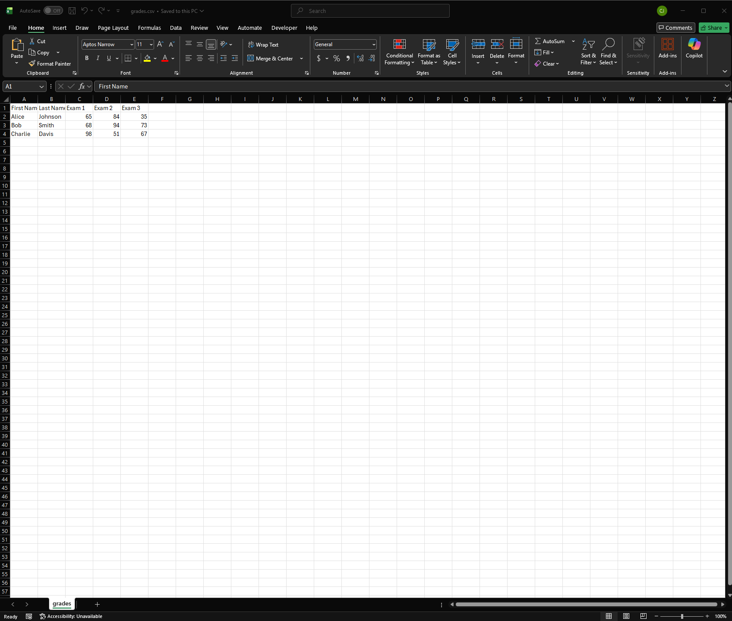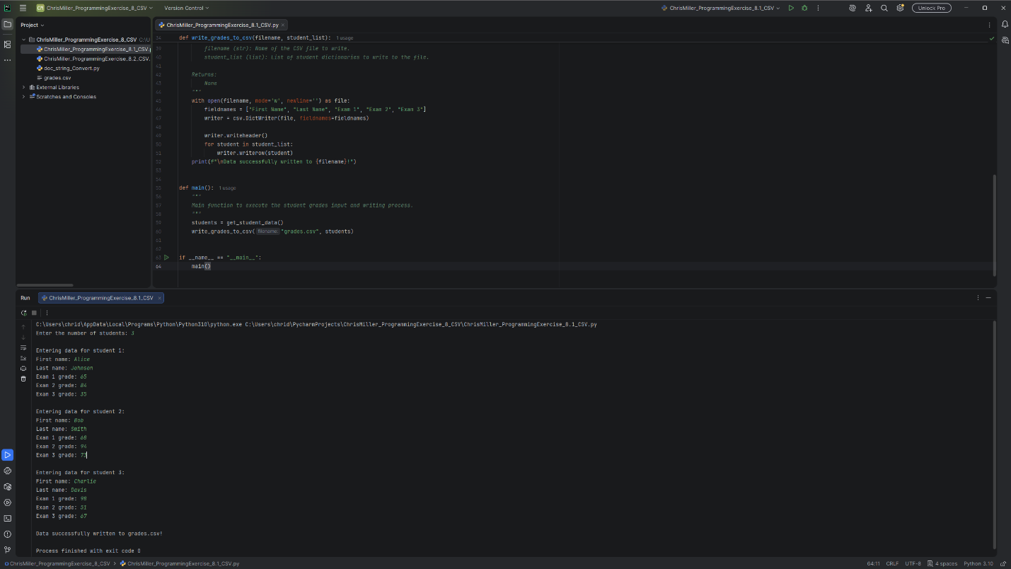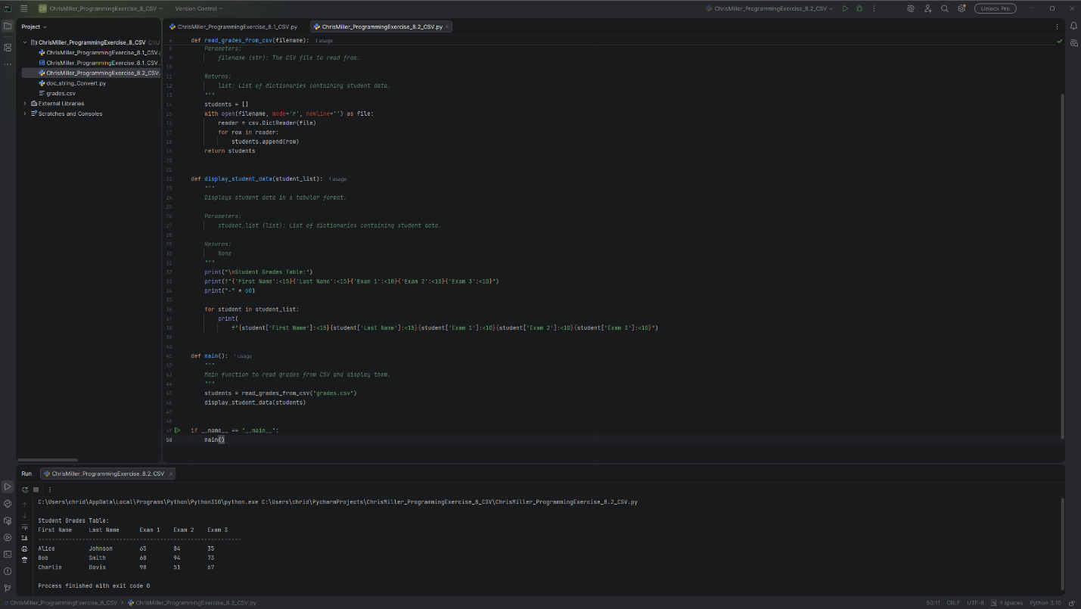
# Technical Design Document: ChrisMiller_ProgrammingExercise_8_CSV

# Name: Chris Miller
# Date: March 23, 2026
# Program Description: input how many students they want to enter. Then enter each student’s first name and last name as strings and the student’s three exam grades as integers.

## Function: get_student_data
Prompts the instructor to enter student data including first name, last name, and three exam grades.

Returns:
list: A list of dictionaries where each dictionary contains a student's information.

Parameters:
filename (str): Name of the CSV file to write.
student_list (list): List of student dictionaries to write to the file.

Returns:
None

#Link to repository: https://github.com/chridmill/Chris-M.-Programming-Concepts-II
# Technical Design Document: ChrisMiller_ProgrammingExercise_8_Display_CSV

# Name: Chris Miller
# Date: March 23, 2026
# Program Description: read the grades.csv file and display the data in tabular format..

## Function: display_student_data
Displays student data in a tabular format.

Parameters:
student_list (list): List of dictionaries containing student data.

Returns:
None

Parameters:
filename (str): The CSV file to read from.

Returns:
list: List of dictionaries containing student data.

#Link to repository: https://github.com/chridmill/Chris-M.-Programming-Concepts-II

