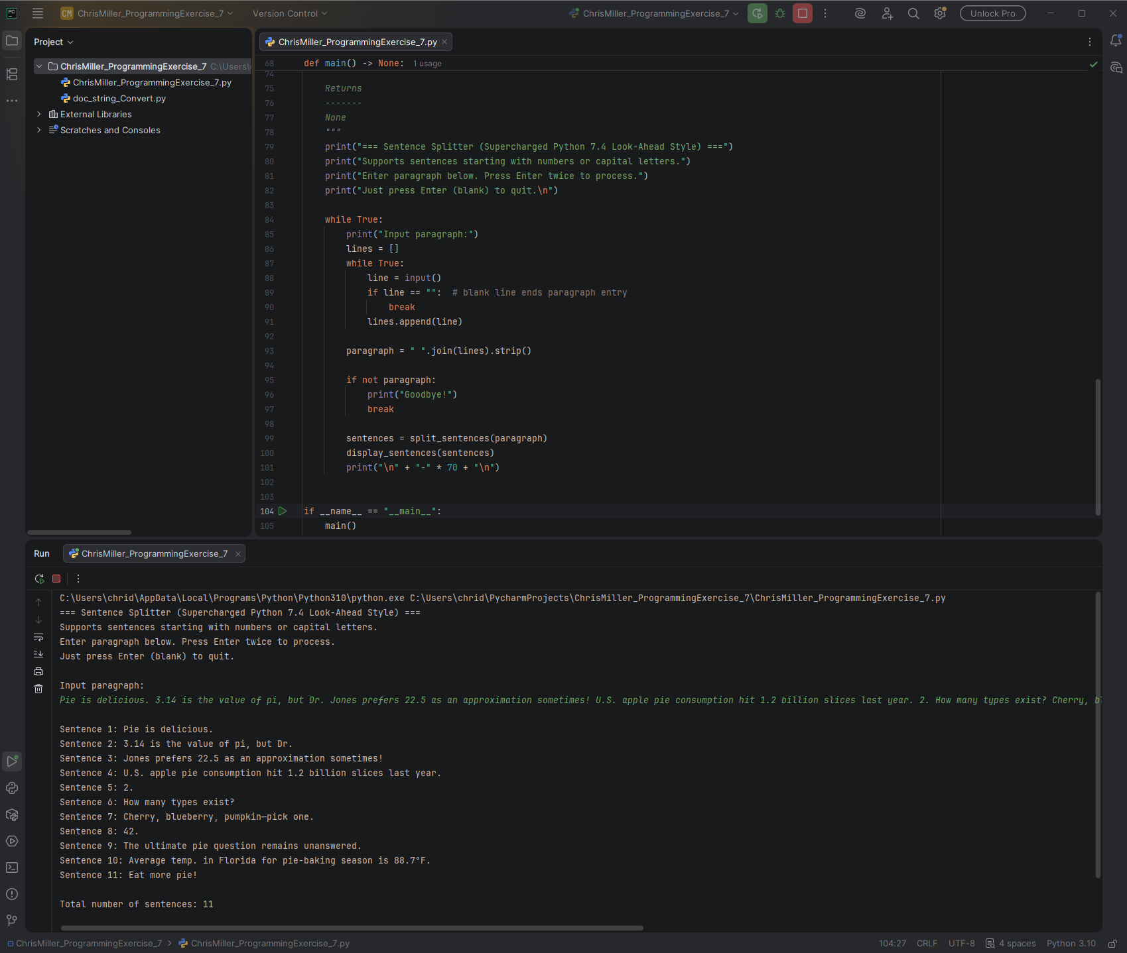
# Technical Design Document: ChrisMiller_ProgrammingExercise_7

# Name: Chris Miller
# Date: March 16, 2026
# Program Description: Split a paragraph into sentences using look-ahead,Display each sentence numbered, followed by the total count.

## Function: display_sentences
Display each sentence numbered, followed by the total count.

Parameters
----------
sentences : list[str]
List of sentence strings to print.

Returns
-------
None
Prints to console.

#Link to repository: https://github.com/chridmill/Chris-M.-Programming-Concepts-II## Function: main
Main function: prompt user for paragraph input and display split sentences.

User enters lines; blank line (Enter twice) ends input and processes.
Empty input (just Enter at start) quits the program.

Returns
-------
None

#Link to repository: https://github.com/chridmill/Chris-M.-Programming-Concepts-II## Function: split_sentences
Split a paragraph into sentences using look-ahead, following Supercharged Python Section 7.4.

Starts sentences with uppercase letter OR digit.
Uses non-greedy matching + positive look-ahead to avoid splitting on:
- Abbreviations (Mr. Dr. U.S.A.)
- Decimals (3.14, 310.5)
- Other mid-sentence periods

Parameters
----------
text : str
The input paragraph or multi-line text.

Returns
-------
list[str]
List of extracted sentences (with original punctuation, stripped whitespace).

Notes
-----
- Uses re.DOTALL so '.' matches newlines.
- Look-ahead (?= ...) checks for space + uppercase/digit or end-of-string without consuming them.
- Adapted from book pattern '[A-Z].*?[.!?](?= [A-Z]|\Z)' to also allow digit sentence starts.

#Link to repository: https://github.com/chridmill/Chris-M.-Programming-Concepts-II

