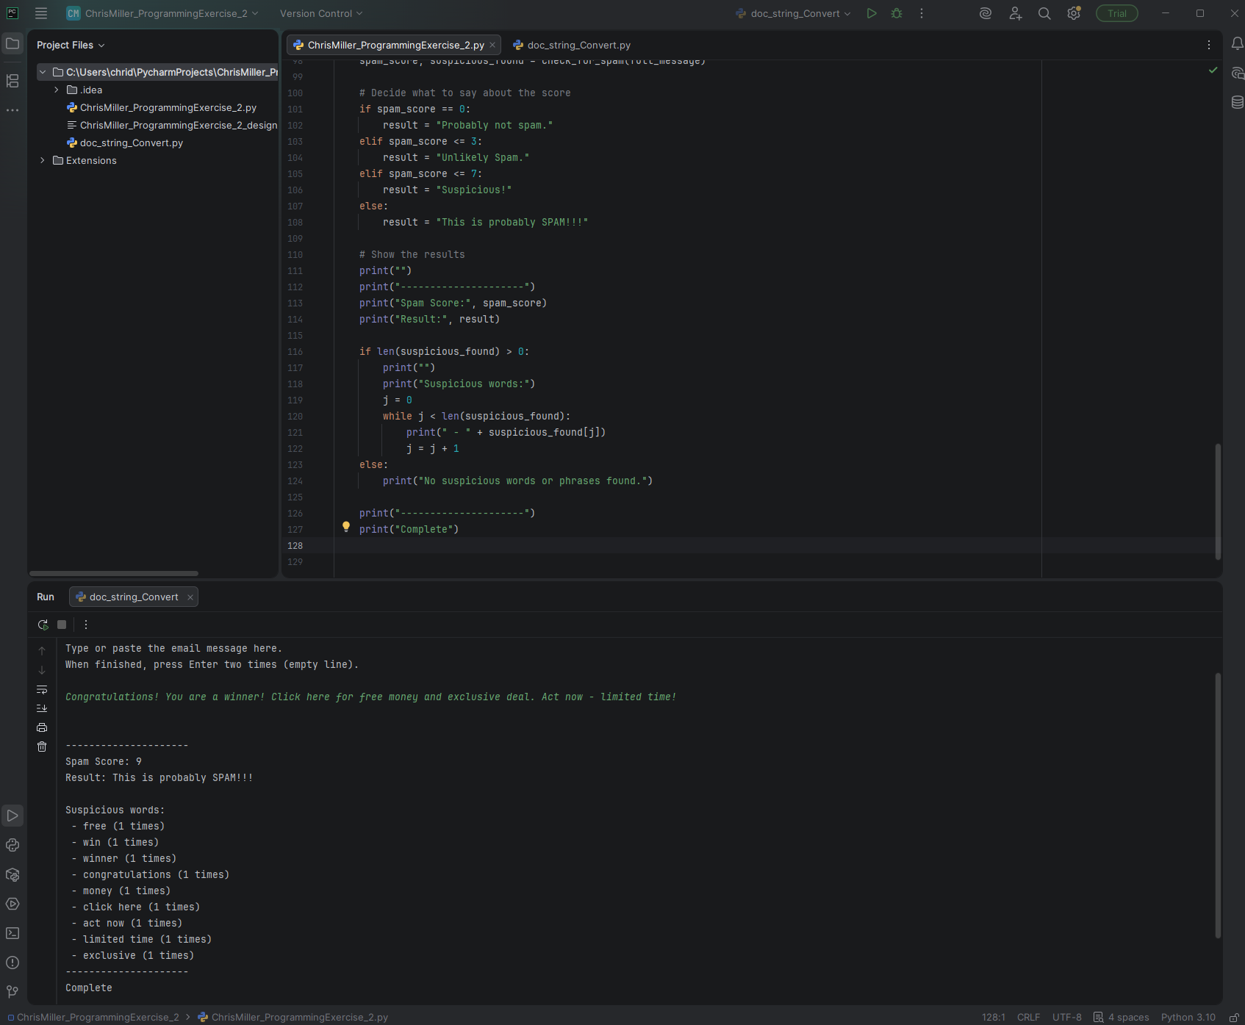
# Technical Design Document: ChrisMiller_ProgrammingExercise_2

# Name: Chris Miller
# Date: February 9, 2026
# Program Description: Scans pasted content for words commonly used in spam messages/scams.

## Function: check_for_spam
Scans the message for suspicious spam keywords.

This function:
1. Converts message to lowercase
2. Counts how many times each spam word appears
3. Builds a total score (points = total matches)
4. Keeps track of which words were found and how often

Parameters:
message (str): The email text to check

Returns:
tuple: (int score, list of strings describing found words)

#Link to repository: https://github.com/chridmill/Chris-M.-Programming-Concepts-II## Function: get_user_message
Collects the email message from the user.

The user can paste or type multiple lines of text.
Input ends when the user presses Enter on a blank line.

Returns:
str: The complete email message as one string.

#Link to repository: https://github.com/chridmill/Chris-M.-Programming-Concepts-II

