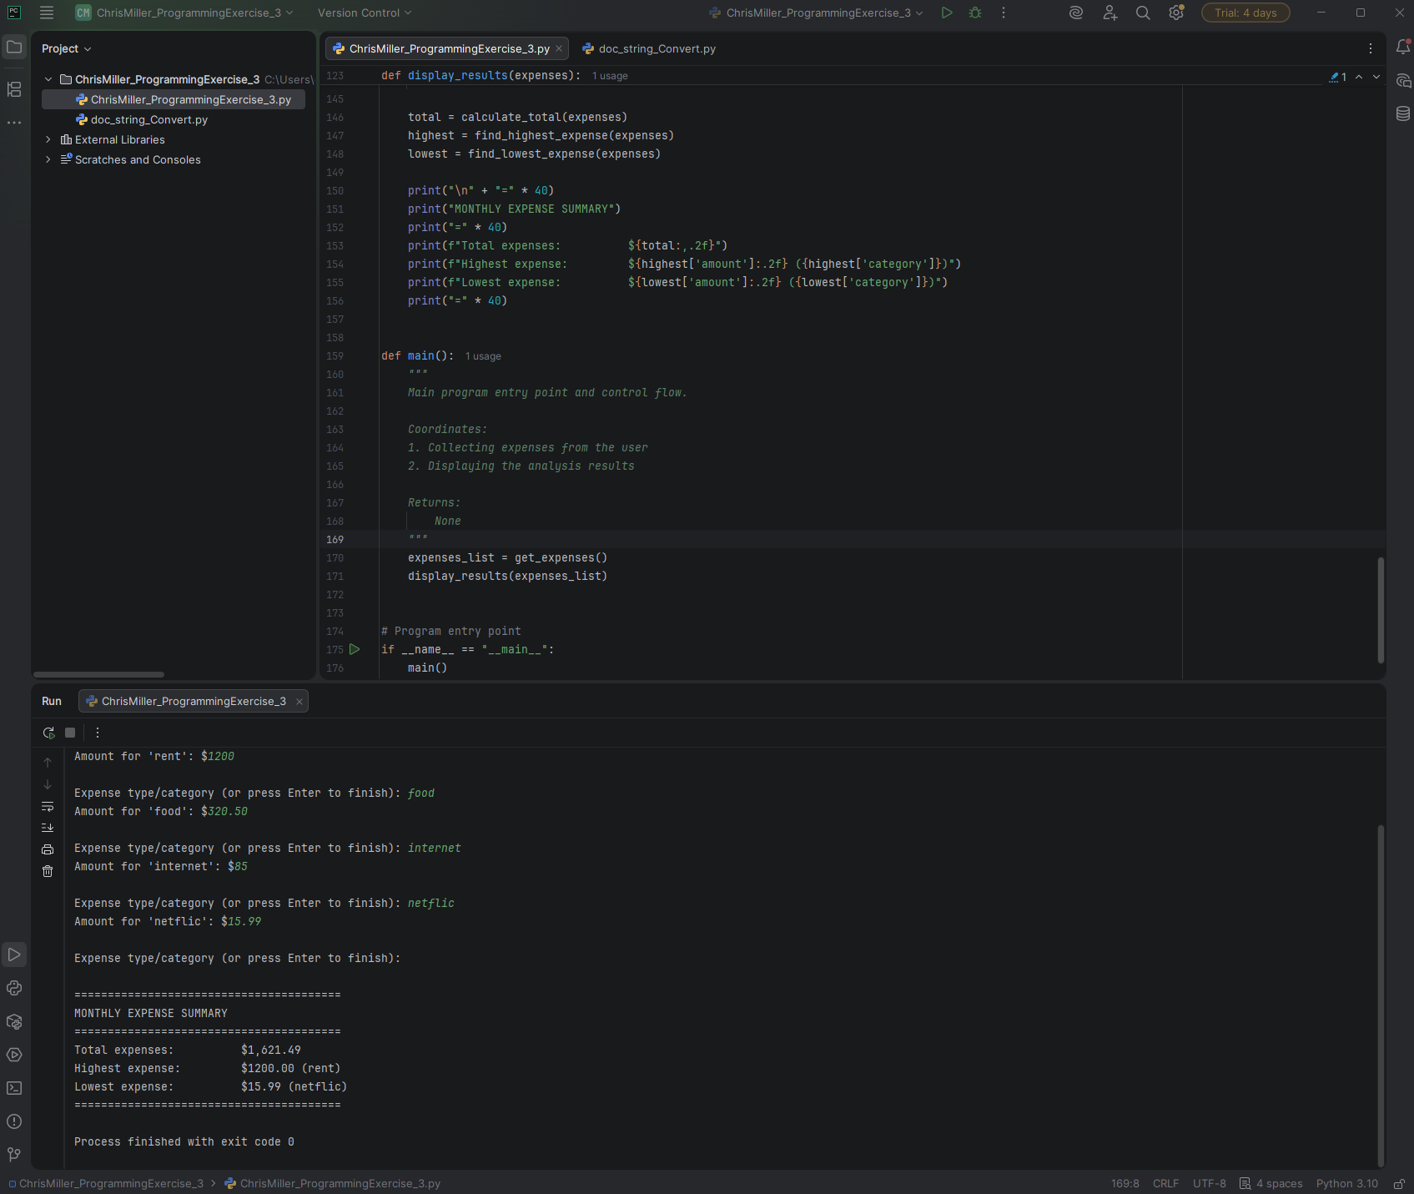
# Technical Design Document: ChrisMiller_ProgrammingExercise_3

# Name: Chris Miller
# Date: February 18, 2026
# Program Description: Asks for expense type & amount, then displays total, largest, smallest.

## Function: calculate_total
Computes the sum of all expense amounts using functools.reduce.

Parameters:
expenses (list[dict]): List of expense dictionaries, each containing
at least an 'amount' key with a numeric value.

Returns:
float: The total sum of all expense amounts.
Returns 0.0 if the list is empty.

Example:
>>> calculate_total([{'amount': 50.0}, {'amount': 120.75}])
170.75

#Link to repository: https://github.com/chridmill/Chris-M.-Programming-Concepts-II## Function: display_results
Displays a formatted summary of the expense analysis.

Shows:
- Total expenses
- Highest single expense (amount + category)
- Lowest single expense (amount + category)

Parameters:
expenses (list[dict]): List of expense records from get_expenses()

Returns:
None: Output is printed to stdout only.

Side effects:
Prints a formatted report to the console.
Handles empty list case with a message.

#Link to repository: https://github.com/chridmill/Chris-M.-Programming-Concepts-II## Function: find_highest_expense
Finds the expense record with the highest amount using functools.reduce.

Parameters:
expenses (list[dict]): List of expense dictionaries. Each must contain
'category' (str) and 'amount' (float/int) keys.

Returns:
dict | None: The complete dictionary of the highest expense
(with 'category' and 'amount'), or None if list is empty.

Raises:
IndexError: Avoided by checking for empty list first

#Link to repository: https://github.com/chridmill/Chris-M.-Programming-Concepts-II## Function: find_lowest_expense
Finds the expense record with the lowest amount using functools.reduce.

Parameters:
expenses (list[dict]): List of expense dictionaries. Each must contain
'category' (str) and 'amount' (float/int) keys.

Returns:
dict | None: The complete dictionary of the lowest expense
(with 'category' and 'amount'), or None if list is empty.

#Link to repository: https://github.com/chridmill/Chris-M.-Programming-Concepts-II## Function: get_expenses
Interactively collects monthly expense entries from the user.

Prompts the user repeatedly for an expense category (type) and its amount.
Collection stops when the user presses Enter without entering a category name.
Validates that amounts are non-negative numbers.

Returns:
list[dict]: A list of expense records. Each record is a dictionary with:
- 'category': str – the name/type of expense
- 'amount': float – the monetary amount

Raises:
ValueError: Handled internally when user enters invalid (non-numeric) amount

Side effects:
Prints prompts and feedback messages to stdout.
Handles input validation errors with user-friendly messages.

#Link to repository: https://github.com/chridmill/Chris-M.-Programming-Concepts-II## Function: main
Main program entry point and control flow.

Coordinates:
1. Collecting expenses from the user
2. Displaying the analysis results

Returns:
None

#Link to repository: https://github.com/chridmill/Chris-M.-Programming-Concepts-II

