**Towards explained differences between IMERG Early Run and Final Run Product**

**Background**

Better characterizing precipitation can benefit early warning of water-related natural hazards. Integrated Multi-satellitE Retrievals for GPM (IMERG) jointly developed by NASA and JAXA provides fine-scale (0.1-degree/30 minute) precipitation observations in the globe, which is recognized as the most accurate satellite precipitation products. It contains three stages (Early Run, Late Run, and Final Run) to accommodate different usages: For instance, Early Run (ER; 3-hour latency) is designed for real-time flash flood monitoring; Late Run (LR; 6-hour latency) for crop forecasting; Final Run (FR; 3-month latency) for research purposes. Due to the timeliness of ER, it is often used as forcing data to drive real-time hydrologic models to issue early warning of flash flood. On the other hand, FR with more time latency, is widely approved to be more accurate than preceding two stages. Therefore, it remains unclear whether ER can be appropriately applied to real-world operations. In this study, based on previous systematic findings (large biases overland), we will conduct decomposition techniques (EOFs) to identify spatiotemporal variations of this difference of ER and FR to aware both end users and algorithm developers who are interested in deploying ER in operations.

**Study domain and data description**

Previous research has found relatively large discrepancies in the tropical hot as shown in Figure 1(d). We will specifically choose one region to inspect the variations, possibly the southeast of US because it is reported as the vulnerable place with considerable flood cases in history (in Figure 2).

Twenty-year IMERG ER and FR data will be used in this study to intercompare the differences and discover the leading modes. Each dataset has a 0.1-degree and 30-min resolution. To ease the computational cost, the precipitation will be aggregated in daily values. Because the extreme precipitation is taken into account, the 95th percentile of daily values will be retrieved for each pixel.

**Methodology**

1. Climatology analysis of extreme precipitation

For the first evaluation, the 95th percentile of daily precipitation is retained for both early and final. First analysis will be focused on the climatological trend, discovering the long-term variation of the extreme values. Several trend analysis techniques will be explored (i.e., linear trend, non-parametric Sean’s method, and etc.) with analogy to previous extreme precipitation studies (Su et al., 2008).

2. EOF analysis of the difference

To further investigate the spatial and temporal variation of the difference, the EOF analysis will be conducted by taking the difference between ER and FR. In doing so, we hope to uncover the leading mode of EOF and infer possible reasons.

3. Composite analysis

Composite analysis is useful to explore possible reasons contributing to the difference. For instance, previous study revealed ENSO factor impacts extreme precipitation in time (Schubert et al., 2008). It has not determined which variable to use but some are taken into considerations: (1) percent of Infrared satellite used in each product; (2) precipitation types.

4. Wavelet transform (hypothesis)

The frequency of satellite overpasses is an important factor to explain this difference. To prove this component, it is assumed this frequency in difference is periodic. By looking at periodic signals from the differences, it might be possible to figure out the overpass time (hypothesis).

References

Su, Buda; Gemmer, Marco; Jiang, Tong 2008 Spatial and temporal variation of extreme precipitation over the Yangtze River Basin. Quaternary International, 186(1).

Schubert, S.D., Y. Chang, M.J. Suarez, and P.J. Pegion, 2008: ENSO and Wintertime Extreme Precipitation Events over the Contiguous United States. J. Climate, 21, 22–39, https://doi.org/10.1175/2007JCLI1705.1

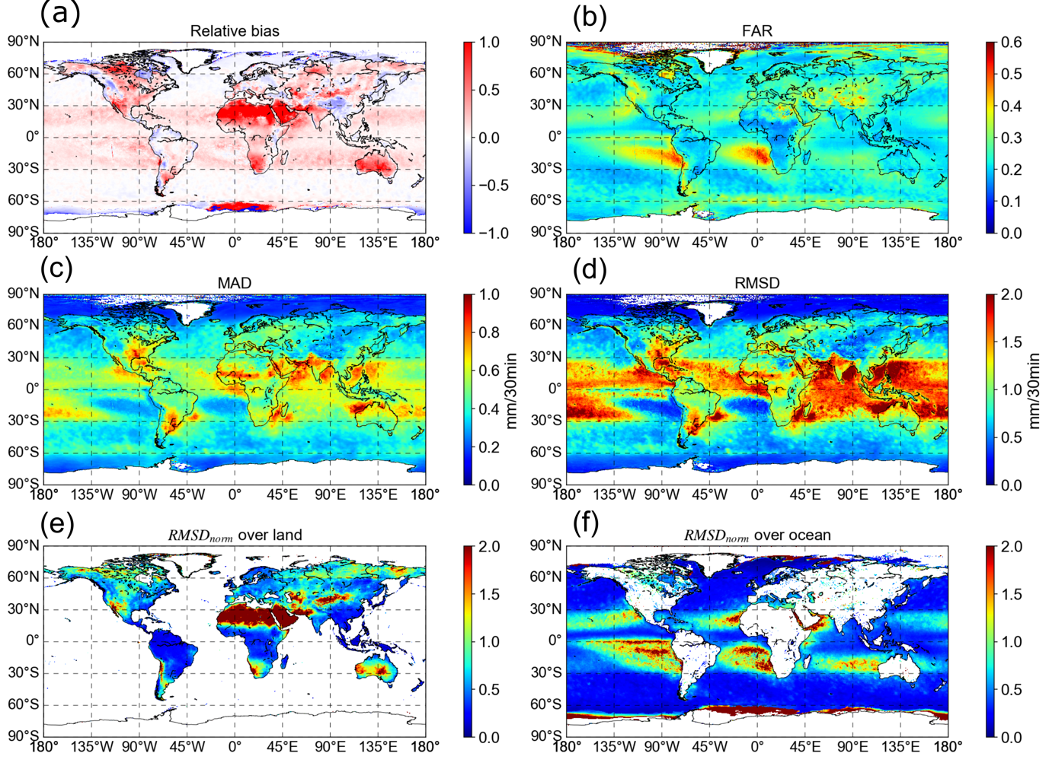

Figure 1 General plots of previous researches examining the differences between ER and FR: (a) Relative bias; (b) False Alarm Rate; (c) Mean Absolute Difference; (d) Root Mean Squared Difference; (e) normalized Root Mean Square Difference over continents; (f) Root Mean Squared Difference over ocean.

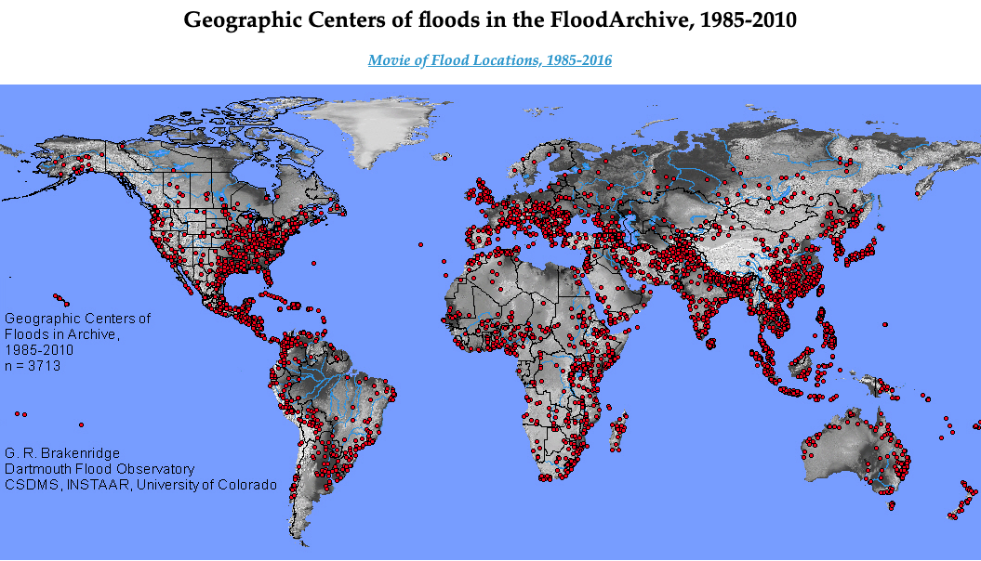

Figure 2 Global flood archive