**Part1. Populations**

Q1. Using zonal statistics to calculate the total population of Volta Basin.

1. Drop shape file of Volta basin and Raster data of population density into QGIS layers panel.

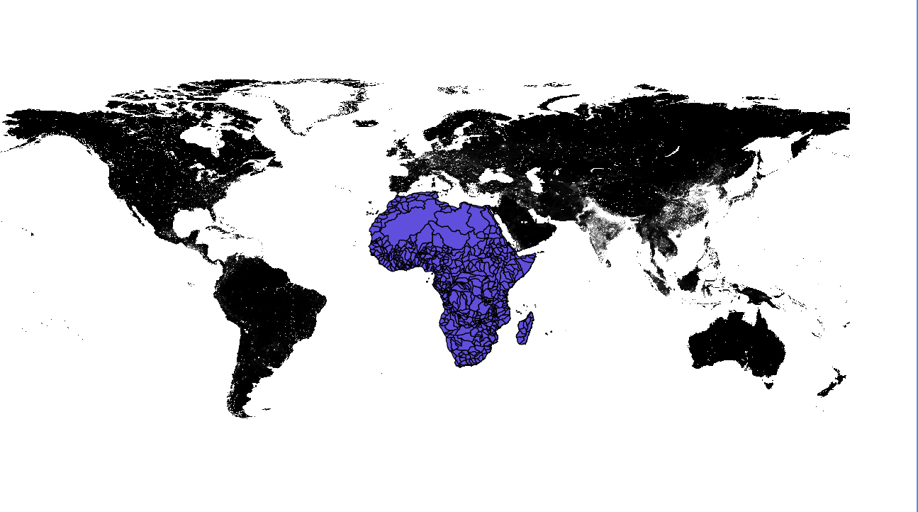

1. Split hydrological basins in Africa with vector data management tools. Set hydrological basin as input vector data and MAJ_NAME as unique ID field. And drop Volta basin data into GIS panel.

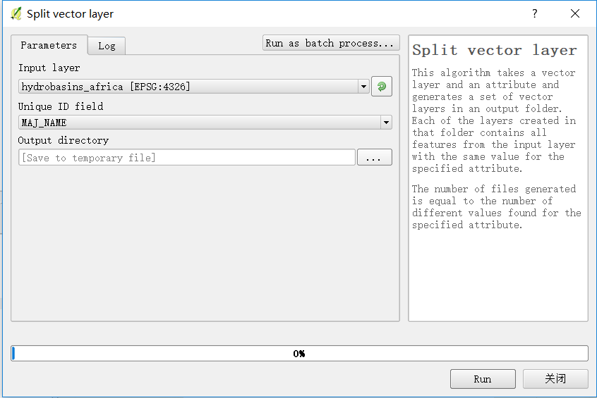

1. Using zonal statistics under the menu of Raster bar to calculate statistical information about given area. Information is shown below.

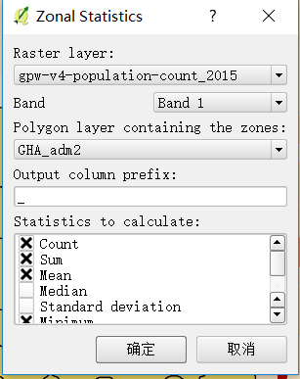

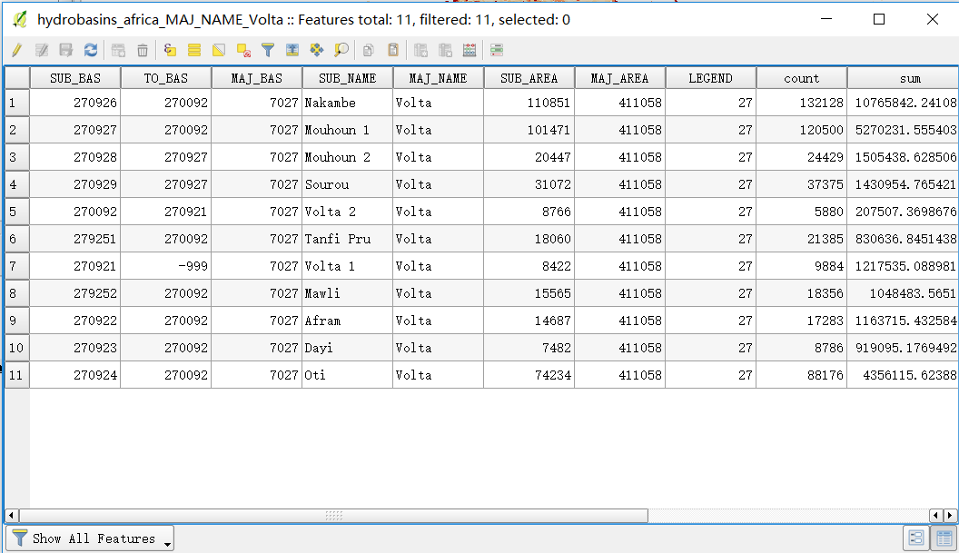

1. Among these information, we are more concerned about sum value as we need the total population of this area. Then inside attribute table, sum up all “sum” field and come up with total population of 28.7 million.

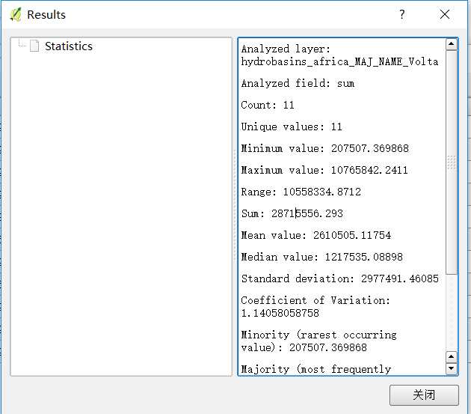

Q2. Make a map to show overlap of Volta Basin and Population Counts

1. Using raster clipper to visualize population count in Volta Basin region. Population counts raster data as input, put Volta basin as mask layer.

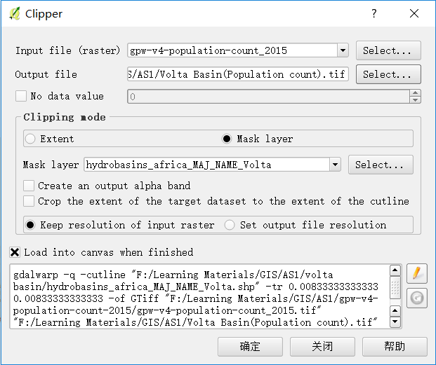

Ultimate map:

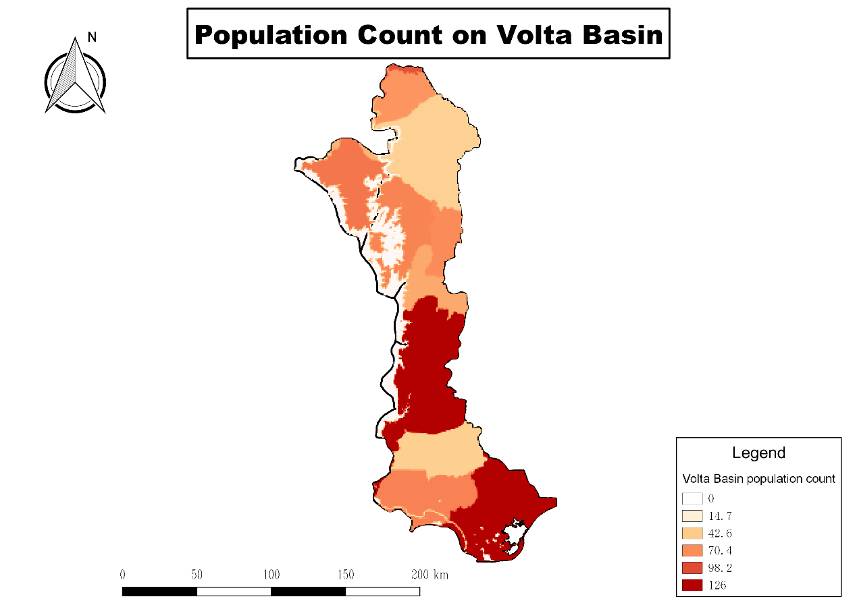

**Part2. Household water demand**

**Part3. Transboundary river basin**

Q1. Calculate total area in Volta Basin.

1. Open attribute table and use calculator to generate a new column, containing area inside each sub-basin.

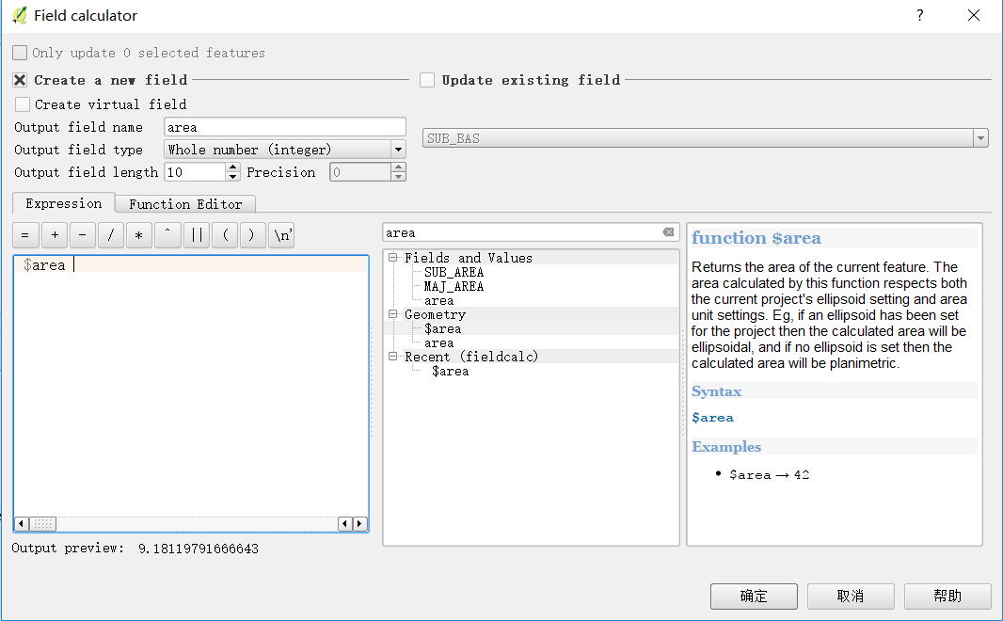

1. With new area info, we ultilise