TDT4230: Graphics and Visualisation
Final Project Report
Real-Time Volumetric Tornado Scene
Christoffer Paulsen

1 Project Overview
The project is a real-time 3D tornado scene built with OpenGL 4.5 and C++. The main idea was to explore volumetric ray marching as a way to render atmospheric effects like tornados and storm clouds, since things like that just don’t really work as normal polygon meshes. The scene has an animated tornado funnel, a big cumulonimbus storm cloud, a debris field spinning around the base, procedurally generated terrain, billboard trees, dynamic sunlight, fog, and a lightning system. Everything runs in real time, and I exposed the important volumetric parameters through a Dear ImGui overlay so I could tweak things live without recompiling.
The project developed incrementally. I started by just figuring out how ray marching works with a simple spherical volume, which is shown in the Appendix. Once I had that working I looked into how to combine ray-marched objects with rasterized geometry in the same scene, which is what led me to deferred shading and G-buffers. At that point I had a basic tornado and some terrain with texture loading, but the scene looked pretty bare, so I added a cubemap skybox, fog to blend the terrain horizon into the sky, and billboard trees scattered across the ground. The last bigger addition was the cumulonimbus cloud above the tornado. It reuses most of the ray marching code from the tornado since the approach is the same, just with a different SDF for the cloud shape.
2 How the Implementation Achieves Its Goal
Rendering Pipeline
I used a multi-pass deferred rendering pipeline. In the first pass all solid geometry (terrain and trees) is rasterized into a G-buffer with world-space position, albedo, surface normals, simple ambient occlusion, and depth. A lighting pass then takes all that and applies sun and ambient lighting, exponential height fog, and soft shadows from the tornado. After that a volumetric pass ray-marches the tornado, cloud, and debris over the already-lit scene, using the G-buffer depth to stop rays at solid surfaces. A final composite shader handles tone mapping and blends everything together.
Volumetric Tornado
The tornado has no mesh at all. It’s a purely procedural density field written in GLSL. A function map(p) returns negative values inside the funnel and positive outside, which is basically a signed-distance-inspired approach. The shape itself uses a height-varying radius with a Gaussian pinch at the waist and a taper toward the top. On top of that I layered two types of animated noise: a low-frequency shape noise that roughens the overall surface, and a high-frequency filament noise that gives it that characteristic rope-like look. The funnel also twists at different rates depending on height and time, and sways around through sinusoidal offsets to make it feel a bit more alive.
For each pixel a ray is cast from the camera into the volume, accumulating density samples at a configurable step size (default 0.16 world units, up to 112 steps). Beer-Lambert is applied at each sample to track the remaining transmittance, and a shorter secondary march toward the sun handles self-shadowing. The phase function is a blended Henyey-Greenstein with a forward lobe and a weak back-scatter term, which makes the tornado look slightly translucent and silvery when viewed into the sun.
Cumulonimbus Cloud and Debris
The storm cloud uses the same ray marcher as the tornado. Its density field is an ellipsoid SDF with two layers of slowly animating noise to simulate billowing, and the albedo shifts vertically and on sun-facing edges to get that dark belly and bright silver lining look. The debris ring is a torus-like SDF around the tornado base, shaded using numerically estimated normals and the same basic ambient-plus-sun lighting as the rest of the scene. All three volumes are ray-marched together in a single pass, sharing the same noise texture and light march.
Terrain and Trees
The terrain is generated from a 512×512 noise heightmap and split into a 20×20 tile grid at startup. Heights are trilinearly interpolated from a pre-computed noise cache and uploaded to the GPU as a flat vertex array, with each tile drawn in a single indexed triangle strip call. The surface uses a normal-mapped grass-rock texture blend and gets lit through the deferred pass. Trees are just billboard quads with an alpha-tested sprite, placed using Poisson disk sampling so they don’t clump up.
3 Notable Problems and How They Were Solved
Performance
Ray marching is expensive. Evaluating the density function hundreds of times per pixel at full resolution burned through the GPU budget pretty fast, so I had to combine a few optimisations to keep things interactive. For shadows I use a cheaper mapShadow() function that skips the filament detail noise, cutting the shadow march cost roughly in half. I also check the bounding volume against screen-space extents before dispatching the pass. On the CPU side, OpenMP parallelises things like terrain tile generation and the noise texture pre-computation.
Visual Artifacts and Banding
A fixed step size produces visible banding rings wherever density changes sharply. The usual fix is to jitter each ray’s starting position by a random offset, which I did, but I used a blue noise texture (1024×1024) instead of white noise. Blue noise pushes the error to high spatial frequencies, which are much less visually obvious than the low-frequency clumps white noise creates. Scaled to one step size, this got rid of most of the banding at the cost of a faint grain that’s much easier to live with. I also had some depth artefacts at the border between the solid terrain and the volume, which I fixed by reading the G-buffer depth and clamping the ray’s maximum travel distance to that value.
Deferred Rendering and Dual Illumination Models
Building the deferred renderer and getting lighting to work consistently across both rendering paths was probably the hardest part of the whole project. Solid geometry is straightforward enough: just store positions, normals, and albedo in the G-buffer and composite it all in a lighting pass. But the ray-marched volumes don’t have any geometry in the normal sense: no vertex normals, no rasterised fragments, so that G-buffer lighting pass just doesn’t apply to them. I ended up having to implement two completely separate illumination models. The rasterised geometry uses a standard deferred Blinn-Phong model from the G-buffer data, while the volumes use Beer-Lambert transmittance with a Henyey-Greenstein phase function and an in-shader light march for self-shadowing. Getting the brightness, shadow intensity, and overall feel of the two to match took a lot of back and forth.
Tuning Values and the Role of ImGui
Another ongoing challenge was just getting the numbers right, and by “right” I mean looking good, not necessarily physically accurate. Things like extinction coefficients, scattering albedo, density thresholds, and noise scale all feed into a parameter space that’s big and very non-linear. A small tweak to the extinction coefficient can take the tornado from nearly invisible to a solid black pillar, and what looks correct depends on step size, density scale, and the phase function all at once, which is hard to reason about analytically. To deal with this I added a Dear ImGui overlay early on so I could adjust everything live without recompiling. That turned out to be really important. What would have been a 10–20 second compile-and-reload loop became instant feedback, which made it much more practical to actually find values that worked.
4 Advantages, Limitations, and Effective Use
Volumetric ray marching is really well suited for this kind of atmospheric effect. Since the shape is defined mathematically rather than as a mesh, you can animate and deform it with noise at basically no memory cost since nothing needs to be re-uploaded to the GPU. The volume rendering equation also naturally gives you self-shadowing, forward-scattering glow, and density-dependent opacity, all of which are genuinely hard to fake convincingly with rasterised geometry. And the same code path handles the tornado, storm cloud, and debris ring without any major structural changes.
The obvious downside is performance. Every extra march step, shadow sample, and noise layer adds to the fragment shader cost, and it stacks up fast. At the settings I needed to suppress banding and get a smooth-looking tornado the GPU was working pretty hard, and it got noticeably worse at higher resolutions or on weaker hardware. There’s also the fundamental tension between step size and quality: too big and you get banding, too small and it’s too slow. Blue noise jitter helps, but it’s not a replacement for just having more samples.
The biggest lesson I took from this was to start simple and build up gradually. Add one noise layer at a time, test each animation term on its own, and only combine things once each part is working. Getting all the parameters right (extinction, albedo, anisotropy, noise scale, step size) takes a lot of experimentation and the ImGui overlay was essential for that since it let me preview changes instantly without recompiling. It was also worth keeping the high-frequency filament noise separate from the shape noise, because that meant I could just skip the filament lookup in the shadow march with no visible quality loss, which cuts shadow cost roughly in half.
5 Resources
Most of my understanding of ray marching and SDFs came from Inigo Quilez’s articles and Shadertoy examples at iquilezles.org. His writeups on distance functions, noise, domain repetition, and soft shadows are honestly the best explanations of these topics I’ve found, and they were my main reference for the tornado density function and the light march.
The volume rendering equation, Beer-Lambert, and Henyey-Greenstein phase function came from Maxime Heckel’s blog post "Real-Time Cloudscapes with Volumetric Raymarching" (blog.maximeheckel.com). It’s a good accessible walkthrough of heterogeneous volume rendering aimed at real-time use. The actual values all needed tuning for my own scene of course.
LearnOpenGL (learnopengl.com) was my go-to reference for all the OpenGL-specific stuff: framebuffer objects, deferred shading, cubemap skyboxes, instanced rendering, texture loading, and GLSL basics. A lot of the actual work, especially getting the tornado shape, noise parameters, and lighting to look right, just came down to trial and error made practical by the live ImGui overlay.

6 AI Usage
I used AI tools throughout the project, mainly for noise parameter tuning, code structuring and refactoring, and adding comments to the codebase. It was most useful as a productivity tool for the more tedious surrounding work and as a sparring partner.

7 Appendix
Table 1: First trials of raymarching a simple spherical volume with noise
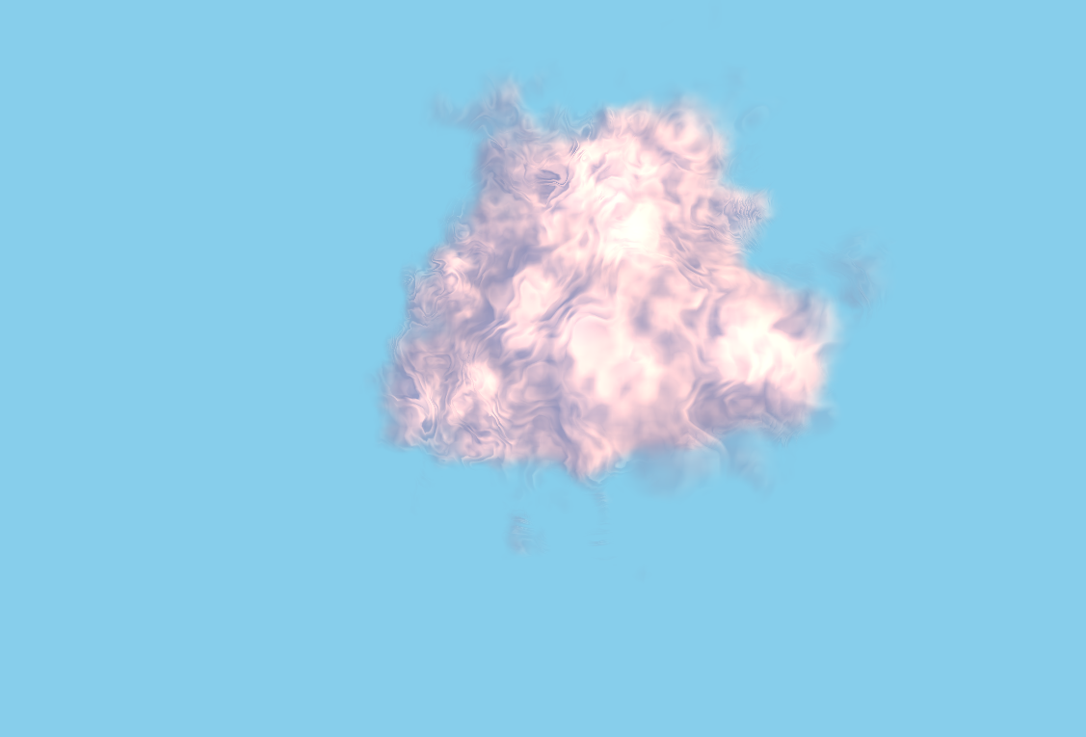  Figure 1: Banding due to too high march step | 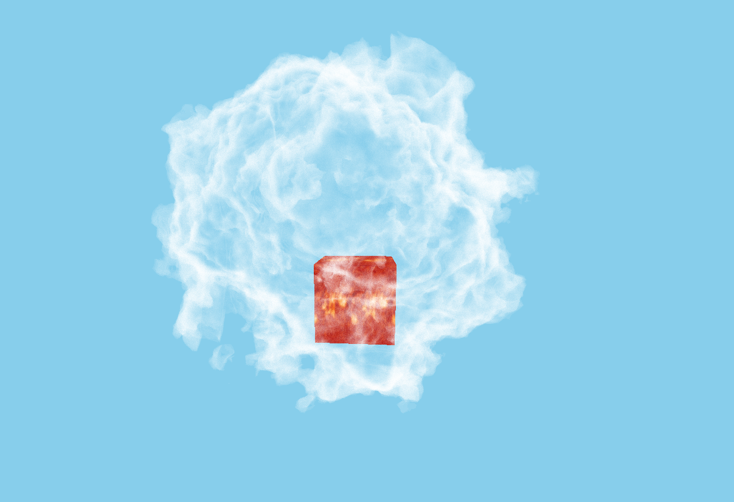  Figure 2: Only shell of volume got color
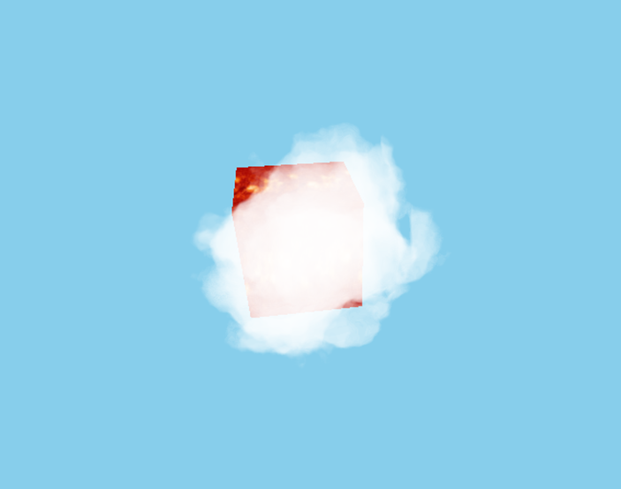  Figure 3: Improved ray marched density (no lighting) | 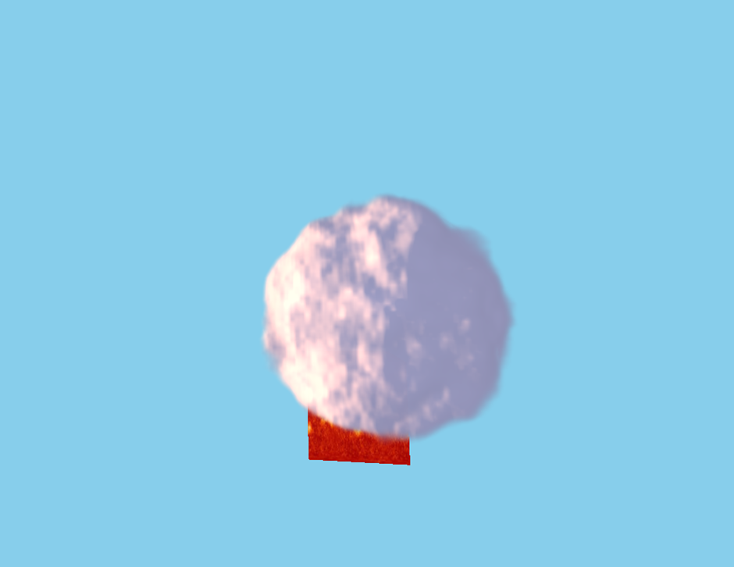  Figure 4: More realistic ray marched density (with lighting)

