Christopher Phan
Data Protection
Professor Renita Murimuri
March 1, 2022
Midterm
- Caesar4.py
  - 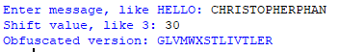
  - 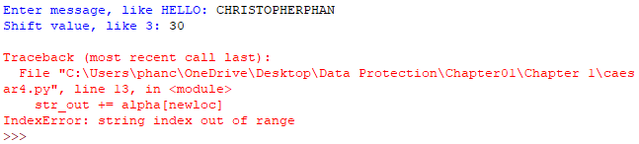
  - 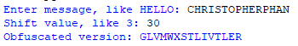
  - There is a very large difference between the outputs from parts B and C. As without the %26 on the newloc coding, the caesar cipher can not work, thus the reason why the output came out as an error on part B.
  - The %26 correlates to the 26 letters within the alphabet. Giving the reason why it gives out the error saying “string index out of range”, since there is no range of any amount of letters whatsoever when it was deleted.
  - “George Orwell” Encryption
    - 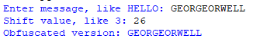
    - 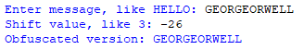
    - The outputs are the exact same as the input, as the shift either positive or negative would go through the entire alphabet and place each character in the exact same place. Meaning that none of the letters of “GEORGEWELL” would not change, and the plaintext and the ciphertext being the same output.

- Caesar5.py
  - 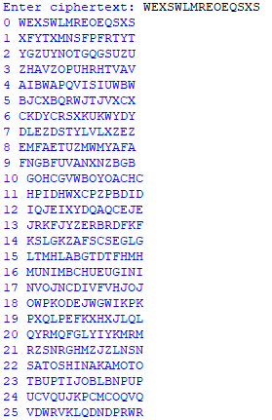
    - Satoshi Nakomoto
  - Caesar5.py can work as a word-unscrambler and as an anagram maker. The reason why for a word-unscrambler is by showing the shift of a ciphertext and can show what the plaintext actually is through finding a shift in order from 1 to 26. The anagram maker is possible due to this too, as a ciphertext can translate to multiple plaintexts as well when using caesar5.py. Or even can resemble certain words but are not spelled entirely correct. This module can create anagrams that are relative to the plaintext as it shows the shift of the ciphertext in 26 different ways.

- MD5 and SHA1 Hashes
  - 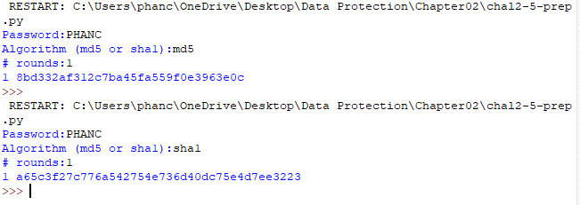MD5 and SHA1 is a hashing function that is more of a one-way function, rather than encryption which can go both ways from encryption to decryption and vice versa. Hashes are usually used for identification purposes, as they are a very precise function, and each hash is very different to the next, even if the file change was minimal. MD5 means message digest, while SHA1 means secure hash algorithm, one is more easier to understand than the other, as SHA1 is much more secure due to its extra randomized characters added to the code. MD5 is 128 bits while SHA1 is 160 bits, showing how one creates tighter security.
  - 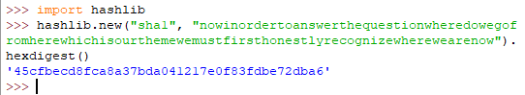

- Kerchoff’s Principle and Entropy
  - Kerchoff’s principle is the principle where the security of a cipher is based on the secrecy of the key and not the secrecy of the cipher. Modern ciphers are still reliant on this principle, as keys have to be secret when they are shared, though the ciphertext has always been public within modern cryptography.
  - Entropy is the degree of uncertainty within a certain function, the higher the entropy the higher the uncertainty of getting a correct answer. High entropy is much preferable to a cipher, though if it is too high, the system is vulnerable to meet-in-the-middle attacks. So entropy must be at a certain degree where the uncertainty is high enough where a guess can not be made, but not too high where it would be interceptable due to the degree of randomness.

- Application of Kerchoff’s Principle and Entropy
  - For a Caesar cipher, there is Kerchoff’s principle in that the key is the amount of shift, but the problem is that the key is not very secret due to it not being randomized and also a noticeable pattern in the plain text. For entropy, there is almost none due to no randomness at all, meaning there is a high degree of certainty of guessing it correctly.
  - For a Vigenere cipher, there is Kerchoff’s principle in that the key is more secret than a Caesar cipher, since there is not only a key that is locked to the numbers of 0-26, but now that key is dependent on a certain word chosen by a party. Though with that key being based on a word, entropy is not that high either, only putting it in a small degree better than a Caesar cipher. The reason being is that there is not much randomness either to the cipher text, meaning that in time and brute force, that the ciphertext can be cracked and reveal the plain text.
  - For hashing algorithms, such as MD5 and SHA1, there is both a high degree of Kerchoff’s principle and entropy. The key is completely hidden and can not be guessed easily, due to the fact that each output from either has a character limit, but all the characters are completely randomized. As well, each output is entirely different even if there is the smallest change in the plain text. Also, since there is no pattern and is completely random, entropy is much higher than both Caesar ciphers and Vigenere ciphers.

- At-rest Encryption and In-transit Encryption
  - At-rest encryption is data that is stored and encrypted by a firewall or an anti virus, meaning that the data is not moving but rather physically on a disk that cannot be accessed by unauthorized people. Examples of this can be an external hard drive that has a key on it or a laptop that has a PIN number input to be accessed.
  - In-transit encryption is data that is stored in a cloud and can be accessed at any time by specific users. This is usually applied to messaging services, in that the data is encrypted before the message is sent and then once received by the specific target is decrypted. Examples of this can be text messages or emails.

- Randomness
  - Randomness is absolutely vital for cryptography, as any data encrypted should not be easily decrypted by any unauthorized users. If there is no randomness in ciphertext, that means there is a recognizable pattern, meaning that it can be effortlessly deciphered. An example of a cipher that has almost no randomness is a Caesar cipher, it is just a straight shift value to the nth degree from the plaintext to ciphertext, signifying that a person can just shift the cipher text by a certain degree and they will certainly get the original plaintext. An example of a cipher that has a strong degree of randomness is hash algorithms, like MD5s or SHA1s, since the length of the ciphertext is in no relation to the plaintext and all the random characters are used in tandem with symbols and numbers.

- ROT13
  - The ROT13 cipher is just a fixed Caesar cipher that is stuck in a shift value of 13. Meaning that every output will always be 13 characters shifted from plaintext to ciphertext.
  - 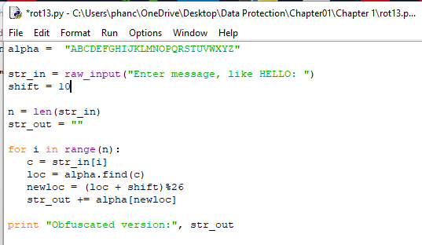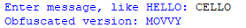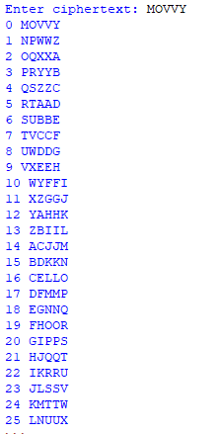
    - How I converted the shift of 13 to a shift of 10 was I went to the ROT13 module and made the shift equal to 10. Proof is shown when I input the same plain text of “CELLO”, it shows the ciphertext “MOVVY”, and using the Caesar5.py module, it proves that the shift was changed from 13 to 10.
  - Examples of ROT13 being used in real life are reading forums and newsletters, as it simplifies the process of encryption and decryption, as encrypted text can be decoded by a single function, and vice versa. The reason being is that now encrypted text can be decrypted by using ROT13 again rather than having an entirely separate function decode it instead.

- Windows and Linux
  - Windows password hashing algorithm is considerably weaker than Linux password hashing algorithm. This is due to the fact that Windows password hashing algorithm is outdated and obsolete from trying to integrate international standards onto itself. Windows can be cracked through either two means: Google or wordlists. If you input the hash code into Google, it will automatically generate what that hash is as a plaintext. If one does not want to go through Google, one can go through a wordlist vector, where a person will have to guess different passwords that the user would encrypt with. Though if the person guesses the correct password, the corresponding hash will be produced, meaning that the person has cracked the code. Windows relies on MD4 and Unicode, this is the main issue with the password hashing algorithm, as each one is very outdated in today’s world, one already having a newer version, MD5, but will not be integrated unless someone goes out of their way to use NTLM v2. As well, Unicode is only used because Windows wants to be used outside of the western world. Linux password hashing algorithm is as up-to-date as it can be for these algorithms, such as implementing a type 6 password, and then creating multiple long random strings for the password hash. The password hash is extremely longer and more complicated than the Windows password hash, contributing to the greater strength it has. Also, Linux password hashing is salted, meaning that random inputs are also placed into the hash, and as well, no password hash is the same as each one is completely randomized, while Windows is unsalted, making it less randomized and more predictable. Showing that, even if someone had the same password as someone else, no one would know as each of their hashes are completely different. Even more, rather than using an outdated hashing algorithm such as MD4, it uses SHA512, and it impounds not with one round, but 5,000 rounds. Making it extremely slow to decrypt as well as more randomized. Linux combines two different hashing algorithms which makes it even harder to crack whatsoever, and to add to that, the password hash is stretched too.

