Christopher Phan
Data Protection
Professor Renita Murimuri
February 1, 2022
Assignment/Lab 2
- 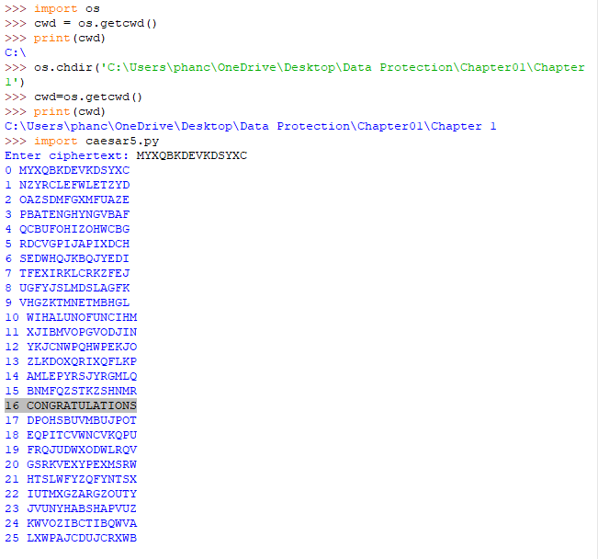
  - To the challenge placed on page 34 for the Caesar ciphers. The plain text is CONGRATULATIONS, using the caesar5.py to decode the cipher text presented.
- 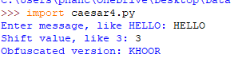
  - Here is my test with caesar4.py. The input was the simple message of HELLO. The operation is simple as it simply shifts the characters of the alphabet by three to the right of itself, based on this “ABCDEFGHIJKLMNOPQRSTUVWXYZ”. The output is just a result of that shift of three, making H to an K, E to an H, L to an O, and O to an R.
- 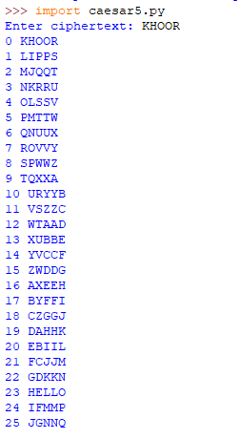
  - Here is my test with caesar5.py. The input was the output from part 2 of this assignment: KHOOR. The operation is simple where it shifts each letter in the process from numbers 0 - 26, where 0 being where there is no shift and 26 being where each letter was shifted over 26 times based on their placement in the alphabetical order. Since we do know the plain text of KHOOR, it is simple to find the word HELLO. Though even if we did not know the plain text, we know the shift is of 3, thus we can use the equation of 26 - 3, meaning that it should appear in shift of 23. If we did not know the information of what the plain text NOR the shift, we can still find the answer as it makes the most sense as it creates a real word.

