Christopher Phan
Data Protection
Professor Renita Murimuri
February 15, 2022
Assignment/Lab 4
Lab 1 - SHA-1 Hashes
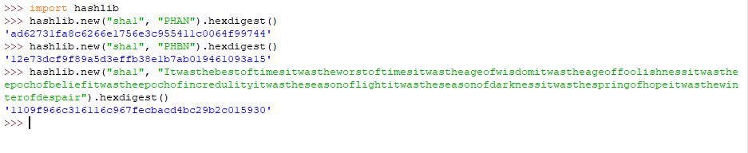
MDs are always the same length no matter what the text is, though each encryption will be different, for example, you can see with my last name and the long message that went through the SHA-1 hash.

Lab 2 - Using Google to Discover Hashes
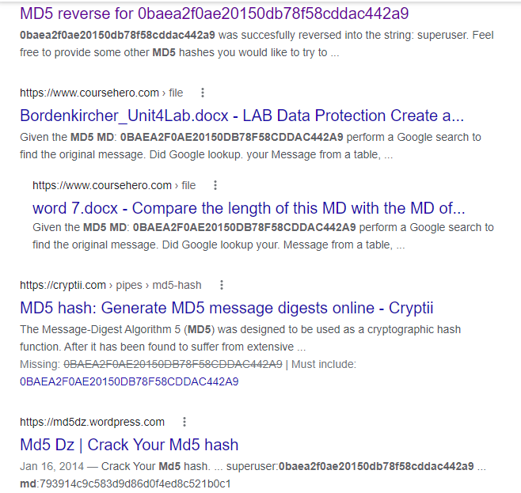
Google brute forced the MD5 MD through using services that are online that are made to decrypt MD5 MD. No table was put up from Google, but rather delegated it to other websites.

Lab 3 - Using Hash Lists
This page illuminates hash secrecy, and that as well gives away hash integrity. As it gives the base algorithm of each hash’s output, thus showing the logic of how the message turns into the MD.

Lab 4 - Generate Window Hashes
