Christopher Phan
Data Protection
Dr. Renita Murimuri
March 29, 2022
Lab 1
- SHA256 Lab: This is a very quick lab to demonstrate SHA256. Calculate a hash with the following scenarios. Provide screenshots for both scenarios.
  - 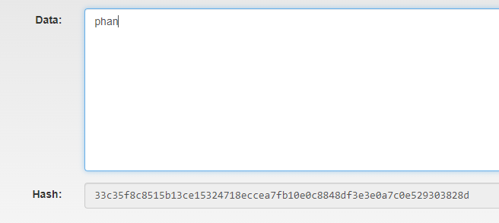
  - 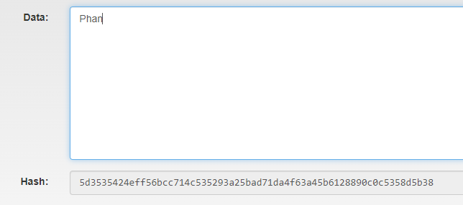

- Working Single Blockchain Lab: Now change the Nonce to any other value and click Mine. What changed? the Nonce or the Hash? Provide screenshots for both original and modified values of nonce.
  - 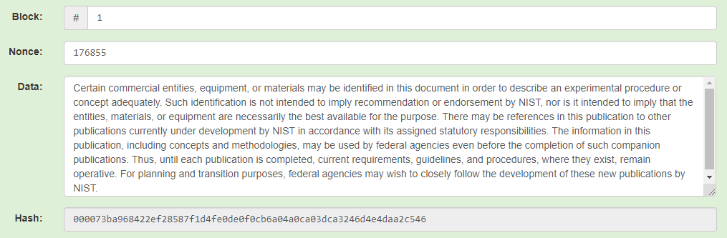
  - 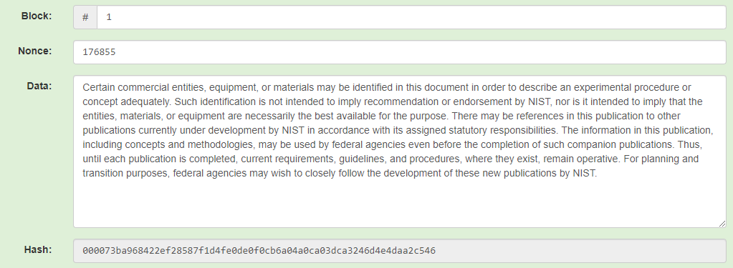
    - I changed the nonce to the variable “999999” and clicked “Mine”, and both the “Nonce” and “Hash” went directly to the same variable shown in 2a. So the data was not altered in any way, thus the “Nonce” and “Hash” were the same without any changes in the coding.

- Peer Blockchain Lab: To complete this lab, you will need to scroll right and left to see Blocks 1-5. Provide screenshots.
  - 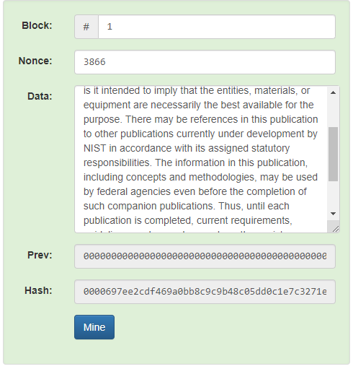
  - 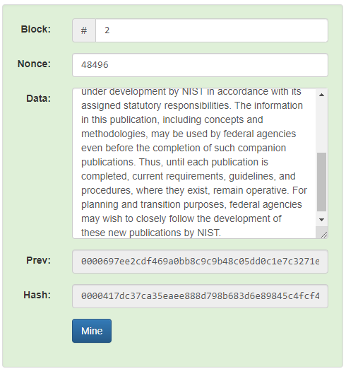
  - Both hashes from Blocks 1 and 2 are different, as Block 2 is dependent on Block 1, as each block shows their previous hashes from the previous block. So that is why the Block 2 hash is different due to that dependency on the previous answer.
  - 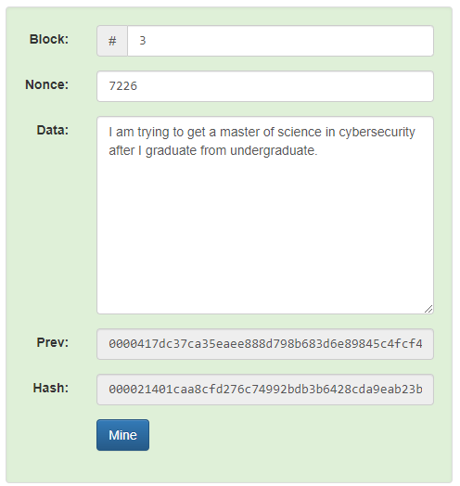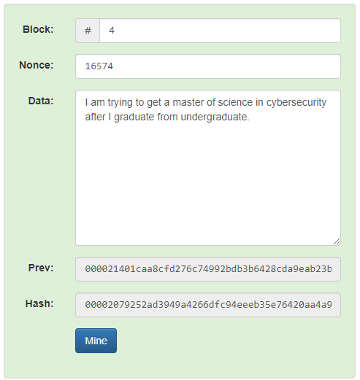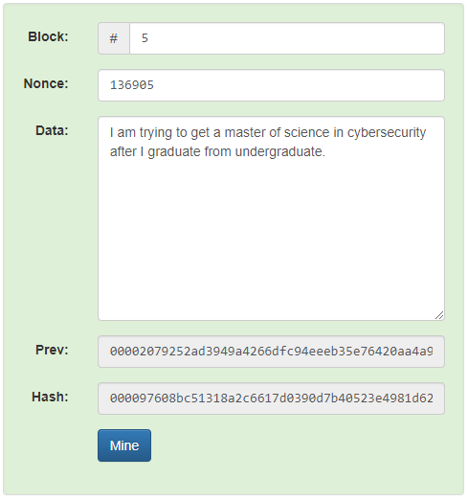
  - 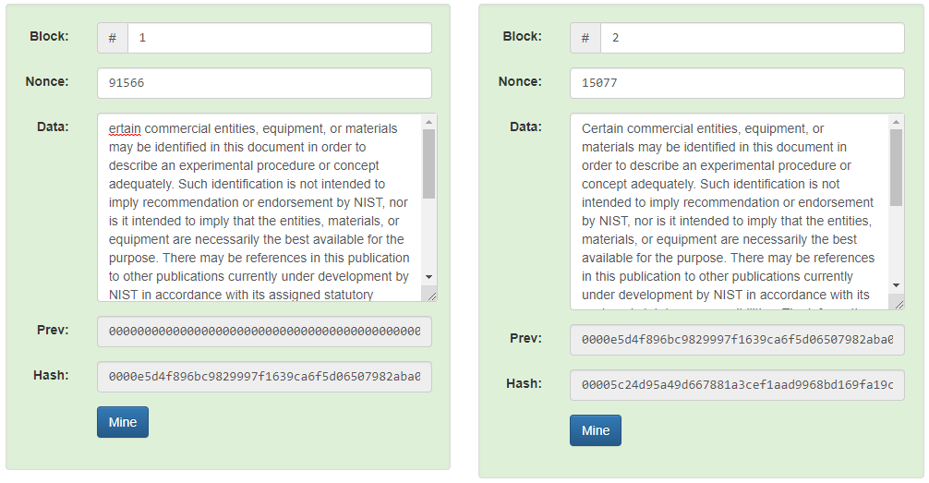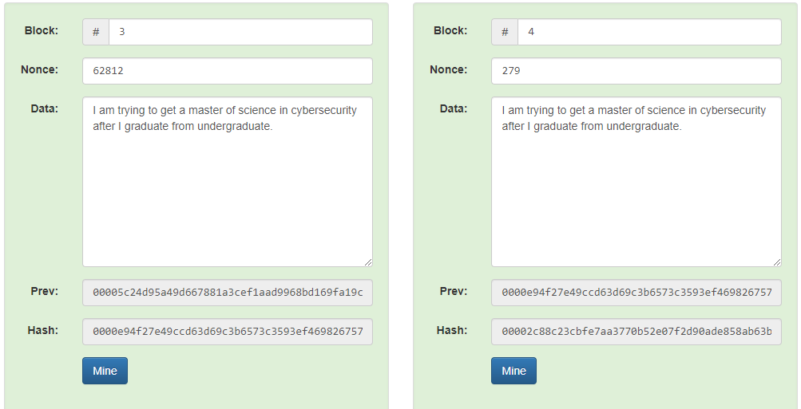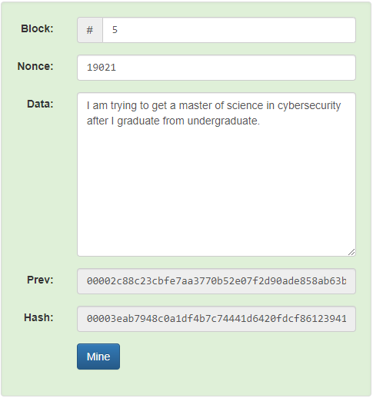
    - Every single “Nonce” and “Hash” changed for Block 1-5 due to each one dependency on each other blocks.

- Distributed Blockchain Lab: To complete this lab, you will need to scroll right and left to see Blocks 1-5 and up and down to see Peer A, B, & C. Blockchain is computed by multiple computers. Here we have 3 peers as a simple example. Repeat Lab 3 with all three peers, but only change the data on Peer B. What is the effect? 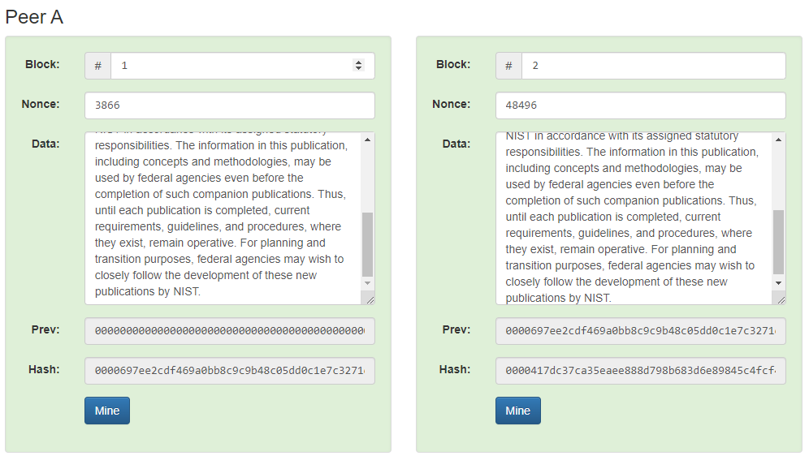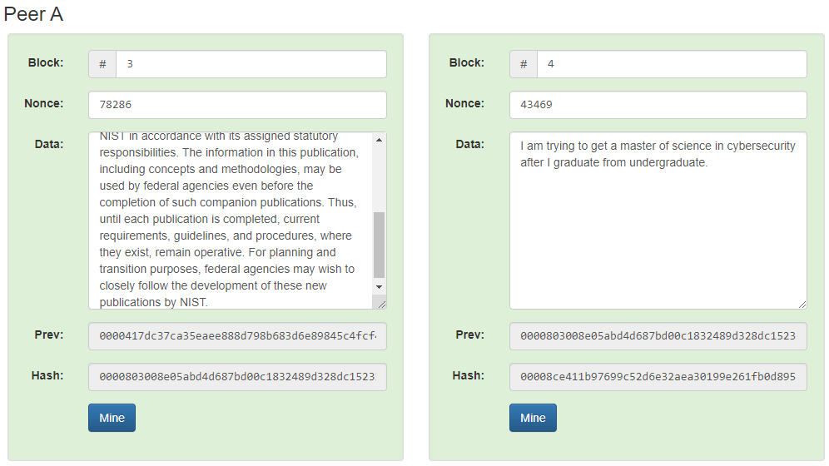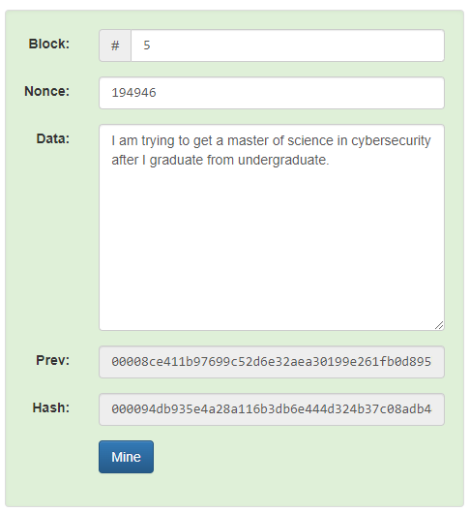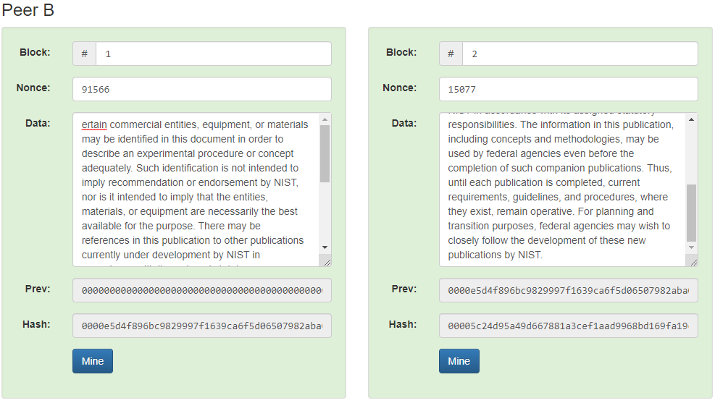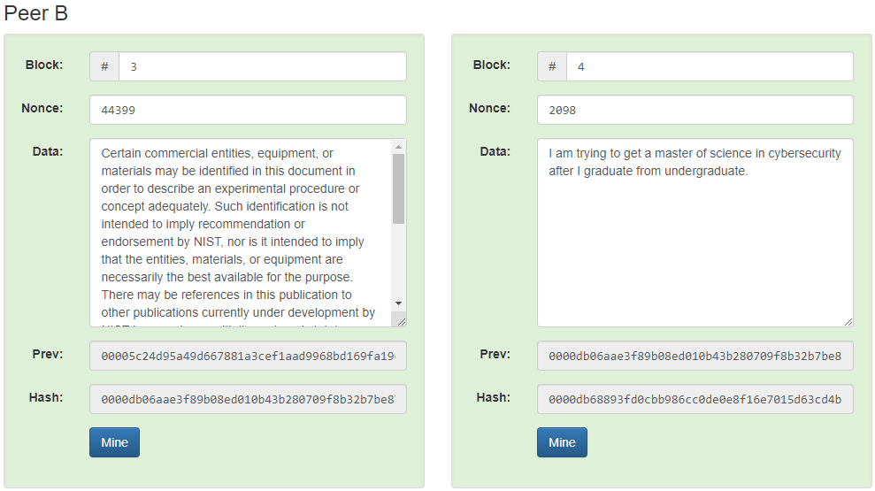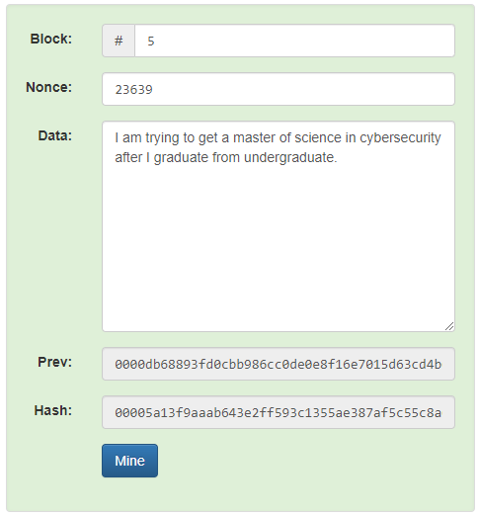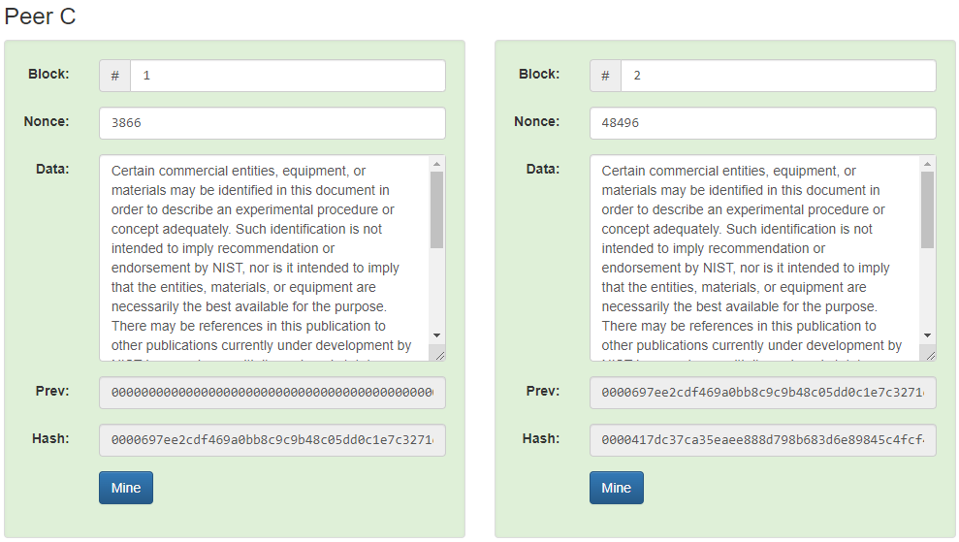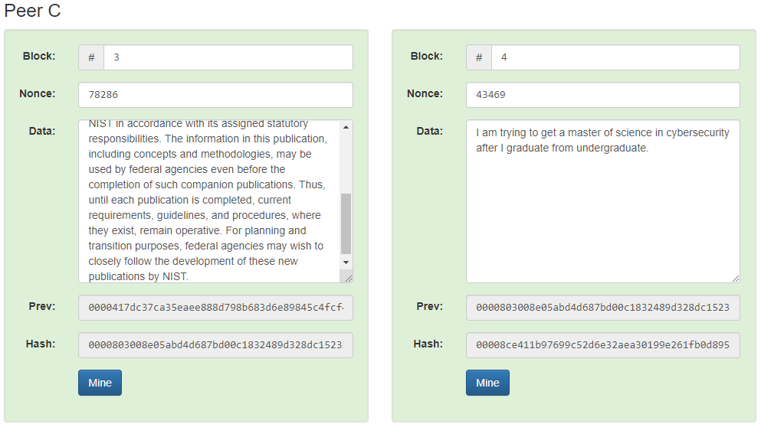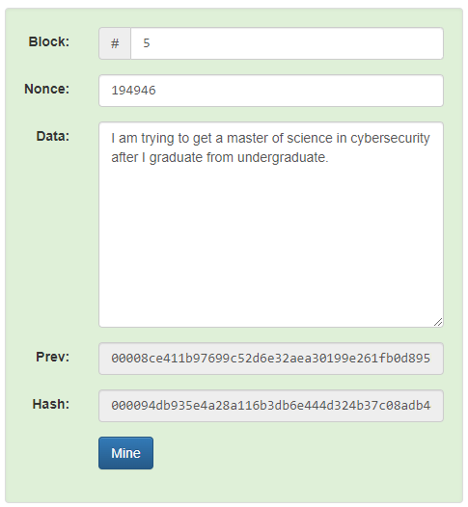
  - Peers A and C have the exact same result, which is the same results that were replicated in 3a-d, but Peer B had the same result as 3e.

- Tokens Peer Lab: In Lab 5, we are going to replace text data with ledger data across 3 peers again. Experiment with changing data in one peer only.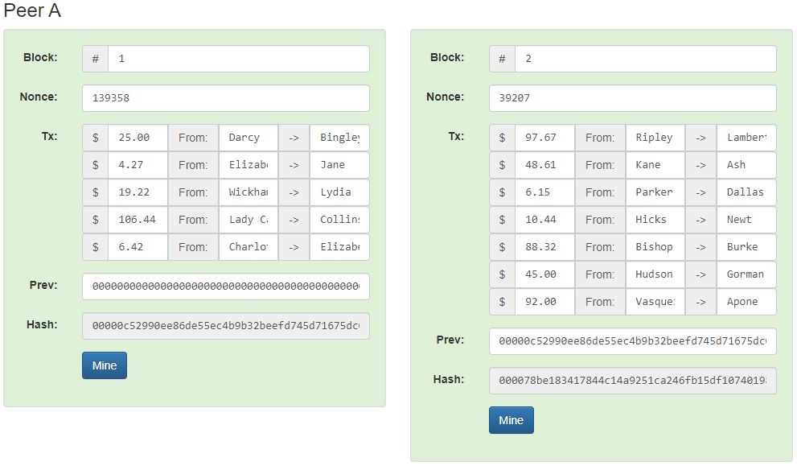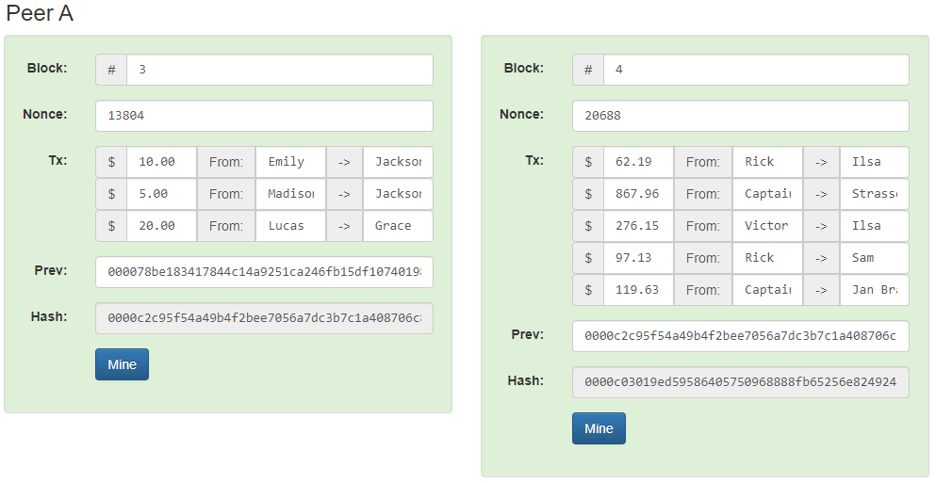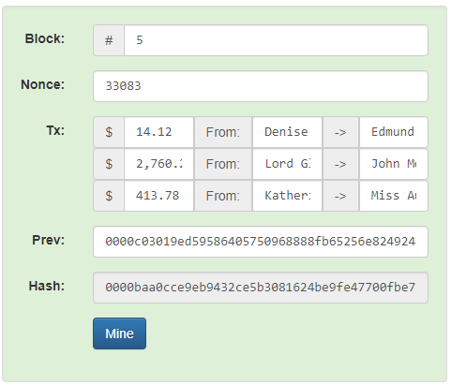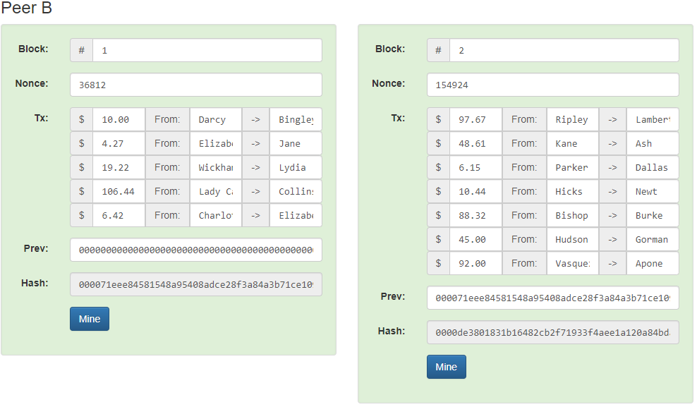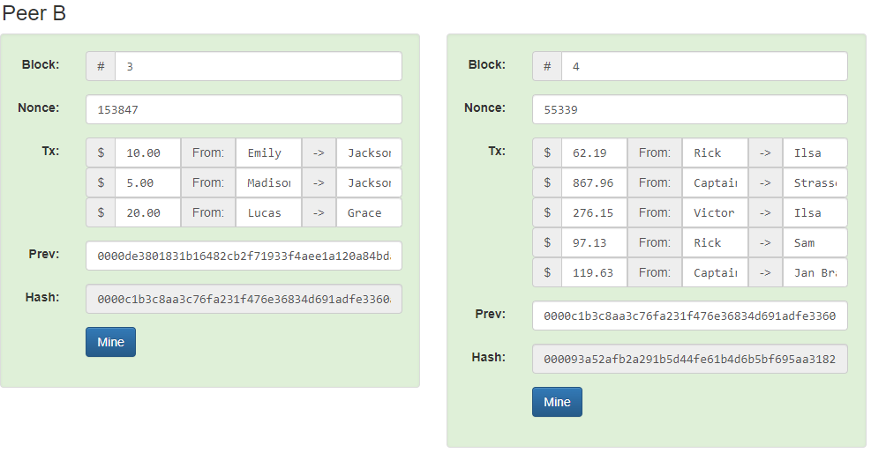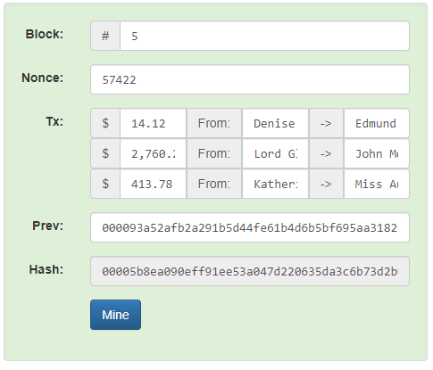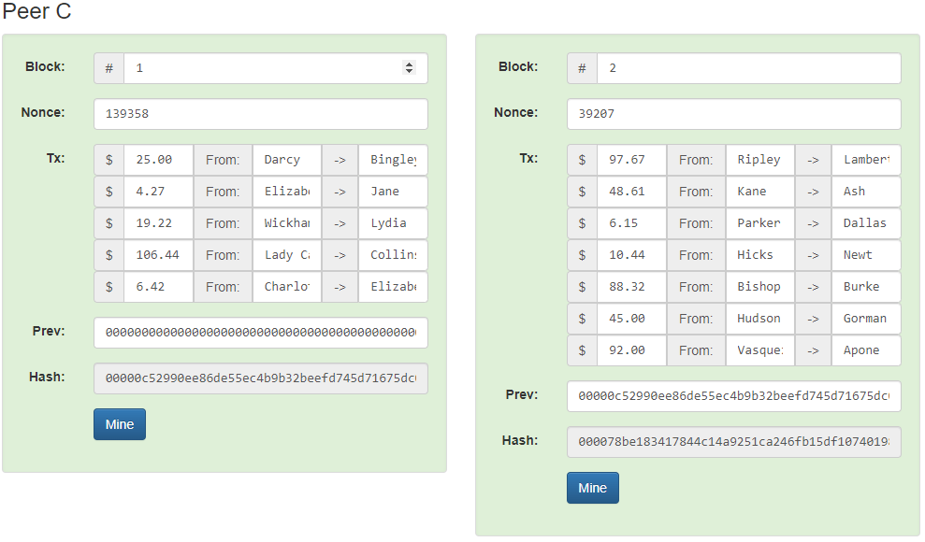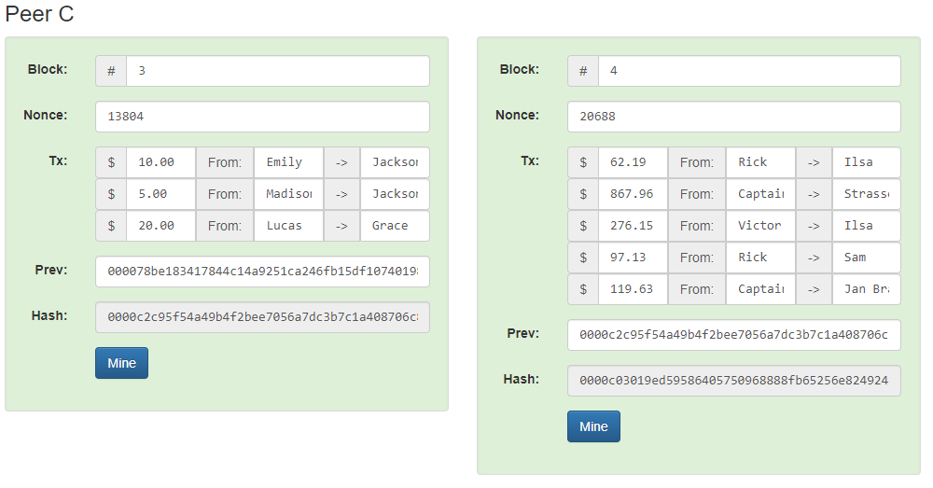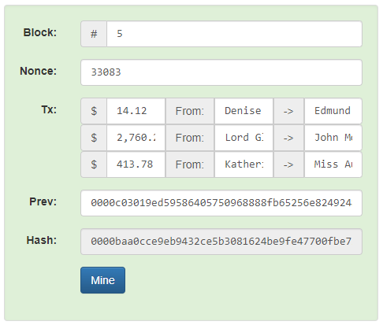
  - The same results happen as 4, where Peers A and C were the exact same results, but Peer B had wildly different hashes, due to changing Block 1 first ledger from $25.00 to $10.00.
Lab 2
- Public/Private Key Lab: Calculate and recalculate public keys based on the private key using the Random button.
  - 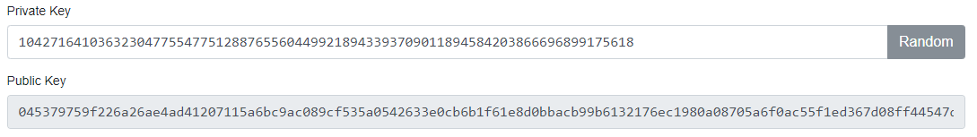
  - 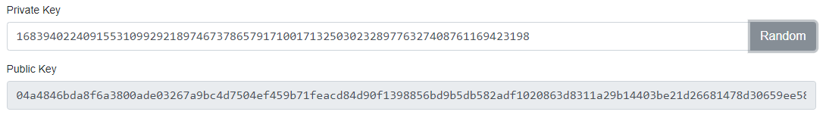

- Signing Messages Lab: Click on the Signatures tab at the top. Create your own message using your private key and Sign the message. Then click Verify to confirm message integrity using the public key. Then change the message on the verify tab (simulating a man in the middle attack) and click verify. What happens?
  - 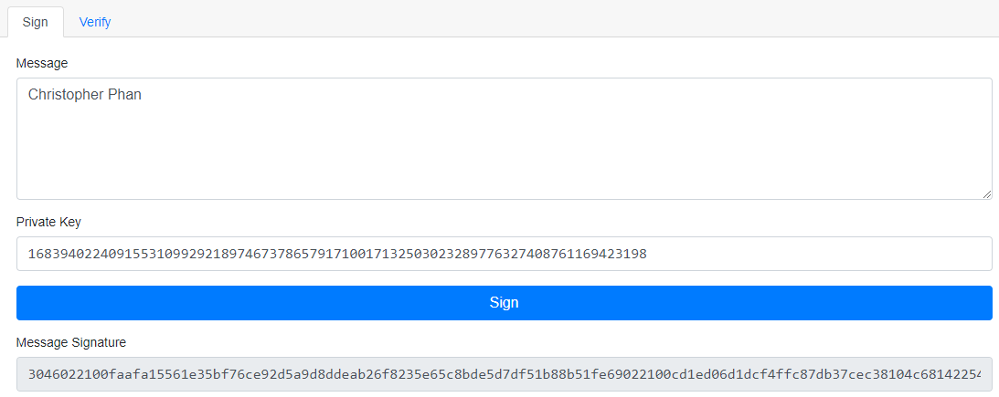
  - 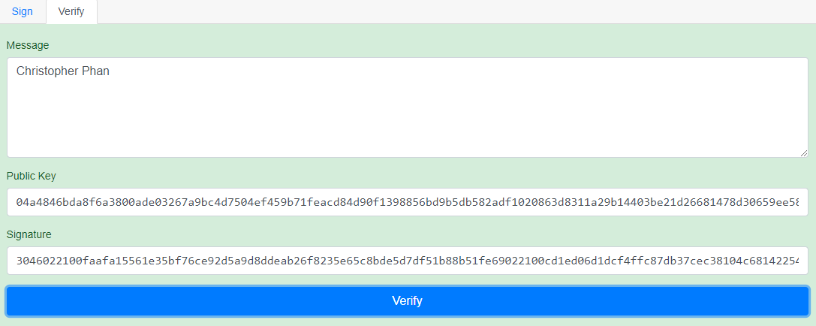
  - 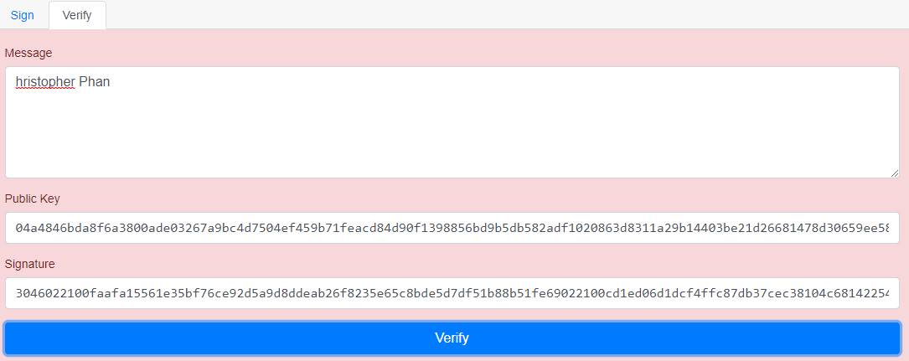

- Signing Transactions Lab: The from and to fields are public keys. Send the recipient $20 and sign. However, I do not want $20. I want $20,000 so I change the value to $20,000 on the Verify tab re-sign. What happens?
  - 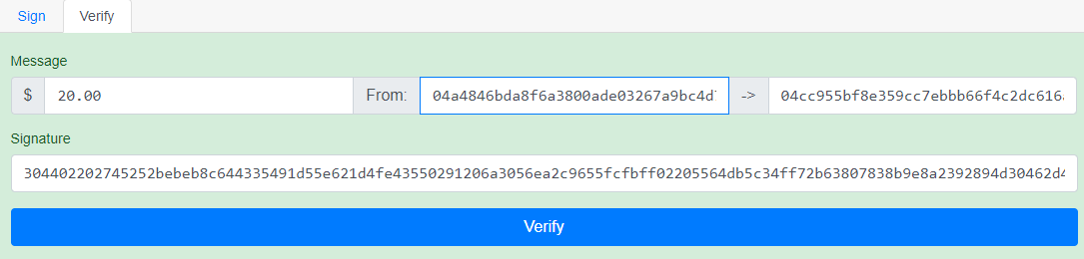
  - 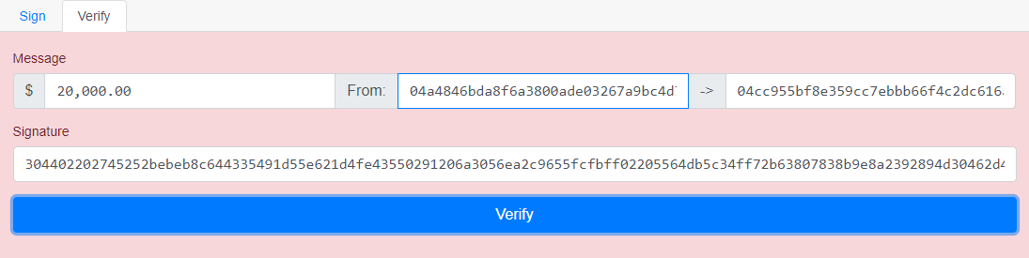
    - The signature does not match for the newly changed $20,000, meaning that it must be verified again.

- Signing Blockchains Lab: Experiment with changing transaction values and Mining.
  - If I change the $100.00 to $10.00 it turns into the figure below on 4b.
  - 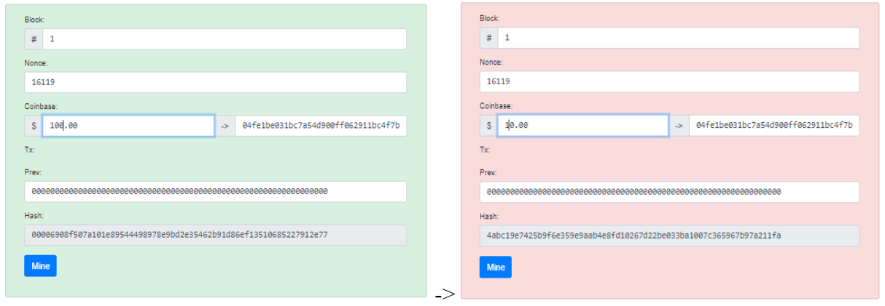
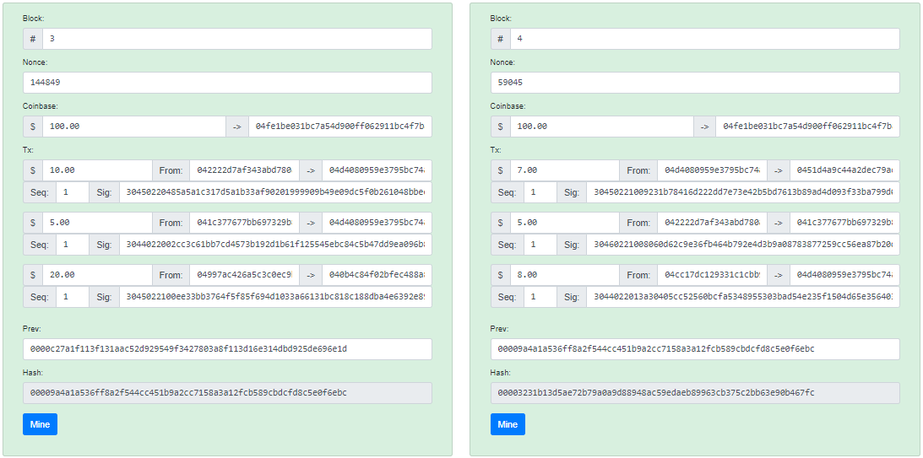
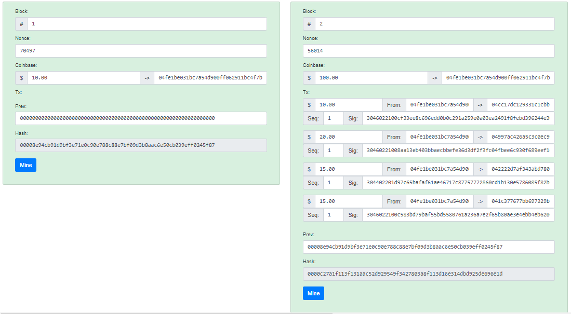
  - It changes into this figure below, changing every subsequent blockchain transaction. Which is shown below in the changed blockchain transaction.

