Digital Forensics, Spring 2023
Christopher Phan
Dr. Renita Murimi
January 19, 2023
Applying the Daubert Standard to Forensic Evidence Lab 01
Section 1
- 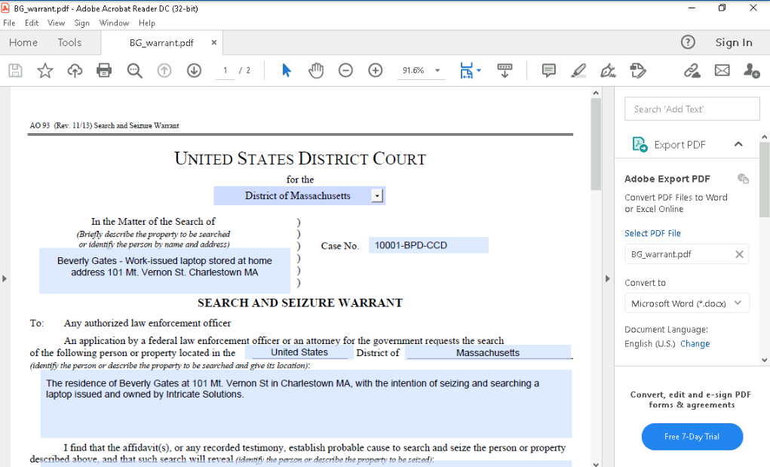
- 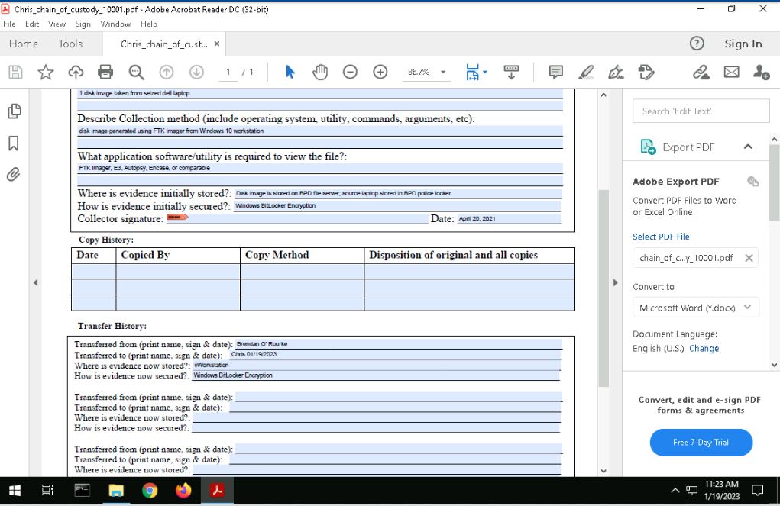
- 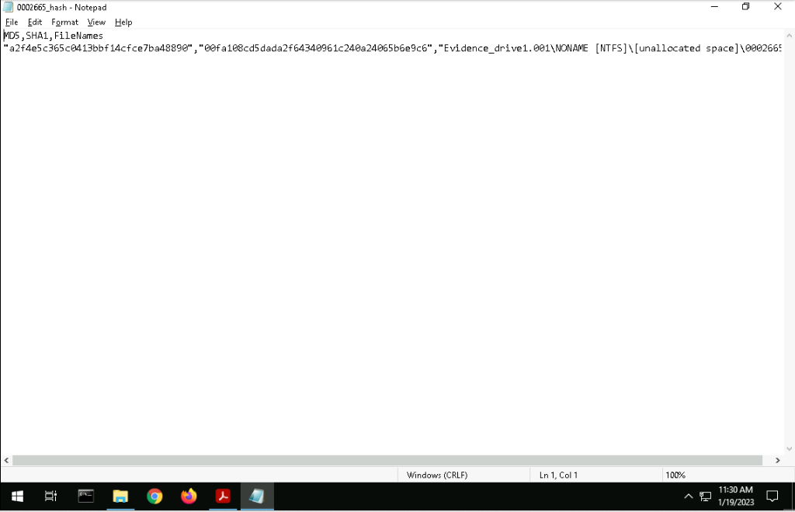
- 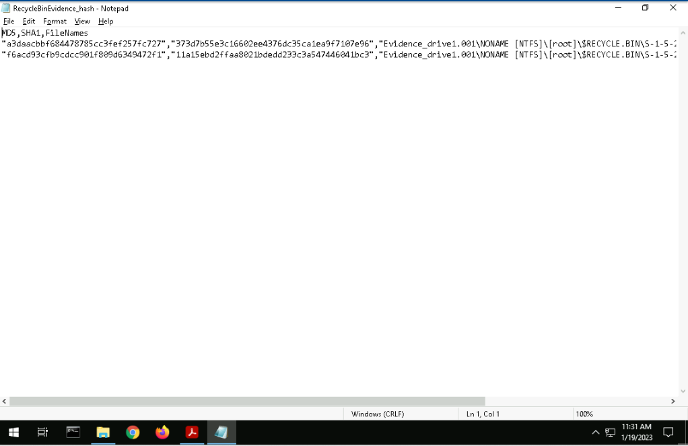
- 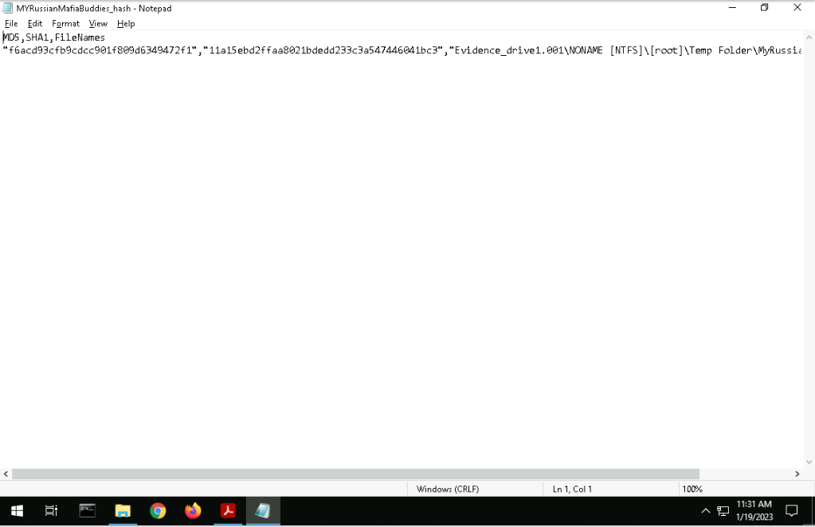
- 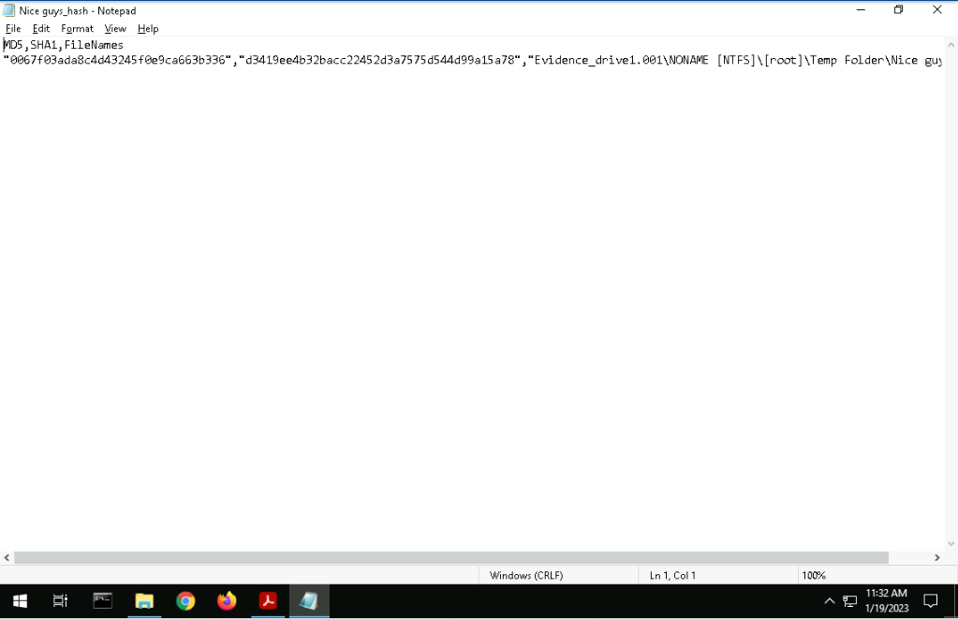
- 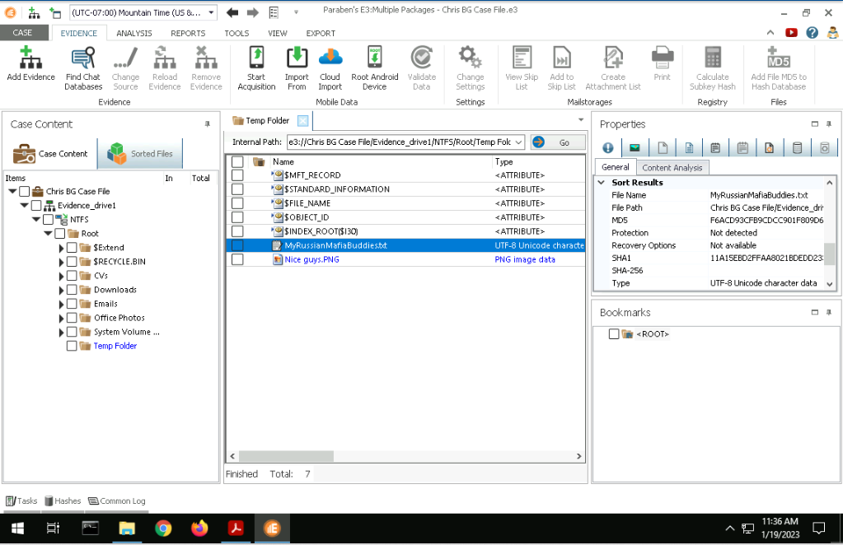
- 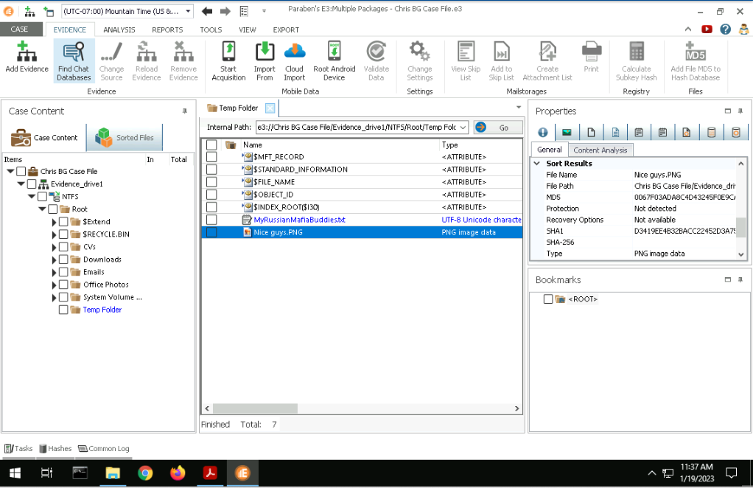
- FTK shows the raw output of the file, displaying it as a note along with the file's contents on a single line. E3 shows a more UI-friendly version of the files, by displaying all the file properties through the tabs on the right side of the screen, showing the entirety of the details of each file, such as size, creation, etc.

Section 2
- 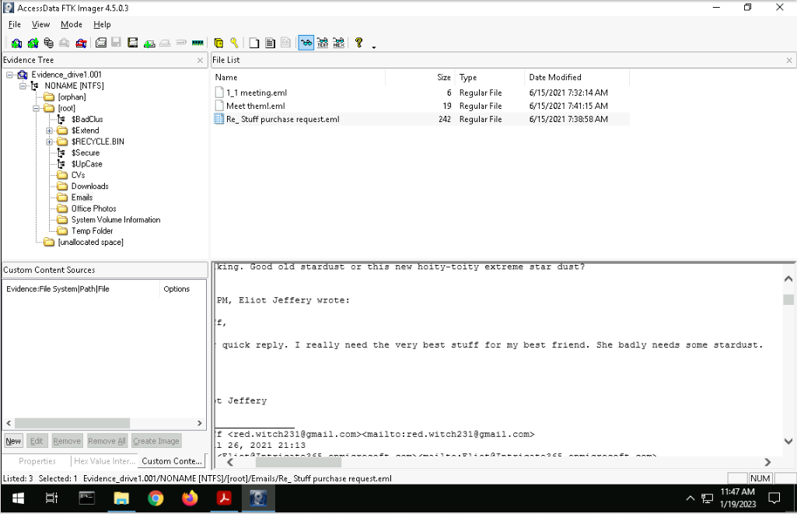
- 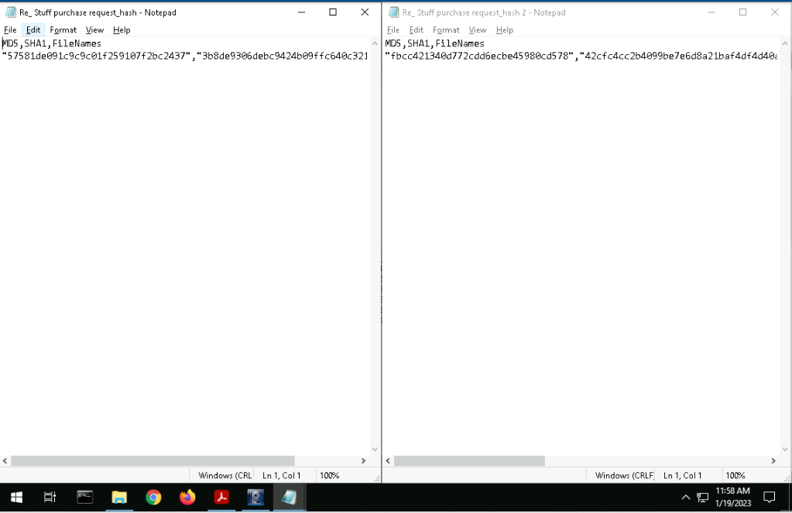
- 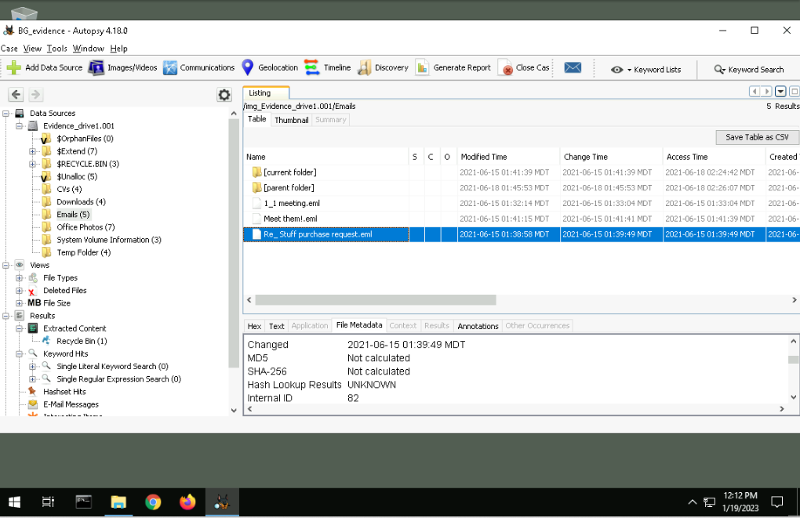
- Based on comparing both MD5 hashes made by FTK and Autopsy, the MD5 is not as easy to find in FTK as it involves exporting the hash list out of the program, while Autopsy displays it for the user immediately. Though, the MD5 results are the same hashes.
- 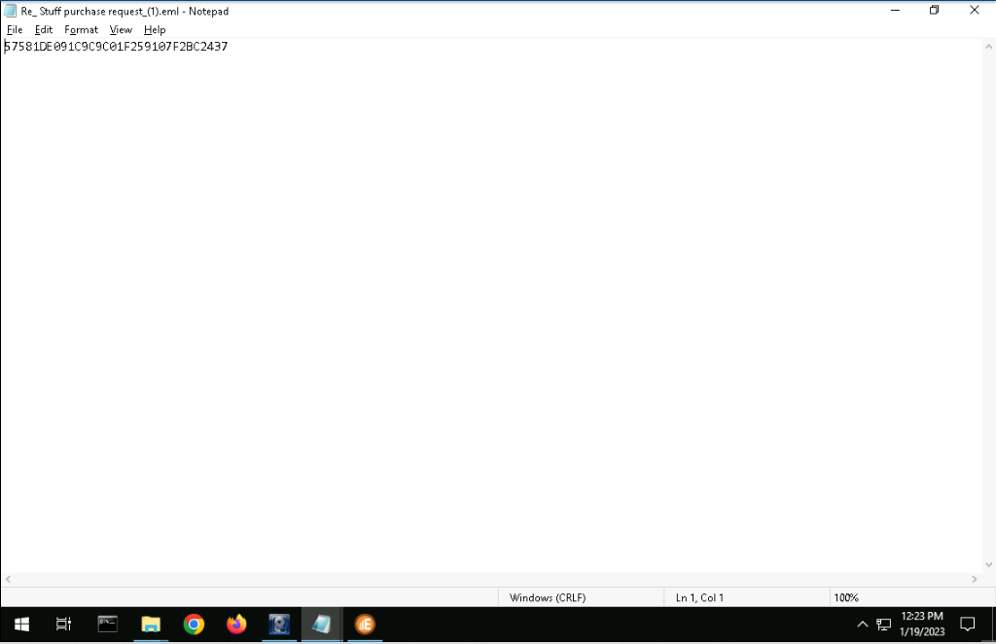
- The difference between E3’s MD5 hash is that it is capitalized and completely by itself, there is no SHA hash nor any other information produced. The hash list export only consists of the MD5 and nothing else based on an initial cursory search.

